SUBCOURSE EDITION

SS0031 C

US ARMY SIGNAL CENTER AND FORT GORDON

PLAN/DESIGN/LAYOUT OF SATELLITE
COMMUNICATIONS SYSTEMS

EDITION DATE: DECEMBER 1994

PLAN/DESIGN/LAYOUT OF SATELLITE
COMMUNICATIONS SYSTEMS

Subcourse Number SS0031

EDITION C

United States Army Signal Center and Fort Gordon
Fort Gordon, GA 30905-5000

4 Credit Hours

Edition Date: December 1994

SUBCOURSE OVERVIEW

This subcourse is designed to teach you a basic knowledge of the types of satellite communications systems currently in the Army inventory.

There are no prerequisites for this course.

This subcourse reflects the doctrine which was current at the time it was prepared. In your own work situation, always refer to the latest official publications.

Unless otherwise stated, the masculine gender of singular pronouns is used to refer to both men and women.

TERMINAL LEARNING OBJECTIVE

ACTION: Demonstrate a basic knowledge of the fundamentals of satellite communications systems.

CONDITION: Given lesson material, paper, pencil, and without supervision.

STANDARD: To demonstrate competency of this subcourse, you must achieve a minimum of 70 percent on the subcourse examination.

i SS0031

TABLE OF CONTENTS
Section Page

Subcourse Overview i

Lesson 1: Overview and Capabilities of Satellite Communications 1-1

Practice Exercise 1-39

Answer Key and Feedback 1-40

Lesson 2: Transmitting Systems and RF Components 2-1

Section I. Waveguide Principles 2-2

Section II. Antenna Feed Systems 2-7

Section III. Modulator Analysis 2-12

Section IV. Indirect-Angle-Modulated Transmitter 2-14

Section V. Direct-Angle-Modulated Transmitter 2-16

Section VI. Transmitter Analysis 2-19

Practice Exercise 2-25

Answer Key and Feedback 2-26

Lesson 3 Receive Systems and Parameters 3-1

Section I. Interference 3-2

Section II. Noise Measurements 3-5

Section III. Noise Measuring Techniques 3-10

Section IV. Parameter Control 3-11

SS0031 ii

Section Page

Section V. Receiver Control Circuits 3-14

Section VI. Frequency-Modulation Feedback Receiver 3-21

Section VII. Phase-Lock Receiver 3-23

Practice Exercise 3-39

Answer Key and Feedback 3-40

Lesson 4: Single Channel Satellite Systems 4-1

Practice Exercise 4-13

Answer Key and Feedback 4-14

Lesson 5: Multichannel Satellite Communications Systems 5-1

Section I. Multichannel Satellite Systems 5-2

Section II. Multichannel Control System 5-15

Practice Exercise 5-33

Answer Key and Feedback 5-34

Lesson 6: Special Communications Systems (SCS) and
Military Strategic Tactical Relay (MILSTAR) 6-1

Section I. Special Communications System 6-2

Section I. MILSTAR 6-4

Practice Exercise 6-9

Answer Key and Feedback 6-10

Appendix Acronyms and Abbreviations A-1

Examination E-1

iii SS0031

THIS PAGE INTENTIONALLY LEFT BLANK

v SS0031

LESSON 1

OVERVIEW AND CAPABILITIES OF SATELLITE COMMUNICATIONS

Critical Task: 01-5768.07-0002

OVERVIEW

LESSON DESCRIPTION:

In this lesson, you will gain a basic knowledge of the different satellite systems.

TERMINAL LEARNING OBJECTIVE:

ACTION: Demonstrate a basic knowledge of the fundamentals of satellite communications systems to include definitions and terms peculiar to satellite communications; the development and purpose of various satellite communications projects; the application of satellites to future military communications systems; effects of channel capacity, bandwidth, transmission path, and frequency ranges on transmission capability and reliability; and comparison between conventional and satellite communications systems.

CONDITION: You will be given lesson material, pencil, and paper.

STANDARD: Demonstrate competency of the task, skills, and knowledge of the material presented by responding to 70 percent of the test questions covering satellite communications, without supervision.

INTRODUCTION

Satellite communications has become a well-established and reliable communications technique. Progress on satellite communications has advanced at a faster rate than the most optimistic forecaster had predicted. As the numbers of operational satellites increase, so will the need for knowledgeable personnel. The emphasis placed on the personnel associated with satellite communications will be shifted from research and development to operation, maintenance, and management.

Personnel associated with satellite communications must become acquainted with the capabilities and the limitations of the equipment used in satellite communications. This subcourse is designed to help you to understand the capabilities and limitations of satellite communications.

1-1 SS0031

LEARNING EVENT 1: REQUIREMENTS FOR IMPROVED COMMUNICATIONS

1. Increased demands.

a. Perhaps the most spectacular evolution in all branches of technology during the last half century has occurred in the field of communications. Sets and components have shrunk in size and grown in reliability, and new techniques have made giant strides in terms of distance and quality.

b. At the same time, the demands made on the techniques and capabilities of communications have increased enormously. Improvements in military transport have given the armed forces the ability to move to almost any area on the globe in a matter of hours. Techniques of military communications must keep pace with this mobility by providing reliable communications to these forces wherever they may be located.

c. The need to constantly improve military communications has long been recognized. Unfortunately, such improvements have often been hampered by crowding of the frequency spectrum, budget limitations, and the slow pace of certain significant advances in the state-of-the-art itself. Although the communications facilities of the various military departments have generally been able to support their communications requirements in the past, the predictable demands of the future require that large-scale improvements be rapidly made if the requirements of the expanding and changing nature of the Department of Defense (DoD) are to be met.

2. Traffic growth.

a. Experience has shown that the usage rate of both commercial and military systems increases by approximately 10 percent per year. It has also been demonstrated that when an improved service is offered, the traffic tends to increase.

b. New facilities, particularly in the form of long-haul communications, will be made available in the near future to areas where they are now either inadequate or nonexistent. This new long-haul traffic will constitute an increasing percentage of the total.

c. The increasing use of data processors and computers, particularly in the military logistic domain, will result in an increase of machine-to-machine traffic volume. This will open new areas and requirements and bring additional users into the Defense Communication System (DCS). With the new users, the growth of traffic from and to all users will also increase.

d. One of the significant examples of this growth is the widespread use of digitized voice transmission. The principal advantage of this transmission method over the analog method is the security it provides, together with its ability to regenerate signals on long-distance circuits. However, digitized voice transmission has its disadvantages as well.

SS0031 1-2

The additional burden the digitized transmission method will place on communications facilities is apparent when the limitations of this technique are recognized. Each digitized voice channel will require a bandwidth of at least 12 of the present standard 4-kHz telephone channels if voice recognition is required.

3. Additional factors affecting growth.

a. The growth in communications is not confined to the United States (US) military and commercial systems. Other countries' systems are experiencing the same exponential growth of traffic. Both here and abroad, new techniques are being developed to make more efficient use of the radio frequency (RF) spectrum, particularly in the high frequency (F) range.

b. These worldwide demands are rapidly exhausting the number of available RFs in the usable RF spectrum. This is the primary limiting factor in expansion of radio communication facilities. The limitations of present systems and the need for an increase in potential capability in military communications systems make the development and implementation of new systems a greater necessity.

LEARNING EVENT 2: REQUIREMENTS FOR A MILITARY COMMUNICATIONS SYSTEM

While many of the requirements to be met by future long-haul communications systems are the same for both commercial and military use, there are, in general, more stringent criteria which must be met by systems for military use.

The military is faced with the need to provide communications that will permit early warning of high-speed attacks and absolute control of forces and weapons in conventional, limited, or operations other than war. To meet these requirements, military long-haul communications systems must be oriented toward reliability, invulnerability, security, flexibility, capacity, and quality. Commercial systems do not ordinarily require invulnerability and security. These required attributes are discussed separately in the following paragraphs.

1. Reliability.

a. In order for a military communications system to fulfil its purpose, it must be highly reliable. The reliability of a system depends on several interlocking factors-the reliability of the equipment and components employed, the reliability of the particular communications media employed, and the skills and knowledge of the personnel operating and maintaining the system. Each of these is important, for reliable equipment is useless without skilled operating personnel, and skilled operating personnel cannot coax dependable performance from poorly designed equipment.

1-3 SS0031

b. The requirements for reliability are much more stringent for a military system than for a comparable commercial system. Even a brief failure of the military system might have disastrous international consequences; and the military system is often forced to provide this reliability while operating in a much more difficult environment than would ever be selected for commercial operation.

2. Invulnerability.

a. A second characteristic that distinguishes the military system from a commercial system is that it must be as invulnerable to overt enemy action as possible. This overt action may take various forms, including physical destruction or capture of parts of the system, or the jamming of the system operations by the transmission of high-powered signals to blanket the system's frequencies.

b. To meet these requirements, the military system must be installed so it can be protected from enemy attack and it must be designed to be as resistant to physical destruction as possible. The latter is often accomplished through hardening of installation sites.

c. Protection against jamming attacks must also be included in the system. Antijamming equipment generally requires larger bandwidths than those normally used in commercial practice, and is therefore generally incompatible with commercial systems.

3. Security.

a. A third requirement placed on the military system is message security. Getting the message reliably from point to point, in spite of overt enemy action, includes the ability to deny enemy access to the information.

b. To ensure the enemy is unable to decipher the information, elaborate encryption techniques are necessary. The implementation of these techniques imposes additional requirements on the communications system which would not normally be within the ability of the commercial communications systems to satisfy. For example, one requirement imposed by the elaborate encryption techniques is an extremely accurate synchronization system.

4. Flexibility.

a. Commercial communications systems grow in a fairly predictable pattern with the growth of the large population centers. Military communications systems have no such directly predictable pattern. It is possible, with the present world political situation, that requirements for reliable, invulnerable, secure communications for military purposes may arise tomorrow in areas where no commercial system would, nor could, be reasonably expected to supply such flexibility.

SS0031 1-4

b. To meet this potential, the military system must not only include the fixed sites, which will be located in selected politically stable areas, but must also have available transportable equipments to move rapidly to areas where emergency demand might arise.

5. Capacity. The military services, for reasons explained previously, require more and more communications channels. The need for increasing channel capacity is especially true when handing digital traffic.

6. Quality. The quality of the transmission required in the military system differs from that in commercial practice. The expected increase in digital traffic will place increased demands on the military systems in terms of digital quality. In order to achieve a high probability of error-free transmission, quality checks will be necessary in most military digital channels.

LEARNING EVENT 3: LIMITATIONS OF PRESENT LONG-DISTANCE TRUNKING SYSTEMS

The facilities for long-distance trunking most generally used in present-day systems consist of HF, ultra high frequency (UHF) ionospheric scatter, and microwave equipment. These facilities may also include tropospheric scatter or multihop line-of-sight (LOS) installations, as well as military and commercial cables. All of these trunking methods have inherent limitations which prevent them from meeting entirely the requirements for which they were designed.

1. High frequency limitations.

a. The propagation of HF signals over long distances depends upon the refraction that occurs in the ionosphere. The height of the ionized layer and the degree of ionization are subject to pronounced variations, daily and seasonally. The degree of ionization is also influenced by sunspot activity-the effect of increased sunspot activity being to increase the maximum usable frequency. Since there is an observed cycle of approximately 11 years in the sunspot activity, the usable portion (for long-distance communication) of the HF band also varies in approximately an 11-year cycle. The usable signal bandwidth may need to be reduced by half its normal value during periods of most severe sunspot activity to maintain reliable communications.

b. Channel capacity in the 3-to 30-megahertz (MHz) HF band is limited most directly by the crowded conditions of the band. This band must be shared by many users, foreign and domestic, and the portions allocated to DCS add up to only a small fraction of the 27-MHz spectrum. The increasing use of single-sideband suppressed carrier transmission for DCS circuits has permitted more efficient utilization of the available bandwidth slots; but circuit requirements also have grown and the band is now more crowded than ever.

1-5 SS0031

c. Long-distance strategic communications by HF propagation is not always as reliable as military commanders feel is necessary in present world conditions. In addition to the variations in usable bandwidth that occur daily, seasonally, and over the 11-year sunspot cycle; there are occasions when the entire HF band becomes relatively useless (blackout) because of magnetic storms caused by solar flares. These latter effects are particularly disrupting communications and from the polar areas.

2. VHF and UHF limitations.

a. Point-to-point radio communications in the very high frequency (VHF) band (30 to 300 MHz) and UHF band (300 to 3,000 MHz) may be accomplished by two basically different techniques. The first technique uses numerous repeaters or radio relays spaced at or near the optical horizon. These systems are referred to as LOS systems. Where VHF is employed, the relays may be somewhat beyond the optical horizon (that is, "fringe area") due to refraction of VHF signals in the atmosphere. Because both VHF and UHF are essentially LOS systems, the transmission path loss is relatively small and low transmission power provides satisfactory communication.

b. While having many advantages over HF, the LOS systems do have limitations. Neither LOS nor tropospheric scatter propagation is capable of spanning a large body of water where lack of islands prohibits the installation of repeater stations, and ionospheric scatter is too limited in bandwidth to provide more than a fraction of the service needed for the DCS. HF radio has therefore furnished our major overseas long-distance links for years.

c. Terminal and repeater stations are vulnerable to both attack and sabotage. The vulnerability of LOS systems is particularly great because of the large number of repeaters.

d. Jamming is possible with only moderate effort. Ground-based or airborne jammers can jam the side lobes of LOS receiving antennas or tropospheric scatter receiving antennas.

3. Cable limitations.

a. The use of cables for long-distance communications is extremely expensive, especially with deep sea cables. Cables are ordinarily used when radio techniques are not feasible or adequate.

b. Wideband communications, on the order of several megahertz, requires the use of RF transmission lines. The most widely used RF transmission line is a coaxial cable. However, when a coaxial cable is used for long-distance communication, it exhibits the characteristics of nonlinear attenuation, with effective cutoff at some particular frequency.

SS0031 1-6

c. Laying wideband cables over long distances is a long-term project and, once in place, the cable systems are relatively inflexible. Cables laid "over land" are generally buried. Even when property acquisition is not considered, this is a long involved operation. The laying of an intercontinental undersea cable may require 5 years or more, including the design and manufacture of the cable itself.

d. From a military standpoint, the greatest weakness of long-distance cables is their vulnerability. A cable system offers an infinite number of points at which it may be attacked or sabotaged. An overland cable may be made fairly survivable if buried deeply enough. An undersea cable can easily be cut by either surface ship or submarine.

LEARNING EVENT 4: ADVANTAGES OF SATELLITE COMMUNICATIONS

It is apparent that new techniques and equipment are needed to overcome the present limitations of our military communications systems. The military department has long recognized the potential advantages of using satellites and have conducted research and development programs for a number of years. These programs are designed to produce a practical military satellite communications system which will incorporate all of the features required by the military. Additionally, communications systems employing satellite links offer a unique combination of advantages for long-distance trunking.

1. Capacity. Eventually satellite systems will be capable of handling hundreds of voice frequency (VF) channels, although the first-generation satellite systems were at first limited to approximately four VF channels.

2. Reliability. The reliability of active satellite communications systems will be limited mostly by the reliability of the equipment employed and the skill of the operating and maintenance personnel.

3. Invulnerability.

a. While it is possible to destroy an orbiting satellite by rocket fire, the present developments in rocketry suggest that this would be quite difficult. It would be particularly difficult to destroy an entire system employing random orbit satellites, primarily because of the number involved.

b. The present state-of-the-art indicates that satellite communications ground stations in certain instances will be vulnerable to jamming attacks. However, by judicious planning and systems design, the enemy could be forced to expend so much time, effort, and equipment to effectively jam our communications facilities that the attempt would be unwarranted from his point of view.

c. A rocket or satellite-based jammer with limited power must be positioned within the main beam of the ground station to be effective. This implies that the rocket or satellite jammer must be in approximately the same position and orbit as the communications satellite. Considerable effort on the part of the enemy would be required to achieve the precision of position necessary to establish such an orbit.

1-7 SS0031

d. In any event, the bandwidth of present satellite receivers is great enough to accommodate the use of spread-spectrum antijam techniques. Such antijam techniques are very effective, even in the face of heavy jamming.

4. Flexibility. Vehicle-mounted satellite ground-station equipment can be flown to remote areas and placed in operation in a matter of hours. Once these stations are operational, long-distance communications can be established with any other satellite ground station within sight of the satellite.

LEARNING EVENT 5: APPLICATION TO THE DEFENSE COMMUNICATIONS SYSTEM

1. The Defense Communications System.

a. The DCS is a communications network established by order of the DoD and placed under the direction of the Defense Information Security Agency (DISA). The mission of the DISA is to ensure the DCS will be so established, improved, and operated as to meet the long-distance, point-to-point telecommunications requirements of the DoD and other governmental agencies as directed.

b. The DCS is a unified communications system that provides the long-distance, point-to-point telecommunication requirements of the DoD. No other facilities are authorized for this purpose. The DCS provides strategic communications facilities for command, operations, intelligence, weather, logistics, and administrative purposes. It provides the quality and quantity of communications capabilities required for these purposes.

c. The DCS network consists of switching centers located in various areas around the world and the links interconnecting them. Individual service units need only provide communications to the nearest switching center to become network subscribers and have access through the network to the entire system.

2. Satellite application.

a. Satellite communications form part of the long-distance links between the switching centers. These links employ the satellites in addition to other firms of existing communications media-HF radio, tropospheric scatter, ionospheric scatter, landline, cable, and LOS microwave. They provide added capacity between various points in the network and, since the satellite links continue in operation under conditions that will render other media inoperable, they provide the important reliability factor necessary to military communications.

b. As the techniques of satellite communications evolve and are perfected, satellite communications can be expected to provide the major part of all intercontinental links in the DCS. Their particular advantages in terms of flexibility and survivability, which increase dramatically as the number of satellites in use is increased, will predictably establish communications satellites as a major factor in the system.

SS0031 1-8

c. Further application will result from the existence of the satellites in sufficient number to satisfy the long-haul strategic requirements. Once this has been achieved, their use will be economically justifiable on the shorter tactical links as well.

LEARNING EVENT 6: PAST EFFORTS AND RESULTS IN SPACE COMMUNICATIONS

The following brief summaries constitute a chronological history of satellite communications efforts. In these, as in discussions of most communications satellite systems, orbital altitude are given in miles. Unless otherwise indicated, these figures represent nautical miles. A nautical mile is approximately 1.11 statute miles.

1. Project Communications Moon Relay (CMR). The moon, being a natural satellite of the Earth, offers the possibility of being used for communications purposes. The US Navy demonstrated in 1951 that it was feasible to use the moon as a reflector of electromagnetic radiation to communicate between distant points on the Earth's surface. By 1956, the feasibility of CMR had been sufficiently demonstrated so the chief of Naval Operations directed the establishment of a two-way telegraph and facsimile CMR link between Washington and Hawaii. In November 1959, the system was successfully used when solar disturbances in the ionosphere disrupted conventional HF circuits between Washington and Hawaii. Transmitter and receiver sites for each end of the CMR link were located some distance apart to minimize mutual interference. For instance, the Washington transmitter site was located at Annapolis, Maryland, and the receiver site was located at Cheltenham, Maryland-a distance of several miles.

2. Project Score. On 18 December 1958, the Score satellite was successfully launched. This was the first satellite designed purely for communications purposes. As a practical demonstration of its capability, President Eisenhower recorded a Christmas message which was rebroadcast to the world via the satellite. Score operated for 12 days, during which time 97 contacts were made. The altitude of Score varied from 110 miles to 920 miles. Since this was a relatively low-altitude orbit, the ground terminals had to be relatively close to each other in order that both stations in each communicating pair could "see" the satellite. Score was designed to receive message traffic as it passed over one station, record the message, and retransmit the traffic as it passed over another station. This technique of recording messages for later transmission is known as store-and-forward.

3. Project Courier. The more refined communications satellite, Courier, was the joint responsibility of the US Army Signal Corps and the US Air Force. Courier was designed with a dual capability-that of recording and retransmitting traffic, as in the earlier Score, and functioning as a direct relay. The first launch attempt failed because of booster difficulties, but Courier IB was successfully put into orbit on 4 October 1960. The satellite weighed 500 pounds and had a diameter of 52 inches. Courier's altitude varied from 598 to 755 miles, with a total operating time of only 18 days. The experiment was considered highly successful because it demonstrated the feasibility of high-capacity store-and-forward satellite communications. The ground equipment associated with this test is still in use and will continue to be used in a modified form for other tests.

1-9 SS0031

4. Project Echo. The Echo satellite was a large inflated balloon with a highly reflective surface. Satellites of the Echo type are known as passive satellites, which serve as reflectors or reradiators of electromagnetic energy and contain no energized electronic circuitry of their own. Orbital altitude varies from 658 to 1,222 miles. On the same day the balloon was launched, the first two-way-voice link via passive satellite was accomplished.

5. Project Westford. The primary objective of Westford was to place an orbital reflective belt of millions of tiny dipoles around the Earth. These dipoles return a large percentage of radiation received to the Earth. The announcement of this project brought a storm of objections from scientists around the world who claimed that this belt of resonant particles would interfere with both radio and visual astronomical observations. On 4 October 1961, a special panel of the President's Science Advisory Committee reported that no permanent damage would accrue from such an experiment, and a launch with a payload of 75 pounds of fine copper dipoles was attempted on 21 October 1961. The experiment failed because the dipoles did not disperse in orbit. On 12 May 1962, the US Air Force announced that the second Westford experiment package had been launched and that dispersal was taking place as planned. The final results of this experiment were not announced.

6. Project Advent. Project Advent was a major military satellite communications effort directed at placing a multichannel active repeater at synchronous altitude. At synchronous altitude the satellite revolved around the Earth at the same angular speed as the Earth's surface. The satellite, therefore, appeared to hang nearly motionless above some point on the Earth's surface. This has many obvious advantages of a low- or medium-altitude nonsynchronous satellite, the most important being that it eliminates many of the technical problems associated with tracking a satellite moving at high speed across the sky. Difficulties encountered in the booster program, combined with other complications, caused cancellation of the entire program and the effort was reoriented into the Defense Communication Satellite Program (DCSP) for DoD. The two "gateway" ground terminals that were built for the Advent program at Fort Dix, New Jersey and Camp Roberts, California, were first modified for the SYNCOM program and have since been remodified for the DCSP.

7. Project Telstar. Telstar I satellite was a medium-altitude communications satellite, commercially designed and launched by National Aeronautics and Space Administration (NASA) to demonstrate the feasibility of intercontinental communications via satellites. Entirely company-founded by American Telephone & Telegraph Company (AT&T), the launch was performed by NASA Orbit was achieved on 10 July 1962 and a live television program was transmitted for the first time between North America and Europe. Trouble developed in the satellite when ionization caused by high-altitude nuclear testing affected certain parts. A specially formulated code was used to turn off the power supply long enough for deionization to occur. Successful operation was restored and continued throughout the remainder of its life. Telstar II was orbited on 7 May 1963. In an attempt to reduce the ionization effects experienced with Telstar I, Telstar II was placed in a higher orbit (6,702 miles maximum altitude) and employed some evacuated devices. Live color television was transmitted via Telstar II from the US to France.

SS0031 1-10

8. Project Relay. Relay was a medium-altitude (820 miles to 4,612 miles) communications satellite, much like Telstar, and was developed by Radio Corporation of America (RCA) for NASA. Relay I was launched on 13 December 1962 by a Thor Delts booster. The Relay satellite weighed 172 pounds and was 33 inches high, with a maximum breadth of 29 inches. Relay's RF power output was greater than Telstar's-10 watts compared with 2.5 watts. Relay's transponders (transmitter-receiver combinations) also differed from Telstar's since they contained frequency triplers, while Telstar changed from receive frequency to transmit frequency by heterodyne mixing. These differences in circuitry plus various construction differences allowed an evaluation of the various techniques involved by comparing Telstar and Relay performance. Much of the ground station equipment used with Telstar was also used with Relay--AT&T's facility at Andover, Maine and the stations at Goonhilly Downs, England and Pleumer-Bodou, France, for instance. Immediately after Relay was launched, telemetry data indicated low power supply voltage. After waiting for some time to see if the power supply voltage might stabilize, the satellite was commanded to switch to the other transponder. After the switch, the satellite functioned normally. It was used to relay television signals from the US to Europe, and to establish the first link via satellite between the US and South America when contact was established with a station in Brazil.

9. Project SYNCOM.

a. In the SYNCOM series, two satellites were successfully launched into orbits having periods of very nearly 24 hours. The 24-hour period caused the satellites to appear to be almost motionless over the equator, providing a permanent link for a pair of ground stations. SYNCOM I apparently was damaged by the firing of the apogee rocket motor that was to circularize its orbit, and radio contact was lost immediately after the motor was fired. However, both SYNCOM II and III were successfully orbited and functioned satisfactorily as real-time repeaters in overseas operations. SYNCOM II drifted north and south of the equator in a figure 8 pattern, but SYNCOM II was in a nearly perfect equatorial synchronous orbit SYNCOM III, then, was more easily tracked by the ground terminal.

b. Owing to the size and weight limitations imposed on the satellite to achieve this type of orbit, each SYNCOM satellite was relatively small. Its package, without antenna or final stage motor, was a cylinder 28 inches in diameter and 15-1 inches high. The weight of the communications package, plus the burned-out final stage motor, was only 86 pounds, of which the communications package alone weighed approximately 50 pounds. Because of the small size and the great distances involved, SYNCOM did not have the communications capacity nor the output power that some of the low-altitude communications satellites possess. The communication-handling capacity of synchronous satellites has increased as the state-of-the-art advanced, and we now are able to place larger satellites into synchronous orbits.

c. One of the advantages of the SYNCOM type of satellite is the elimination of the technical problems involved with antenna tracking of a continuously moving satellite. This is an advantage of the synchronous orbit wherein the satellite appears to hang motionless in the sky.

1-11 SS0031

LEARNING EVENT 7: APPLICATIONS OF SATELLITE COMMUNICATIONS

1. Transoceanic live television. Military communications satellites will probably not be used for regular television broadcasts. However, in the event that commercial communications satellites are not in position to cover important public events, military satellites may be pressed into service for television relay.

2. Commercial communications. There is a definite increasing trend on the part of business interests to use computers in their operations. Machine-to-machine communications are now used regularly within continental limits. Satellites have extended this type of communications to other continents and increased efficiency of business using transoceanic digital data communications.

3. Telephone communications. Worldwide telephone communications have approached reality with the introduction of satellite communications. The inhabitants of remote regions are no longer denied the benefits of modern technological breakthroughs in communications. The vast expense of constructing and maintaining telephone lines over inaccessible terrain will be largely eliminated by using communications satellites. The only additional need will be a suitable ground terminal placed in an advantageous position.

4. Direct-distance dialing. Direct-distance-dial telephone communications systems are being extended on a worldwide basis. The short dialing pulses used on these systems create many technical problems that are difficult to solve when using existing long-distance communications facilities. The large values of line constants (inductance and capacitance) in undersea telephone cables cause serious distortion of the dialing pulses. Moreover, the noise, fading, and interference problems on the long-distance HF radio circuits cause many dialing inaccuracies. Designers of direct-distance-link telephonic communications systems are therefore looking toward the utilization of communications satellites to satisfy their needs. Experience with communications satellites has proved the received signal to be admirably suited to carry direct-dialing pulses. The received signal from a satellite is normally stable and relatively free from noise. Further, the absence of large values of inductance and capacitance assures comparative freedom from pulse-length distortion.

5. Other applications. As satellite communications come into practical use, other applications will be found which have not been conceived at the present time. Space communications technology has advanced at a very rapid rate and is expected to continue to advance. Therefore, it is reasonable to assume that many new and startling applications can be expected within the near future.

SS0031 1-12

LEARNING EVENT 8: SATELLITE COMMUNICATIONS SYSTEM CONCEPT

A communications satellite has been described as a "microwave radio repeater in the sky." This implies that the satellite is a link in an existing communications system. A block diagram of an integrated communications system including a satellite link is shown in Figure 1-1. Inclusion of a communications satellite as part of the microwave radio link overcomes many of the obstacles experienced by long-distance HF radio communications.

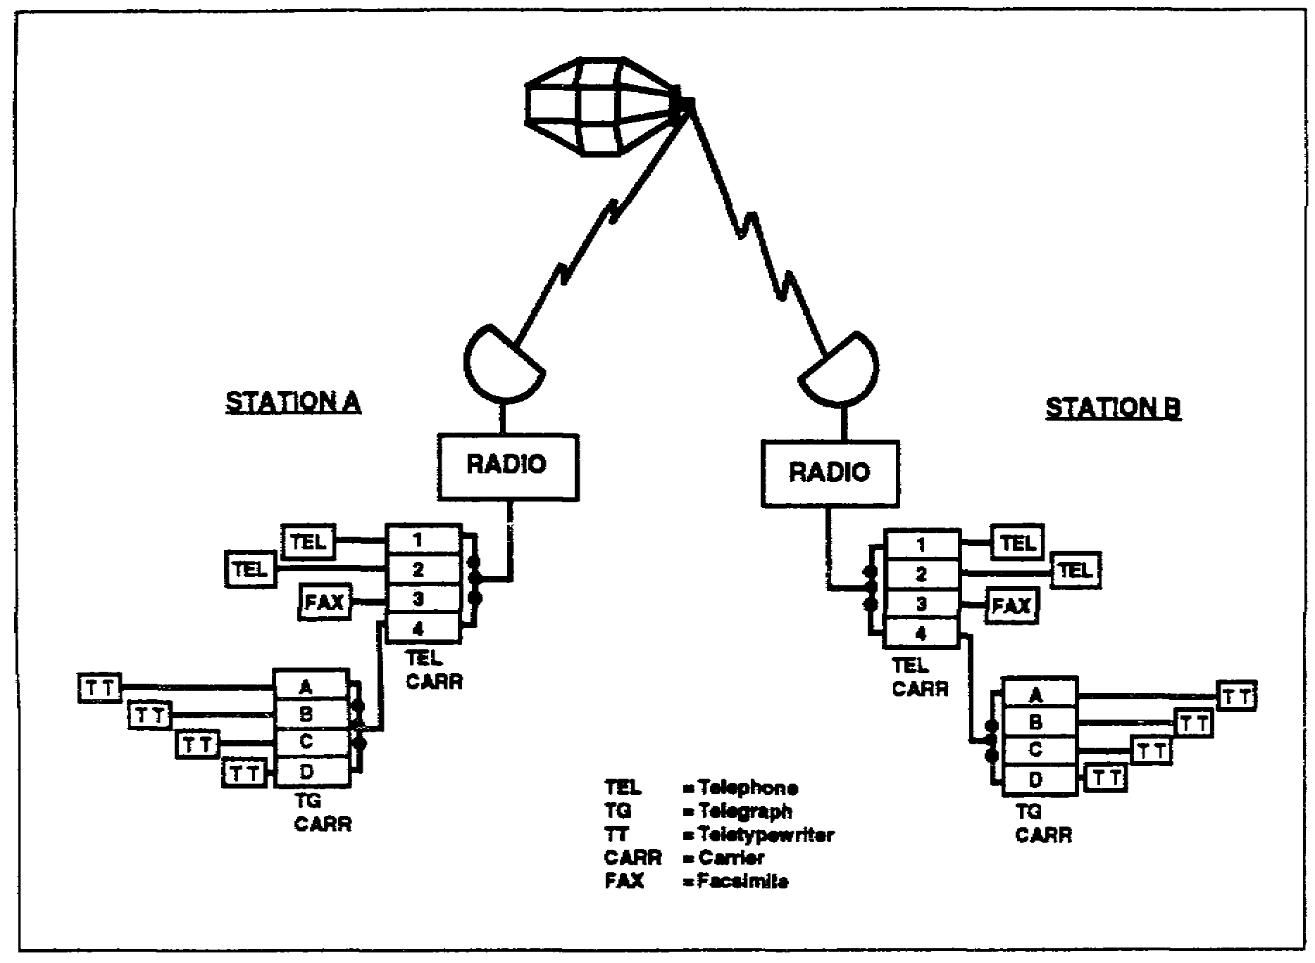

Figure 1-1. An integrated satellite communications system.

1. Integrated satellite communications system. Figure 1-1 is a simplified diagram showing only one subsystem of each type normally found in an integrated communications system. In practice, many subsystems of each type may be used, as well as different combinations of equipment in the various subsystems. The system shown in the diagram is designed to pass information in the form of teletypewriter, telephone, and facsimile traffic. Frequency division multiplexing (FDM) subsystems are normally selected for this application so as to make maximum use of the bandwidth available in each voice channel. This follows from the fact that analog signals, varying in either frequency or amplitude, occupy far less bandwidth than digital signals for comparable amounts of conveyed information.

1-13 SS0031

2. Telegraph multiplexing.

a. Sending. If four teletypewriter channels are to be multiplexed by the telegraph carrier set, a VF is assigned to each of the four channels at station A. As each channel of the send side is keyed by the telegraph intelligence, the frequency shifts a small amount to either side of the assigned frequency. This is the frequency shift keying (FSK) method. All of the channel output circuits are attached to a common line called the send bus. All the channel output signals therefore appear on the send bus at the same time. Each channel is assigned a separate carrier frequency to establish its position in the spectrum of the composite output signal. A send filter in each channel output circuit passes only the carrier frequency and side frequencies needed to transfer character information. Moreover, the send filter electrically isolates one channel output circuit from the others. Both channel frequency assignments and filter characteristics are used to prevent interchannel interference in the transmitted composite line signal.

b. Receiving. In the receiving process at the distant terminal (station B), each respective telegraph carrier channel frequency is selected from the composite signal on the receive bus by means of filters that are very similar in design to the sending filters. Each filter therefore passes the analog VF carrier as it shifts between mark and space frequencies, together with the intelligence components needed to reconstruct the original teletypewriter signal. Since each of the four channels operates at a discrete carrier frequency and the channel intelligence sideband components accompany the carrier through the filter bandpass, there is effectively no crosstalk or interchannel interference under normal circumstances. However, distortion of the signal, or interference with it anywhere during transmission over any part of the complete system, can result in distortion of the received signal pulse or interchannel interference.

3. Signal quality. The signal quality (circuit quality) of a communications system, which includes telegraph (teletypewriter) transmission, is indicated as telegraph distortion that appears in the receiving telegraph loop. When traffic is sent from station A to station B, signal quality is measured in the receive loop of station B. Conversely, when traffic is sent from station B to station A, signal quality is measured in the receive loop of station A.

a. Distortionless operation. A distortionless telegraph circuit produces no change in the length of any received direct current (DC) signal pulse. A receiving teletypewriter attached to such a circuit receives DC signal pulses of precisely the same length a those sent into the sending loop. For example, the sending teletypewriter is operating at a speed of 60 words per minute (WPM), it produces DC unit signal pulses of 22 milliseconds (ms) each. If the received mark or space unit signal pulses are also 22 ms, the interconnecting circuit or system is free from telegraph distortion. Notice that neither the pulse shape nor pulse amplitude is the determining factor of telegraph distortion; the pulse length is the important value.

b. Amount of distortion. The amount of telegraph distortion is measured as the amount of change in unit pulse length. If the received unit mark pulse length changes for some reason from 22 to 20 ms, the percentage of telegraph distortion is (22-20)/22, or approximately 9 percent. Since the mark pulse has been shortened, the space pulse has

SS0031 1-14

been lengthened by the same amount. Therefore, we say that the received teletypewriter signal has 9 percent spacing bias. Conversely, an increase of mark pulse length results in a corresponding decrease of space pulse length; this is marking bias distortion. The primary causes for bias distortion are improper adjustment of teletypewriter and terminal equipment as well as distributed constants (inductance, capacitance, and resistance) in the interconnecting line facilities.

c. Total distortion. Total distortion is the sum of all individual distortions. The total must never exceed 40 percent anything over that value is sure to result in misprinting of the copy. It is the nature of telegraph signals that as speeds of transmission increase, the percentage of telegraph distortion increases proportionately. Moreover, the total distortion normally runs higher on radio communication systems than wire systems because of the noise on the radio transmission path.

d. Monitoring. Misprinting will not occur in a telegraph system until the distortion exceeds a certain value that depends on the characteristics of the printing equipment. The teletypewriter operator therefore cannot know when his signal quality is deteriorating until misprinting occurs. It is therefore necessary that the signal condition be known at all times in an operating system. Each receiving telegraph loop may be monitored with automatic sensing devices that alert station personnel to the condition of rising telegraph distortion.

e. Causes. There are many causes of telegraph distortion, and many points in the overall system where the distortion may develop. Every operator and technician in the system must be aware of the possibilities that exist, and must understand that overall system operation meets satisfactory requirements only when the telegraph sign in the receive loop comes within the test parameters established for the telegraph carrier subsystem. The possible causes of telegraph distortion in an integrated communications system include condition and adjustment of equipment; characteristics of the interconnecting loops, lines, and facilities; and the condition of the radio transmission path between the two radio sets.

f. Concept. Most of the communication channels in the DCS carry record transmission (teletypewriter). The message originates and terminates at the opposite ends of the teletypewriter system. The fundamental concept of the overall integrated communications system therefore involves a realization that all equipments and devices in the system serve only one purpose-to provide facilities for the receiving teleprinter to reproduce precisely the same message that was sent out by the distant teletypewriter keyboard.

4. Telephone multiplexing. Each of the individual channels in the FDM telephone carrier terminal operates on a discrete assigned frequency, as in the telegraph terminal. However, a greater separation of carrier frequencies is needed to accommodate the increased bandwidth occupied by each telephone conversation, as compared with the narrow bandwidth of each telegraph carrier channel.

1-15 SS0031

a. Bandwidth. The bandwidth of each of the four channels in the telephone carrier terminal is approximately 3,200 hertz (Hz), extending from approximately 300 to 3,500 Hz. In military communications, for convenience, this channel extending from 300 to 3,500 Hz is referred to as a 4-kHz voice channel. Any signal below 300 Hz or above 3,500 Hz cannot pass over the system. This bandwidth is usually sufficient to carry all components of understandable speech. It is evident from Figure 1-1 that all four telegraph channels can be placed within the bandwidth of one telephone carrier channel. In some installations, as many as 16 narrowband telegraph carrier channels have been multiplexed into one telephone carrier channel.

b. Power distribution. The amount of power in any one channel signal within the 16-channel composite signal is far less than the power of one channel of a 4-channel system. As long as the signal-to-noise ratio (S/N) remains high, all 16 channels can be expected to print satisfactorily. However, when conditions are not satisfactory, it is sometimes desirable to reduce the number of channels from 16. The same principle holds true for the total number of telephone carrier channels in use at any time. Reducing the number of channels in use also reduces the composite signal bandwidth. This reduction of signal bandwidth also improves the S/N because the radio receiver operator can then reduce the bandwidth of the intermediate frequency (IF) transformers in the same proportion.

c. Signal amplitude. The signal amplitude in each channel of the telephone carrier terminal tends to vary over wide limits. Each channel, therefore, is normally provided with a peak limiter to prevent the loud talkers from overloading the system. It is always important that the telegraph carrier composite signal level be maintained at a level below the point where the peak limiter goes into operation. If the peak level exceeds this value, it could cause crosstalk and interchannel interference. Further, if the composite signal level from the telephone terminal overloads the radio facilities in any manner, telephone crosstalk may result, along with telegraph tone crosstalk. Under this operating condition, the first circuit casualty will probably be a telegraph carrier channel. Good system operation demands adherence to the established level of signal for each subsystem channel, as well as for each subsystem composite line signal.

d. Facsimile channel. Since the facsimile signal commonly uses amplitude-modulated 1,800 Hz carrier, the sideband intelligence and the carrier fit into the 3,200-Hz bandwidth of a telephone carrier channel. Unlike telephone conversations, however, facsimile reproduction is very sensitive to distortion, because what appears to the ear as minor annoyance in a telephone message shows up in the reproduced facsimile image as streaks. Also, any loss of the synchronizing pulse causes the reproducer to lose synchronism, resulting in reproduction of a "torn" picture. Facsimile needs a circuit that has a high S/N.

LEARNING EVENT 9: DIGITIZED COMMUNICATIONS SYSTEM

1. Vocoder use. Because of its space and weight limitations, the satellite has limited power output. The very weak signal received at the ground terminal is sometimes masked by a curtain of noise. One method of improving the S/N is to use a vocoder,

SS0031 1-16

which is basically a voice coder. Essentially, a vocoder converts sounds into digital signals, which are then multiplexed on a common line facility.

a. System use. Figure 1-2 shows how vocoders are applied to telephone channels of an-integrated satellite communications system. The tone digital signals are placed on channels 1 and 2 of the telephone carrier set.

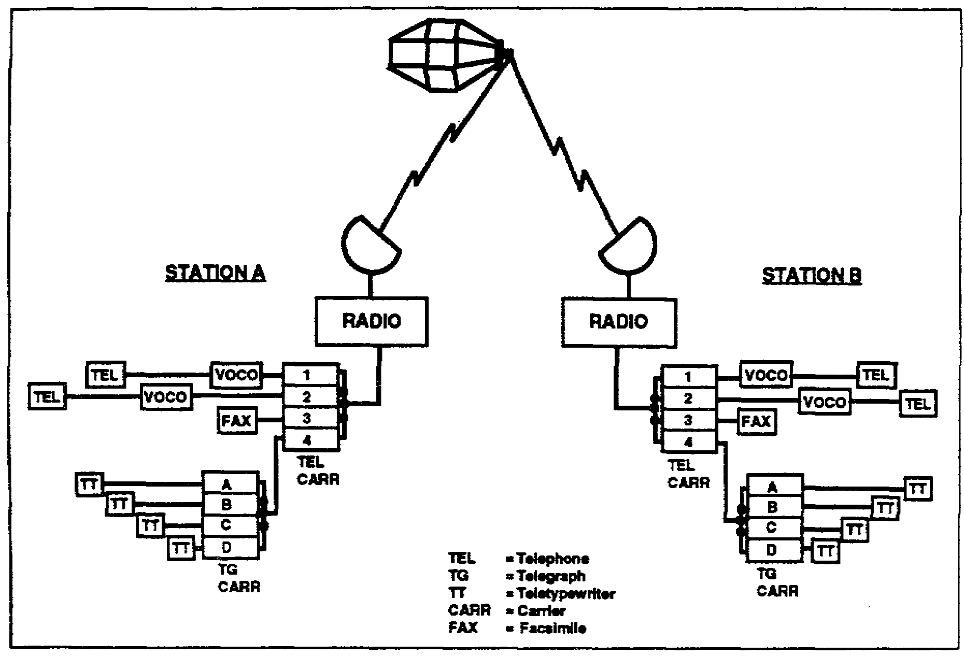

Figure 14. Vocoder applied to telephone channels of a satellite communications system.

b. Operation. The vocoder senses and separates the various sounds that make up a voice signal (buzz, hiss, pitch, and so forth) and produces from these synthetic sounds a sequence of pulses. The pulses then key VF oscillators that impart the intelligence to the tone carrier. When the tone signals are received at the distant ground station, the corresponding channel vocoder demodulates the intelligence from the VF pulse sequence. The intelligence so obtained keys a series of sound sources to produce an artificial telephone voice that approaches the quality of a natural telephone voice.

c. Advantages. The advantage of the digital (pulse) method of voice transmission over the analog (wave) method is that limiting circuits in the receiver are used to minimize the noise peaks without distorting the signal as would happen with peak clipping of analog signal peaks. The received pulses then reconstruct the pulse sequence.

1-17 SS0031

What the listener hears is not the original voice message, but an artificial voice signal that is reconstructed from the signal sources in the local vocoder. The result is an improvement in the S/N over conventional voice transmission.

d. Disadvantages. The primary disadvantage of the vocoder system of voice transmission is the relatively large bandwidth required to achieve naturalness of voice. Although satisfactory vocoder voice transmission is feasible in the 3,200-Hz bandwidth of a telephone carrier channel, the reproduced sound does not have enough natural timbre to allow voice recognition by the listener. The problem may be solved by using the band space occupied by a number of transmission channels to gain additional bandwidth for the vocoder signal pulse train, or by using prearranged identifying codes so the listener can establish positive speaker identification. Secondary disadvantages include more circuit complexity and the need for absolute system synchronization.

2. Security. Security of the system can be improved and simplified by coding the sequence of vocoder pulses in a security device designed to perform this function. In the integrated communications system described, it is necessary to secure each channel of communications at the source of signals. For example, each of the four teletypewriters, the two telephones, and the facsimile set must have its own security device. One method of overcoming this problem is to secure the digital intelligence by one security device. One arrangement is shown in Figure 1-3.

a. Securing channels. Each of the four telephone channels has its own vocoder to digitize the voice signals. The security device then combines the digital signals from all four channels into a sequence determined by the characteristics of the security device. In this way all four channels are secured simultaneously.

b. Teletypewriter application. It is not presently possible to combine the several channel frequencies of an FDM telegraph carrier set with a vocoder. The speech-plus-duplex (S/D) system must therefore be employed to achieve teletypewriter transmission when using a vocoder. One teletypewriter is applied to each telephone circuit. Since the security device secures all channels simultaneously, the teletypewriters do not need individual security devices.

SS0031 1-18

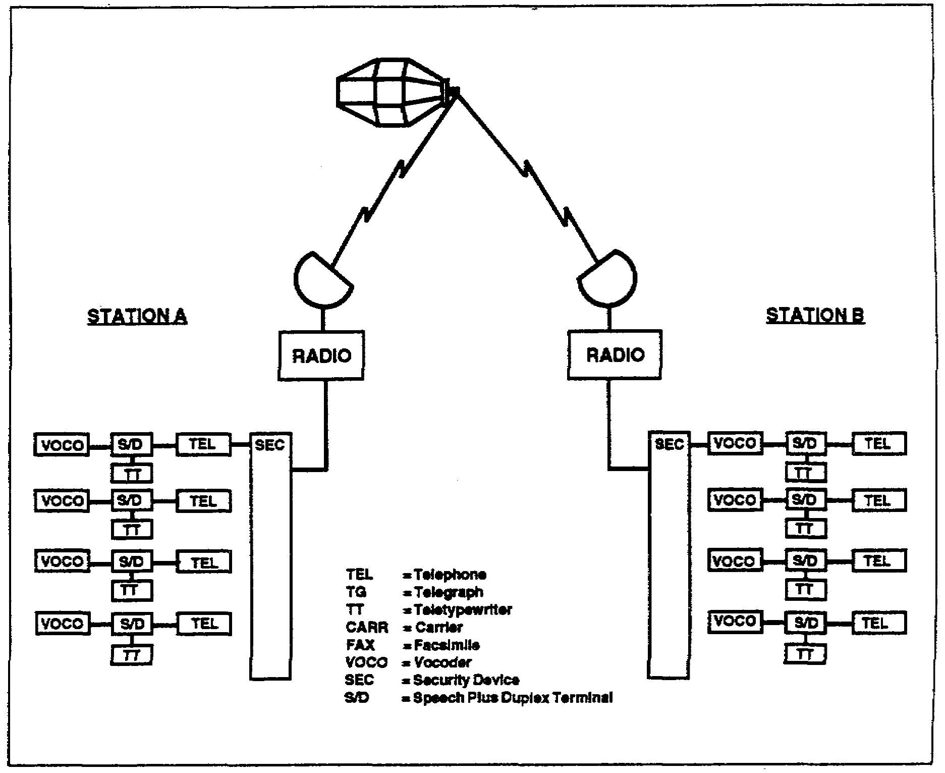

Figure 1-3. Securing all channels with a single device.

LEARNING EVENT 10: IMPROVING COMMUNICATIONS BY USING SATELLITES

Inclusion of a communications satellite as part of the radio link overcomes many of the long-distance radio communications obstacles other than signal distortion

1. Application. A communications satellite system is similar in many respects to a conventional microwave LOS radio relay system. The primary difference is the height of the repeater. The great altitude of the satellite repeater allows the ground terminals to operate LOS over distances equivalent to that of HF radio using only one repeater and relatively low radiated power. The bandwidth capability of microwave satellite communications is limited only by the characteristics of the satellite and the ground terminals. The bandwidth in turn determines the number of communications channels. The combination of wide bandwidth capability and low-noise LOS transmission makes the satellite communications system very useful in long-distance communications.

1-19 SS0031

2. Signal quality. The quality of the received signal determines the usefulness of any communications link. Signal quality, in turn, is determined by the S/N of the communications link. Methods of improving the S/N of a satellite communications system require consideration of several basic factors.

a. Reduction of manmade noise. Manmade noise is reduced either by removing the noise source from the vicinity of the receiving antenna or by placing the receiving antenna in an area remote from noise sources. Careful shielding of circuit components also helps to reduce noise.

b. Reduction of atmospheric noises. Atmospheric noise is nearly impossible to remove from the signal because the atmosphere is included in part of the radio transmission path. However, atmospheric noise is less noticeable in the VHF and UHF than in the lower frequency ranges. Generally, the higher the frequency of transmission, the less the effect of atmospheric noise on the signal.

c. Thermal noise. Thermal noise is related to temperature. Ground terminals of satellite communications systems are designed to minimize this source of noise. Radio receiving sets in the ground terminals reflect the finest and latest circuit techniques to minimize the effect of thermal noise. Parametric amplifiers using refrigerated circuit elements further reduce the effect of temperature rise on internal noise development. Three major sources of natural thermal noise are Earth temperature, sun, and certain galaxies (galactic noise). Noise from these sources is reduced by correct antenna orientation at specified times.

d. Directional antennas. The use of highly directional antennas at the ground terminals is an absolute necessity in satellite communications. Moreover, the ground terminals must orient their directional antennas precisely toward the satellite in orbit. Even a slight inaccuracy of antenna pointing by either ground terminal reduces the signal level sharply and raises the noise level.

e. Type of signal. The type of radiated signal has a bearing on the S/N. Frequency modulation (FM) has the advantage of peak noise reduction over amplitude modulation (AM), and is favored at present. FM, however, requires a relatively large bandwidth in the radio receiving and transmitting equipment. Generally, in radio receivers, the wider the bandwidth the less gain per stage is available in the RF and IF amplifiers. Also, the wider bandwidth allows low-level noise to enter the received signal. High-level noise is normally removed by limiter circuits. Further refinement of design may someday improve the noise reduction in AM circuitry. When that becomes practical, a great many more channels of communications can be accommodated in the same frequency spectrum occupied by the FM signal in present-day design. Furthermore, narrowing each channel of communications also improves the S/N.

f. Power considerations. The amount of power in the intelligence-bearing portion of any composite radio signal is related to the number of channels in use. The fewer the channels, the more power can be concentrated in each one, thus improving the S/N.

SS0031 1-20

This is an especially important consideration of communications satellites because of their size and weight limitations. If several ground systems are required to share a satellite spectrum, the power is distributed in each of the several signals. The more ground systems that try to use the satellite at the same time, the less power will be transmitted from the common satellite for each system. Consequently, there is a further deterioration of the S/N. Also, overloading by any one system may cause crosstalk between the several systems. It is obvious that the technique of system operation becomes a controlling factor in the S/N.

LEARNING EVENT 11: COMMUNICATIONS VIA SATELLITES

1. Communications satellite systems offer the advantage of global communications in the microwave spectrum. These radio relay systems will apply the wideband operating characteristics of microwave equipment to long-distance radio circuits. The practical result of this combination will be large increases in the amount of traffic the long-distance circuits can handle, as well as greater reliability due to LOS transmission and reception.

2. Several types of communications satellite systems are being studied. One system would utilize huge aluminized plastic spheres of 100-foot diameter or greater. This type of satellite communications system is called passive because the messages are sent through radio waves bounced from the reflecting surfaces to the receiving antennas. One advantage of the passive satellite is the freedom from complicated instrumentation in the satellite package. However, the disadvantage appears in the complexity of ground tracking equipment.

3. Another system would employ active-repeater satellites. Such satellites are equipped with radio receivers and transmitters and other apparatus to receive, store, amplify, and retransmit messages. They serve, in effect, as microwave repeaters in the sky.

LEARNING EVENT 12: PRINCIPLES OF SATELLITES

1. A satellite is an attendant body that revolves about another body, usually with reference to the solar system. An example of a celestial satellite is the moon, which revolves about the Earth. An artificial satellite is simply a manmade moon. In revolving about the Earth, it must obey the same laws the natural moon and planets obey in revolving about the sun.

2. Any satellite, whether natural or artificial, remains in orbit through the action of two forces-the satellite's inertial force and the force of gravity.

3. If a satellite is to be placed in orbit, the vehicle must be accelerated to orbital velocity. The force imparted to the satellite counteracts the gravitational attraction of the Earth. Since this gravitational attraction decreases with the distance from the center of gravity of the Earth, a different orbital velocity is required for each distance from the Earth. In every case, the satellite must attain a velocity that will balance the attraction

1-21 SS0031

due to the gravitational force. If the velocity is too low, the satellite will fall back to Earth. If the velocity is too high, the satellite will move into an orbit farther away from Earth. If the velocity becomes great enough, the satellite will reach escape velocity and will sail off into space. For a satellite relatively close to Earth, the required orbital speed is about 18,000 miles per hour. A vehicle placed in orbit as far away as the moon (roughly 210,000 miles) would need only to have an orbital speed of about 2,412 miles per hour. Table 1-1 gives the relationship between altitude and orbital speed.

Table 1-1. Altitude versus orbital speed.

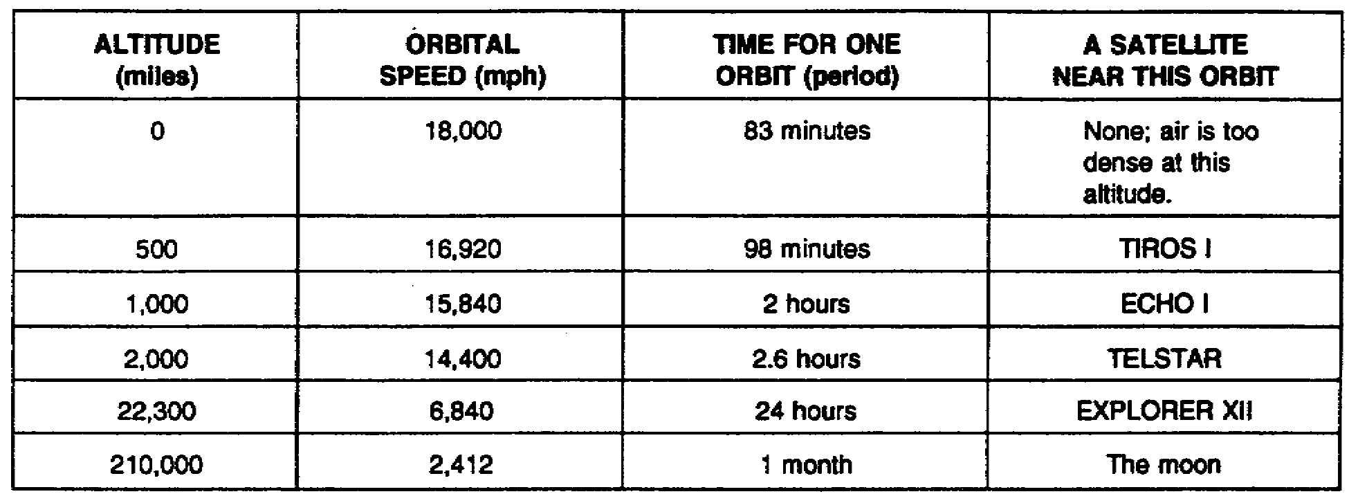

4. A satellite launched into a circular orbit parallel with and 22,300 miles over the equator is termed synchronous, fixed, or stationary. This satellite will take about 24 hours to complete one revolution, the same time the Earth takes for one full rotation on its axis. Therefore, the satellite remains more or less fixed over one spot on the Earth. To a ground observer, the satellite would appear to stand still. The time required for a satellite to complete one orbit is called the period.

5. It is virtually impossible to launch a satellite into an exactly circular orbit because the Earth is not precisely circular itself. Usually the satellite path will be an elliptical orbit. The perigee may be only a hundred or so miles, while the apogee may be several thousand miles in some of the more exaggerated ellipses. As the orbiting satellite approaches the perigee, it speeds up; as it approaches the apogee, it slows down. These principles are illustrated in Figure 1-4.

SS0031 1-22

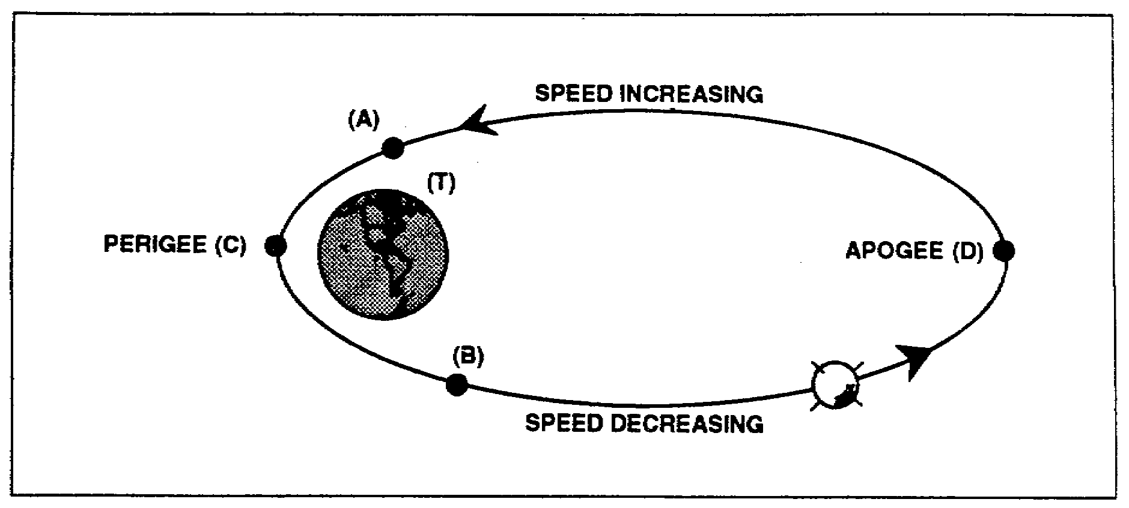

Figure 1-4. A satellite orbit.

LEARNING EVENT 13: PASSIVE COMMUNICATIONS SATELLITE SYSTEM

1. Passive satellite. The passive satellite system shown in Figure 1-5 on page 1-24 illustrates how the satellite furnishes a reflecting surface at which both stations aim their highly directional antennas. It is called a passive satellite because it merely reflects the signals; it does not receive nor does it transmit a signal for communications purposes. As the satellite passes overhead, the radio waves bounce off the reflecting surfaces and are effectively scattered in many directions. The resulting received signal is a very weak replica of the transmitted signal.

2. The satellite. The satellite shown in Figure 1-6 on page 1-24 is a balloon fabricated of aluminum-vapor-coated polyester film 0.00005 of an inch thick (about half the thickness of the cellophane wrapping on a cigarette package). It is 100 feet in diameter, with a reflecting surface of 31,000 square feet. At the time of launch it is folded up in the nose of a rocket. After the rocket places the nose cone into orbit, compressed gas expands the balloon to its full size.

1-23 SS0031

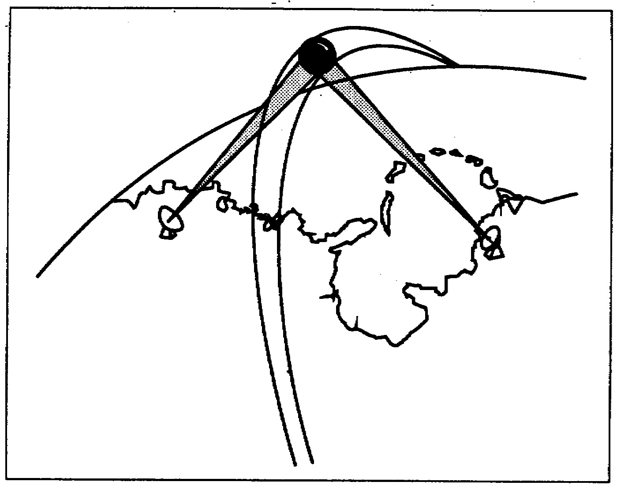

Figure 1-5. A passive satellite communications system.

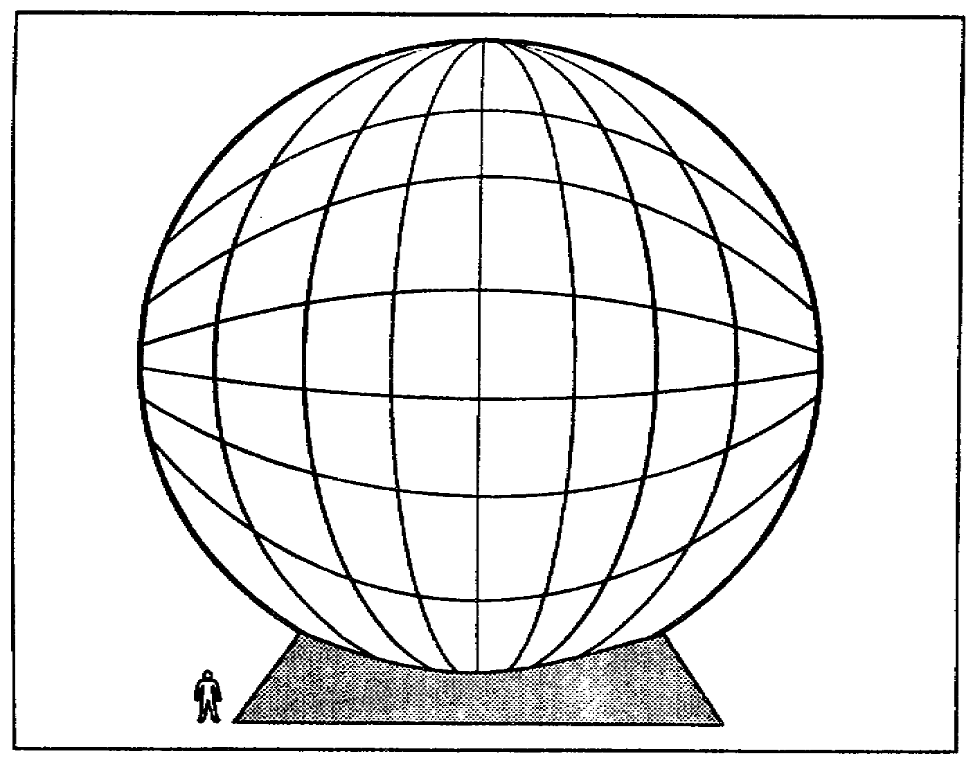

Figure 1-6. A passive satellite.

SS0031 1-24

3. The antenna system. The antenna system is highly complex because the antennas at both stations must track the satellite perfectly. If the antenna "aim" from either of the two ground stations is faulty, the radio beam from that antenna will miss the satellite and the entire communications system may fail. To assist in aiming the antenna at the satellite, a small transmitter is attached to the outer skin, radiating a signal just strong enough to enable the antennas to track the satellite as it travels through its orbit. The same antenna can be used for both transmission and reception by keeping the transmitting and receiving frequencies far enough apart in the spectrum to avoid interference. An example of the highly complex tracking antenna system required for a passive satellite system is shown in Figure 1-7.

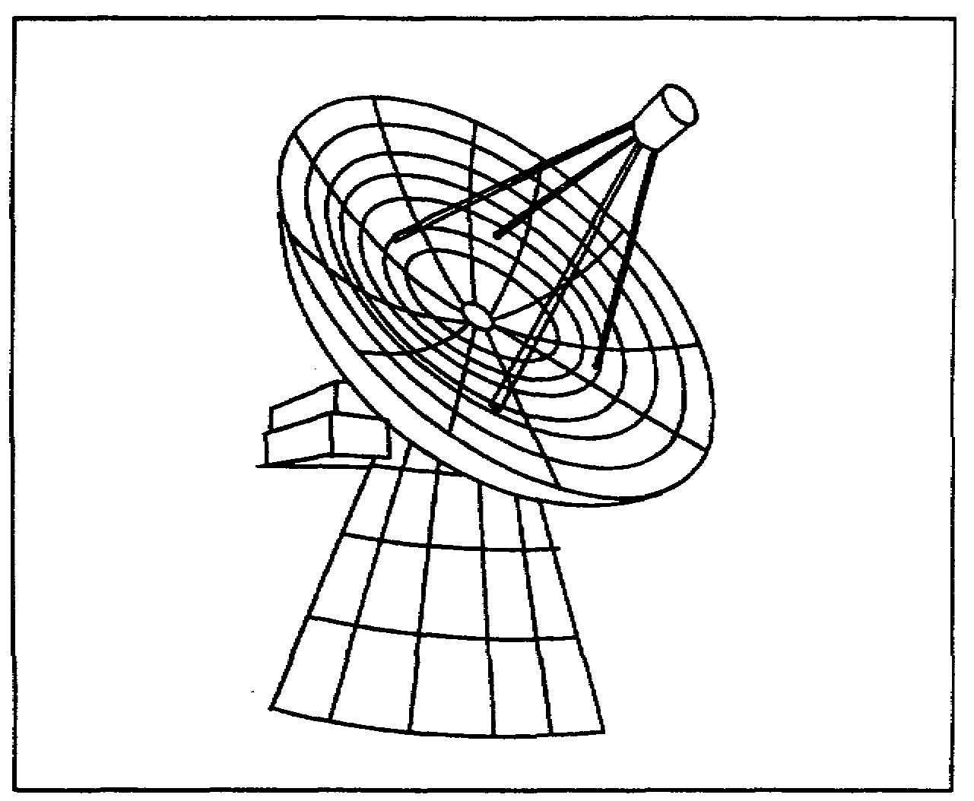

Figure 1-7. A satellite tracking antenna.

4. Future trends in passive satellite communications. Communications systems employing passive satellites are limited to horizon angles of transmission and reception that is, as soon as the satellite disappears over the horizon, communications via that satellite is at an end until it next appears over the opposite horizon. Any future system utilizing passive satellites will therefore consist of several satellites in nearly identical orbits, so that one or more will always be visible above the horizon. Each station will require more than one antenna system so that as one satellite goes over the horizon the second antenna system can be aimed at the satellite coming into view. In this way, continuity of communications can be maintained. Since the received signal strength is proportional to the reflecting surface area, future passive satellites probably will use larger balloons.

1-25 SS0031

LEARNING EVENT 14: ACTIVE-REPEATER -ORBITAL SATELLITE COMMUNICATIONS

An active-repeater communications satellite differs from a passive satellite in that the former is equipped with radio receivers and transmitters and other apparatus to receive, store, amplify, and retransmit messages. It serves as a real-time repeater of a store-and-forward repeater, or both, depending on the devices used.

1. Real-time and store-and-forward modes of operation.

a. Real-time repeater. A real-time repeater is a combination of a microwave receiver, converter, and transmitter in one unit. It receives a signal, converts it to a different frequency, and retransmits it at increased strength instantaneously. In other words, as fast as the message is received, it is immediately sent out on a second frequency. There is no time delay involved with this system. The bandwidth of the transmitted signal is identical with that of the received signal. The message received at the ground receiving station can be immediately demodulated with no delay in the terminal receiving process. The rate of any pulse signal received by this method remains the same as the rate in the transmitted signal. For example, if the sending teletypewriters are operating at 60 WPM, the telegraph signal pulses at the output of the receiving terminal can be applied directly to receiving teletypewriters operating at the same rate of speed (60 WPM). With this method, one ground station communicates with another ground station by using the real-time satellite as a microwave repeater.

b. Store-and-forward repeater. A store-and-forward repeater receives a signal, stores it, and retransmits it on reception of a prearranged code signal. It can receive information at a high rate of speed, record it, and retransmit it again at a high rate of speed. The ground station originating the messages must process them with suitable recording devices so that the messages can be transmitted to the repeater at high speed. When the prearranged code signal causes the repeater to "unload" its messages at high speed, the receiving station must be capable of recording the messages at an equivalent high speed. Before the messages can be demodulated by the terminal equipment, the recording tape must be "played back" at a rate which the terminal station teletypewriter equipment can handle. The system must have a very broad bandwidth to allow for the transmission of the sidebands that are developed in the transmitter. Tape recording equipment does not have to be synchronized as long as the speed of the tape recorders can be adjusted at the terminal equipment to match the teleprinter operating speeds. In other words, the tape may be run over the system at a rate corresponding to many hundreds of words per minute, but when the received tape is run through the reproducing cycle, it must operate at a speed so that the terminal correctly interprets the message traffic and the printers correctly reproduce the messages.

c. Selection of type of repeater. If a choice is to be made between the facilities of either of the two methods just described, a code signal can direct the satellite to bypass the recorder, thus making it a real-time repeater in place of a store-and-forward repeater.

d. Antenna tracking. The antenna tracking systems for both passive and orbital active-repeater satellites are similar in their operating characteristics.

SS0031 1-26

2. Orbits. Some satellite systems are designed for medium altitude (about 5,000 miles). The satellite tracking problem is very similar to that of passive satellites. The tracking antenna at each station must track each satellite as it passes overhead in its orbit. A second antenna system must pick up each of the various satellites as it comes over the horizon and track it to maintain continuity of communications. It is evident that to maintain worldwide satellite communications, a number of identical satellites in different orbits will be necessary, as shown in Figure 1-8.

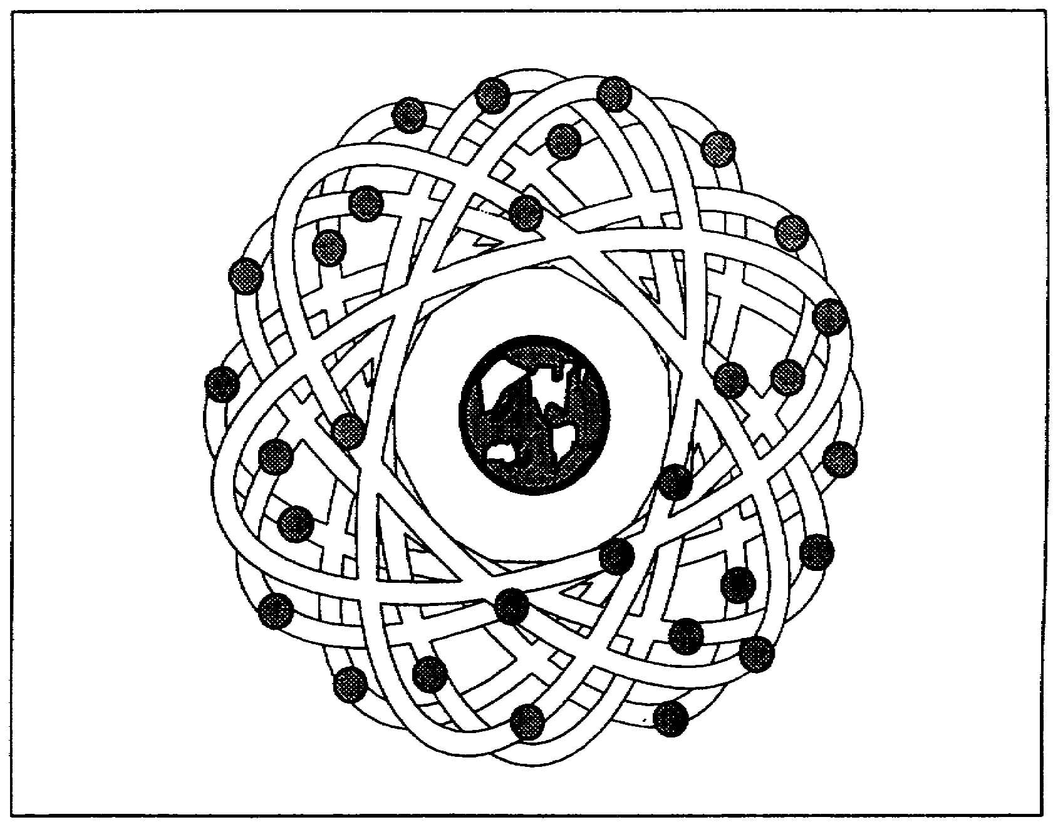

Figure 1-8. Active-repeater satellite communications systems, medium altitude.

3. Doppler shift. When radio signals are sent to or received from an orbiting communications satellite, a change in frequency occurs due to a phenomenon known as Doppler shift. Doppler shift is defined as the change in frequency with which energy reaches a receiver when the source of radiation and the receiver are in motion relative to each other. As the satellite approaches the transmitting station, the signal frequency being received in the satellite will increase, and as the satellite moves away from the transmitting station, the signal frequency will decrease. Likewise, as the satellite approaches the receiving station, the frequency of the received signal will increase, and as it moves away from this station, the frequency will decrease.

1-27 SS0031

a. Altitude of orbit. The orbital altitude of a communications satellite greatly affects the extent of Doppler shift. Low-altitude orbits have the greatest Doppler shift because the relative motion between the ground terminals and the satellite is great. Medium-altitude orbits have less Doppler shift because of the reduced relative motion between the ground terminal and the satellite. Synchronous-altitude (or near-synchronous) orbits have the least Doppler shift because the relative motion between the ground terminals and the satellite is minimal.

b. Compensation. Compensation for frequency variation caused by Doppler shift is normally accomplished in the radio receiver within the ground terminal. This placement minimizes circuit complexity within the satellite. The basic component of the compensation circuit is a discriminator. The discriminator produces an output voltage that is proportional to the frequency difference between the incoming signal and the normal signal. This output voltage is applied to a voltage-controlled oscillator to make it track the incoming RF signal, and thus produce the correct IF used in the receiver.

LEARNING EVENT 15: ACTIVE REPEATER SYNCHRONOUS SATELLITE COMMUNICATIONS

A synchronous satellite does not change its position to any marked degree with respect to the Earth. It travels in a circular orbit but, because of its great distance from the Earth (22,300 miles), its orbit speed keeps it suspended above a selected spot on the equator. By placing three synchronous satellites equidistantly around the Earth, it is theoretically possible to cover most of the Earth's surface with the radiation pattern from these satellites. Any radio station in the radiation field pattern (Earth area) covered by one satellite can relay messages to any other radio station in the field pattern of that satellite on a real-time basis. A problem exists in coordinating the stations desiring to use the services of the satellite because of the limited number of communications channels available. The problem is solved by the DCS taking control of the satellite communications channels after the satellite has been placed in orbit. High-priority messages concerning the safety and security of the country have first call on the available channel.

LEARNING EVENT 16: SYSTEM CHARACTERISTICS

Each type of satellite communications system was designed to fulfill a specific need or to satisfy a particular experiment. The characteristics of each design type are summarized in the following paragraphs:

1. Passive satellite system.

a. It is universally adaptable; that is, anyone having the necessary facilities can make use of it as long as the satellite is in view. There is no limit to the number of users, so long as each user uses a different frequency.

SS0031 1-28

b. Since the surface of the passive satellite is a very good reflector, it will relay a signal of any type without changing the characteristics of that signal. In other words, the satellite will not cause any reduction in bandwidth of the signal.

c. The passive type of satellite offers no discrimination to frequency. However, other conditions not associated with the satellite impose a frequency limitation.

d. The round surface of the satellite creates no directional effects. The reflected signal can be received at any location where the satellite can be seen.

e. The spherical shape of the satellite causes the radio signals to be reflected equally in all directions from the hemisphere facing the ground radiating antenna. Therefore, the received signal level is very weak--weaker than the signal from most active satellites.

f. The sphere may lose its shape in a short time after launching because of possible meteoroid bombardment of the surface. When this happens, the sign strength may change and the signal loses quality. It is therefore believed that this type of satellite will have a relatively short useful life.

g. The ground tracking systems are very complex.

h. The Doppler effect is not a major problem because, as the passive satellite in its orbit moves toward the ground receiver, the increase in frequency resulting from this movement exactly compensates for the decrease in frequency as the satellite moves away from the ground transmitter. Similarly, there is a compensating action when the satellite moves away from the receiver and toward the transmitter.

i. Except for a low-power beacon radio transmitter used in tracking, there is normally no equipment in this type of satellite.

2. Real-time repeater system.

a. Since the type of satellite used in this system amplifies the signal, a relatively strong signal can be received any time the satellite is in view. Very little power is required by the satellite amplifier to deliver a relatively strong signal to the ground station because of the small power loss in LOS communication.

b. The relatively strong received signal provides an accurate aiming point for the ground tracking stations.

c. In the real-time repeater system there is no delay in message transmission.

d. The number of communication channels and, consequently, the bandwidth are limited by the characteristics of the equipment installed in the satellite.

e. The frequency of transmission is a fixed value and cannot be varied.

1-29 SS0031

3. Store-and-forward system.

a. The satellite employed in this system may be operated as either a real-time repeater or a store-and-forward repeater by shunting the recorder.

b. The satellite can receive and send at high speeds when it is in the most advantageous position-with respect to the ground stations.

c. The satellite holds its messages until a suitable code signal from a ground station causes the tape recorder to "unload" or play back.

d. This system can handle more information in less time than real-time repeaters or passive reflectors because of the high speed of record and playback of the tape recorder in the satellite.

e. The equipment must be capable of very broadband operation because of the high speed at which the tape recorder must record and play back.

f. This type of satellite requires highly sophisticated circuitry, and therefore is susceptible to equipment failure more often than satellites using simpler circuitry.

4. Synchronous system.

a. The Doppler shift has been minimized because the satellite hovers above a selected point on the Earth's surface.

b. The ground-based receiving and transmitting antennas can be maintained in a more or less fixed position, greatly simplifying the tracking antenna mechanisms.

c. Since the satellite will be in sunlight 99 percent of the time, solar cells can provide a nearly constant source of power.

d. Temperature control equipment is not required because the satellite spends almost all its time in sunlight.

e. The satellite is always within range of the ground stations. This permits constant and uninterrupted communications as long as the satellite and ground equipment are functioning.

f. A potential enemy can interfere with transmission from the satellite because he can determine its position at all times.

g. The frequency of transmission is a fixed value and cannot be varied.

h. The number of communications channels is limited by the bandwidth characteristics of the equipment installed in the satellite.

SS0031 1-30

5. Near-synchronous system.

a. The Doppler shift is barely discernible because of the slow relative motion between the satellite and the ground terminals.

b. Complex-ground-based receiving and transmitting antenna positioning systems are required to track the drifting satellite at the relatively slow rate of about 1.3 degrees per hour.

c. Since the satellite is in sunlight most of the time, power for the satellite circuits is furnished by solar cells.

d. Because the satellite is exposed to sunlight most of the time, temperature compensation equipment is not required, thus saving on-board weight.

e. Two or more of the Initial Defense Communication Satellite System (IDCSS) communications satellites are in view of any ground terminal at all times, assuring relatively uninterrupted communications. The only time that communications may be broken is during the "handover" process. This time loss can be minimized by using two ground terminals at each station, the antenna of one terminal pointing toward a setting satellite and the antenna of the other terminal pointing toward a rising satellite.

f. The near-synchronous orbits greatly complicate the attempt by a potential enemy to interfere with the satellite signal.

g. The near-synchronous orbits minimize the possibility of physical destruction of the satellite by a potential enemy.

h. The frequency of transmission remains a relatively fixed value; the amount of frequency change that can be accommodated by the system is limited by the ability of the satellite circuits to accommodate the change.

i. The number of communication channels in the communications system is limited by the bandwidth capabilities of the on-board equipment in the satellite.

6. Low- and medium-altitude orbit systems.

a. A complex antenna tracking system is required because the satellite travels at relatively high speed.

b. In all active satellites, special circuits must be built into the ground receiving equipment to compensate for frequency changes caused by the Doppler shift.

c. When low- and medium-altitude orbit systems are equipped with a store-and-forward repeater, they provide a higher degree of security than other systems. The enemy stands little chance of interfering with the signal, which is transmitted only when the satellite passes nearest the ground station.

1-31 SS0031

d. Low- and medium-altitude orbits minimize the possibility of physical destruction of the satellite by a potential enemy.

e. Satellites pass through the shadow of the Earth, and must therefore have temperature control circuits and storage batteries to keep the on-board communications equipment operating properly.

LEARNING EVENT 17: RADIO LINKS BETWEEN GROUND TERMINALS AND A SYNCHRONOUS SATELLITE

Two ground terminals (A and B) and a synchronous-type communications satellite are illustrated in Figure 1-9. Five major frequencies serve four basic subsystems aboard the satellite-communication, beacon, command, and telemetry.

1. Communication. Two directions of transmission (A to B and B to A) are used to achieve full-duplex operation. Each direction of transmission uses a different set of two discrete frequencies, making a required total of four frequencies to achieve full-duplex operation. This results from the fact that a different frequency is required for the uplink and downlink in each direction of transmission.

a. A to B. The communications radio receiver in the satellite receives the uplink signal (f_{1a}) from ground terminal A and converts it to a second frequency (f_{1b}). The communications radio transmitter on board raises the power level of f_{1b} and relays it over the downlink to ground terminal B. A second frequency is needed because if the received signal were relayed without conversion, the transmitter signal would block the receiver.

b. B to A. The communications radio receiver in the satellite receives the uplink signal (f_{2a}) from ground terminal B and converts it to a second frequency (f_{2b}). The communications radio transmitter on board amplifies the converted signal and sends it to terminal A over the downlink. Two discrete frequencies are also needed for this direction of transmission to avoid receiver blocking.

2. Beacon. The same downlink beacon signals are used by both ground terminals to give the antenna tracking systems a target. The beacon signal may be generated by a separate radio transmitter or the tracking equipment in the ground terminals may use the received communications signal as its source of target information, depending on the type of communications signal used.

a. Beacon transmitter. A beacon radio transmitter is needed when the communications signal is analog (continuous signal). The beacon transmitter in this case must operate on its distinct RF (f₅). It normally operates at a lower frequency than that of the communications channel. This arrangement normally requires the use of two receivers--one for tracking and one for communications.

SS0031 1-32

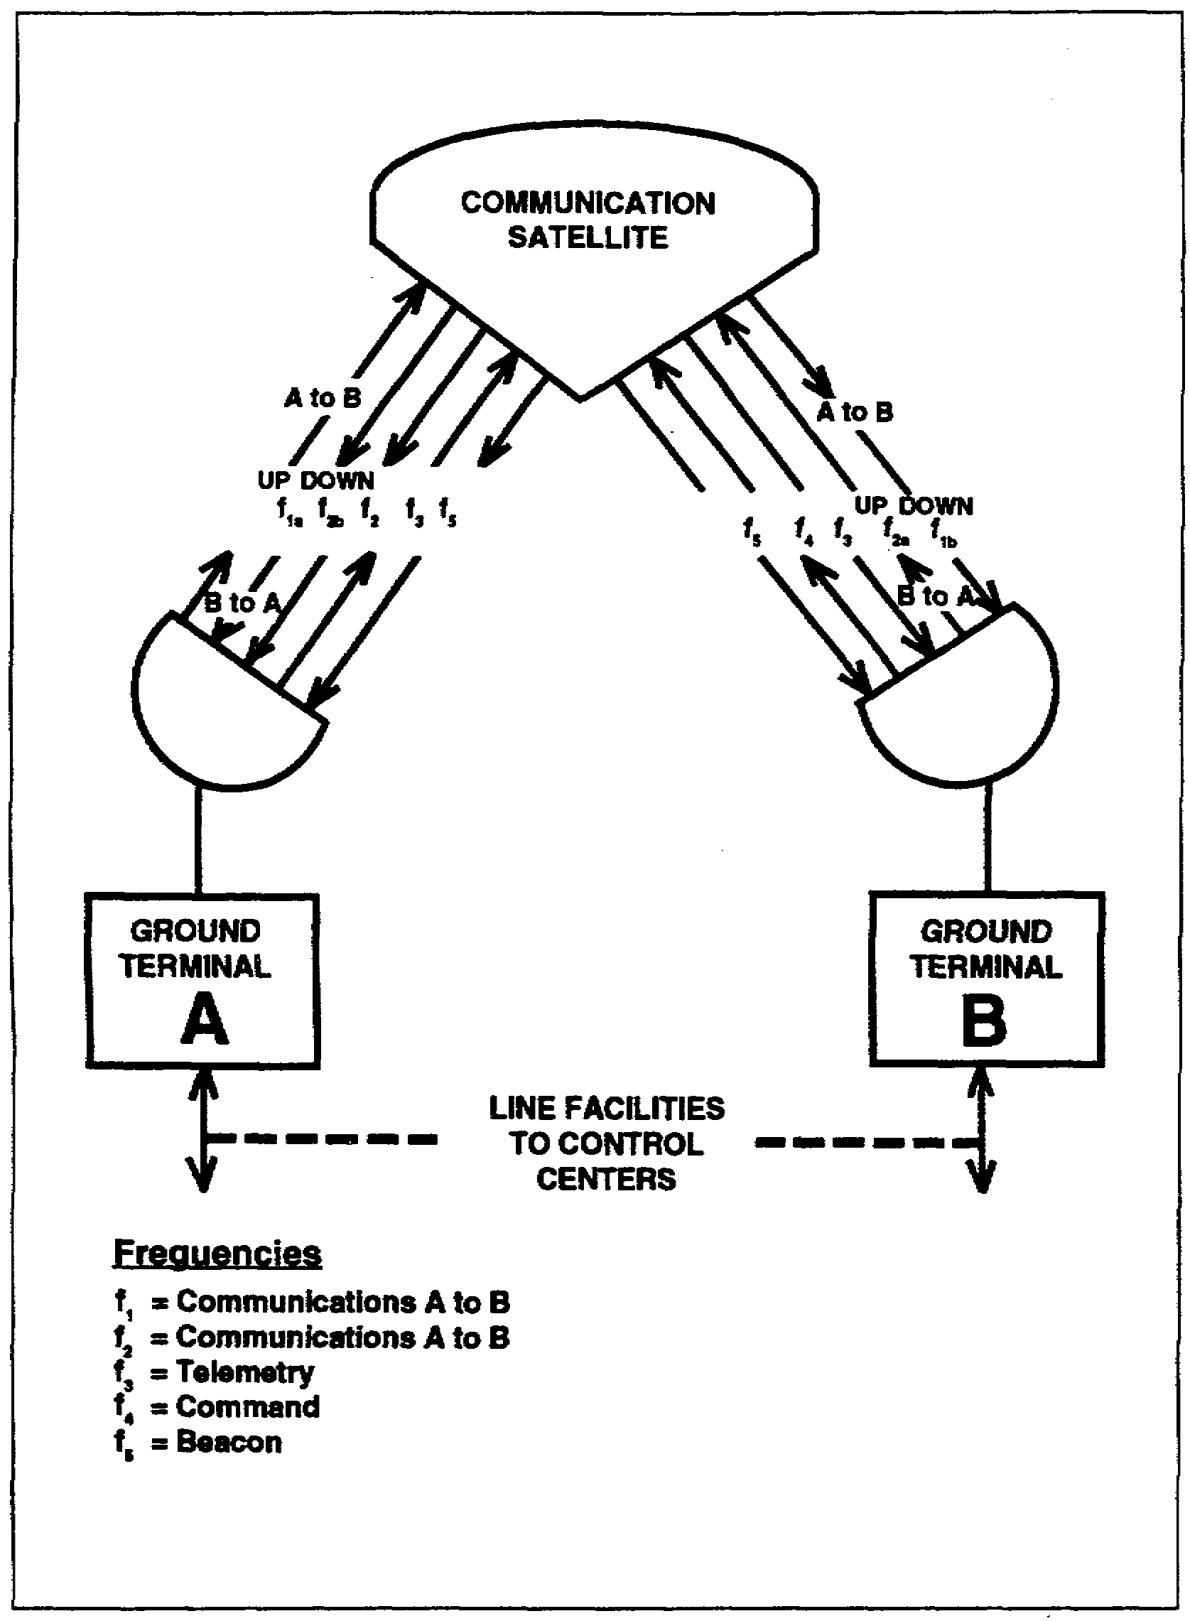

Figure 1-9. A synchronous satellite link communications system.

1-33 SS0031

b. Digital signal. When a digital communications signal is transmitted, the beacon-identifying signal bits can be inserted within the digital structure of the communications signal. Under this condition, a separate beacon signal is not required and only one receiver is needed for automatic tracking and communications.

3. Command. The function of the command feature is to permit the ground stations to control the "stunts" required of the satellite. These "stunts" include firing of the apogee rocket, firing of the gas nozzles that spin the satellite, switch from one communications receiver or communications transmitter to the other, or switch from one power supply to the other. The command signal is uplink only. The telemetry channel serves as the downlink feedback function for command.

a. Issuance of commands. Commands are extremely important for a synchronous-type satellite because it is through these commands that the satellite is "parked" in its synchronous orbit. Only one ground station is authorized to issue commands to the satellite.

b. Command radio subsystem. The command transmitter in the ground station develops a sequentially multiplexed RF signal for transmission on the uplink to the command receiver in the satellite. After demodulation of the command signal, an on-board decoder decodes the sequentially multiplexed radio signal and sends the command signals to the appropriate circuit.

4. Telemetry. Telemetry has many functions. One important function, mentioned previously, is that of providing a command system feedback channel to display to the ground station control operator the extent of the satellite's reaction to command. Another important function is to relay on-board conditions of the satellite to the ground control station. An additional function of telemetry is to relay signal information to the ground control station regarding the environmental conditions surrounding the satellite. Telemetry in communications satellites is normally downlink.

5. Responsibilities. The responsibility of command and telemetry is given by the DoD to the Air Force, while the responsibility for communications is given to the DCS.

LEARNING EVENT 18: BLOCK DIAGRAM OF A SYNCHRONOUS COMMUNICATIONS SATELLITE

Although the block diagrams discussed in this paragraph represent one type of current synchronous satellite, they are likely to become outdated in a short period of time. Use the diagrams only as a guide for further study and a better understanding of future satellites. The circuits are generally divided into functions for telemetry and command, and for communications.

SS0031 1-34

1. Assigned frequencies. It is necessary to assign hypothetical frequencies of operation in the uplinks and downlinks given in Figure 1-10 to show the functions of the block diagrams. We will assume frequency assignments as follows:

a. Communications (FM).

Terminal A to B uplink: 7,360 MHz (f_{1a})

Terminal A to B downlink: 1,815 MHz (f_{1b})

Terminal B to A uplink: 7,260 MHz (f_{2a})

Terminal B to A downlink: 1,715 MHz (f_{2b})

b. Beacon (FM). The bacon signal (f₅) is downlink only at 1,820 MHz.

c. Command (AM). The command signal (f₄) is uplink only at 148 MHz.

d. Telemetry (FM). The telemetry signal (f₃) is downlink only centering on 136 MHz.

2. Command. The block diagram of the command and telemetry sections is shown in Figure 1-10. The turnstile antenna, consisting of the four elements projecting from the bottom of the satellite, is used to receive ground-station commands and to transmit telemetry. The hybrid network, together with the diplexer, minimizes interaction between the command (f₄) and telemetry (f₃) signals. Reduction of interaction is further assured by using AM for command and FM for telemetry. The command receiver demodulates the command signal to extract its sequentially coded intelligence. The command decoder then furnishes the respective commands to the appropriate subservient circuits. One command channel verifies to the telemetry channel that the command signal has been received in the satellite. Commands transmitted to the satellite include signals for telemetry and communications system switching, gas jet firing, and apogee motor firing.

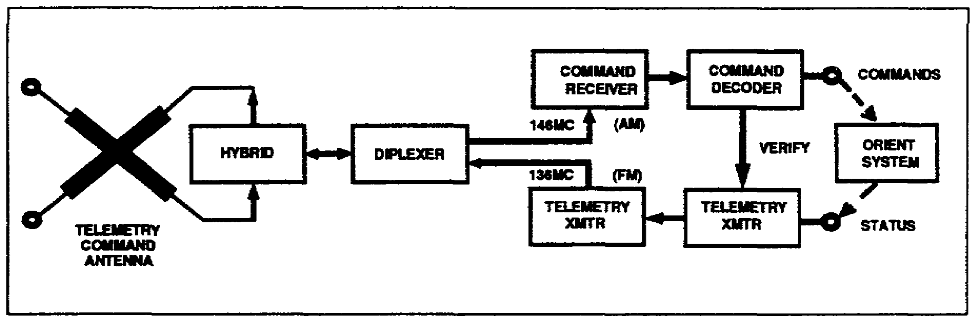

Figure 1-10. Command and telemetry section of synchronous communications satellite, block diagram.

1-35 SS0031

3. Telemetry. The telemetry transmitter receives the status signal that develops from the encoding of sensor signals within the satellite. Encoded signals represent samples of temperature, power supply voltage and current, signal strength at the communications receiver and transmitter, solar sensors output, and pressure in the hydrogen peroxide gas system. The telemetry transmitter raises the power of the 136-MHz FM signal and sends it to the ground stations by way of the diplexer-hybrid combination and the turnstile antenna. The dashed lines in the diagram represent the signal flow from the command channel to the orientation system (control jets), and the signal flow from sensors in the orientation system to the telemetry channel. This is part of the feedback circuit for the operator in the ground control terminal.

4. Security. The circuit shown in Figure 1-10 is vulnerable to interference. Signals that happen to be similar in structure to authorized command signals may cause the jets in the satellite to activate. This is very undesirable because the result may be a change in the spin axis orientation which will, in turn, cause a change in the antenna field pattern coming toward the Earth. It is also undesirable in that the satellite may be forced into a different orbit whereby it will change position from its intended synchronous "park." One method of overcoming these difficulties is to include a sequential decoder in the satellite which responds only to specially coded signals from the ground terminals.

5. Communications. The block diagram of the communications circuit is shown in Figure 1-11.

a. Signal processing. The communications antenna projects from the top of the satellite and is used for simultaneous reception of the uplink signals and transmission of the downlink signals. Uplink signals are 7,360 MHz (f_{1a},) from ground terminal A and 7,260 MHz (f_{2a}) from ground terminal B. Both signals simultaneously pass through the hybrid and diplexer into the transponder receiver. A communications oscillator signal heterodynes with the two uplink signals to produce the downlink frequencies of 1,815 MHz (f_{1b}) to ground terminal B and 1,715 MHz (f_{2b}) to ground terminal A.

b. Beacon signal. In diplexer 2, a beacon oscillator signal of 1,820 MHz (f₅) joins with the two downlink communication signals. The composite of all three signals is amplified in the transponder transmitter which raises the power level of the composite signal. The amplified signal is fed back to the hybrid-diplexer 1 combination and then to the communications antenna where it is radiated to the two ground terminals.

SS0031 1-36

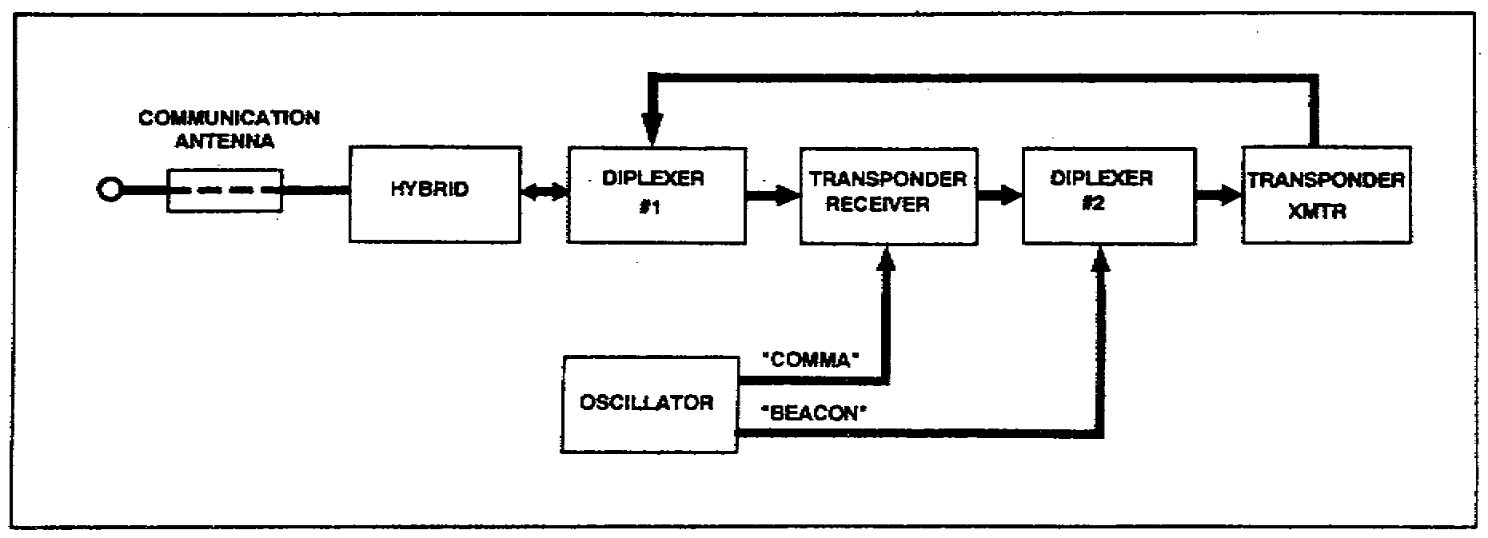

Figure 1-11. Communications and beacon section of a synchronous
communications satellite, block diagram.

LEARNING EVENT 19: NEAR-SYNCHRONOUS COMMUNICATIONS SATELLITE

1. Near-synchronous satellite. The block diagram of a near-synchronous satellite is similar to that of a synchronous satellite. The primary difference between the two diagrams is the absence of a command channel in the near-synchronous type. Inclusion of a command channel raises the possibility that interference might change the orbit of the satellite. Deleting the command capability removes this possibility, thus improving the security against tampering with orbital position. A beacon feature is included so that ground terminals may use automatic tracking. A telemetry subsystem is also included to inform ground stations of equipment status as well as environmental conditions.

2. Random access. Random orbits facilitate multiple access; several ground stations may use a satellite as a common facility. Simultaneous communications by several ground terminals through the same satellite may cause interchannel interference. One possible solution to the problem is to include an on-board signal source that sounds a busy signal when the satellite is queried. The busy signal could be included as part of the telemetry signal sent out by the satellite. A second possible solution to the problem might be a coded signal that opens an electronic gate to the channel. Use of the satellite would thereby be limited to the ground terminals in possession of the special code.

3. Transmission bandwidth. Several information (communications) channels must be available as choices for the uplinks and downlinks. Frequency conversion is performed to generate a minimum of four information channels for each two-way communications systems between ground terminals. The transmission channel bandwidth must be large enough to simultaneously pass all the information channel frequencies. In this way, link frequencies may be added or removed as traffic loads change; also it permits shifting the frequencies of the information channels for flexibility and for security operations. Moreover, the bandwidth must be broad enough to accommodate the signals used in broadbanding techniques.

1-37 SS0031

4. Stabilization. Although first-generation communications satellites in near-synchronous orbits use spin stabilization, the gravity-gradient experiment may prove to be more useful. Stabilization of communications satellites in orbit is important to maintain proper antenna orientation with respect to Earth.

SS0031 1-38

LESSON 1

PRACTICE EXERCISE

The following items will test your grasp of the material covered in this lesson. There is only one correct answer for each item. When you complete the exercise, check your answers with the answer key that follows. If you answer any item incorrectly, study that part of the lesson which contains the portion involved.

1. An integrated communications system that covers a large area contains local lines, equipment loops, long-distance trunks, and tributary lines. Communications systems using satellite links are normally used as-

A. Local lines
B. Equipment loops
C. Tributary lines
D. Long-distance trunks

2. The antenna of a ground terminal in a communications satellite system must track the satellite in its movement across the sky. Many of the technical problems associated with this operation can be largely eliminated by using satellites in what kind of orbits?

A. Random
B. Equatorial
C. Synchronous
D. Extremely high-altitude

3. Assume that the ground terminals of a satellite communications system are in contact through an orbiting satellite. As the ground terminal antennas track the satellite in the direction of the sun, the operators should notice-

A. A signal fade due to increasing density of ionization
B. An increase of thermal background
C. An increase of satellite power output
D. More interchannel interference

4. Which reason indicates that FM is preferred to AM in satellite communications systems?

A. FM uses a narrow bandwidth signal
B. FM requires less output power than AM
C. FM minimizes the effect of noise peaks
D. FM operates at higher frequencies than AM

1-39 SS0031

LESSON 1

PRACTICE EXERCISE

ANSWER KEY AND FEEDBACK

Item Correct Answer and Feedback

1. D. Long-distance trunks (page 1-7, Learning Event 4)

2. C. Synchronous (page 1-11, para 9c)

3. B. An increase of thermal background (page 1-20, para 2c)

4. C. FM minimizes the effect of noise peaks (page 1-20, para 2e)

SS0031 1-40

LESSON 2

TRANSMITTING SYSTEMS AND RF COMPONENTS

Critical Task: 01-5768.07-0002

OVERVIEW

LESSON DESCRIPTION:

In this lesson, you will learn transmitting systems and RF components.

TERMINAL LEARNING OBJECTIVE:

ACTION: Demonstrate a basic knowledge of the purpose and characteristics of waveguides, waveguide filters, joints, mode launchers, isolators, dipole horn, polyrod, cassegrainian feeds, parabolic and hyperbolic reflectors, and variable circular polarization. Know how preemphasis and deemphasis networks, limiting circuits, and phase-lock-loop circuits are used to improve S/N. Be able to describe how translators, exciters, and high-powered amplifiers are used in satellite transmitters to modulate the frequency.

CONDITION: Given lesson material, paper, and pencil.

STANDARD: Demonstrate competency of the task, skills, and knowledge of the material presented by responding to 70 percent of the test questions covering satellite communications, without supervision.

INTRODUCTION

In Lesson 1, we discussed the fundamentals of satellite communications, different terms and definitions associated with satellite communications, as well as reliability, invulnerability, and flexibility. In this lesson, we will address waveguide principles, transmission of energy, and the advantages waveguides have over ordinary conductors for transmitting energy. As a signal officer, it is your responsibility to be as familiar as possible with the material presented in this lesson.

2-1 SS0031

SECTION I. WAVEGUIDE PRINCIPLES

LEARNING EVENT 1: TRANSMISSION OF ENERGY

1. The transmission of energy at the microwave frequencies requires special care to avoid loss of energy. Transmission lines used at these frequencies are considerably different, physically and electrically, from those used for lower frequencies.

2. The reason for the special transmission lines is that the radiation loss in a two-wire conductor increases as the frequency increases. This radiation effect increases to a point where most of the energy will be radiated into space and practically none will reach the output end.

3. A coaxial line may be used for transmission at these frequencies; even though the inner conductor radiates energy, all of this energy is kept within the confines of the outer and inner conductors. The energy cannot escape into space because the outer conductor prevents this. The outer conductor of a coaxial line controls the energy more than the inner conductor. If the inner conductor is not needed, it can be removed. When this is done, the resulting transmission line is called a cylindrical, or circular, waveguide. When a hollow rectangular conductor is used, the transmission line is called a rectangular waveguide.

4. Moving electrical energy consists of magnetic and electric fields, and ordinary current and voltage are incidental phenomena that are results of these fields. When a piece of hollow conductor is used as a transmission line, it is difficult to discuss it in terms of current and voltage, so the electromagnetic wave concept becomes more useful.

LEARNING EVENT 2: ADVANTAGES

1. Waveguides have several advantages over ordinary conductors for transmitting energy at microwave frequencies. At these frequencies, ordinary conductors radiate most of the energy applied to them. In waveguides, radiation losses are almost zero because all the energy is confined inside the waveguide.

2. In a coaxial line, leakage in the dielectric used to support the inner and outer conductors causes considerable signal attenuation. The frequency of the transmitted energy determines the amount of dielectric loss. As the frequency increases, the amount of electromagnetic energy absorbed by the dielectric also increases. Dielectric loss of energy is eliminated in a waveguide because there is no center conductor requiring a solid dielectric support.

SS0031 2-2

3. The cross-sectional area of the inner conductor in a coaxial line is considerably smaller than that of the outer conductor. Therefore, skin effect makes the effective resistance of the inner conductor much higher than that of the outer conductor. The removal of the center conductor in a coaxial line eliminates a major cause of skin-effect loss. The inner surface of a waveguide is large enough to considerably reduce the skin-effect loss.

4. As a result of these advantages, the waveguide is a very efficient transmission line for RF energy above 1,000 MHz.

LEARNING EVENT 3: DIMENSIONS

1. In any system of transmission, the ability to handle high power is usually limited by the distance between the conducting surfaces and the type of dielectric used. If the diameter of a coaxial line is too small for a given transmitted power, the energy will arc over from the center conductor to the outer or ground conductor.

2. A waveguide of the same diameter will handle much higher power than will the coaxial line because the distance of the arc-over path is twice as long.

3. Despite these advantages, the waveguide has not entirely replaced the coaxial line. The size of the waveguide is determined by the wavelength of the energy to be transmitted. Unlike other transmission lines, waveguides have a limiting frequency below which they cannot transmit energy. This is known as the cutoff frequency. The rectangular waveguide is the most commonly used, and its cutoff frequency varies inversely with the dimensions of the waveguide. (See Figure 2-1.) This relationship is such that waveguides are practical only at and above the microwave frequency range.

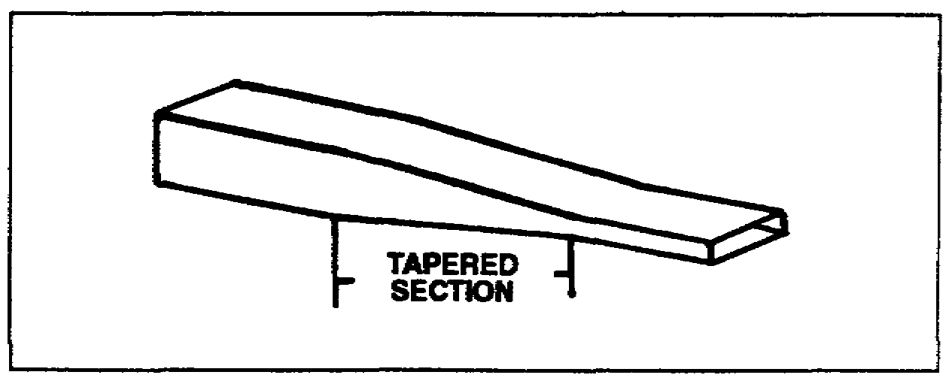

Figure 2-1. Waveguide transformer.

LEARNING EVENT 4: BENDS

1. Waveguide plumbing. To have energy move from one end of a waveguide to the other without reflections or standing waves, the size, shape, and dielectric material of the waveguide must be constant throughout its entire length. Any abrupt change in the size

2-3 SS0031

or shape of the waveguide will cause reflections; therefore, any change must be very gradual unless special devices are used. When it is necessary to change the shape or direction of a waveguide, then bends, twists, or terminations are used. These are sometimes called waveguide plumbing.

a.. Twisted bends. In some installations it is necessary to change the direction of the waveguide or to rotate the electromagnetic field. When a waveguide is terminated with an antenna, the electromagnetic field may have to be rotated so the antenna can be properly polarized. This can be done by twisting the waveguide as shown in Figure 2-2. The twist is gradual and is extended over two wavelengths or more to prevent reflections.

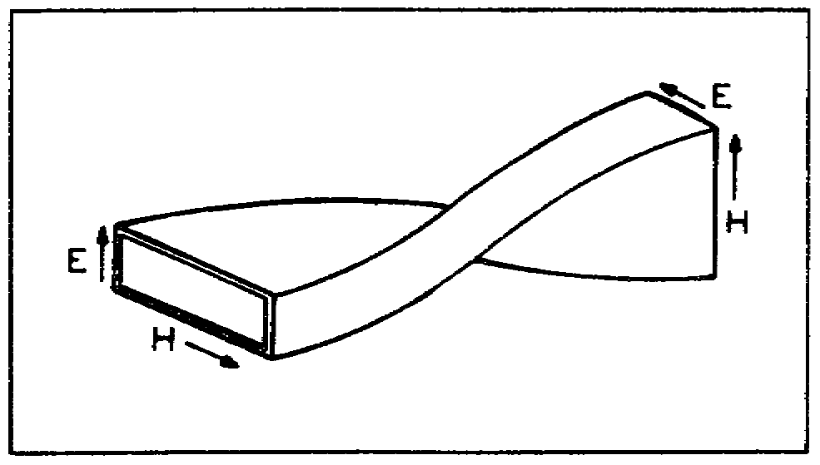

Figure 2-2. Twisted section of waveguide.

b. Gradual bends. When the direction of a waveguide is changed, a gradual bend is used as shown in Figure 2-3. Some bends may be 90 degrees and others may be more or less than 90 degrees. The radius of the bend must be greater than two wavelengths to minimize reflections.

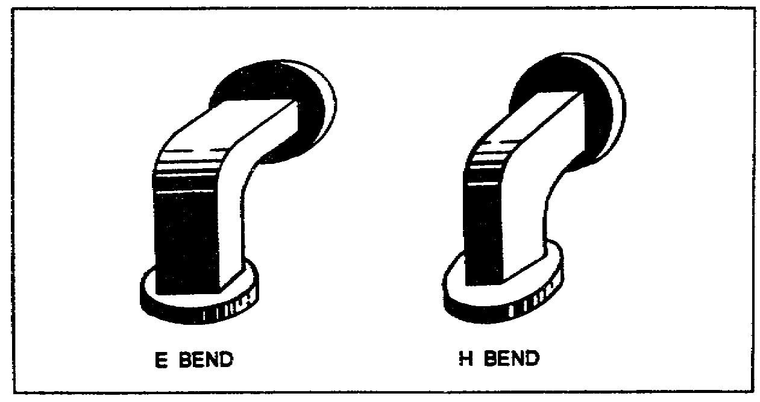

Figure 2-3. Gradual bends.

c. Sharp bends. Some installations may require a sharp bend as shown in Figure 2-4. The bends are bent twice at 45 degrees, one-quarter wavelength apart.

SS0031 2-4

Reflections do occur in these bends, but the combination of the direct reflection at one bend and the inverted reflection at the other bend will cancel. The fields then appear as though no reflection had occurred.

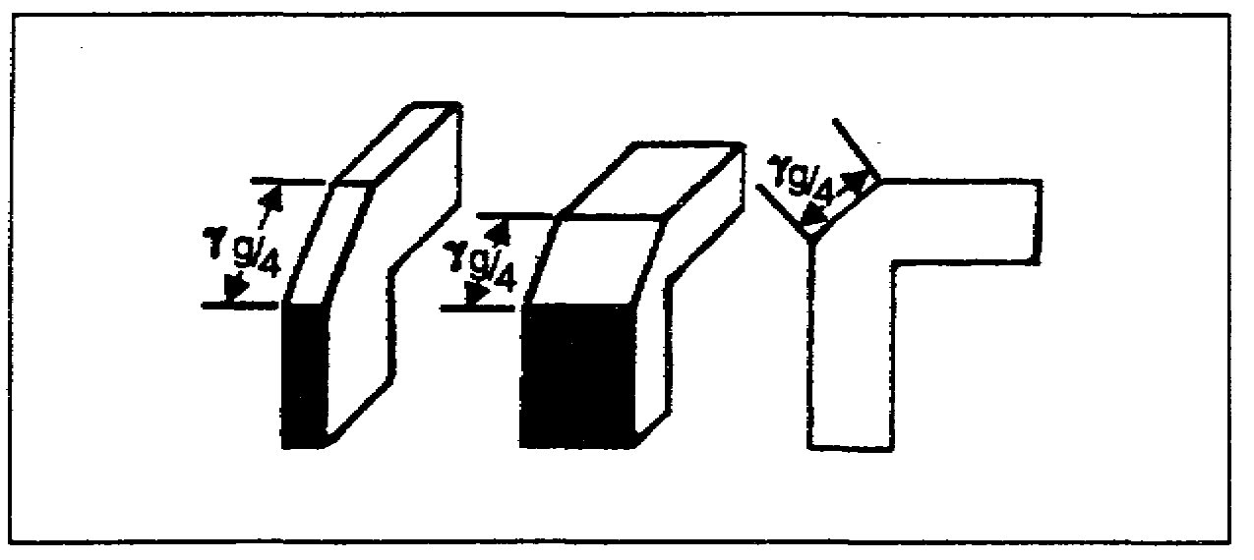

Figure 2-4. Sharp bends.

2. Construction. All bends can be made in either the narrow or wide dimension of the waveguide without changing the mode of operation. The construction of these bends is very critical. The inside of the waveguide must be smooth and free of dents or ripples. Any distortion of the inside surface will cause undesired reflection. Because of this, the twists and bends are made at the factory and supplied to the installation.

LEARNING EVENT 5: FLEXIBLE WAVEGUIDE

A section of flexible waveguide is sometimes used to connect two rigid sections of waveguide when there is an alignment or vibration problem. It is also used where the waveguide is subject to flexure at a low rate. Because of its construction, the flexible waveguide may be bent or twisted in any desired direction.

1. Some common types of flexible waveguides and their construction are shown in Figure 2-5, page 2-6, and explained below.

a. The type of waveguide shown in A, Figure 2-5 is constructed of spirally wound strips of brass which are crimped together. When the waveguide is flexed, the strips slide one over the other and contact is maintained.

b. Part B, Figure 2-5 shows a similar section covered with rubber and with flanged connectors soldered to the ends. The rubber covering seals the waveguide so that it may be pressurized and serves as a mechanical protection. This is the general appearance of all types of flexible waveguides.

2-5 SS0031

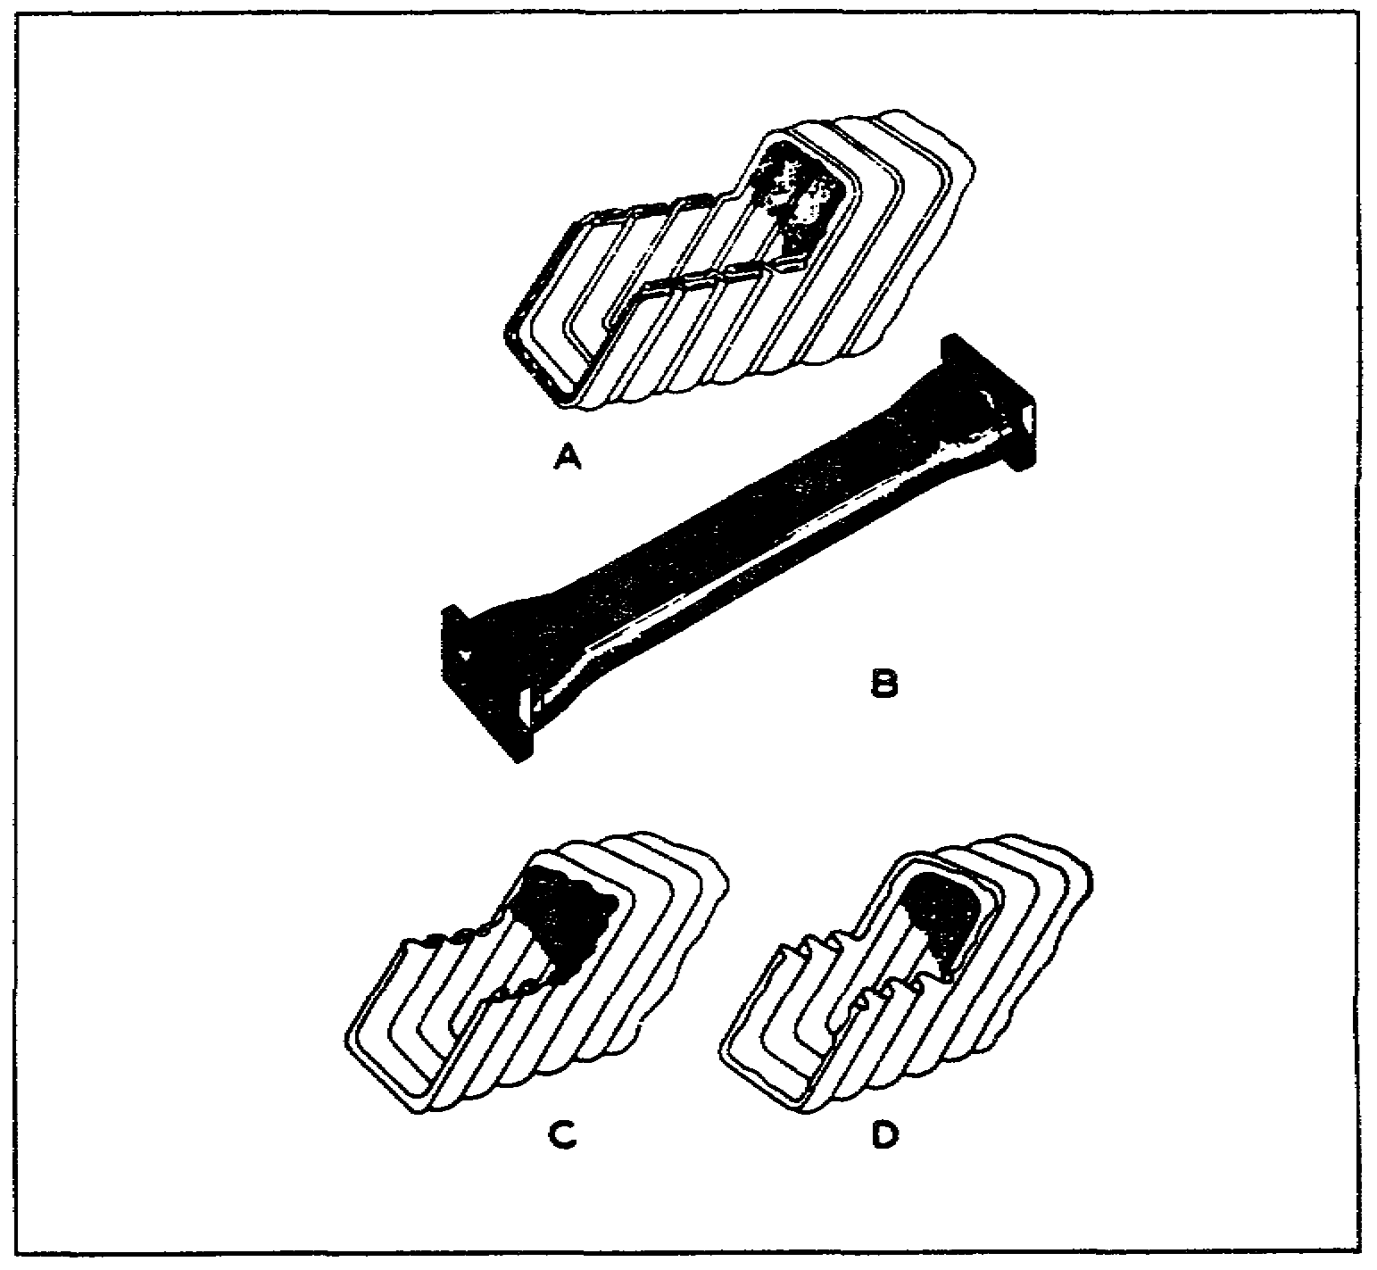

Figure 2-5. Flexible waveguide.

c. Part C, Figure 2-5 shows another spirally constructed waveguide. Each strip is crimped tightly to the next stage so that no slippage is possible. The waveguide is flexed by bending the thin walls of the corrugated metal.

d. Part D, Figure 2-5 shows a flexible, one-piece waveguide. Here again the thin corrugated metal is bent.

2. Since skin effect keeps the current on the inner surface of the waveguide, the inside surfaces of the flexible section are either chromium plated or silver plated for maximum current conductivity. The higher power losses caused by reflections and standing waves of flexible waveguide make it impractical for general use. In places where the use of flexible waveguide is required, the length is kept as short as possible to keep losses at a minimum.

SS0031 2-6

SECTION II. ANTENNA FEED SYSTEMS

LEARNING EVENT 6: ANTENNAS

An antenna is used either for sending electromagnetic energy into space or for collecting electromagnetic energy from space. Fortunately, separate antennas are not required for communications equipment to transmit and receive electromagnetic energy. Any antenna will receive energy from space with the same efficiency with which it transfers energy into space. Because of this property, known as reciprocity, this discussion will treat antennas from the viewpoint of the transmitting antenna. The same principles apply when the antennas are used for receiving electromagnetic energy.

LEARNING EVENT 7: WAVEGUIDE RADIATOR

1. When electromagnetic energy is to be radiated into space, the efficiency of the radiator is a major consideration. Suppose the waveguide is left open on one end, as shown in Figure 2-6. The energy propagated to the open end will encounter an impedance mismatch between the waveguide and space. Part of the energy will be radiated into space and part will be reflected back into the waveguide because of the impedance mismatch. The reflected energy will cause standing waves in the waveguide.

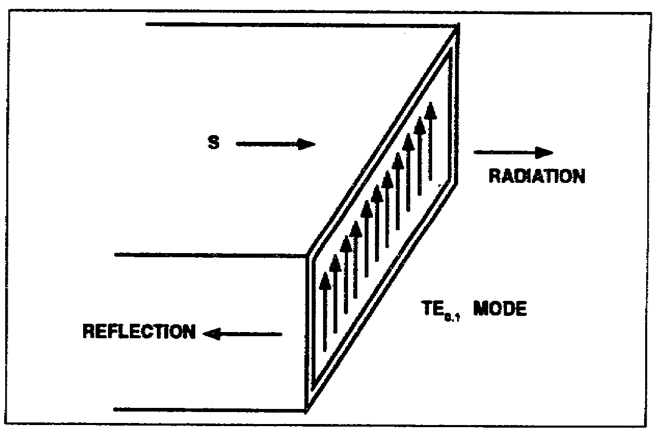

Figure 2-6. Waveguide radiator.

2. Despite this loss of efficiency, the waveguide radiator is sometimes used to radiate energy into space. The waveguide opening is an aperture, and the size and shape of this aperture determines the polar distribution and gain of the radiator. Because the waveguide radiator is the open end of the waveguide, the aperture dimensions are the waveguide dimensions.

2-7 SS0031

3. Strange as it may seem, the gain of the waveguide radiator is somewhat greater than the gain of a dipole. The polar distribution in the electric plane is similar to the figure 8 pattern of the dipole. The waveguide radiator also has a greater tuning range than the dipole. The tuning range limits are the same as the waveguide limits. As the frequency of the energy in the waveguide is increased to where the waveguide dimension is more than one wavelength, the energy is attenuated. Also, if the frequency is decreased sufficiently, it will reach the cutoff frequency of the waveguide, and propagation ceases.

LEARNING EVENT 8: DIPOLE TERMINATION

The fact that a waveguide radiator has greater gain than a dipole might lead you to think it is a simple way to radiate energy into space. Actually it is simple, but there is still the problem of the impedance mismatch between the waveguide and space. An impedance mismatch prevents maximum transfer of energy, so energy is lost in the waveguide because of standing waves.

1. If a waveguide is terminated with a dipole, as shown in Figure 2-7, a good impedance match can be obtained. It is much simpler to excite a dipole from a waveguide than from a coaxial line. To excite a dipole from a waveguide, the dipole is mounted on a web that fits into the open end of the waveguide. The web is mounted in the waveguide so that it is parallel with the wide side of the waveguide. This places the dipole so that it is parallel to the E lines in the waveguide.

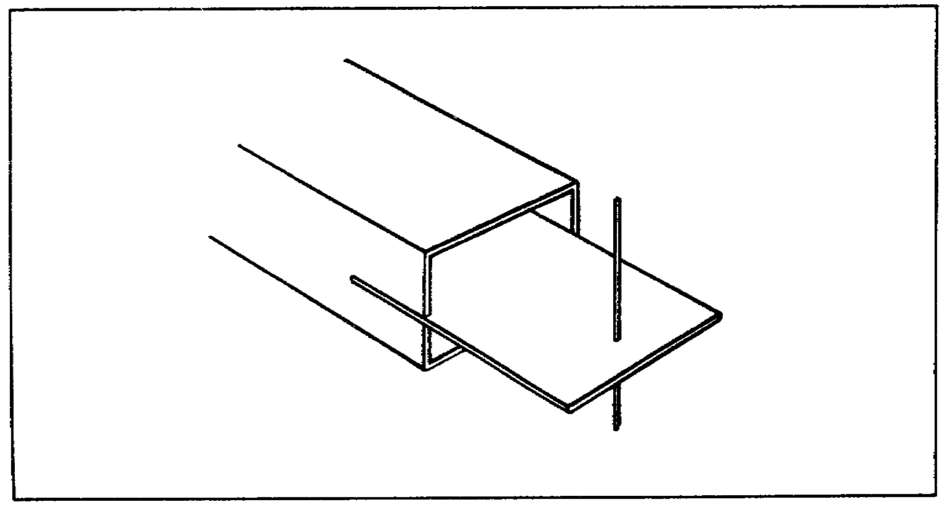

Figure 2-7. Dipole termination of a waveguide.

2. The impedance of the dipole is determined by the depth to which the web is inserted and the position of the dipole with respect to the opening in the waveguide. Usually, the waveguide has a tapered section on the end and the web is inserted in this section. This provides a very good impedance match between the waveguide and space.

SS0031 2-8

3. To obtain the desired radiation pattern, several dipole elements may be mounted on the web. The most common arrangement though, is a single dipole with a reflecting element. The reflecting element can be either another dipole or some type of reflecting material shaped according to the beam pattern desired.

LEARNING EVENT 9: TAPERED HORN

1. The gain of a waveguide radiator may be increased by enlarging the aperture. This is done by attaching a flare or horn to the waveguide as shown in Figure 2-8. The waveguide termination is commonly known as a tapered horn antenna. The tapered horn antenna is designed to transform a transverse wave at the end of the waveguide to a similar transverse wave at the end of the tapered horn without causing attenuation. The throat of the tapered horn (the junction between the tapered horn and the waveguide) serves as a filter device and allows only a single mode to be propagated freely to the aperture. The tapered horn will not support propagation of a particular mode unless the transverse dimensions of the tapered horn are greater than the dimensions of the waveguide.

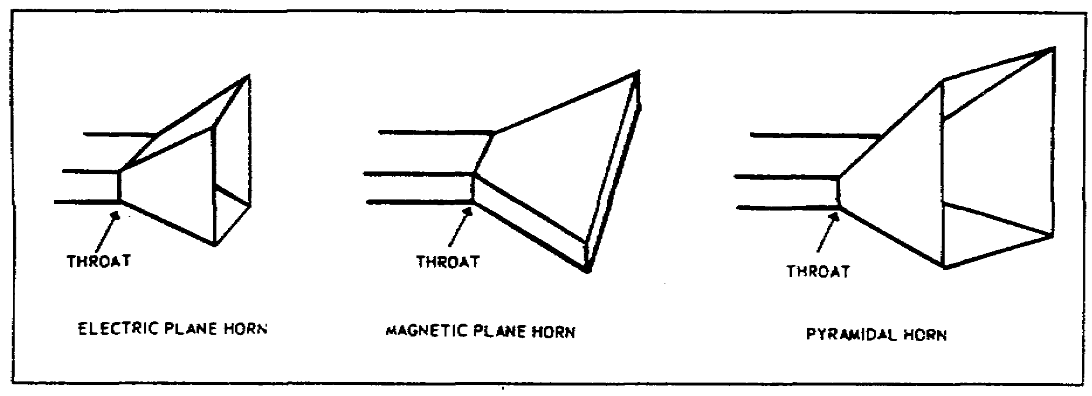

Figure 2-8. Tapered horn antenna.

2. The dimensions of the open end of the tapered horn are chosen to obtain the desired radiation pattern and to prevent spherical distortion of the propagated wave. The taper of the horn serves to match the impedance of the waveguide to the impedance of space. At one end, the impedance of the tapered section matches that of space; at the other end, it matches the impedance of the waveguide.

LEARNING EVENT 10: REFLECTOR FEED SYSTEM

1. Since microwave frequencies have essentially the same behavior as light waves, they can be focused into beams. One of the reflectors used to focus the energy into a narrow beam is a paraboloid. The focal point and the contour of the reflector determine the size of the reflected beam. The paraboloid reflector is often called a parabolic reflector.

2-9 SS0031

2. The parabolic reflector on a reflector-type antenna system may be fed by a front- or rear-feed system. In a front-feed system, the waveguide is curved around the edge of the reflector as shown in A of Figure 2-9. In a rear-feed system, the waveguide passes through the reflector from the back side as shown in B of Figure 2-9.

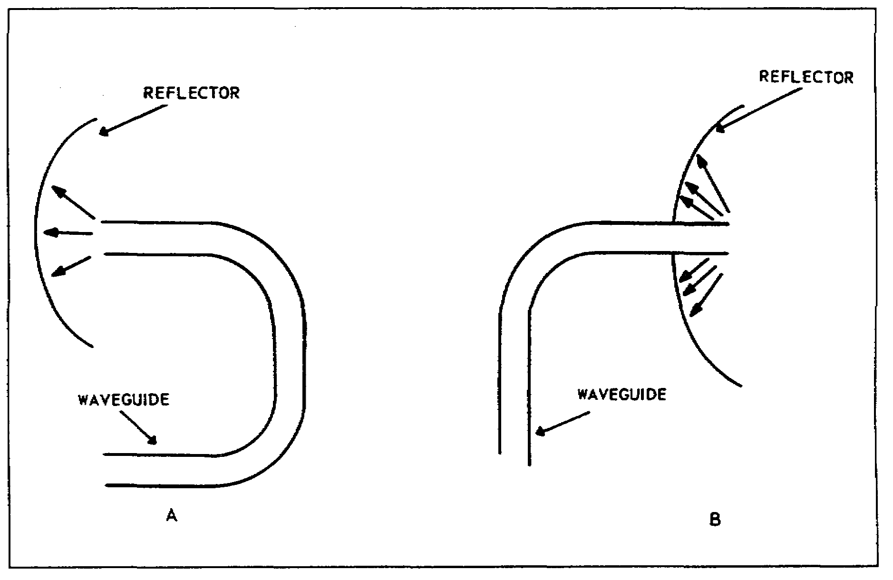

Figure 2-9. Reflector feed systems.

LEARNING EVENT 11: CASSEGRAINIAN ANTENNA

A cassegrainian antenna is a rear-fed antenna which uses two reflectors to concentrate the electromagnetic energy into a narrow beam. The antenna system is composed of a feed system, a hyperboloidal reflecting surface, as shown in Figure 2-10. The waveguide horn illuminates the hyperbolic subreflector which, in turn, illuminates the main parabolic reflector. Use of the hyperboloid ensures a more uniform illumination of the main paraboloid.

SS0031 2-10

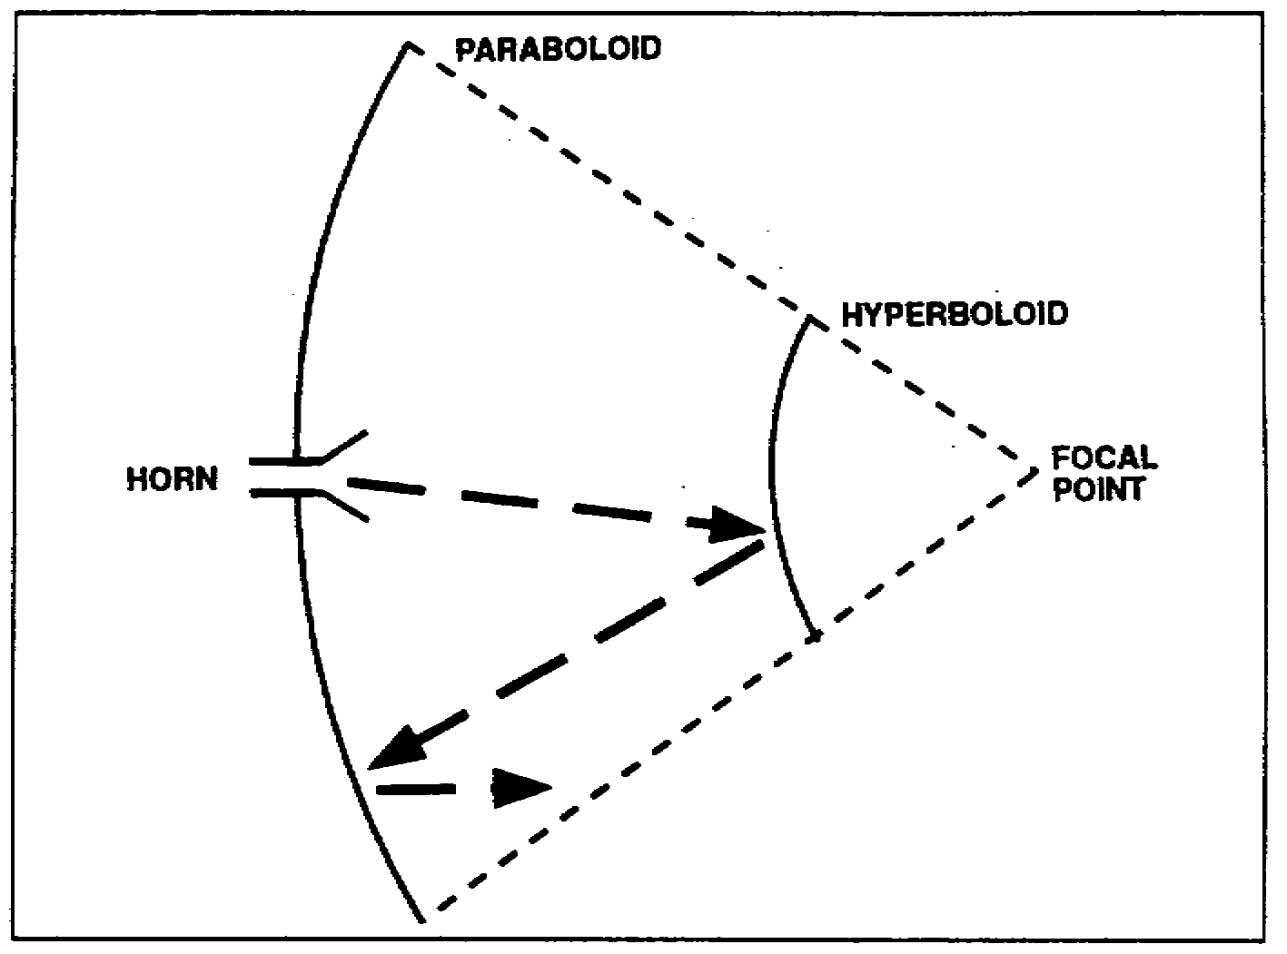

Figure 2-10. Cassegrainian antenna.

LEARNING EVENT 12: POLYROD ANTENNA

A polyrod antenna is an end-fed directional dielectric antenna that consists of a long tapered rod energized by a section of waveguide. A dielectric material such as polystyrene is used to construct the rod. The dielectric rod guides the electromagnetic waves in the direction of the rod's axis. The polyrod antenna may be used alone as shown in Figure 2-11 or it may be used with conventional reflectors.

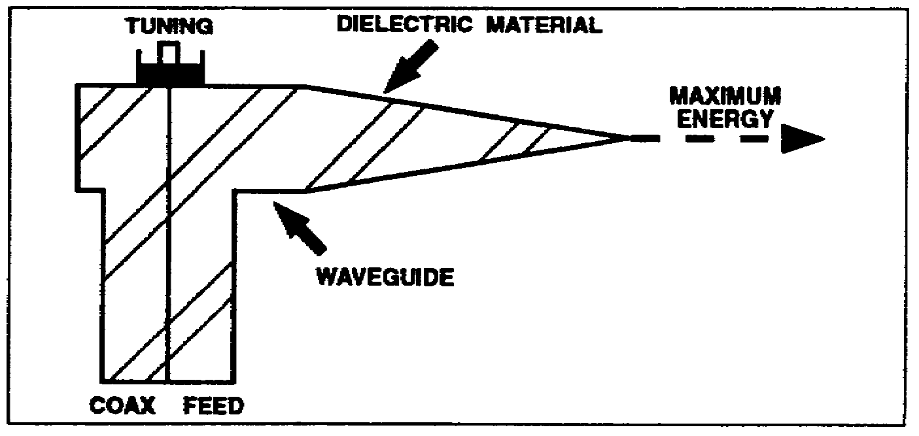

Figure 2-11. Polyrod antenna.

2-11 SS0031

LEARNING EVENT 13: CASSEGRAINIAN ANTENNA WITH POLYROD FEED

The polyrod feed system can also be used in conjunction with the cassegrainian antenna to obtain a highly efficient low-noise antenna system as shown in Figure 2-12. The polyrod feed guides the electromagnetic energy to the hyperboloid subreflector. The polyrod's dielectric material is tapered toward the waveguide horn so that the dielectric material can provide a uniform illumination of the hyperboloid subreflector. By using the combined polyrod feed and the cassegrainian antenna instead of the conventional cassegrainian feed and antenna system, the overall antenna size can be reduced by approximately 40 percent.

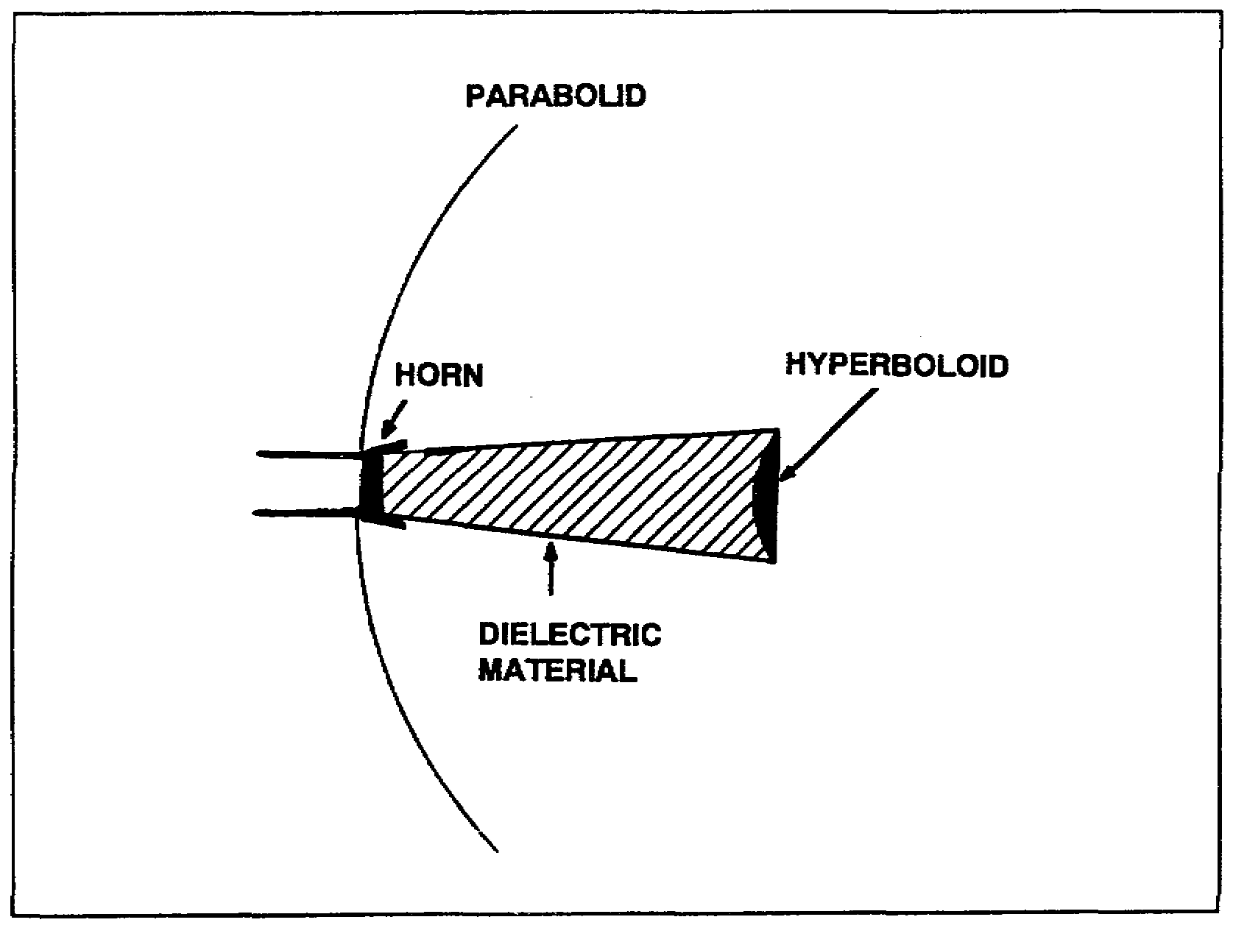

Figure 2-12. Cassegrainian antenna with polyrod feed.

SECTION III. MODULATOR ANALYSIS

LEARNING EVENT 14: MODULATORS

The primary purpose of the modulator is to convert a baseband input from the terminal equipment to an angle-modulated signal. Angle modulation is a modulation category that includes both frequency modulation and phase modulation. The baseband input usually consists of FDM signals from the teletypewriter/voice multiplexing equipment.

SS0031 2-12

LEARNING EVENT 15: MODULATOR STAGES

1. A typical modulator unit will contain various shaping circuits and amplifiers, as well as the actual modulating circuit. A block diagram of a simplified modulator unit is represented in Figure 2-13.

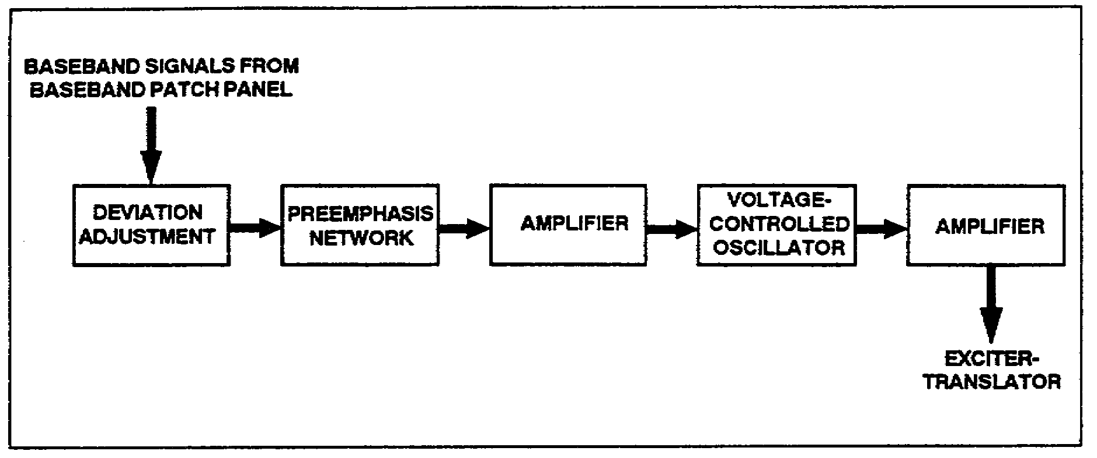

Figure 2-13. Simplified modulator unit.

2. The normal baseband input is coupled from the baseband patch panel to a series of circuits which prepare the baseband signals for modulation.

a. Deviation adjustment are used to establish the desired amplitude of the baseband signals and, since signal amplitudes are converted to frequency deviations during modulation, the adjustments also determine the frequency deviations of the modulated signals.

b. A preemphasis network emphasizes the high-frequency components by reducing the amplitude of the low-frequency components of the baseband signal by a greater amount than that of the higher frequencies. This unbalance in the overall sign causes the signal power level in the receiver (after demodulation and filtering) to be increasingly large at the higher frequencies, thus compensating for the increased noise that occurs at the higher frequencies. The receiver will be equipped with a deemphasis circuit to restore the signal to its original amplitude. This compensation tends to equalize the S/N across the frequency band. A preemphasis network is also called a high-pass filter circuit.

c. The baseband amplifier provides the required amplification for the baseband signals prior to modulation. In some modulators, the amplifier network comprises additional shaping circuits, such as clippers, limiters, preemphasis networks, deemphasis networks, and filters. These additional shaping circuits are used to reduce the overall noise and to improve the baseband signal.

3. Direct- and indirect-angle-modulation techniques are employed in various types of microwave communications terminals.

2-13 SS0031

a. If a direct-angle modulation technique is used, the baseband signals (after preparation) are applied directly to the subcarrier oscillator circuit to produce the desired type of angle modulation. If low values of oscillator frequency and frequency deviation exist, it may be necessary to include a number of multiplier stages to raise them to the desired values.

b. If indirect-angle modulation techniques are used, the baseband signals and the output of the subcarrier oscillator are applied to a modulation-amplifier circuit to produce the desired type of angle modulation.

4. After modulation, the signal generally undergoes additional amplification in an RF amplifier stage. The signal is then coupled to the exciter-translator unit in the transmitter.

SECTION IV. INDIRECT-ANGLE-MODULATED TRANSMITTER

LEARNING EVENT 16: INDIRECT-ANGLE MODULATION

Most transmitters amplify and multiply an angle-modulated signal up to the desired frequency and power level. The block diagram of a simple indirect-angle-modulated transmitter is shown in Figure 2-14.

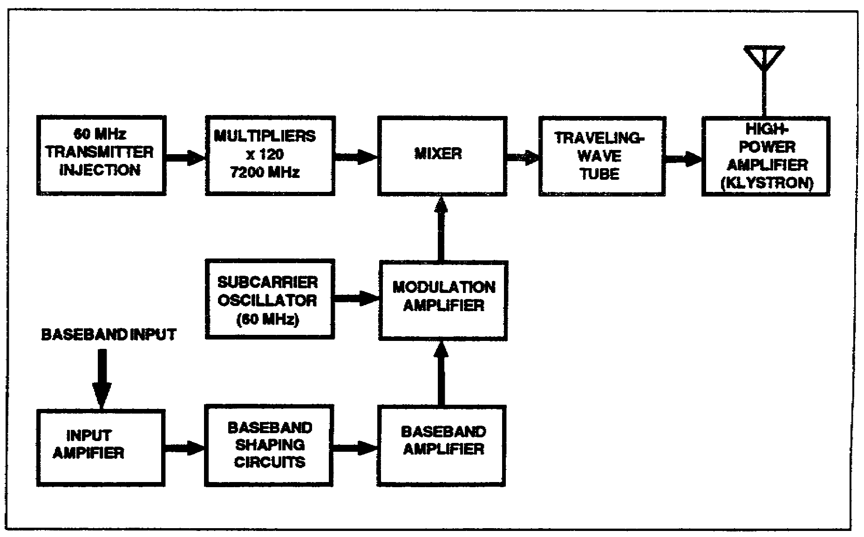

Figure 2-14. Indirect-angle-modulated transmitter.

SS0031 2-14

LEARNING EVENT 17: BASEBAND CIRCUITS

1. The input amplifier is a linear amplifier used to prepare the baseband signal for modulation. The baseband circuits must alter the signals so they have the correct frequency and amplitude relationship. The amplitude and frequency of the baseband signal must be accurately controlled to properly modulate the subcarrier frequency. The output of the amplifier is coupled to the baseband-shaping circuits.

2. Preemphasis, deemphasis, and limiter circuits are used as baseband-shaping circuits. The limiter circuits remove the portions of the baseband signal that exceed the predetermined limits. The preemphasis and deemphasis circuits operate on the high frequencies in such a manner as to improve the overall S/N of the baseband signal.

3. The baseband amplifier increases the power level of the baseband signal and isolates the shaping circuit from the modulation amplifier.

LEARNING EVENT 18: MODULATOR

The prepared baseband signal and the unmodulated 60-MHz subcarrier signal are combined in the modulation amplifier to form the modulated-subcarrier signal. The indirect modulation process in this amplifier involves amplitude, phase, and frequency modulation techniques.

LEARNING EVENT 19: TRANSMITTER INJECTION STAGES

1. The transmitter injection voltages are usually generated by a separate frequency-generating subsystem. This subsystem usually contains a highly stable frequency standard, amplifiers, and frequency synthesizers. In addition to the injection output used in the transmitter, the subsystem also provides synchronizing voltages for other subsystems within the communications system.

2. The transmitter injection voltage can also be developed by a single highly stable oscillator. For example, the stage illustrated in Figure 2-14 could be a single crystal oscillator stage operating at a frequency of 60 MHz.

LEARNING EVENT 20: FREQUENCY MULTIPLIERS

The frequency of the transmitter injection voltage is multiplied by a series of multiplying stages to a value of approximately 7,200 MHz-the frequency required for transmission. The individual circuits used to perform this multiplication generally do not multiply the frequency by more than 6. To perform the multiplication of 120, as shown in Figure 2-14, three stages of multiplication can be used-x6, x4, and x5.

2-15 SS0031

LEARNING EVENT 21: MIXER

The mixer circuit heterodynes the 60-MHz angle-modulated subcarrier signal from the modulator and the 7,200 MHz injection signal from the multiplier stages to produce a 7,200-MHz modulated carrier to be used as the uplink frequency.

LEARNING EVENT 22: TRAVELING-WAVE TUBE

The traveling-wave tube (TWT) is a special type of electron tube which provides amplification for wideband signals. The operation of the TWT depends upon the technique of velocity-modulating the electron beam inside the tube structure.

LEARNING EVENT 23: HIGH-POWER AMPLIFIER

1. Another type of velocity-modulated tube, a klystron, is used to provide the final amplification needed to raise the modulated signal to the desired power level for transmission. This circuit usually operates with very high voltages and requires a cooling system to reduce the operating temperature.

2. Several fault detection circuits are used to remove the high voltage or the RF drive from the high-power amplifier when any defect or malfunction occurs.

SECTION V. DIRECT-ANGLE-MODULATED TRANSMITTER

LEARNING EVENT 24: ANGLE MODULATION

All angle-modulated transmitters use either direct or indirect methods for producing the angle modulation. The modulating signal in the direct method has a direct effect on the frequency of the carrier. In the indirect method, the modulating signal uses the frequency variations caused by phase modulation. In either case, the output of the transmitter is an angle-modulated wave, and the receiver cannot distinguish between them. A simplified directly modulated transmitter is shown in Figure 2-15.

SS0031 2-16

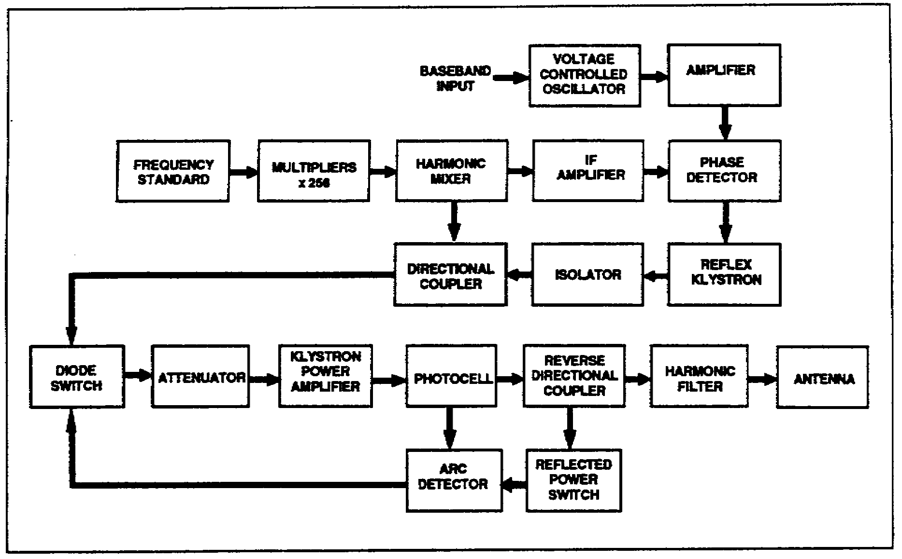

Figure 2-15. Direct-angle-modulated transmitter.

LEARNING EVENT 25: BASEBAND CIRCUITS

1. The baseband input signal is applied to the voltage-controlled oscillator (VCO). The VCO's output frequency of 34 MHz is varied in proportion to the baseband input frequency.

2. The amplifier amplifies the modulated subcarrier and applies the signal to the phase detector stage.

LEARNING EVENT 26: HARMONIC MIXER

The injection voltage from the multiplier stages is applied to a x4 multiplying circuit within the harmonic mixer stage. The multiplied output is mixed with the transmit frequency from the reflex klystron after the transmit frequency has been coupled through an isolator and a directional coupler. The output from the harmonic mixer is a 34-MHz IF that is amplified and coupled to the phase detector.

LEARNING EVENT 27: PHASE-LOCK LOOP

1. The inputs to the phase detector consist of a modulated subcarrier and a nominal IF of 34 MHz, which is the difference between the transmit frequency and the multiplied

2-17 SS0031

frequency standard output. The output of the phase detector, therefore, is proportional to the modulated subcarrier input and the difference in frequency between the outputs of the reflex klystron and the multiplied frequency standard. The output of the phase detector is applied to the repeller plate of the reflex klystron. If the output of the phase detector is positive, the output frequency of the reflex klystron will decrease; a negative output from the phase detector will cause the klystron frequency to increase.

2. When an input from the baseband circuits is applied to the phase detector, the phase detector will produce an output that causes the reflex klystron to deviate from its center frequency. The output of the klystron is fed through an isolator and a directional coupler and a sample of this signal is applied to the harmonic mixer. The changing input to the mixer causes the 34-MHz IF signal to change and this variation is applied to the phase detector as the reference input.

3. When a small frequency difference exists between the modulated subcarrier input and the reference signal, the output of the phase detector is a sinusoidal voltage. This sinusoidal voltage will modulate the reflex klystron, thus producing phase lock automatically. The signal from the klystron now only requires amplification before transmission.

4. The phase-lock-loop circuit consists of the phase detector, reflex klystron, isolator, directional coupler, harmonic mixer, and IF amplifier. Its purpose is to reduce the deviation of the klystrons modulated output signal or to compress the signal into a narrower bandwidth.

LEARNING EVENT 28: POWER AMPLIFIER

1. The input states for the klystron power amplifier are a diode switch and a ferrite attenuator that function as an isolator. The diode switch normally allows the input drive to be coupled to the klystron power amplifier. However, an input from the protection circuits will cause the diode switch to remove the input drive from the klystron power amplifier. The ferrite attenuator is a variable attenuator that is used to vary the power level of the input drive.

2. The klystron power amplifier is a velocity-modulated amplifier that is used to raise the power level of the RF input signal to the level required for transmission. Power amplifiers used in transmitters are usually equipped with a heat exchanger or some type of cooling system to remove the excess heat from the amplifier.

3. The harmonic filter absorbs the unwanted harmonic energy from the signal to be transmitted.

LEARNING EVENT 29: FAULT DETECTION CIRCUITS

1. The fault detection system removes the RF drive from the klystron power amplifier if arcing or if an excessive voltage standing wave ratio exists in the waveguide system.

SS0031 2-18

2. The photocell will sense an arc in the output waveguide and will apply the signal to the arc detector. The output of the arc detector will cause the diode switch to remove the RF drive from the klystron power amplifier.

3. The reverse directional coupler samples the reflected energy to the waveguide. When the voltage standing wave ratio exceeds a predetermined value, the reflected power switch and the arc detector will cause the RF drive to be removed from the klystron power amplifier.

SECTION VI. TRANSMITTER ANALYSIS

LEARNING EVENT 30: TRANSMITTER INJECTION

Voltages used for transmitter injection can be considered as an additional subcarrier's output. The frequencies will be mixed with the modulator's output in the translator portion of the transmitter to form the final angle-modulated output signal.

LEARNING EVENT 31: FREQUENCY GENERATOR SUBSYSTEM

The frequency generator subsystem provides signals that are used throughout a microwave communications station. All of the frequency outputs of this system are derived from a frequency standard. The frequency standard produces an extremely accurate output signal which is continually monitored and compared with appropriate frequency references. An error in the frequency standard's output can be corrected through adjustments. The output of the frequency standard is coupled to the injection units through a synthesizer driver, frequency synthesizers, and an injection patch panel. (See Figure 2-16, page 2-20.) These simplified block diagrams represent the techniques used in one particular station, but similar techniques will be used in other types of stations to develop the required injection voltages.

1. The synthesizer driver, using the frequency standard's output signals, develops the fixed frequencies needed to drive the frequency synthesizers. In this particular example, the synthesizer driver receives an input of 5 MHz from the frequency standard, divides it to 1 MHz and develops 22 different output frequencies which are used as the inputs to the frequency synthesizers.

2. The frequency synthesizers contain circuits which are capable of converting the relatively few (22) fixed input frequencies into outputs that can be varied from 0.01 Hz to 50 MHz in selectable steps as low as 0.01 Hz. Frequency selections are made by the push buttons on the front panels of the frequency synthesizer unit.

2-19 SS0031

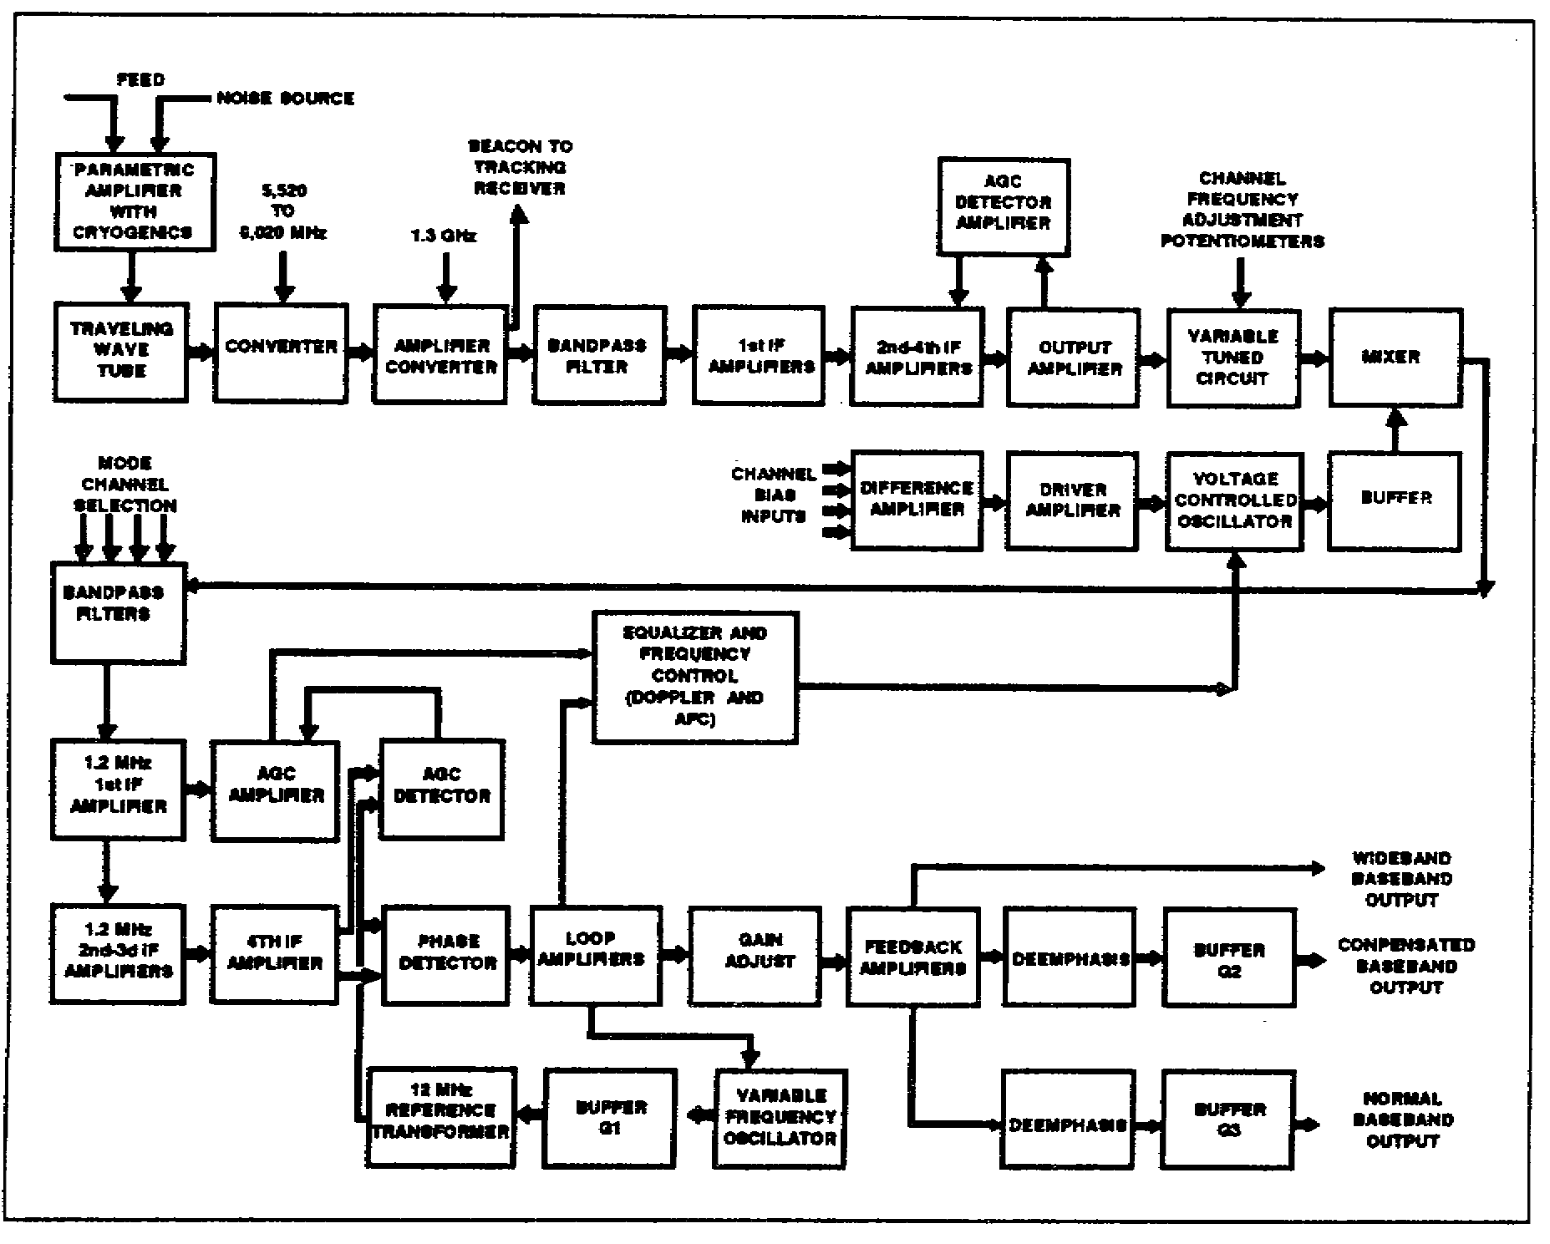

Figure 2-16. Frequency generator subsystem.

3. The transmitter injection unit contains circuits which prepare the input signals for application to the transmitter's translator circuits.

a. Tracking filters are used in some injection units to filter the synthesizer's input signal frequency spectrum to improve the S/N. The tracking filter is basically a VCO that has a phase-lock-loop circuit. The output of the VCO is locked to the input frequency through the action of the phase-lock-loop circuit.

b. Basically, the oscillator-synchronizer functions in the same manner as the tracking filter. The main difference is that the input signal is compared with a reference signal, but there is no oscillator output signal. Instead of the conventional oscillator output, there is an output error signal which is used to control another signal source (usually a klystron oscillator).

c. Multipliers are used in some injection units to raise the frequencies to the values required for efficient operation in the translator unit.

SS0031 2-20

LEARNING EVENT 32: TRANSLATOR

The translator provides the necessary mixing action required to prepare the modulated signal for transmission. The translator unit is composed of isolator., buffer amplifiers, filters, mixers, and attenuators. (See Figure 2-17.)

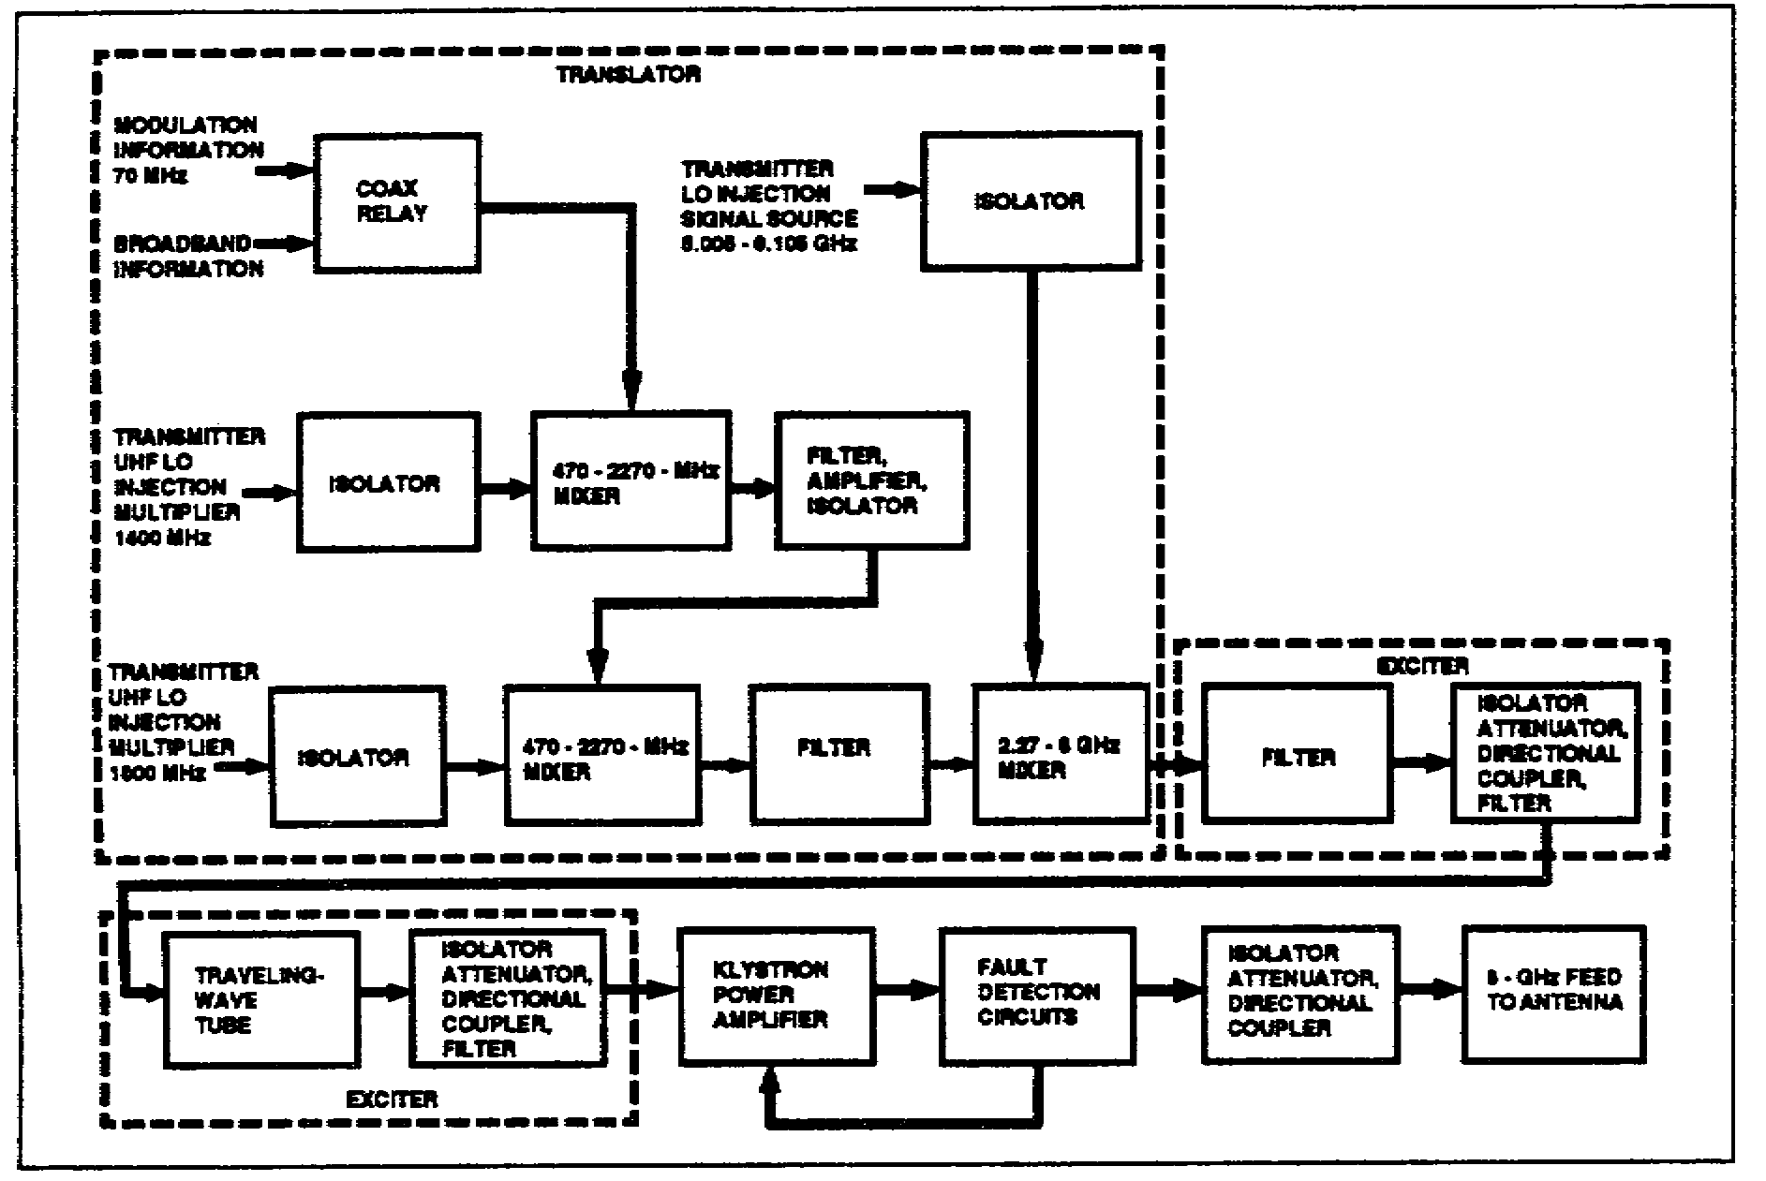

Figure 2-17. Transmitter subsystem.

LEARNING EVENT 33: TRANSLATOR OPERATION

1. Each isolator allows the energy that is propagated in a forward direction to pass through with negligible opposition, but energy that is propagated in a reverse direction is shunted to a dissipating element which effectively absorbs this reverse or backward-wave energy.

2. The overall translating process uses three mixing stages. If a single mixing stage is used with the 70-MHz modulated signal mixing with the final-oscillator-injection voltage, two disadvantages are apparent. The final oscillator-injection voltage would have to approach the final transmitted frequency. This is not too important in itself but it creates a major problem in that both the upper and lower sideband frequencies are very close to the carrier frequency. Any attempt to reduce the amplitude of the undesired lower sideband without affecting the upper sideband is difficult. The use of multiple mixers provides easier suppression of the undesired sideband and other spurious signals.

2-21 SS0031

a. The first translator mixes the 70-MHz modulated signal with the 400-MHz injection frequency to produce the output of 470 MHz. The filter removes the lower sideband from the output signal.

b. The 470-MHz output of the first translator is mixed with the 1,800-MHz injection frequency to produce an upper sideband of 2,270 MHz (lower sideband removed by filter). This output signal is then mixed with the final injection frequency of 5.005 GHz to 6.105 GHz to produce the final modulated signal. This signal is in the range of 7.25 to 8.4 GHz.

LEARNING EVENT 34: EXCITER

1. The exciter in a microwave transmitting system can be a TWT with its associated filters, attenuators, and couplers. Its purpose is to amplify the modulated signal to a power level that will satisfactorily drive the power amplifier.

2. Variable attenuators are used to provide a means to remotely control the input power levels to the exciter and the final-power amplifier.

LEARNING EVENT 35: POWER AMPLIFIER

1. The final power amplifier employed in most microwave transmitters is a multicavity-klystron tube. The klystron will amplify the input power by approximately 20,000.

2. Devices that operate continuously at high-power levels generally require a means of cooling to prevent heat damage. This cooling system can be a refrigeration system, a heat-exchanger system, or a simple blower. The study of cooling systems is known as cryogenics.

LEARNING EVENT 36: FAULT DETECTION

1. Fault detection circuits are used throughout a communication station to protect its components from overloads that may be caused by the failure of other components.

2. Various types of fault detection circuits are used to protect the klystron power amplifier. Some of these circuits are also installed to ensure the safety of the operator.

a. An extensive interlock chain is provided in each station for maximum safety of personnel and equipment. The klystron beam voltage is removed immediately whenever the high-voltage section of the power-amplifier cabinet is opened. Beam voltage also is removed for a failure due to improper filament current, improper focus current, body current and beam overcurrent coolant overtemperature, coolant underflow, or coolant overpressure.

SS0031 2-22

b. Arc protection is usually achieved by sensing a change in body current and firing a triggered spark gap which crowbars (instantly removes) the beam supply voltage. Protection from excessive reflected power and RF arcing is achieved by removing RF drive from the klystron when the input-waveguide solid-state switch is reverse biased.

2-23 SS0031

THIS PAGE INTENTIONALLY LEFT BLANK

SS0031 2-24

LESSON 2

PRACTICE EXERCISE

The following items will test your grasp of the material covered in this lesson. There is only one correct answer for each item. When you complete the exercise, check your answers with the answer key that follows. If you answer any item incorrectly, study again that part of the lesson which contains the portion involved.

1. Waveguides are capable of handling more power than a coaxial cable because-

A. The distance of the arc-over path is twice as long
B. The waveguides have less resistance than the coaxial line
C. The waveguides have an inner coating of silver
D. The waveguides do not use dielectric supports

2. The primary purpose performed by the modulator in a satellite communications ground station is conversion of-

A. Baseband signals to modulated signals
B. Modulated signals to baseband signals
C. Beacon signals to modulated data signals

3. Some angle-modulated transmitters used in satellite communications ground stations require several multiplier stages. These multiplier stages are needed to-

A. Provide the frequency required to indirectly modulate the subcarrier
B. Raise the power level of the subcarrier oscillator output signals
C. Increase the frequency deviation and the subcarrier oscillator frequencies to the desired value
D. Create additional harmonics to synchronize other subsystems in the communications network

4. What happens when fault detection circuits sense a malfunction in the transmitter's RF system?

A. The antenna is disengaged from the transmitter
B. The baseband signal is removed from the modulator
C. The RF drive is removed from the high power amplifier
D. The transmitter injection voltage is removed from the translator mixed stage

2-25 SS0031

LESSON 2

PRACTICE EXERCISE

ANSWER KEY AND FEEDBACK

Item Correct Answer and Feedback

1. A. The distance of the arc-over path is twice as long (page 2-3, Learning Event 3, para 2)

2. A. Baseband signals to modulated signals (page 2-12, Learning Event 14)

3. C. Increase the frequency deviation and the subcarrier oscillator frequencies to the desired value (page 2-14, Learning Event 15, para 3a)

4. C. The RF drive is removed from the high power amplifier (page 2-16, Learning Event 23, para 2)

SS0031 2-26

LESSON 3

RECEIVE SYSTEMS AND PARAMETERS

Critical Task: 01-5768.07-0002

OVERVIEW

LESSON DESCRIPTION:

In this lesson, you will learn the basic knowledge of the purpose, operation, and characteristics of receivers used in satellite communications ground terminals.

TERMINAL LEARNING OBJECTIVE:

ACTION: Demonstrate a basic knowledge of the purpose, operation, and characteristics of receivers used in satellite communications ground terminals. Recognize the effects of various parameters such as atmospheric, celestial, season, terrestrial, fading, and internal/manmade. Take steps to overcome these parameters and improve communications S/N.

CONDITION: Lesson material, pencil, and paper.

STANDARD: Demonstrate competency of the task, skills, and knowledge of the material presented by responding to 70 percent of the test questions covering satellite communications, without supervision.

INTRODUCTION

This lesson will provide you with the basic knowledge of the purpose, operation, and characteristics of receivers used in satellite communications. Additionally, it will describe ways of recognizing the effects of various parameters and some internal steps to overcome and improve communications S/N.

3-1 SS0031

SECTION I. INTERFERENCE

LEARNING EVENT 1: GENERAL

External interference consists of all external natural and manmade disturbances which interrupt or interfere with the electrical or electronic properties of operation, maintenance, or testing, and which cause either improper operation or indication, or diminished equipment performance.

LEARNING EVENT 2: ATMOSPHERIC

1. Atmospheric interference is caused by the many thunderstorms that occur over the surface of the Earth. In ordinary communications equipment, this interference appears as noise, a constant background rumble with loud crashes occurring at irregular intervals. The noise may not be heard at all times, but it is always present in receivers and may be a source of an unidentifiable interference problem.

2. Lightning produces electromagnetic waves which are scattered in all directions. These waves are received locally as overriding volume crashes. In addition, the waves can be transmitted to distant antennas because these waves can be reflected and refracted from the ionosphere at such an angle as to be directed to the distant receiving antennas.

LEARNING EVENT 3: CELESTIAL

1. Cosmic noise is a continuous noise received from other galaxies. This noise is probably caused by magnetic storms resulting from the thermonuclear reactions continuously occurring on the suns of these distant galaxies. This noise is not particularly directional because the transmitting galaxies completely surround our own galaxy.

2. The noises received from within our own galaxy are called galactic noise and are normally directional because they originate from definite traceable sources. Again, this is a type of noise that is comparatively constant.

3. Noise received from the stars within our own galaxy is highly directional and normally possesses a greater amplitude than cosmic interfering signals.

4. The noise received as a result of the thermonuclear reactions occurring on the sun is the greatest source of noise existing outside the sphere of our own planet. During periods of sunspot activity, this highly directional source will vary as the Earth rotates and maximum interference will result when the receiving antenna is directed toward the sun. This solar noise has the greatest effect in the Arctic Zone and the least effect in the Torrid Zone.

SS0031 3-2

LEARNING EVENT 4: SEASONAL

1. In any given area, the change from spring to summer or from any season to another will result in changes in both atmospheric noises and interference caused by solar radiation.

2. The atmospheric seasonal changes are primarily due to changes in temperature and humidity. As the temperature or humidity gradually increases, the interfering noises will increase in direct proportion.

3. During the night, when the portion of the Earth in which you are located is not facing the sun, you will not receive the same amplitude of solar noises. The electron bands in the upper atmosphere will lift and be a greater distance from the Earth. Interfering noise from the sun will diminish because the sun is not primarily directed toward the night side of the Earth.

LEARNING EVENT 5: TERRESTRIAL

1. Interference caused by geographical conditions is associated with the metallic or chemical content of the Earth surrounding the location of the ground station.

2. In specific areas or points, the Earth may have a high metallic content which will effectively introduce a magnetic field. This magnetic field may be coupled into the transmitting or receiving equipment by way of the desired signal, it may couple the desired signal to ground, or it may reduce the power of the signal. This metallic interference normally remains constant.

3. The interfering noise signals that accompany volcanic eruptions are normally effective only in the local region. The noise is caused by particles that have been electrostatically charged by the movement of gas and lava up through the Earth's surface, by the heat of the lava, and by the precipitation of dust or smoke particles.

LEARNING EVENT 6: FADING

1. Signal fading is not a noise-producing type of interference. It is classed as interference only because it makes reception of a desired signal difficult and thus interferes with the efficiency and accuracy of electrical or electronic equipment.

2. Fading, or fluctuation, of a desired signal may be due to disturbances in the medium through which the signal is propagated. The tropospheric, stratospheric, and ionospheric layers above the Earth's surface constitute the medium. An incoming signal may lose or gain strength; either condition is called fading. However, it is only when the normal signal strength weakens that reception becomes difficult. The signal strength may drop

3-3 SS0031

so low that the signal fades or disappears in the background noise. While the background noise level may remain constant, the desired signal may rise or fall below that level. The frequency of the fading cycle may be slow or rapid and may result in an instantaneous complete loss of the signal.

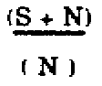
3. For all practical purposes, the effect of fading is a function of the signal-plus-noise-to-
noise ratio of the particular equipment involved.

If the background noise level remains constant and the signal diminishes, the reception of a weak signal becomes difficult. The application of automatic gain control is useless because increasing the gain to amplify the fading signal to the normal level will cause the noise level to be amplified an equal amount, and the result is the same poor signal-plus-noise-to-noise ratio. The peculiar atmospheric conditions that cause fading may last for hours or only a few minutes. Generally fading is more prevalent during the summer months and during daylight hours.

LEARNING EVENT 7: INTERNAL AND MANMADE

1. Internal interference is present to some extent in every electrical or electronic receiver. This noise arises from the natural action of electrons in transit within electron tubes and in other circuit components. Even if the receiving equipment is perfectly aligned and all of the internal components are in the best condition, the internal interference will still exist.

a. Thermal noise is caused by the thermal agitation of electrons in conductors. Thermally agitated electrons generate minute voltages which add to or subtract from the circuit voltage and thereby cause electric noise.

b. Short-effect noise is caused by the inconsistency of electrical currents. Electrical current is composed of minute electrical impulses which are the result of electrons changing energy states. This lack of continuity creates noise. Short-effect and thermal noise are closely related in their causes and effects.

c. Spontaneous emission is created by electrons giving up energy when they revert to a lower energy state. This energy induces noise voltages into the conductors.

2. Many kinds and types of equipment produce undesirable radio frequency impulses which are transmitted and travel out through the air exactly as if they were deliberately prepared for broadcast. In addition, some equipments radiate back through the power line to other equipments unless the radiation is stopped by an impedance or absorbed by a reactance.

SS0031 3-4

SECTION II. NOISE MEASUREMENTS

LEARNING EVENT 8: NOISE TEMPERATURE

1. The noise voltage appearing across the terminals of a resistor is proportional to the temperature of the resistor. The noise voltage is due to thermal agitation; that is, electron motion caused by the heating of the electrons in the structure of the resistor. If the resistor is heated to a higher temperature, the noise voltage increases; if the temperature is lowered, the noise voltage decreases. A useful measure of these noise voltages is a quantity that is proportional to voltage squared, or power. The rule that this noise power or voltage increases with temperature can be expressed in a more precise way if the noise is measured as a noise power and the temperature is measured on an absolute scale.

Pn = K₁T when Pn = noise power,
K₁ = a constant,
T = absolute temperature (in degrees Kelvin)

a. To compare noise temperature measurements without regard to the type of device or bandwidth involved, it is necessary to use a standard noise temperature reference.

b. The Kelvin scale is used to show absolute temperatures. The Kelvin scale shows absolute temperature because its zero point is referenced to the (theoretically) lowest possible temperature (absolute zero). Absolute zero is the temperature at which all thermal agitation (molecular activity) theoretically ceases.

c. The standard noise temperature is defined as 290° Kelvin (62.6° Fahrenheit, 17° Centigrade).

3-5 SS0031

d. Temperature measurements that are expressed in the more common temperature scales, fahrenheit and centigrade, can be converted to the Kelvin scale by use of the appropriate conversion factors given in Table 3-1. Measurements made in degrees Kelvin can also be converted back to the more common temperature scales.

Table 3-1. Temperature conversion factors.

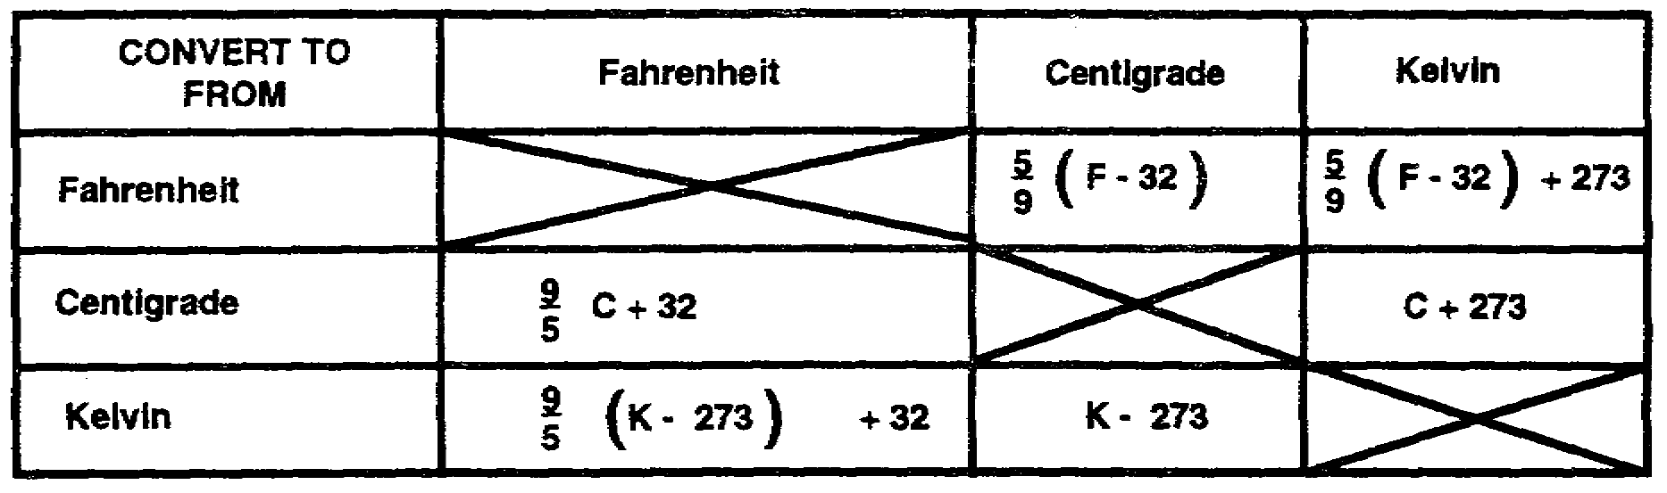

2. The noise power developed across a resistor is directly proportional to the absolute temperature. This leads to the concept of noise temperature. Since a given resistor generates a given amount of noise for a given temperature, it is possible to refer to that amount of power by a noise temperature equivalent. The measuring system, which will include amplifiers, has some bandwidth. If this measuring system were used to measure a signal of a fixed bandwidth which is less than the measuring system's bandwidth, then a further increase in the measuring system's bandwidth would not change the measured power. Such is not the case with noisy resistors. Doubling the bandwidth of the system doubles the measured power halving the bandwidth halves the power. This means the power available from the resistor depends on bandwidth as well as temperature. The previous expression for noise power can be rewritten to include the bandwidth.

Pn = K₂TB when Pn = noise power,
K2 = a constant (different from K₁),
T = absolute temperature, in degrees Kelvin,
B = bandwidth in Hz

3. This indicates that specifying the amount of noise power available from a resistor does not mean too much unless we also know the bandwidth of the measuring system. This is where the noise temperature becomes valuable, inasmuch as it gives a measure of the noise power available from the transistor. The noise temperature does not depend on the bandwidth of the measuring system. Further measurements might be made to determine whether changing the resistance of the resistor while maintaining the same temperature would yield different noise powers. The results of this experiment would give a negative result; therefore, the power does not depend on the value of the resistance.

4. Many other sources of noise behave in much the same manner as the resistor discussed. In the case of the resistor, the thermal noise temperature and noise

SS0031 3-6

temperature were the same numerically, since the equivalent is defined on that basis. In the base of other equivalents, this often is not true.

5. If proper units are chosen, the equation for the noise power that can be delivered by a matched source at a noise temperature, to (Pn = K₂TB), is:

Pn = K₂TB when Pn = noise in watts,
B = bandwidth of load in Hz,
T = temperature of source in degrees Kelvin,
K = Boltzman's constant,
-23
1.38 x 10 joules/degree Kelvin (or watt sec/degree Kelvin)

6. Since receiver bandwidths vary greatly, it is more convenient to express noise power in terms of noise per unit of bandwidth.

Pn = KT
B

LEARNING EVENT 9: NOISE FIGURE

1. Some criterion is needed to rate receivers and receiving systems, indicating whether they are good, poor, and so forth. The noise figure provides a numerical indicator as far as the noise performance is concerned. The noise figure does not completely specify receiver performance since it says nothing about gain, bandwidth, distortion, and so forth-all of which must be satisfactory as well.

2. The concept of noise figure has gone through many stages of development, and many slightly different types of noise figure (spot noise figure, average noise figure) have been developed. This paragraph treats only one type-average noise figure, the noise figure normally used in measuring a receiving system's performance. The noise figure expresses the relative merit of a receiver in comparison with a so-called perfect receiver. The perfect receiver is one that adds no noise to that produced by the antenna resistance and has a noise figure of 0 dB. The quantity normally is expressed as a power ratio converted to decibels, and the smaller the noise figure the better the receiver. The noise figure to be considered is a single number characterizing the receiver and, in a sense, is an average noise figure over the passband of the receiving system. Separate noise figures or spot noise figures could be quoted at each frequency within the band, much the same as different gains can be quoted at various frequencies for a simple amplifier. Just as it is common to refer to an amplifier as a 20-dB amplifier, meaning that its maximum gain is 20 dB (100), so is it also common to quote a single noise figure as an average over the whole passband. It is this average noise figure that will be of greatest interest as a criterion for rating a system's performance. More specifically, it will be average standard noise figure.

3. The average standard noise figure gives a measure of the amount of noise that an amplifier (or any other component) contributes to its output. The noise power at the

3-7 SS0031

output of an amplifier (Pn0) consists of the power contributed from two separate power sources-noise power developed within the amplifier (Pn2) and matched source noise power (Pn1) applied to the amplifier's input. Since the input noise power undergoes amplification within the amplifier stage, the input noise power (Pn1) is multiplied by the gain (G) of the stage. The noise output can then be written as-

Pno = GPn1 + Pn2

4. If the amplifier were a perfect amplifier and contributed no noise of its own, the total noise output of the amplifier would be GPn1. However, any practical amplifier contributes some noise.

5. The noise figure of an amplifier is simply the noise output at the load (Pn0) divided by the matched source noise power (Pn1) and the gain (G) of the stage.

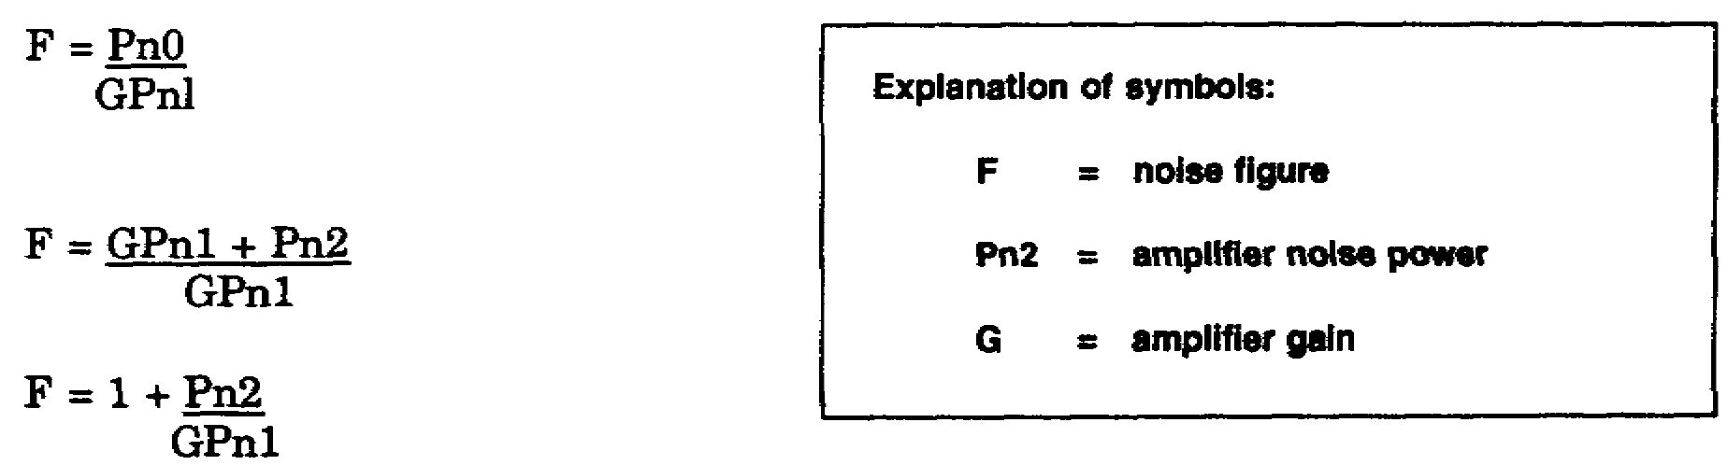

Pn1 = matched source noise power at a temperature of 290° Kelvin.

6. The noise figure may be quoted as a number or a ratio, or in terms of decibels. For example, a noise figure of 2 and a noise figure of 3 dB have the same meaning. Both expressions indicate that the noise from the amplifier and the noise from the matched source are the same. The noise figure in decibels can be determined by formula.

F = 10 log 1 + Pn2
dB GPn1

LEARNING EVENT 10: EQUIVALENT NOISE TEMPERATURE

1. Sensitivity is one of the most important receiver parameters. It is defined as the minimum input signal required to produce a specified output signal having a specified signal-to-noise ratio.

2. The signal-to-noise ratio of a receiver is determined by the amount of receiver gain and the noise contribution. Generally this ratio is expressed as SIN. We are most concerned with the noise contribution of a receiver and therefore we use the expression Pn2/G.

SS0031 3-8

3. The expression Pn2/G indicates the relative noise contribution and gain of an amplifier. This expression is the equivalent noise temperature of the receiver (Te).

4. The first step in arriving at Te is to determine the noise figure. The noise figure of a receiver is obtained by measuring the noise power. Once the noise figure has been obtained, conversion to equivalent noise temperature may be performed.

5. The equivalent noise temperature is obtained by rearranging the noise figure expression.

F = 1 + Pn2
GPn1

Pn1 (F -1) = Pn2 = Te (equivalent noise temperature)
G

290(F - 1) = Te (in degrees Kelvin)

LEARNING EVENT 11: FACTOR METHOD OF DETERMINING NOISE CONTRIBUTION

1. A simplified method of determining the relative noise contribution of a receiver is in current use. This method is known as the Y factor method. This method does not use complex devices or calculations.

2. The Y factor method provides a means of determining the relative noisiness of a receiver on a day-to-day basis. The Y factor of a receiver cannot be compared with the Y factor of another type of receiver without introducing constants and subsequent calculations.

3. The Y factor of a receiver is defined as the receiver's noise power output with a matched source (290° K) input divided by the noise power output without the noise source supplied.

Y = Pn2 + Pn1 when Pn1 = matched source noise power,
Pn2 and
Pn2 = receiver noise

4. The Y factor may be expressed in terms of a ratio or in decibels. It is usually expressed in term of decibels. To express the Y factor in decibels, use the formula-

Y = 10 log Pn2 + Pn1
DB Pn2

3-9 SS0031

SECTION III. NOISE MEASURING TECHNIQUES

LEARNING EVENT 12: METHODS OF MEASUREMENT

An ideal receiver would be one with no noise other than that generated by thermal agitation. The degree in which a receiver approaches this ideal is indicated by the noise figure. There are several methods that can be used to obtain the measurements necessary to determine the noise figure.

LEARNING EVENT 13: NOISE GENERATOR METHOD

1. A noise generator is designed to produce a random noise signal that covers a frequency range in excess of the receiver bandwidth. The DC input reading of the generator can be converted to obtain the true noise power. The noise generator method of determining the noise figure has the advantage over other methods because no knowledge of either the gain or the response characteristics of the amplifier is necessary, since the amount of noise from the noise generator is amplified and governed by the effective bandwidth. The noise generator method of measurement consists of comparing the noise actually present in the receiver with the calibrated output of the noise generator. The measurements are taken with an AC voltmeter, a dB meter, or a milliwatt meter.

2. For an accurate measurement, the noise generator output impedance is adjusted to the same impedance as the normal signal source for the equipment under test. This is the impedance at the transmission line termination from an antenna or antenna multicoupler. The shortest possible leads should be used between the noise generator and the receiver.

3. The indicator (an AC voltmeter, dB meter, or milliwatt meter) may be connected across either the detector load or the receiver output. If an AC voltmeter is used as indicator, the noise generator should be adjusted for an output voltage 1.4 times the no-input voltage indication; if a dB meter is used, the noise generator should be adjusted for a 3-dB increase over the no-input meter indication; if a milliwatt meter is used, the noise generator should be adjusted for twice the no-input reading. The noise figure is then indicated on the output level control of the noise generator.

LEARNING EVENT 14: SIGNAL GENERATOR METHOD

1. Sine wave signal generators are usually available in maintenance shops more often than noise generators. However, the signal generator method is not as practical or accurate as the noise generator method for field measurements. When using the signal generator method, you must take into account the bandwidth and response curve of the receiver. Generally the bandwidth used is the frequency range between the half-power points of the response curve. For an accurate measurement, the sine wave generator output impedance should be the same impedance as the normal signal source for the receiver.

SS0031 3-10

2. When using the sine wave generator, the measuring procedure is similar to that for the noise generator method. First, with no sign output from the signal generator, measure the noise power output of the receiver. Then turn the signal generator on, set the output signal at the center frequency of the response curve for the receiver, and adjust the output signal level until the test meter indicates twice the power of the no-signal level. With the reading from the meter, the noise figure can now be calculated.

LEARNING EVENT 15: ENSI METHOD

1. The equivalent-noise-sideband-input (ensi) method of noise level measurement determines the equivalent input voltage of all random noise that appears in the output of the receiver being tested. This test is sometimes used in preference to other methods of measuring noise level because, over a limited frequency range, it is not appreciably affected by changes in the input signal.

2. The receiver volume control should be set to avoid overloading the audio amplifiers and the tone control should be set for maximum HF response. The signal generator is set at the center frequency of the receiver response curve and adjusted for an unmodulated carrier signal output. A voltmeter is connected in a manner similar to that used for the noise generator method and used to measure the output power. The signal output power can then be calculated by subtracting the noise output power from the combined power output. With this figure, the noise level can be calculated.

SECTION IV. PARAMETER CONTROL

LEARNING EVENT 16: IMPROVEMENT FACTOR

1. For the receiver to deliver to the baseband output a recovered baseband wave of the best possible quality (highest S/N), the receiver's amplifier and demodulator stages must be designed not only for the type of modulation, but also for the exact parameters of the chosen type of modulation. The primary function of the receiver is to amplify and frequency-translate. If the type of modulation is AM, the receiver must have a sufficiently accurate automatic gain control (AGC) to avoid overload, nonlinearity, and limiting. Any nonlinear amplifying of an AM wave will distort the demodulated baseband wave. On the other hand, angle-modulated receivers usually limit the amplitude intentionally to provide better immunity against noise. Amplitude limiting has no effect on the frequency or phase deviations in an angle-modulated wave.

3-11 SS0031

2. The receiver's bandwidth must be wide enough to pass the modulated spectrum bandwidth to avoid distortion in the demodulated baseband signal. This means that for single sideband, the receiver's bandwidth need be only as wide as the baseband. For receivers using angle modulation, the receiver's bandwidth can be many times the width of the baseband, depending on the chosen magnitude of the modulation index. The receiver's bandwidth should not be wider than the minimum needed to pass the modulated wave. By using a minimum bandwidth, the receiver's noise power is minimized. The bandwidth of the receiver has a greater influence than any other receiver parameter on the receiver output S/N. The noise content of a demodulated output signal is related directly to the bandwidth of the input signal.

3. The efficiency of any demodulator is measured by its ability to produce the highest quality output S/N with the least possible input carrier-to-noise ratio (C/N). The improvement factor (Fm) has been developed as an indication of the efficiency of any demodulator.

4. The Fm is defined as the baseband S/N output divided by the C/N input.

Fm = S/N (output)
C/N (input)

It has been pointed out that achieving the desired S/N output quality with the highest possible Fm is extremely desirable. The maximum possible Fm for AM is 1. This is realized with single sideband (SSB). The largest Fm for double sideband is one-half. For angle modulation, the Fm can be much larger than 1, as shown in Figure 3-1. For comparison, the broken line shows the S/N output to be exactly equal to the C/N input for SSB. The FM Fm (in dB) is the S/N difference between the FM line and the SSB line. It is seen from Figure 3-1 that the larger the modulation index, the greater the Fm for FM.

However, FM has a carrier-to-noise threshold which must be exceeded for the full modulation Fm to be in effect. For example, again from Figure 3-1, a modulation index (M) of 2 has an Fm of 6 (8 dB), but the C/N must exceed an 18-dB threshold.

When M is 10, the Fm is 150 (22 dB) and the threshold is 28 dB. For C/N greater than the threshold, the Fm is-

Fm = 3M²
2

As the carrier-to-noise level decreases below threshold, in addition to the rapid degradation of the Fm, the audible-noise character in the baseband output changes from a fine-grain "hiss" to an erratic sputter of "pops." In practice, the threshold demarcation is gradual rather than sharply discontinuous, as shown in Figure 3-1.

SS0031 3-12

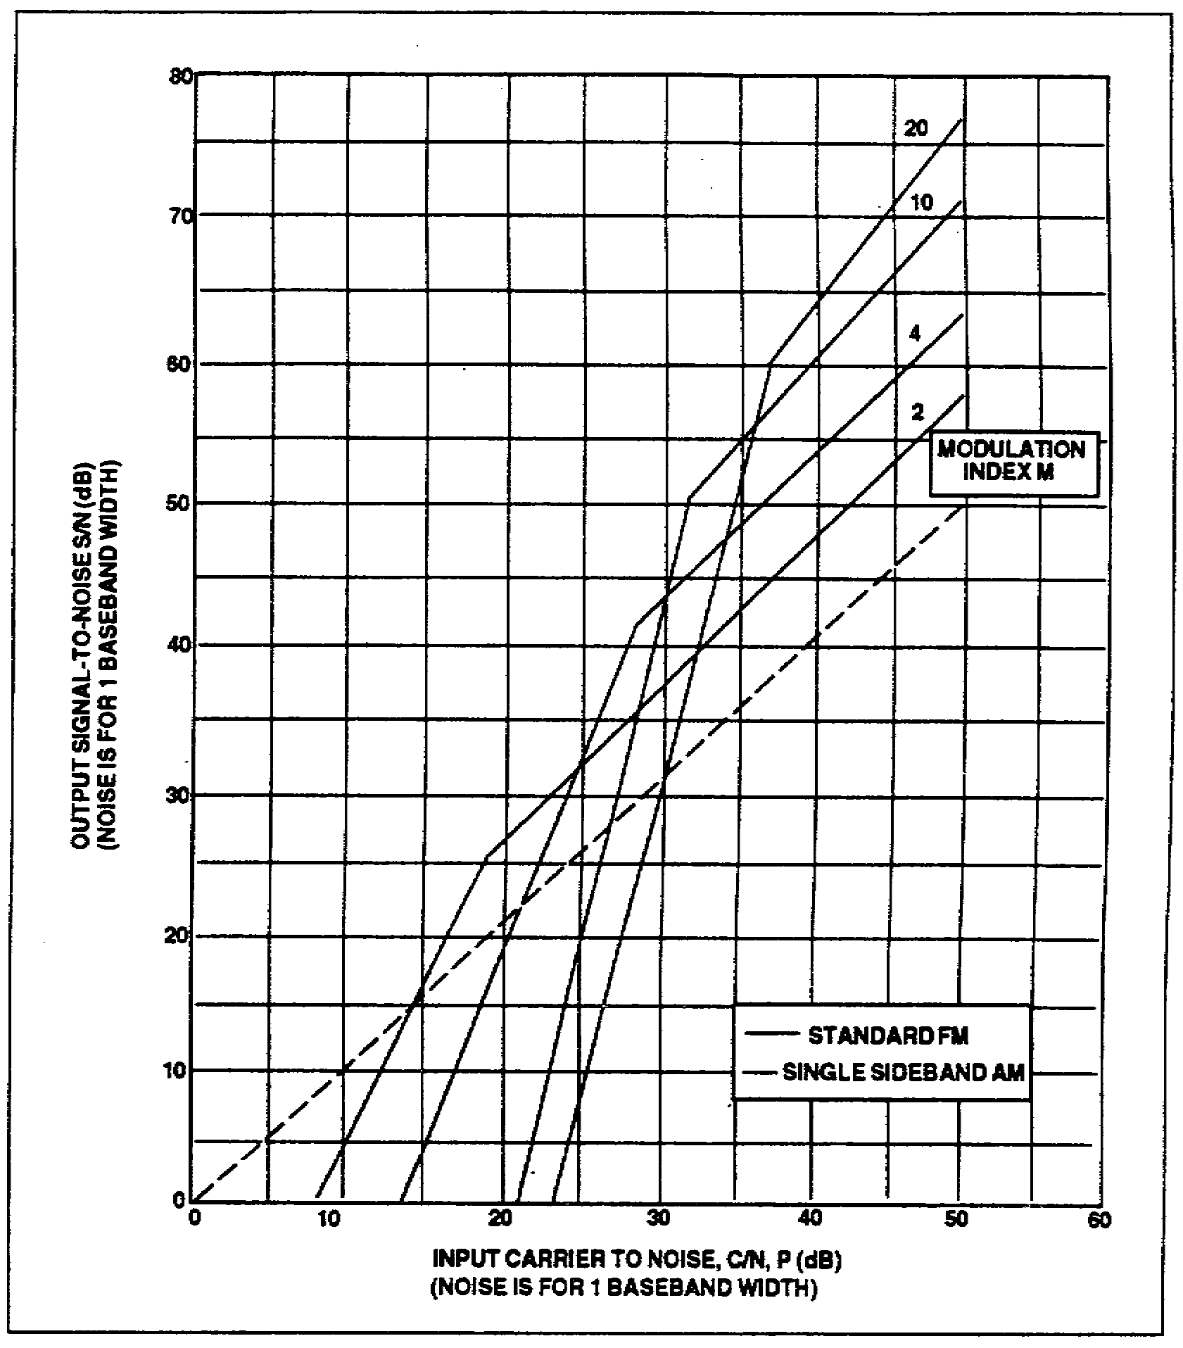

Figure 3-1. S/N versus C/N for frequency modulation.

LEARNING EVENT 17: BASEBAND AND BANDWIDTH CONTROLS

1. The transmitter in a typical microwave station is used to convert the baseband input from the terminal equipment into an angle-modulated signal whose carrier frequency is in the range of 50 to 90 MHz. The receiver is used to convert the angle-modulated signal back to the baseband signal prior to applying the signal to the terminal equipment.

2. Both the transmitter and the receiver have the same number of operating modes. The selected mode determines the number of VF channels that can be used, the maximum

3-13 SS0031

baseband frequency range that can be satisfactorily processed, and the type of modulation that will be employed. An example of a nine-mode system is shown in Table 3-2.

Table 3-2. Operating modes.

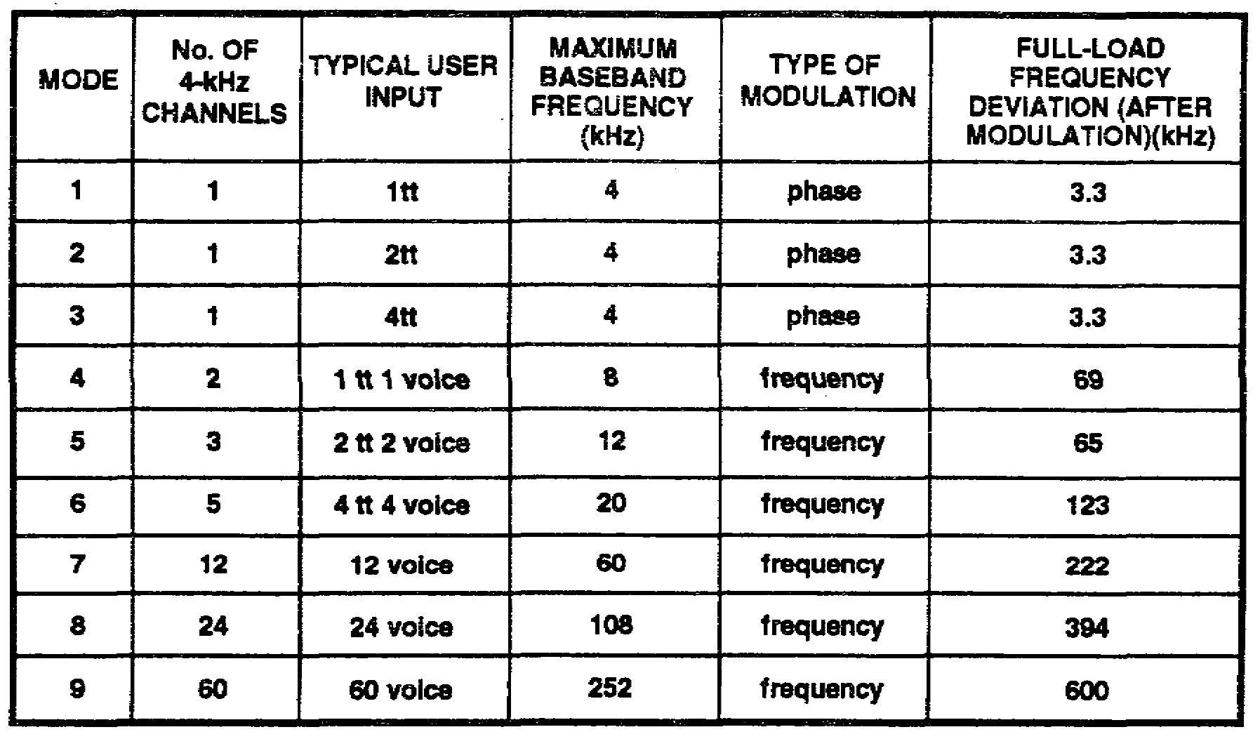

3. Mode selection in the receiver involves the selection of appropriate filters, deemphasis circuits, output circuits, and feedback circuits. The selected filters and circuits control the bandwidth of the receiver, which, in turn, controls the number of channels that can be passed on to the terminal equipment.

4. Additional controls throughout the VF circuits are used to control the range of the baseband frequencies. Compandor assemblies contain compressors and expandors-compressors for VF signals being transmitted and expanders for signals being received. These circuits compress the dynamic range of the VF signals at the sending end and expand the signals to their original condition at the receiving end.

SECTION V. RECEIVER CONTROL CIRCUITS

LEARNING EVENT 18: FREQUENCY-MODULATION FEEDBACK

1. Angle modulation is a technique used to achieve improvement factors greater than 1. This means that at the receivers input the demodulated or baseband S/N is better (higher) than the C/N. For ordinary demodulation (without feedback) of an angle-modulated signal, the C/N at the input must be greater than the moderately high carrier-

SS0031 3-14

to-noise thresholds for the improvement ratio to be realized. A communications link must achieve a satisfactory baseband S/N quality at the lowest possible C/N power. The relatively high threshold of carrier-to-noise ratio that an angle-modulated signal must exceed for satisfactory demodulation of the signal with conventional FM detectors is therefore an obvious disadvantage. However, in recent years, two demodulation techniques have been developed that can demodulate satisfactorily down to considerably lower threshold levels, and that retain the improvement factor of angle modulation at signal levels above the threshold. One demodulation technique utilizes frequency-modulation feedback (FMFB). The FMFB circuit is also called a threshold extension circuit and a signal enhancer. The second technique employs a phase-lock-loop (PLL) detector. The FMFB and PLL circuitry differ considerably, but the performance is essentially the same for both circuits.

2. The received signals are at relatively low power levels. Therefore, the amount of noise that accompanies the received signals is of prime importance. This noise may be reduced by narrowing the receiver's bandpass, but this method would also introduce distortion should the deviation of the angle-modulated signal exceed the bandpass of the receiver. A more acceptable method is to degenerate the signal automatically when the deviation exceeds certain limit. In effect, the bandpass appears to be narrower to the higher frequency (more troublesome) noise signals. Both frequency and phase modulation have a carrier that deviates (higher and lower, or ahead and behind, in phase) with the complex wave shape of the baseband signal but, practically, it also contains noise. The greater the deviation, the greater the bandwidth occupied by the spectrum of the modulated carrier. A functional diagram of an FMFB circuit is shown in Figure 3-2.

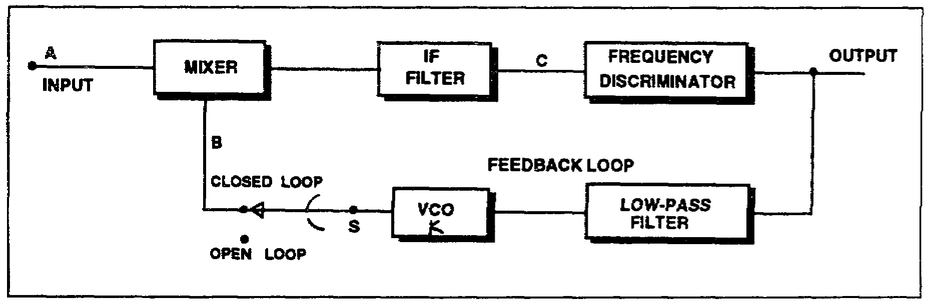

Figure 3-2. FMFB block diagram.

3. Assume for the moment that switch S in Figure 3-2 is in the "open-loop" position and that a large deviation FM wave with modulation index M1¹ is applied to the input terminal of the mixer at point A. At the same time an identical FM wave, but with a

¹Modulation Index is the ratio between the maximum frequency deviation and the maximum frequency of the modulation signal.

3-15 SS0031

slightly reduced deviation (modulation index M2), is applied to the other terminal of the mixer at point B. The mixer output will be the sum and difference frequencies of the two waves. The difference frequency is selected by an IF filter. This difference frequency at point C will have a modulation index M3 which will be the difference of the modulation indexes of the two FM waves (M3 = M1 - M2). This resulting waveform with reduced deviation may be passed through a filter whose bandwidth is approximately 3M/M1 times that required of the large deviation wave. The signal is then frequency-detected in a circuit such as a discriminator. The second FM wave (M2) can actually be derived by feeding the output signal of the frequency discriminator through a low-pass filter to frequency-deviate a VCO. The larger the gain the feedback loop, the more the input deviation is reduced in the IF.

4. To explain the threshold improvement gained by using FMFB, the threshold mechanism of conventional FM will be detailed. The threshold occurs in a conventional FM receiver when the random-noise peaks exceed the carrier amplitude prior to the frequency detector (discriminator) for a sufficient percentage of time. Each time a noise peak exceeds the carrier amplitude, an impulse in amplitude (a spike) appears at the frequency discriminator output. This noise appears as a random sequence of spikes which are heard as sharp pops in an audio system or seen as spots on a TV screen. For voice, data, or TV channel, operation below threshold is generally unsatisfactory.

5. The FMFB, then, must reduce these noise spikes, and thereby reduce the threshold. This is accomplished by feeding the detected signal and noise back to the VCO. The noise that is fed back will reduce the incoming noise, thereby reducing the threshold of the system and, at the same time, the improvement factor for high-level S/Ns will remain that of the transmitted wave. These are significant improvements in terms of equipment. To demonstrate this action, let's take two examples.

a. First, a 100,000-to-1 (50 dB) S/N is desired at the output or baseband signal. By using conventional FM (Figure 3-3), a minimum C/N of 560-to-1 (27.5 dB) is required; for FMFB, only 70-to-1 (18.5 dB) is needed. This means that by using FMFB, we are able to reduce the carrier power by 9 dB, which is a factor of 8.

b. As a second example, take a more typical baseband S/N of 3,000-to-1 (35 dB). Again referring to Figure 3-3, we see that the carrier power can be reduced by 6.6 dB, or a factor of 4.6. Realize that a decrease of 6 dB is equivalent to halving the receiving antenna diameter or doubling the slant range.

6. Shown in Figure 3-3 are the modulation indexes needed to design an optimum system. Since bandwidth is directly proportional to the modulation index, the RF bandwidth can be computed. For the two examples just presented, the modulation indexes are between two and three times larger for FMFB; hence, we can expect the RF bandwidth for optimum FMFB to be two to three times larger than conventional FM.

SS0031 3-16

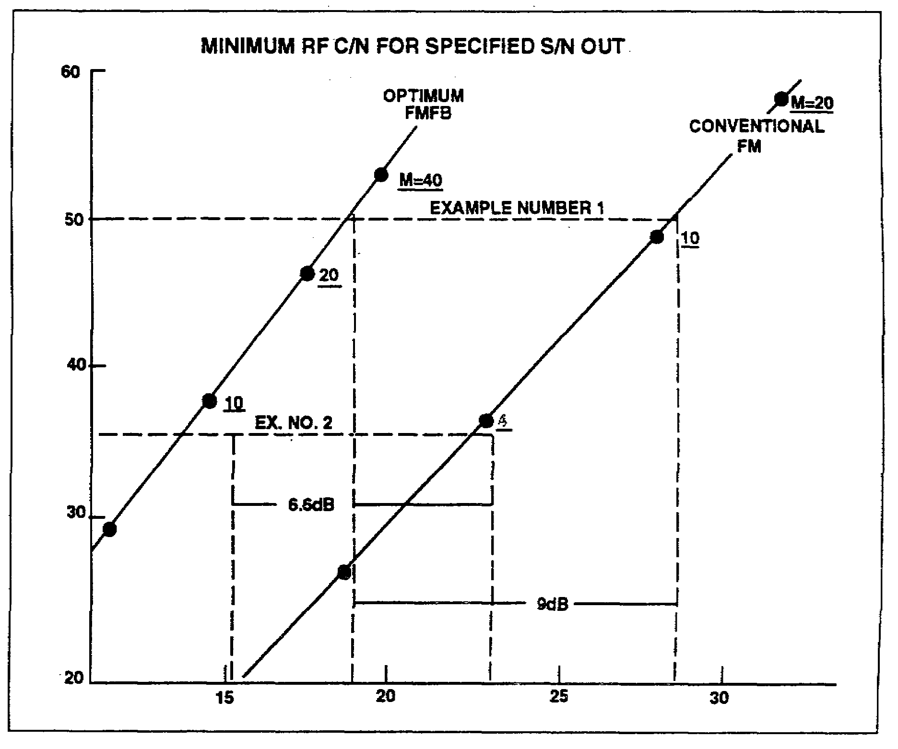

Figure 3-3. RF carrier-to-noise threshold.

7. Noise operates on an angle-modulated signal in such a way that only some of the noise energy angle-modulates the carrier and only the angle-modulated portion of the noise is reduced by the feedback. For moderately high input angle-modulation indexes, requiring only a moderate amount of loop-feedback gain, networks can be designed which will ignore the amplitude-modulated portions of the noise. As the modulation index of the input signal is increased, the amplitude portion of the noise modulation causes the threshold to rise to some intermediate value between the 6-dB lower angle-modulation limit and the high threshold it would have had without feedback.

8. An example of the action of FMFB can be seen in Figure 3-4, page 3-18. Let A indicate the normal amount of carrier deviation that would occur in the IF signal if FMFB were not used. Noise would cause unwanted carrier deviations as shown. Introduction of FMFB will minimize carrier deviation due to noise as shown in waveform B.

3-17 SS0031

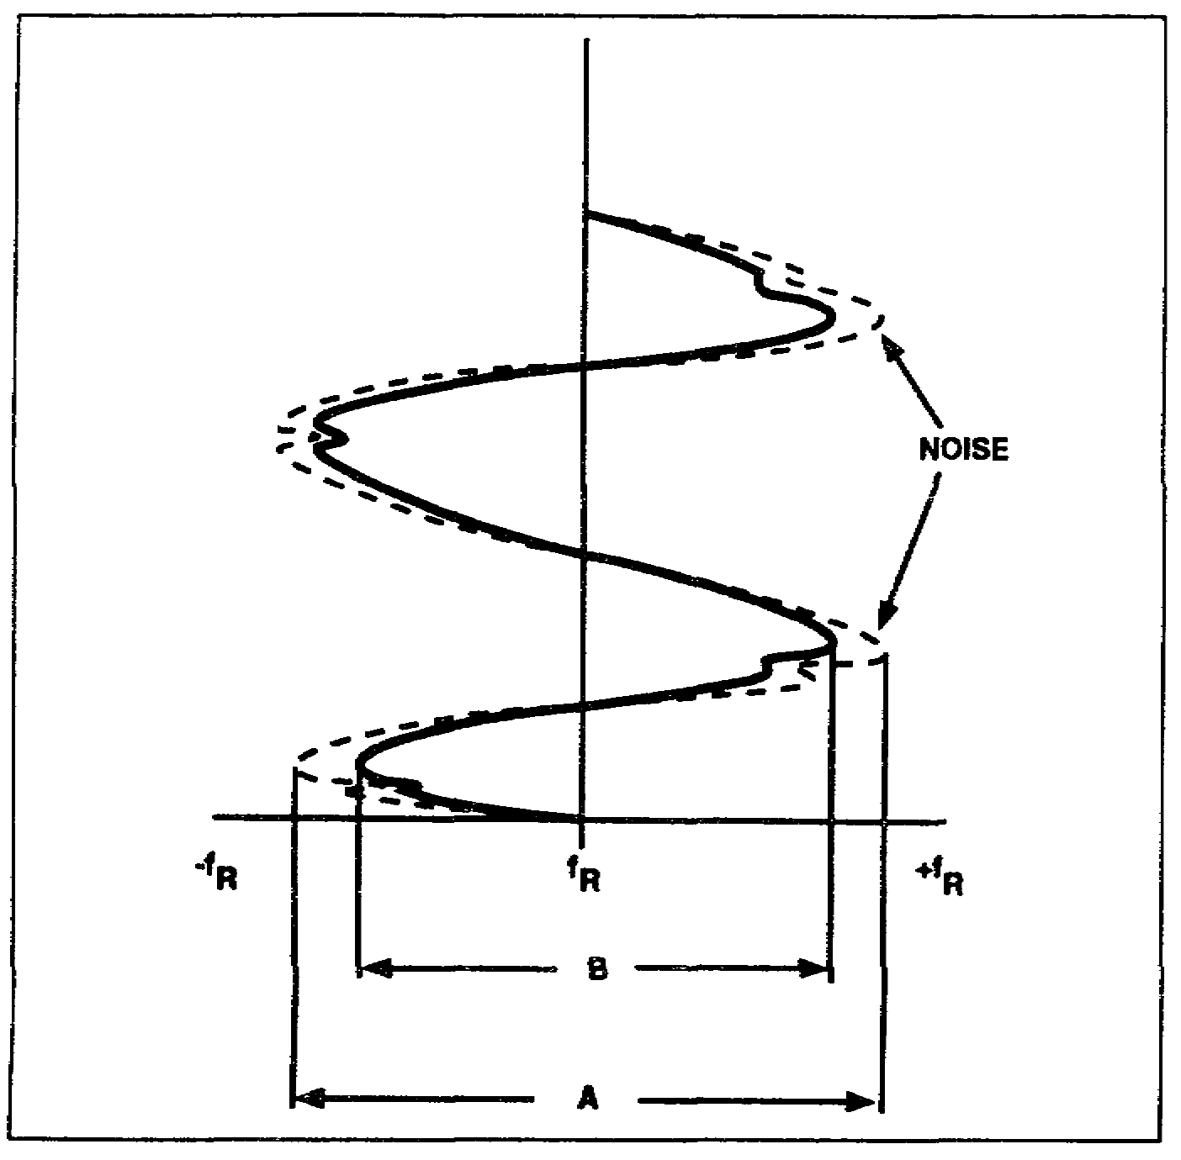

Figure 3-4. FMFB effects on carrier deviation.

LEARNING EVENT 19: AUTOMATIC FREQUENCY CONTROL

1. During the receiving-demodulation process, the local-oscillator output is mixed with the incoming carrier signal to produce an intermediate frequency. The difference between the local oscillator and carrier frequencies is the IF.

2. If the carrier frequency or the local-oscillator frequency drifts, the average IF will change. If the average frequency of the IF signal is permitted to drift, the extremes of the carrier deviation will exceed the limits of the IF amplifier bandpass. As a result, distortion will appear in the demodulated signal. Therefore, it is necessary to produce an IF signal whose average frequency is centered in the IF amplifier bandpass. This will ensure that the deviation of the incoming signal will not exceed the limits of the IF amplifier bandpass.

3. To ensure the centering of the signal in the IF amplifier bandpass, it is necessary to have a circuit that will sense the average frequency (or phase) changes and produce a voltage that will change the frequency of the local oscillator. The automatic frequency control (AFC) circuit will produce this corrective voltage.

SS0031 3-18

LEARNING EVENT 20: FREQUENCY-SENSITIVE AFC LOOP

1. The block diagram of an AFC circuit is shown in Figure 3-5. Here the mixer combines the local-oscillator and incoming carrier frequencies and generates a difference (intermediate) frequency. The IF amplifier increases the amplitude of the signal to a level sufficient for demodulation by the discriminator.

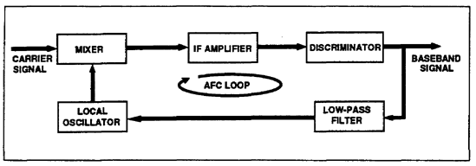

Figure 3-5. Frequency-sensitive AFC circuit.

2. The discriminator is a frequency-sensitive device that converts the IF changes that are above or below the desired IF into positive or negative DC (baseband) signals. If there are no frequency changes in the IF, there is no output from the discriminator.

3. Since the incoming signal is frequency modulated, the IF varies at the baseband frequency rate. If these variations are fed back to the local oscillator, the local oscillator's frequency will change and cause the mixer to reduce the deviations in the IF signal. It is generally undesirable to use the baseband to control the local oscillator. Therefore, AFC circuits use a low-pass filter to prevent the baseband frequency from being fed back to the local oscillator. The low-frequency variations representing the drift of the IF average value will be passed by the low-pass filter to the local-oscillator stage.

4. The local oscillator is a VCO whose output is combined in the mixer to produce the IF. A DC voltage is applied to the local oscillator from the discriminator through the low-pass filter to control the operating frequency.

5. The AFC loop will attempt to maintain the IF at a constant value regardless of whether the IF tends to increase or decrease.

a. Assume that the increases and that, as a result, the discriminator produces an average output which is positive. (The output polarity depends on the actual circuit configuration and the requirements-of the local oscillator.) The positive voltage, when applied through the low-pass filter, causes the local-oscillator frequency to increase. As the frequency of the local oscillator increases, the IF decreases toward the desired value. As the IF decreases, the output voltage from the discriminator will also decrease. When the average IF is at the proper value, the output from the discriminator has an average value of zero.

3-19 SS0031

b. As the IF decreases, the output from the discriminator assumes an average voltage which is negative. The average negative voltage causes the local-oscillator frequency to decrease and the IF to increase toward the desired value. As the IF approaches the desired value, the voltage output from the discriminator approaches an average value of zero.

LEARNING EVENT 21: PHASE-SENSITIVE AFC

1. Except for the phase detector and the reference oscillator, the phase-sensitive AFC loop shown in Figure 3-6 is essentially the same as the frequency-sensitive AFC loop shown in Figure 3-5.

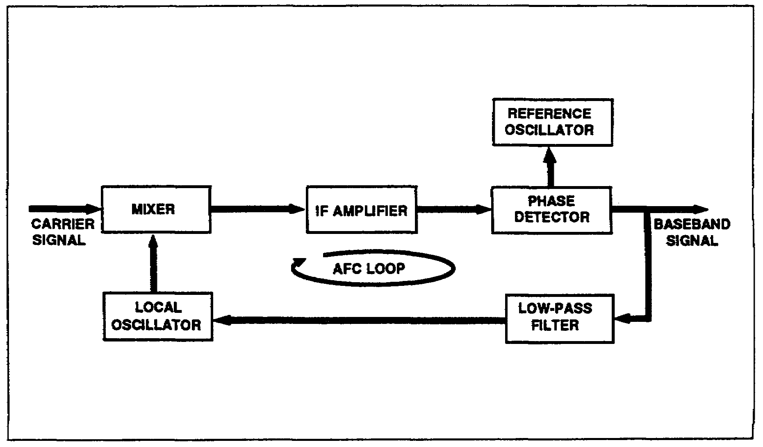

Figure 3-6. Phase-sensitive AFC loop.

2. The phase detector senses the changes in the phase of the IF with reference to the output signal's phase from the reference oscillator. These phase changes cause an average DC output from the phase detector. The reference oscillator is a highly stable oscillator that operates at the same frequency as the IF.

3. An increase in the IF is sensed as an advance in the phase of the IF. The phase detector will produce an average DC output that is proportional in the amount of the phase change. This output voltage is applied to the local oscillator as in the frequency-sensitive AFC loop. A decrease in the IF is sensed as a lag in phase by the phase detector which will produce an average output of opposite polarity from that generated by an advance in phase. When there is no phase difference, the output is zero. The phase-sensitive AFC circuit is similar to a PLL demodulator.

SS0031 3-20

LEARNING EVENT 22: AUTOMATIC GAIN CONTROL

1. Because of fluctuations in the propagation characteristics of free space and the Earth's atmosphere, the power level of the received signals will not be constant. These fluctuations will cause undesired amplitude variations in the demodulated signal.

2. The effects of these variations may be minimized by reducing the gain of the IF amplifiers when the received signal is at a relatively high amplitude and increasing the gain when the signal is at a low level. The circuit used to provide this gain control is called an automatic gain control (AGC) circuit.

3. Control of IF amplifier gain may be accomplished either automatically or manually. A combination of both methods is generally used.

SECTION VI. FREQUENCY-MODULATION FEEDBACK RECEIVER

LEARNING EVENT 23: FM RECEIVER

The simplified FM receiver shown in Figure 3-7, page 3-22, includes circuits used for AGC, AFC, and FMFB. The preamplifier and the first conversion stages are omitted from this figure, but are similar to those in the receiver shown in Figure 3-8, on page 3-24.

LEARNING EVENT 24: BASIC OPERATION

1. Frequency conversion takes place in the mixer stages. Since this receiver uses three conversion (mixer) stages, it is commonly called a triple-conversion receiver. The 60-MHz IF amplifier amplifies the input from the first mixer. The amplified 60-MHz output is mixed with a frequency of 49.2 MHz in the second mixer stage to produce a lower IF of 10.8 MHz. Before applying the 10.8-MHz IF to the third mixer stage, the IF is amplified by the 10.8-MHz IF amplifier stage. The 10.8-MHz IF is mixed with the output of the second VCO to produce an 800-kHz F.

2. The 800-kHz output of the mixer has a variable bandwidth which is controlled by mode selector switches on the receiver control panel. The passband of the mixer is varied by the different resistive loads that are placed across the mixer's tank circuit by the noise selector switches.

3. After the desired bandwidth is selected at the third mixer, a conventional stage of amplification amplifies the 800-kHz IF signal and passes it to the limiting stage. The limiter operates on both the positive and negative swings of the IF signal to control the amplitude of the signal applied in the discriminator. The discriminator circuit converts the FM intelligence from the 800-kHz IF signal to usable audio or video signals. The circuits in the video-amplifier stage filter, attenuate and amplify the signal according to the selected mode and bandwidth.

3-21 SS0031

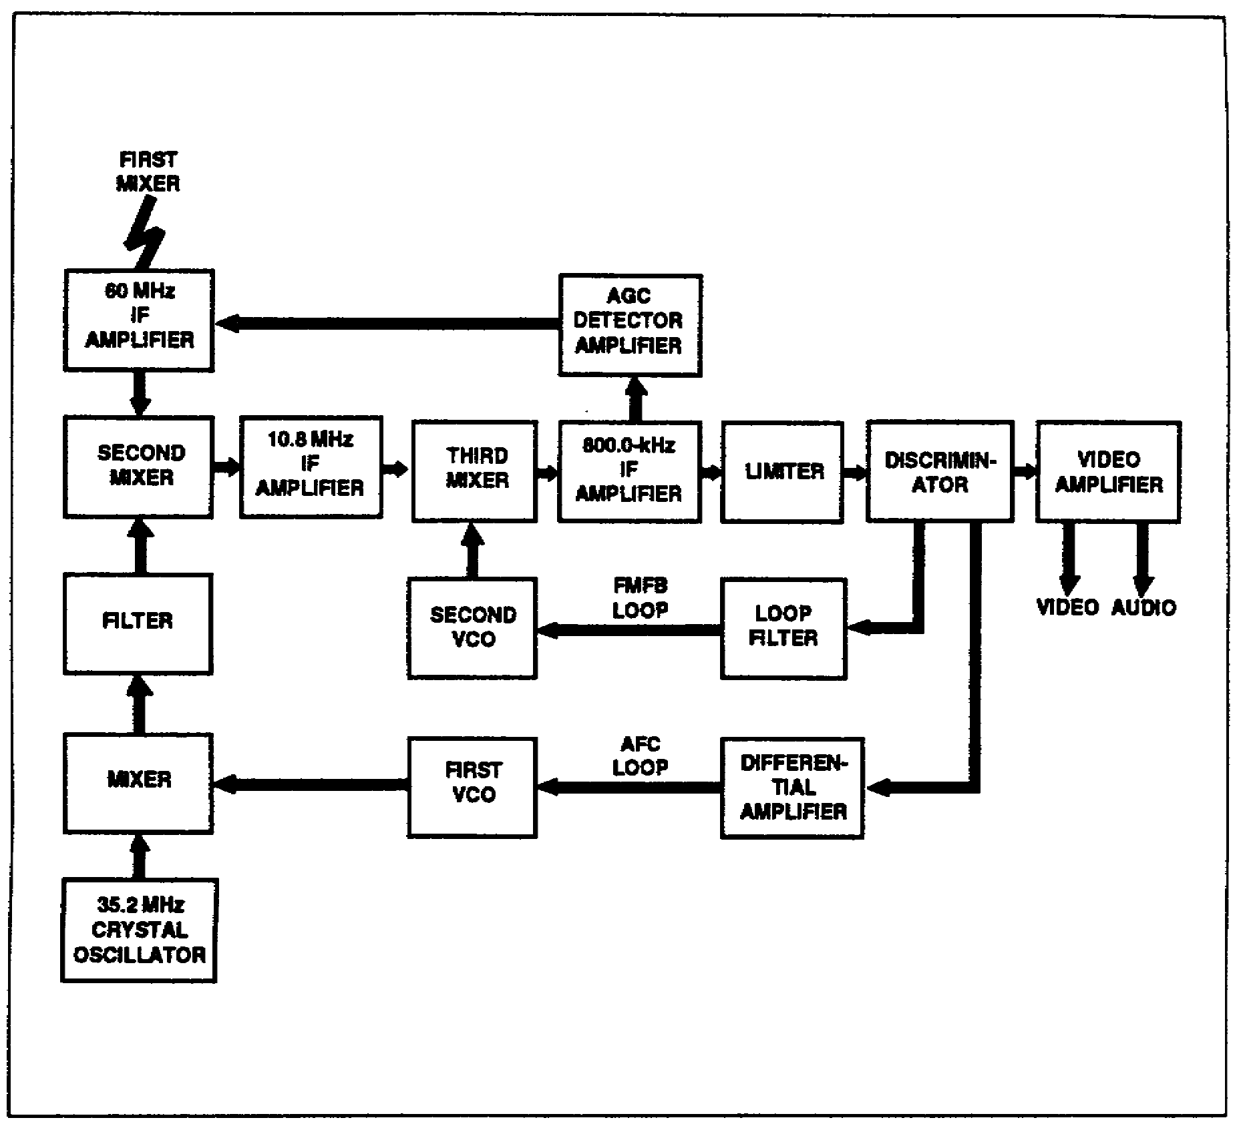

Figure 3-7. Simplified FMFB receiver block diagram.

LEARNING EVENT 25: AGC LOOP

The 800-kHz IF is also applied to the AGC detector and amplifier. The AGC amplifier provides an amplified DC correction voltage to the 60-MHz IF amplifier. The AGC voltage is capable of varying the 60-MHz IF amplifier's gain over a range of 20 dB.

LEARNING EVENT 26: FMFB LOOP

1. The FMFB loop uses degenerative feedback to effectively compress the FM signal deviation in order to maintain a narrow IF bandpass. A demodulator using FMFB permits an increase in the output S/N above that of a conventional FM demodulator at low-signal levels. The increase in the S/N ratio is obtained by processing the signal input

SS0031 3-22

in the demodulator so that it will pass through a smaller IF bandwidth than would be required by an unprocessed signal. The reduction in the IF bandwidth allows a smaller amount of noise power to be delivered to the limiter and the discriminator and, therefore, produces a better output S/N.

2. The process by which the FM signal deviation is reduced consists of varying the injection frequency into the third mixer in the same direction as that of the received FM signal deviation. The resulting mixer-output-frequency deviation is the difference between the input signal deviation and the injection-frequency deviation. This is with reduced deviation is filtered and amplified in the 800-kHz IF amplifier and then demodulated in the discriminator. The resulting signal, at audio or video frequencies, is then returned to the second VCO and is used to vary the oscillator's frequency with the incoming signal's frequency deviation. This feedback process is necessary for proper reduction of signal deviation which, in turn, is required when using a narrow IF bandwidth.

3. The FMFB loop is closed only during certain demodulation modes. In the other modes of operation of the demodulator, the FMFB loop is open and the second VCO, not receiving a tracking voltage from the FMFB loop filter, acts as a conventional local oscillator. When the FMFB loop is open, the receiver operates as a conventional FM receiver.

LEARNING EVENT 27: AFC LOOP

1. A portion of the discriminator's output is applied to the differential amplifier stage. When the input to the differential amplifier is 0 volt, the differential amplifier permits the first VCO to operate at its center frequency of 14 MHz. When the input is other than 0 volt, the differential amplifier changes the operating frequency of the first VCO.

2. The 14-MHz output of the first VCO is mixed with the 35.2-MHz crystal oscillator output to provide the 49.2-MHz injection voltage for the second mixer. The AFC circuit controls the 49.2-MHz injection voltage which, in turn, controls the 10.8-MHz IF.

SECTION VII. PHASE-LOCK RECEIVER

LEARNING EVENT 28: GENERAL

The simplified receiver, shown in Figure 3-8, is representative of the receivers designed for use with present near synchronous satellites. This receiver is capable of operating on any one of four preset 2.5-MHz-wide channels in the 50- to 90-MHz frequency range. The operating channel of the receiver is selected by means of the channel select signals from the receiver control circuits. In addition, the receiver can be operated in any one of nine

3-23 SS0031

modes of operation selected by means of the mode-select signals from the receiver control circuits. The receiver consists of a preamplifier section, a converter section, an amplifier-converter section, a preselector section, a demodulator section, a baseband amplifier section, and a control section.

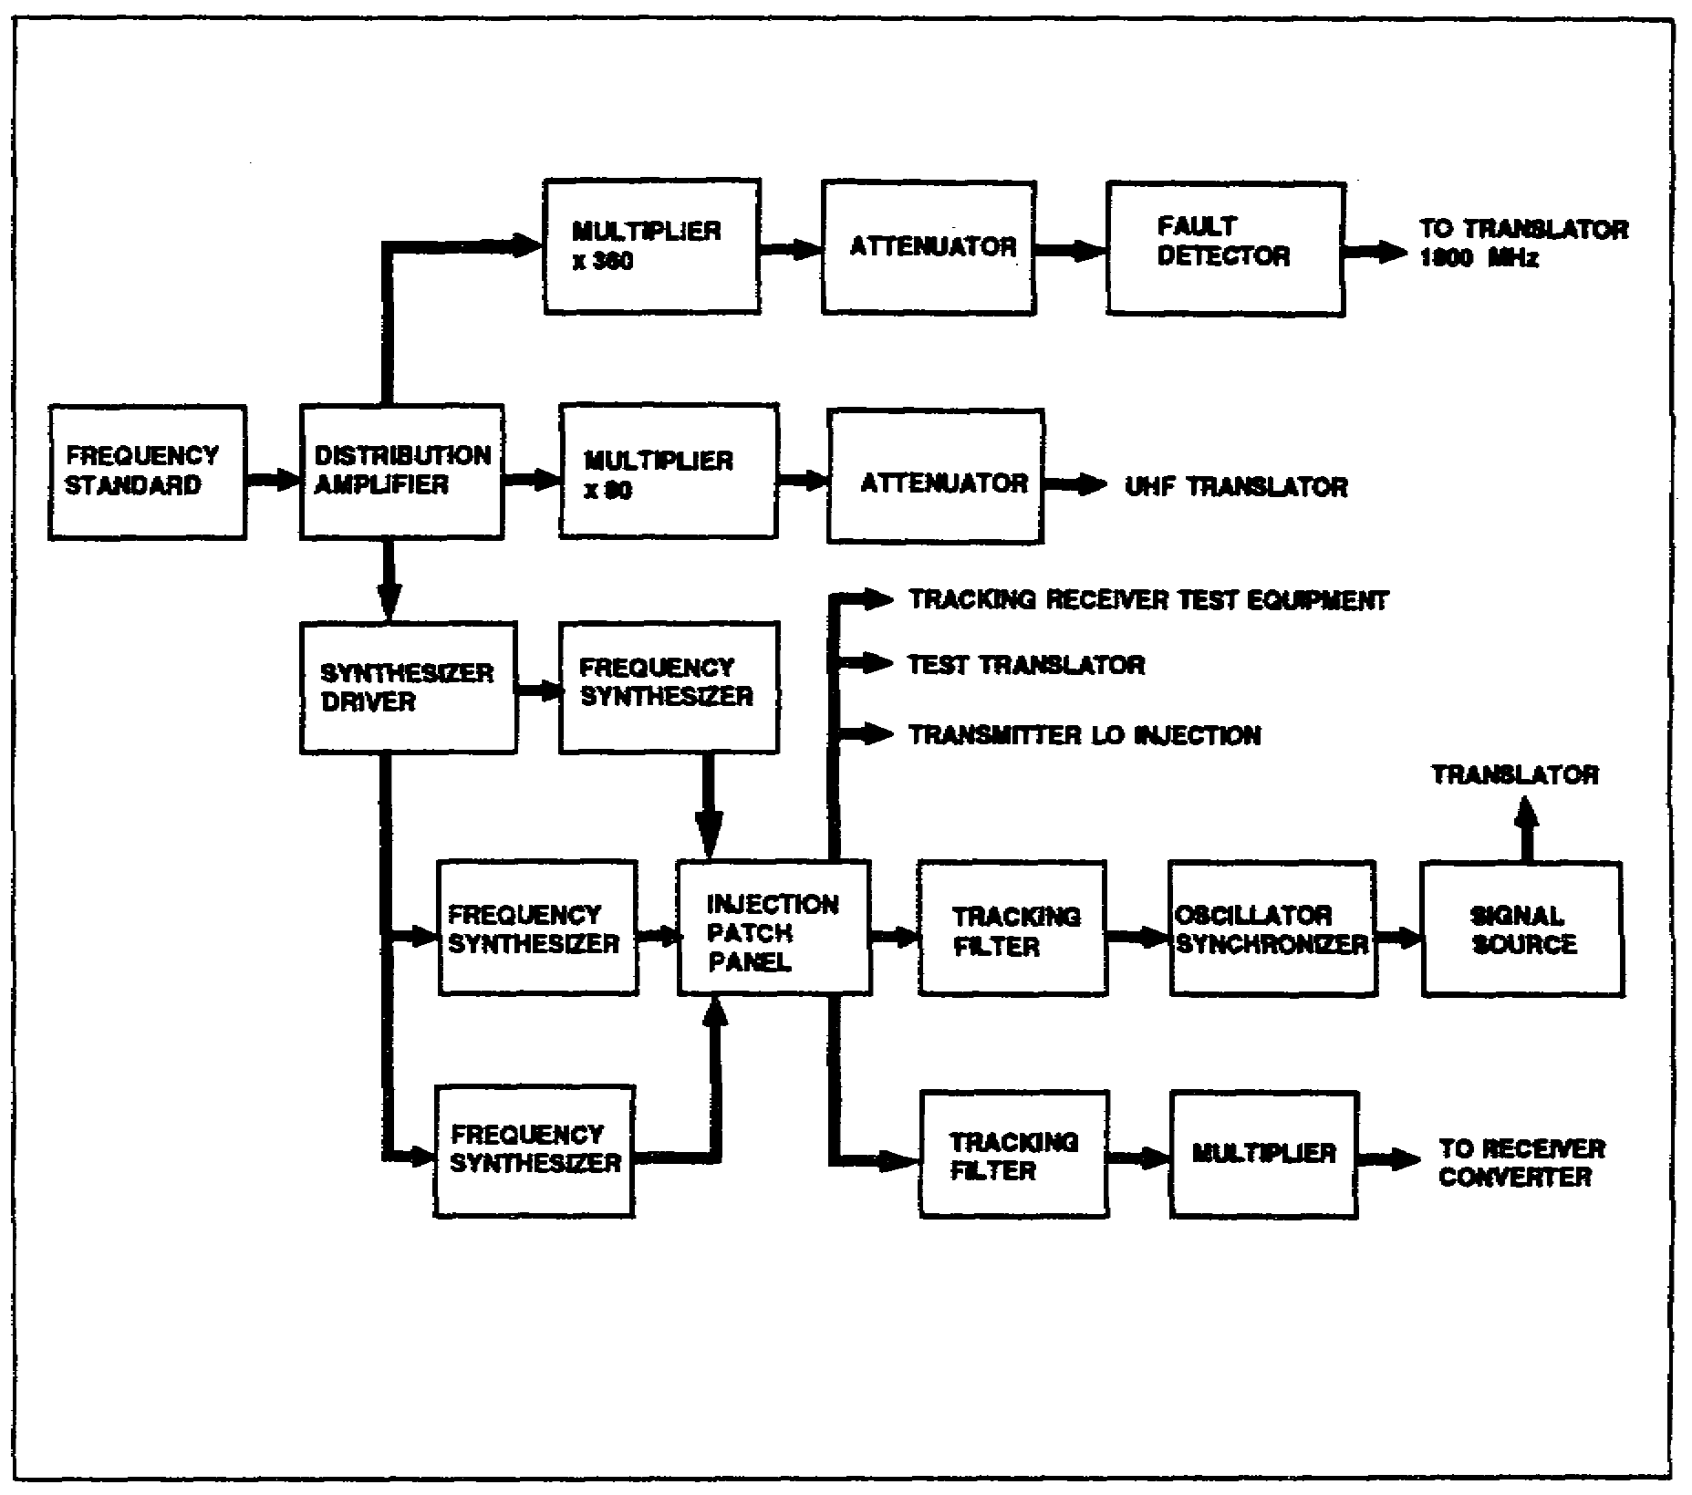

Figure 3-8. Simplified phase-lock receiver block diagram.

LEARNING EVENT 29: PREAMPLIFIER

The components contained in the receiver's preamplifier are usually located as near as the antenna possible to provide for maximum receiver sensitivity. The input signals are coupled directly from the antenna to the preamplifier. The preamplifier section of the simplified receiver contains a parametric amplifier and a TWT.

1. A low-noise cryogenic parametric amplifier is used in the preamplifier to provide sufficient gain and to ensure an equivalent noise temperature of less than 200° Kelvin for

SS0031 3-24

the receiver when tuned across the receive band of frequencies. Since the parametric amplifier is the first amplifier in the receiver, it determines the noise characteristics for the complete receiver.

2. The power requirements of the parametric amplifier’s RF pump are met by an RF module (noise source). The component in the RF module that generates the pump frequency is a klystron.

3. The low-noise wideband TWT provides additional amplification of the 8-GHz incoming signal.

LEARNING EVENT 30: CONVERTER

The converter unit provides the first frequency conversion for the receiver. The signals applied to the converter have a bandwidth of approximately 500 MHz. The mixer stage within the converter unit converts the 8-GHz signals from the TWT to 1,730 MHz. The beacon signal channel can be any designated frequency within the range from 1,230 to 2,230 MHz which results is an output bandwidth of 1 GHz. The TWT located in this unit provides the required gain needed to offset the losses incurred in the transmission downline and the rotary joint appearing between the antenna and the receiver.

LEARNING EVENT 31: AMPLIFIER CONVERTER

The amplifier-converter unit performs two significant functions. The first is that of diplexing between the beacon and communication channels; the second is that of converting the communication channel frequency to an output frequency centered at 70 MHz with a bandwidth of 50 MHz.

1. The beacon channel part of the diplexing function is provided with a tunable preselector which can be tuned within the frequency range of 1,230 to 2,230 MHz, which corresponds to the input operating range of the tracking receiver. The beacon signal is applied to the tracking receiver.

2. The communication channel part of the diplexing capability is mixed with the local-oscillator injection voltage to generate the 70-MHz IF. Feedback of the injection voltage into the beacon channel is minimized by the isolators and the bandpass filters in the unit. The 70-MHz output is amplified by a TWT to the level required by the communication channel. Two 70-MHz outputs are provided by the amplifier-converter unit; one output is used as the input to the noise figure meter, and the second is fed through the receiver patch pan to the bandpass filter.

LEARNING EVENT 32: PRESELECTOR

The preselector section of the receiver consists of the bandpass filter, the 70-MHz IF amplifiers, and the variable-tuned circuit.

3-25 SS0031

1. The 70-MHz input signal is coupled by means of a coaxial cable from the RF patch panel to the input of the bandpass filter. The bandpass filter passes the signals in the 50-to 90-MHz frequency range with an attenuation of less than 1 dB. The filtered signal is then fed to the 70-MHz IF amplifiers.

2. The wideband five-stage amplifier provides a gain of up to 50 dB (100,000) in the 50-to 90-MHz range. The second, third, and fourth IF amplifier stages are controlled by an AGC signal which is developed by the AGC detector and amplifier. The AGC signal is capable of maintaining the output level constant to within 2 dB with an input variation of as much as 50 dB above the threshold level.

3. The amplified 50-to 90-MHz signal is coupled to the variable-tuned circuit. The variable-tuned circuit is a voltage-controlled tuned circuit with a 2.5-MHz bandpass. The center frequency of the tuned circuit is determined by the voltage applied to it from the channel-frequency potentiometers. The voltage applied to it, and thus its frequency, is determined by the setting of the selected potentiometer.

LEARNING EVENT 33: DEMODULATOR

The demodulator section of the receiver contains an AGC loop, an AFC loop, and a PLL, and consists of a mixer, a difference amplifier, a driver amplifier, a VCO, a buffer amplifier, bandpass filters, 12-MHz IF amplifiers, a phase-lock demodulator, and an equalizer and frequency control circuit.

1. The AFC loop signal, which controls the frequency of the VCO, can be either a sweep signal or a Doppler tracking signal. The AGC signal controls the gain of the second and third 12-MHz IF amplifiers, and also turns the AFC sweep signal on and off. The phase-lock signal controls the frequency of the variable frequency oscillator.

2. The selected signal from the preselector section is fed to the mixer, where it is mixed with the output of the VCO to produce a 12-MHz IF signal. The basic frequency of the VCO is set by the voltage from one of four channel-frequency-adjust potentiometers in the preselector section, and one of them is selected at the same time that a channel-frequency potentiometer is selected. The selected VCO-bias-adjust potentiometer is adjusted so that the frequency of the VCO is 12 MHz above the frequency which was found with the selected channel-frequency-adjust potentiometer. The voltage from VCO bias-adjust potentiometer is coupled to the VCO by way of the difference amplifier and the driver amplifier. The difference and driver amplifiers maintain the linearity of the frequency-to-voltage characteristic of the VCO for all portions of the band.

3. Although the basic frequency of the VCO is determined by the setting of the selected VCO-bias-adjust potentiometer, its exact frequency is controlled by the AFC voltage from the AFC loop. The 12-MHz signal from the mixer is filtered by the selected filter in the bandpass filter network, amplified by the 12-MHz IF amplifiers, and coupled to the AGC detector and phase detector in the phase-lock demodulator. The AGC detector detects the

SS0031 3-26

amplitude characteristic of the selected signal, while the phase detector detects the frequency deviation. When the selected signal is not present at the AGC detector, there is no AGC output. The AGC detector output is coupled to the AGC amplifier in the equalizer and frequency control unit, while the output of the phase detector is coupled by way of the loop amplifier to the equalizer and frequency control unit. When there is no signal present to input of the AGC detector, there is no output from the AGC amplifier. When there is no output from the AGC amplifier, the equalizer and frequency control unit produces an alternating sweep voltage. The sweep voltage is coupled to the VCO and causes the oscillator to sweep up and down in frequency. The sweeping action continues until a 12-MHz IF is produced. This 12-MHz signal appears at the input of the AGC detector and permits an AGC voltage to be developed. When the level of the AGC detector output exceeds the AGC amplifier's threshold level, the AGC amplifier produces an output signal that eliminates the alternating sweep voltage. The output of the equalizer and frequency control unit is then controlled by the output of the phase detector. If the input to the phase detector drifts from 12 MHz, the equalizer and frequency control unit produces a signal that causes the VCO to change frequency and return the IF signal to 12 MHz.

4. The bandwidth of the signal fed to the detectors is determined by the bandpass filter unit which contains six different bandwidth filters, individually selectable according to the mode of operation. The bandpass of each filter is centered at 12 MHz.

5. The four-stage 12-MHz wideband amplifier is capable of a gain of 60 dB and has an AGC range in excess of 40 dB. Therefore, its output level of 0 dBm can be maintained essentially constant with input signal variations from -20 to -60 dBm.

6. The 12-MHz IF signal is shifted 90 degrees in phase and coupled to the AGC detector, and is fed unshifted in phase to the phase detector. Both of these detectors perform their functions by comparing the incoming 12-MHz IF signal with a 12-MHz reference signal developed by the 12-MHz variable frequency oscillator and fed to the detectors by way of the buffer stage and the 12-MHz reference transformer.

7. The PLL controls the frequency of the 12-MHz variable frequency oscillator for most of its modes of operation. This phase-lock demodulation process permits demodulation of signals with C/Ns below the carrier-to-noise thresholds. For conditions of severe signal loss, the PLL is disconnected from the variable frequency oscillator and a crystal is used to stabilize he variable frequency oscillator's frequency. When the receiver is operating under these conditions, the AFC loop that controls VCO becomes a narrowband loop that tracks the carrier component of the incoming signal.

3-27 SS0031

LEARNING EVENT 34: BASEBAND AMPLIFIER

1. The baseband signal, which is the demodulated output from the phase detector in the demodulator section, is coupled to the baseband amplifier section where it passes through one of seven gain-adjust potentiometers. The gain-adjust potentiometers provide preset gain for the different modes of operation. The baseband signal is fed through one of these potentiometers, which is selected according to the mode of operation, to the baseband amplifiers.

2. The feedback-pair amplifier is a wideband amplifier with a 75-ohm output that is essentially flat from 300 Hz to 500 kHz. This wideband output is not now being used but is available for future use.

3. Buffer amplifier G2 is a baseband amplifier that accommodates 12 to 60 voice channels. It has a 75-ohm output with a frequency response of 300 Hz to 252 kHz. Amplitude reduction of the input signal's HF components applied to this amplifier is provided by one of three selectable deemphasis filters. The broadband 75-ohm output is not currently used but is available for future multiple access use.

4. Buffer amplifier G3 is the normal baseband amplifier and has a 600-ohm balanced output with a frequency response of 300 Hz to 20 kHz. This amplifier's input is deemphasized by the deemphasis filter. The output of this amplifier is coupled to the baseband patch panel in the terminal equipment. This output accommodates from one to five voice channels.

LEARNING EVENT 35: MONITORS AND CONTROL CIRCUITS

1. Meters and indicator lights are used to monitor AGC voltages, AFC-sweep voltages, voltage outputs from power supplies, baseband output levels, and threshold margin levels. Carrier loss and carrier lock-on signals from the equalizer and frequency control unit are coupled to the receiver control circuits. These signals are fed to indicator lamps to indicate whether or not the receiver is locked onto the received signals.

2. The nine mode-select signals from the receiver control circuits are distributed to various modules in the receiver. These mode-select signals are applied through OR gates to the designated receiver circuits.

3. The receiver control circuits, consisting of indicators and selector switches, are located on a remote control panel. The remote control panel contains nine electrically interlocked mode selector switches, four electric interlocked satellite channel selector switches, a carrier loss/lock-on indicator, and a threshold margin meter.

SS0031 3-28

LEARNING EVENT 36: MEASURING POWER LOSSES AND GAINS

1. Introduction.

a. In operating certain types of equipment you will be measuring power losses and gains. A unit called the decibel (dB) simplifies your task because instead of having to calculate losses and gains that range anywhere from .000001 watt up to .004 watt, you use meters that express power losses and gains in terms of minus dB(s) and plus dB(s). With this method, there are no complex decimal calculations to perform.

b. Before you can use the decibel, you have to know something about it. That's the aim of this learning event--to tell you what the decibel is, how the decibel is derived, and, most important, how you will use the decibel in your daily work.

2. What is the decibel?

a. The dB is a transmission measuring unit used to express power loss and gain. When used to express loss, a minus sign is placed before dB like this: -10 dB. When used to express gain, a plus sign is placed before dB like this: +10 dB.

b. The dB does not express exact amounts like the inch, the pound, or the gallon. The dB does not tell you how much power you have. Instead, the dB tells you the ratio of power in a circuit.

c. In other words, the dB compares the output power of a circuit to the input power. If there is less output power than input power, then you have a dB loss. If there is more output power than input power, then you have a dB gain.

3. How you compute dB loss and dB gain.

DB losses and gains are computed using the follow formula²:

Number of dB = 10 x log of P1 (larger power)
P2 (smaller power)

²This formula is used both for dB loss and dB gain. The rule to flow is to always let P1 equal the larger amount of power. You will know you have a loss (-dB) when the input power is greater than the output power. Similarly, you will know you have a gain (+dB) when the output power is greater than the input power.

3-29 SS0031

4. Solving the formula for dB loss. A transmission line is shown in Figure 3-9. The input power to the line is 1 milliwatt (mW) and the output power is .5 mW. It is easy to see that this line causes a power loss of 50 percent. But what is the dB loss? You can use the formula to find out.

Number of dB = 10 x log P2 (larger power)
P1 (smaller power)

dB= 10 x log 1
.5

Dividing 1 by .5 you get 2 as the result. This gives:

dB = 10 x log 2

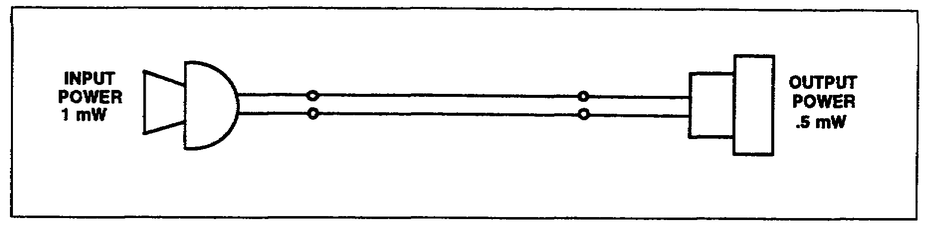

Figure 3-9. Transmission line with 50 percent power loss.

SS0031 3-30

Now look at Table 3-3 to find the log of 2. The log is .3010 so you have-

dB = 10 x .3010

Table 3-3. Logarithms.

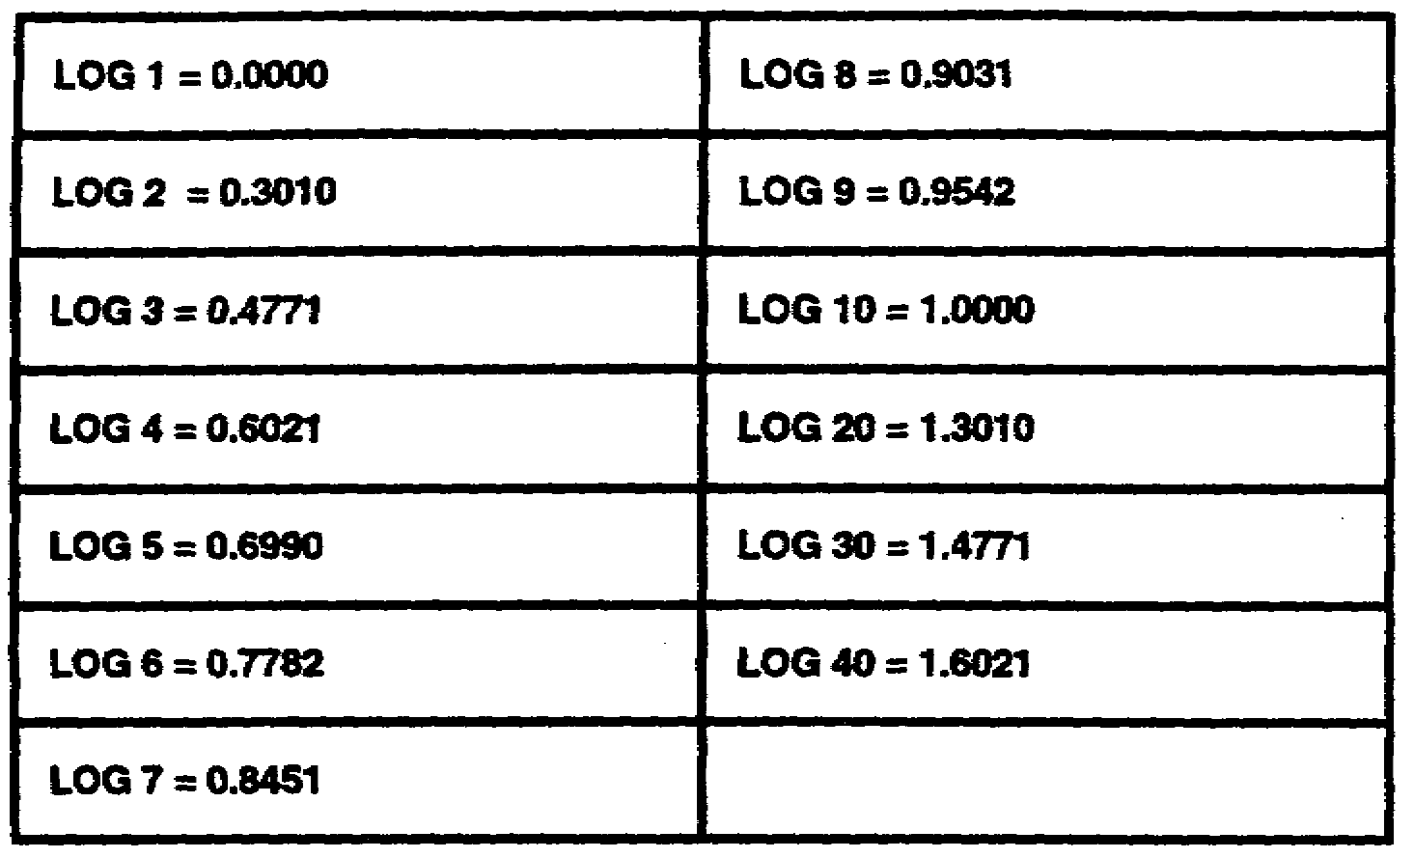

Since you're dealing with a power loss, you use a minus sign to express the final answer:

-3.01 dB or approximately -3 dB

5. Solving the formula for dB gain.

a. Figure 3-10 shows a repeater that amplifies the input power to twice its original value. You see that the input power to the repeater is 1 mW and the output power is 2 mW. You can find out how much dB gain this repeater provides by using the formula:

Number of dB = 10 x log P2 (larger power)
P1 (smaller power)

dB = 10 x log 2
1

dB = 10 x log 2

3-31 SS0031

You know the log of 2 is .3010. Therefore you have:

dB = 10 x .3010

This time you have a gain so you use a plus sign to express the final result:

+3.01 dB or approximately +3 dB

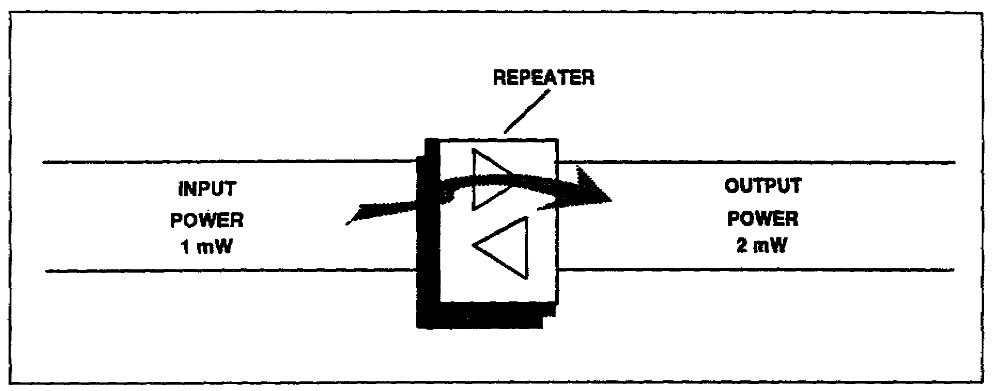

Figure 3-10. Repeater providing power gain.

b. In the first example, you had a power loss of 50 percent and this gave a loss of 3 dB. Then, in the second example, you had a gain of twice as much power and this gave you a gain of 3 dB. This brings out two important facts that you should remember:

(1) Loss of 3 dB always represents a 50-percent power loss. It doesn't matter how much power is involved. When you lose half the power you always have a loss of 3 dB.

(2) A gain of 3 dB always represents a gain of twice as much power. Again the amount of power involved doesn't matter. Whenever you gain twice as much power, you have a gain of 3 dB.

c. Seeing how formulas for dB loss and gain are solved has given you an idea of how decibels express the power ratio in a circuit. There is no need to go into any further computations. Instead, the formulas have been worked out for several common dB losses and gains. The results of these computations are given in Table 3-4.

6. You can find out how much power is lost or gained if you know the number of decibels lost or gained. Or you can find out the number of decibels lost or gained when you know the amount of power lost or gained. To show you how to use Table 3-4, here are a few examples.

a. Example 1. Suppose you have a circuit like that shown in Figure 3-11. The input power is .001 watt and the output power is .000001 watt. The input power is

SS0031 3-32

greater than the output power so you have a power loss. To find the power loss, you divide .001 by .000001 which equals 1.000. In Table 3-4, this corresponds to 30 dB. So your answer is -30 dB.

Table 3-4. Formulas.

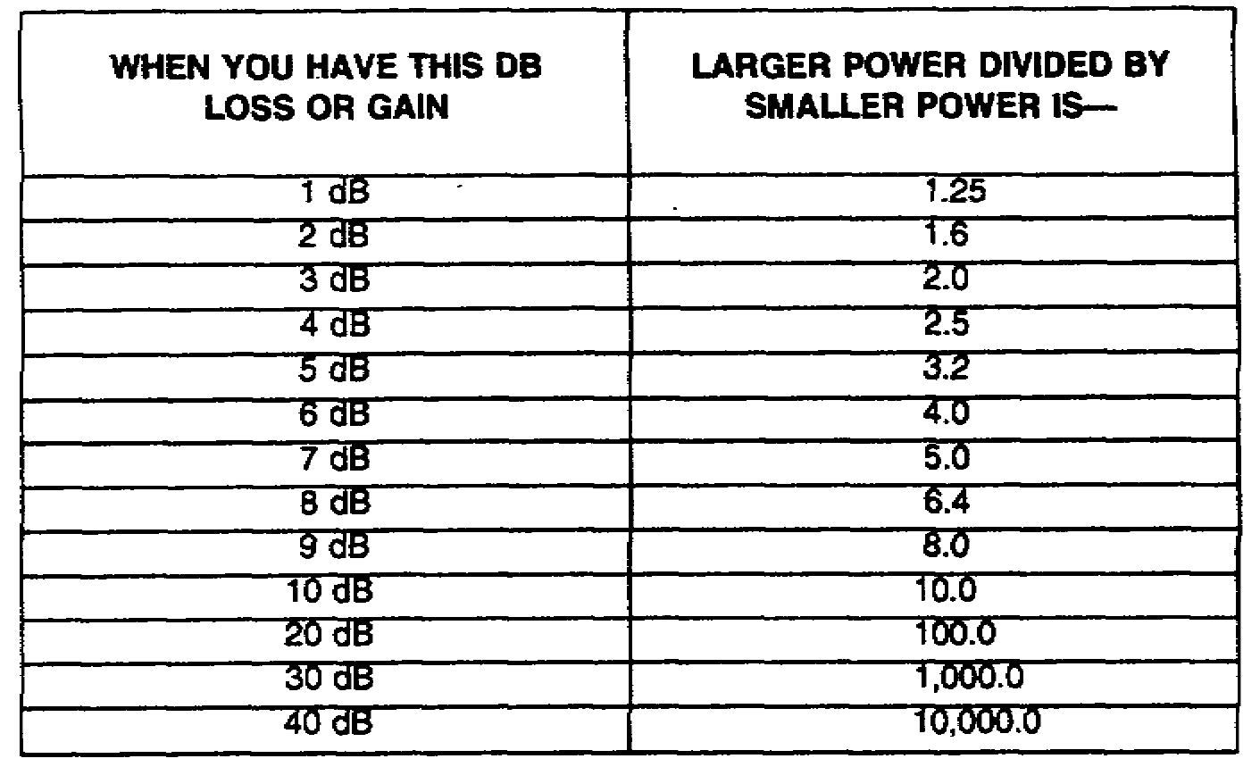

b. Example 2. Suppose you know the dB gain is 40 dB. The ratio of the output power to the input power is found by referring to Table 3-4, where 40 dB corresponds to a ratio of 10,000. If you know the input power is .001 watt, you can find the output power by multiplication: .001 watt X 10,000 = 10 watts.

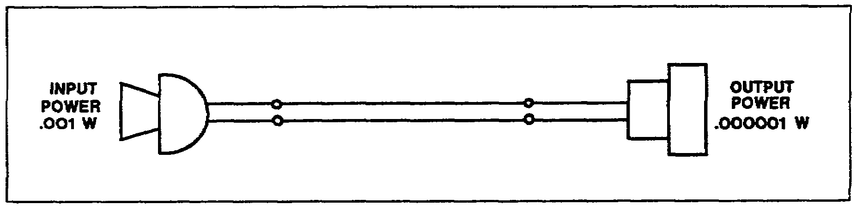

Figure 3-11. Circuit showing power loss.

7. The decibel milliwatt (dBm) represents a reference level.

a. Before explaining the dBm, let's first find out what is meant by a reference level. The simplest way to explain it is to use an everyday example.

b. Suppose you had $100 in a savings account at the beginning of a year. This $100 could act as a reference level. You could actually plot your savings account for the whole year on a graph as shown in Figure 3-12. You’d put $100 in the center of the vertical axis. And then place plus signs above $100 and minus signs below $100. Then as the

3-33 SS0031

year went on, if you deposited $10 in February, you'd plot +$10 (above $100). Then, if in March you had to withdraw $40, you'd plot this to show that you had -$30 (below $100). And as the year progressed, you'd plot the other months as shown.

c. Using this method, at the end of a year you'd be able to tell exactly what your net savings were for that year. All you'd need to do is check the last month. In the graph you can see that the last month shows a level of +$40 (above $100). This means that, although your account has changed many times during the year above and below $100, you still come out with a net gain of $40 (above $100). The actual amount of money that this represents is $140. Now just as we use an amount of money here for a reference level, in telephone work we use an amount of power as a reference level.

8. The reference level for dBm is 1 mW of power.

a. The reference level used in telephone work is .001 watt (1 mW) of power. This level was chosen because it represents the average amount of power generated by the voice in a telephone transmitter. And by using 1 mW, you can compare all dB losses and gains in a circuit to this reference level.

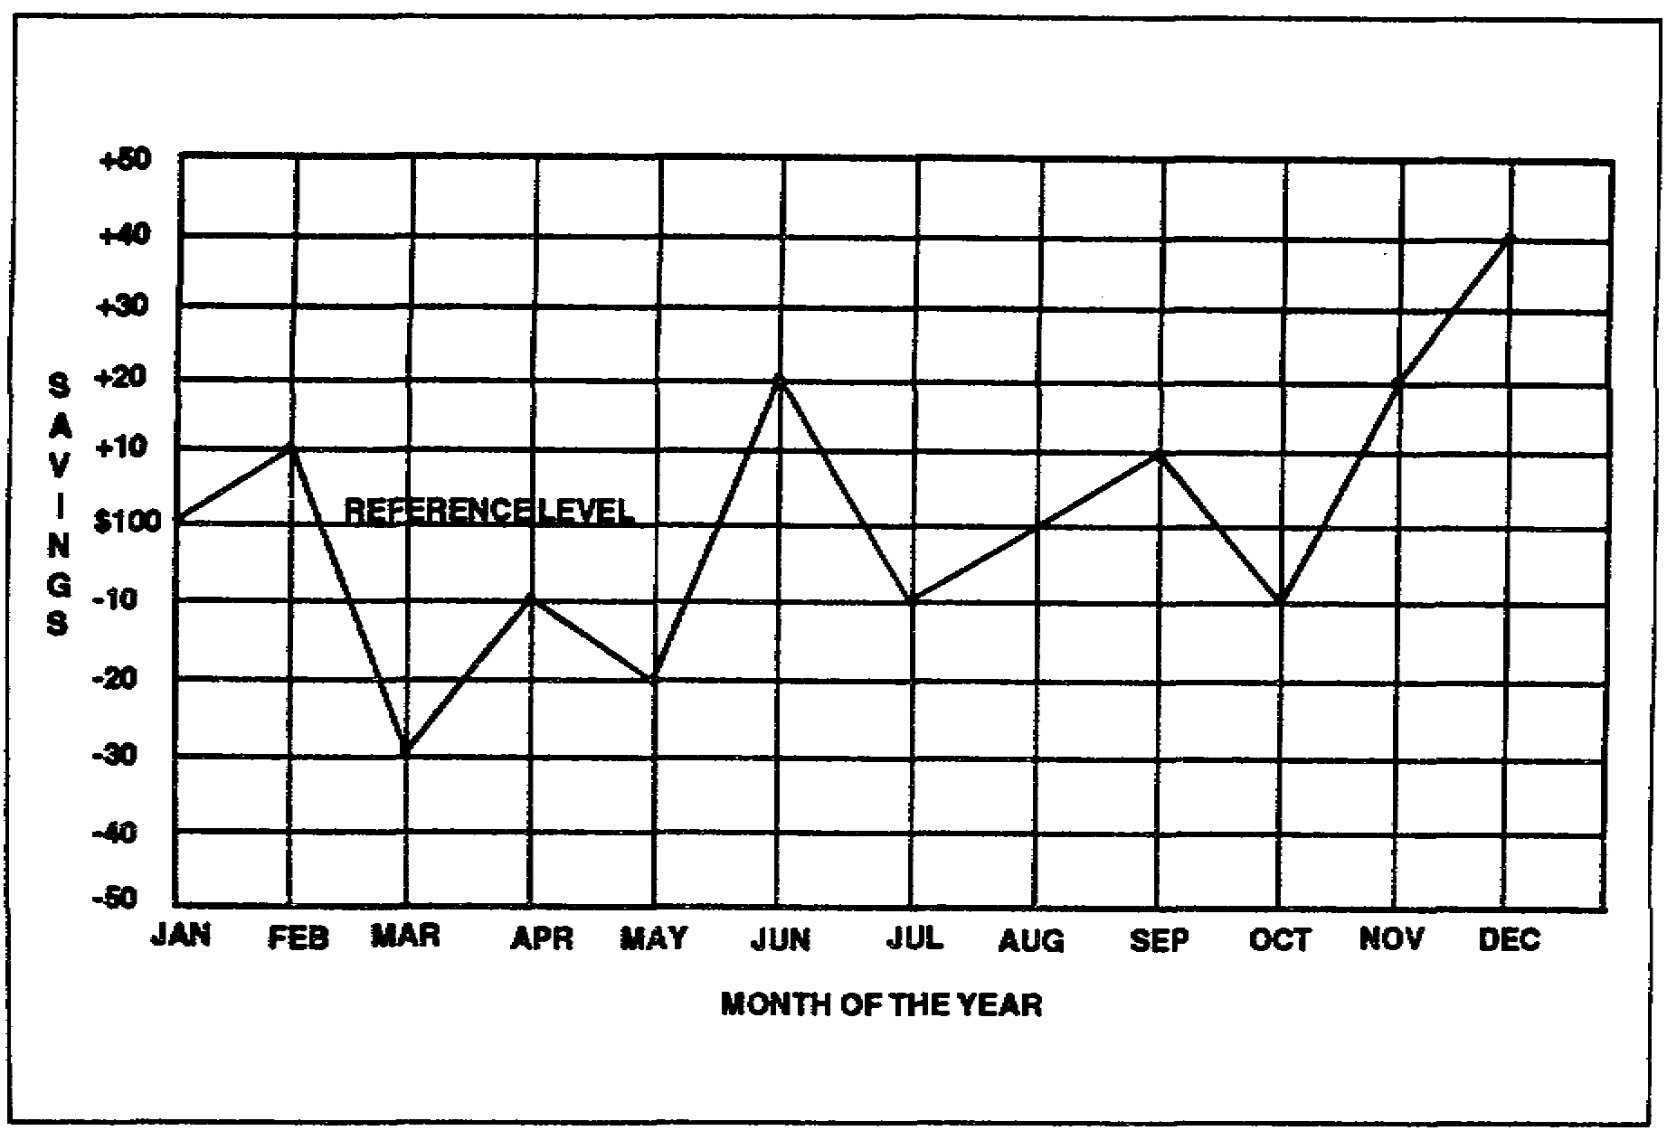

Figure 3-12. The use of a reference level.

b. For convenience, 1 mW is designated as being equal to 0 dB. Then, to make sure no one forgets that 1 mW is the reference level, a small letter m is tacked on after 0 dB like this: 0 dBm. The letter m, of course, stands for 1 mW. Summing up, then: The

SS0031 3-34

standard reference level used in telephone work is 1 mW which is expressed as dBm. Remember, whenever you see 0 dBm, it means 1 milliwatt of power.

9. How to use this reference level.

a. The easiest way to find out is to look at what happens in an average telephone system like that shown in figure 3-13.

b. In the figure, you see a telephone system with a graph (energy level diagram) below it. The graph shows what is happening to the voice power as it travels along the system. You can see that the input level is 0 dBm (meaning 1 mW). The first section of line extending from the line input to the repeater gives a loss of 30 dB. This brings the power level at the repeater input down to -30 dBm (30 dB below the reference level of 0 dBm).

c. Then the power represented by -30 dBm (actually .001 mW) enters the repeater and becomes amplified. The repeater provides a gain of 36 dB. This brings the power at the output of the repeater up to a new level of +6 dBm (which represents 4 mW).

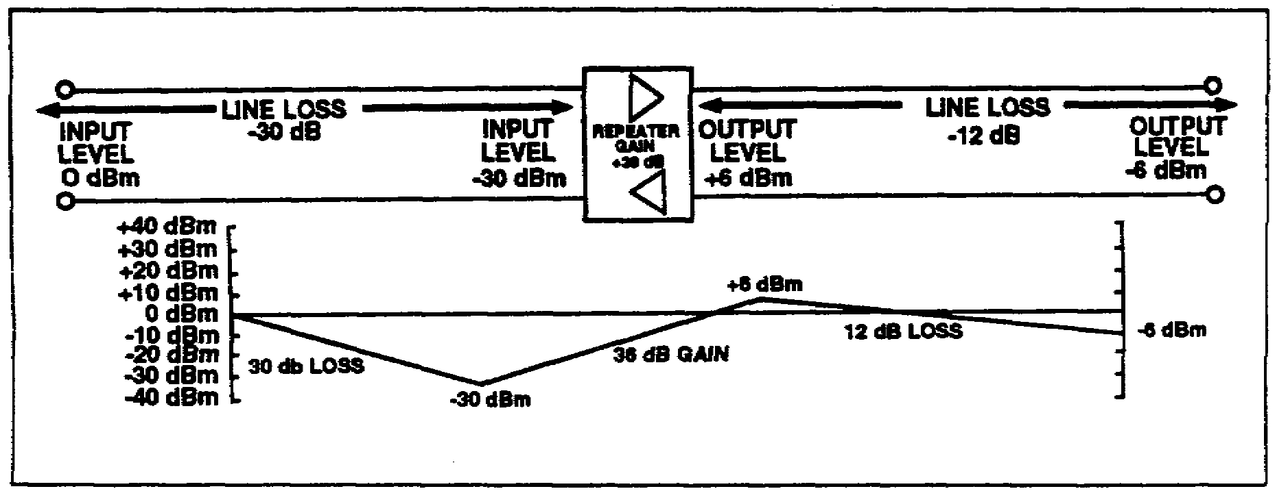

Figure 3-13. How dBm is used in a telephone system.

d. Next, as the power moves toward the end of the line, it suffers another loss of 12 dB. This gives a final output level of -6 dBm (actual power is .25 mW).

10. Conclusion.

a. You can see that dB losses and gains are added algebraically. That is, a +36 dB and a -30 dB gives a +6 dB. And a +6 dB and a -12 dB gives a -6 dB.

b. Notice that dB and dBm are not used in the same way. The dB is used to express the amount of loss or gain. Then, after the loss or gain has taken place, dBm is used to express the new power level arrived at because of the loss or gain.

3-35 SS0031

c. By using 0 dBm as the reference level you can easily tell the net loss in the circuit. Even though the power level changed several times along the circuit, the received power is at a level of -6 dBm. The letter m after dB tells us that this is 6 dB below the input level of 0 dBm. So we can say that, regardless of how much loss or gain has taken place, the circuit net loss is only 6 dB. If this seems a little hard to understand, think back to the money example. Remember how, at the end of the year, you had saved $40 above the reference level of $100. You called this $40 a net gain for the whole year.

11. The standard frequency for dBm.

a. You know now that 0 dBm represents 1 mW of power. And this 1 mW, in turn, represents the voice power. Now, since voice power is made up of AC voltage and current, you must also be concerned with frequency. This means that when you state the input level to a circuit is 0 dBm, you must also specify the frequency.

b. The standard frequency used for testing in telephone work is 1,000 Hertz (1 kHz). When you make dB loss and gain measurements, you will use a device that feeds a frequency of 1 kHz at a level of 0 dBm to the line input. Then, at various points along the line, another device will be used to measure the dB loss or gain. This device will not only tell how much loss or gain there is, but it will also indicate the level in dBm.

c. These devices are used as shown in Figure 3-14. The one that supplies the power is called an oscillator. And the one that measures the power is called a decibel meter.

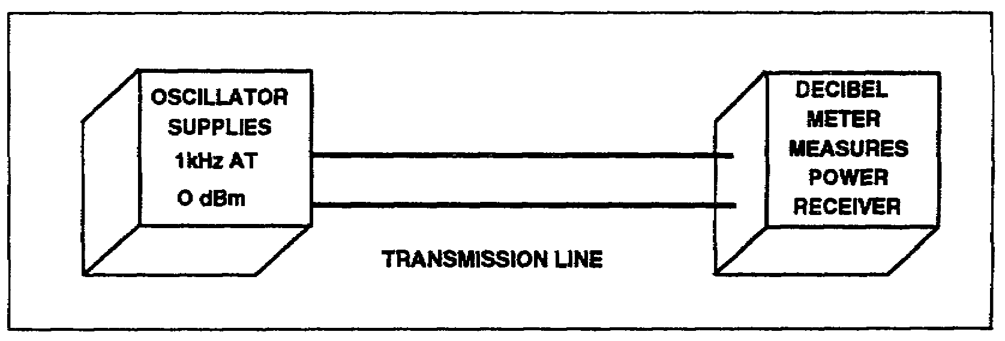

Figure 3-14. Use of oscillator and transmission measuring set.

12. Summary. Here are the most important points covered in measuring power losses and gains:

a. The dB is a transmission measuring unit used to express power loss and gain in a telephone system.

b. A minus sign placed before dB (-3 dB) indicates a power loss.

c. A plus sign placed before dB (+3 dB) indicates a power gain.

d. Decibel (dB) losses and gains in a circuit are added algebraically.

SS0031 3-36

e. The dB by itself indicates an amount of power loss or gain but it does not tell exactly how much power is involved.

f. A reference level of a milliwatt of power is used with the decibel so that a definite amount of power can be expressed.

g. To accomplish this, 1 mW is designated as being equal to 0 dBm.

h. This 0 dBm is then used as a reference level and losses and gains are compared to 0 dBm. This means that a level of -3 dBm is 3 dB below the reference level. And, since a 3 dB loss represents a 50-percent power loss, a level of -3 dBm is equal to .5 mW. Similarly, a level of +3 dBm is equal to 2 mW since a gain of 3 dB doubles the power.

i. The frequency used with the reference level of 0 dBm is 1,000 Hertz (1 kHz).

j. This, then, is the standard frequency and testing power used in telephone work-1 kHz at 0 dBm.

k. In transmission measurement, 1 kHz at 0 dBm is supplied by an oscillator. A decibel meter is used to measure the amount of dB loss or gain at many points along the circuit.

3-37 SS0031

THIS PAGE INTENTIONALLY LEFT BLANK

SS0031 3-38

LESSON 3

PRACTICE EXERCISE

The following items will test your grasp of the material covered in this lesson. There is only one correct answer for each item. When you complete the exercise, check your answers with the answer key that follows. If you answer any item incorrectly, study again that part of the lesson which contains the portion involved.

1. When a receiving antenna is tracking a satellite, the noise picked up by the antenna varies in intensity as the satellite moves from one horizon to the other. The maximum noise is picked up by the antenna when the antenna is pointing at the-

A. Sun
B. Moon
C. Milky Way
D. Planet Venus

2. What is gained by reducing the effective bandwidth in the 800-kHz IF signal?

A. Reduction of noise power applied to the discriminator
B. Increase of signal power applied to the discriminator
C. Reduction in the C/N applied to the limiter
D. Reduction in the frequency deviation of the FM signal applied to the limiter

3. The number of voice channels normally processed through a receiver with a buffer amplifier G3 varies from-

A. 1 to 5
B. 1 to 60
C. 5 to 24
D. 12 to 60

4. What is the purpose of FMFB?

A. To ensure maximum frequency deviation
B. To minimize the noise content of the IF signal
C. To provide regenerative feedback to the IF amplifiers
D. To minimize the noise content of the received carrier signal

3-39 SS0031

LESSON 3

PRACTICE EXERCISE

ANSWER KEY AND FEEDBACK

Item Correct Answer and Feedback

1. A. Sun (page 3-2, Learning Event 3, para 4)

2. C. Reduction in the C/N applied to the limiter (page 3-22, Learning Event 26, para 1)

3. A. 1 to 5 (page 3-28, Learning Event 34, para 4)

4. D. To minimize the noise content of the received carrier signal (pages 3-14 and 3-15, Learning Event 18, paras 1 and 2)

SS0031 3-40

LESSON 4

SINGLE CHANNEL SATELLITE SYSTEMS

Critical Task: 01-5768.07-0002

OVERVIEW

LESSON DESCRIPTION:

In this lesson, you will learn the single channel satellite system.

TERMINAL LEARNING OBJECTIVE:

ACTION: Demonstrate an in-depth knowledge of single channel satellite communications systems, to include planning considerations, systems description, deployment and employment, and configuration. Demonstrate a basic knowledge of the planning and control of tactical satellite (TACSAT) systems, the space segment, electronic countermeasures (ECCM) and antijamming techniques, and transmission techniques.

CONDITION: Given lesson material, paper, pencil, and without supervision.

STANDARD: Demonstrate competency of task, skills, and knowledge of the material presented by responding to 70 percent of the test questions covering satellite communications.

INTRODUCTION

This lesson will give you the basic knowledge on the operation, purpose, and characteristics of single channel satellite systems. It will cover such areas like deployment, system configuration, and employment. As a signal officer dealing with satellites, these areas are very important for you to know.

LEARNING EVENT 1: SYSTEM DESCRIPTION

1. Manpack single-channel TCSAT terminals provide reliable, highly portable communications. They have minimum setup and teardown time and satisfy a need for extended distance communications.

4-1 SS0031

2. The manpack system operates in the UHF band between 225 MHz and 400 MHz. The manpack terminals use a UHF satellite system fleet satellite (FLTSAT) and Air Force satellite (AFSAT) space segments.

3. The Army terminals using the FLTSAT space system are the AN/PSC-3, AN/VSC-7, AN/URC-101, and AN/URC-110. The AN/PSC-3 is a manpack terminal carried by one operator. The AN/VSC-7 is a vehicle-mounted terminal which normally acts as a net control station (NCS) and can control up to 15 subscribers. The AN/URC-101 and AN/URC-110 are manpack terminals, each carried by one operator.

LEARNING EVENT 2: DEPLOYMENT

1. Army units such as Special Forces groups and Ranger battalions deploy manpack TACSAT terminals worldwide. The physical environment does not restrict these deployments. The terminals are lightweight and compact and can be moved easily by one person. The NCSs are normally vehicle-mounted. They are usually operated from a forward operation base by Special Forces groups or from a battalion headquarters by Ranger battalions. A network can be a small deployment (three to four terminals with one AN/VSC-7/NCS) or a larger deployment (more than one AN/VSC-7/NCS).

2. Manpack terminals deployed worldwide are issued to support Army units. AN/VSC-7s and AN/PSC-3s satisfy the real-time mission requirements of the following organizations:

• Special Forces

• Ranger battalions

• Airborne/Air Assault divisions

• Selected Infantry divisions (light and mechanized)

LEARNING EVENT 3: EMPLOYMENT

1. The Special Forces units use the AN/PSC-3s for group/detachment headquarters, forward operating bases, and operational teams spread over extended distances. Command and control between major headquarters is primarily secure voice. All users at the Special Forces team level operate in a data burst mode using the OA-8990 data burst device.

2. The Ranger regiment/battalions command nets provide command and control from regimental headquarters through command headquarters. They use secure voice and data burst in their operations.

SS0031 4-2

3. The Airborne/Air Assault divisions use the AN/PSC-3s primarily to provide a long-haul command and control link between major headquarters during initial deployment. Once on the ground, those headquarters still requiring a communications link not available by LOS means or by multichannel satellite link will continue to operate via the AN/PSC-3 network. The primary mode is secure voice, though secure teletype (AN/UGC-74) is also used.

4. Selected Infantry divisions (light and mechanized) use the AN/PSC-3s to provide a long-haul command and control link between major headquarters during initial deployment of a contingency operation. The primary mode is secure voice, though secure teletype (AN/UGC-74) is also used.

LEARNING EVENT 4: SYSTEM CONFIGURATION

1. The AN/PSC-3 is a battery-operated, highly portable manpack TACSAT terminal. It employs an RT-1402 receiver/transmitter (R/T) unit that provides two-way communications in the frequency range of 225 MHz to 400 MHz. The R/T functions in both satellite mode and LOS mode of operation. It can be configured to provide data or secure voice.

a. In the data mode, it uses the digital message device group (DMDG) OA-8990 as the input/output (I/O) device. It provides data rates of 300 bp/s or 1,200 bp/s.

b. In the secure voice mode, the AN/PSC-3 uses either the advanced narrowband digital voice terminal ANDVT) or a communications security (COMSEC) interface device such a the VINSON KY-57.

c. In addition to voice and data, the AN/PSC-3 can interface with facsimile, teletype, net radio interface (NRI), and FM retransmission media.

2. The NCS uses the same basic AN/PSC-3 R/T unit reconfigured to form an AN/VSC-7. The vehicle's electrical system provides power for operation. The NCS can control as many as 15 terminals in a network. Because it is a single-channel system, it is configured with data needs being satisfied by some terminals and secure voice needs being satisfied by other terminals. The call mode operation is a unique calling function. It allows the sending station to alert a distant unit with a visual indication. It also allows an optional 5-second audible alarm. The NCS can transmit or receive any one of 15 selective calls. It can also receive all conference calls regardless of the selective control setting on the NCS applique front panel. The NCS selects any one of the 15 units operating in its net for selective call transmissions. Conference calls will be received by all units operating in the net with their controls set to receive selective call messages.

4-3 SS0031

LEARNING EVENT 5: ANTIJAMMING AND ECCM TECHNIQUES

1. Physical damage and hostile electromagnetic jamming threaten all communications including satellite. This system presently does not offer any antijamming protection to the TACSAT terminal. Mobile TACSAT terminals offset the need for providing protected multiple ground relay sites. In addition, it reduces exposure time to hostile actions. The protection of these terminals by terrain, such as valleys, further reduces the possibility of detection. Where ordinary means of communications are subject to varying degrees of radio direction finding (RDF), the satellite system can be used to deter enemy RDF success. The short transmission times of burst mode present less attractive jamming targets than the longer continuous communications of regular nets. The only options available to tactical UHF satellite terminals are data burst, alternate frequency selection, mobility, and reducing the on-air time of each transmission.

2. The digital message device group (DMDG) OA-8990( )/P is the major "used with" component of the AN/PSC-3 and AN/VSC-7 in the burst communications system (BCS). This hand-held device provides digital input to the radio for burst transmissions at data rates of 300 and 1200 bp/s. It provides the operator with the ability to transmit in a few seconds what would normally take minutes in a standard continuous mode (CW) mode. The DMDG microprocessor unit features a 32-keyboard, a 16-character light emitting diode (LED) display, an HF modem, and a 1,020-character memory. Power is supplied by rechargeable Nicad batteries. Data rates are 300 or 1200 bp/s using American standard code for information interchange (ASCII) 6-bit code. Selection of bit rate for compatibility with the satellite is accomplished by an internal switch. The maximum DMDG weight will be 3.9 kilograms (8.0 lbs); maximum volume will be 3.7 cubic centimeters (225 cu in). Interface equipment used with but not part of the manpack system, such as TSEC/KY-57 and KY-65 secure voice applique devices are current Army inventory assets and may be issued as dictated by mission requirement.

SS0031 4-4

LEARNING EVENT 6: NEED AND-EMPLOYMENT

1. Most of the satellite communications in today's military environment are multichannel. It is in fact, more economical to process many voice channels over a single wideband satellite channel than to restrict the satellite to single-channel usage. However, there still exists a strategical need for single-channel operation in which satellite communications offer the best means of mission accomplishment.

2. Special Forces and other users find that satellite communications fill the special needs more effectively than other means of communications. Therefore, the Army has developed a single-channel UHF manpack system to fill these needs. Figure 4-1 illustrates a basic manpack system concept of operations.

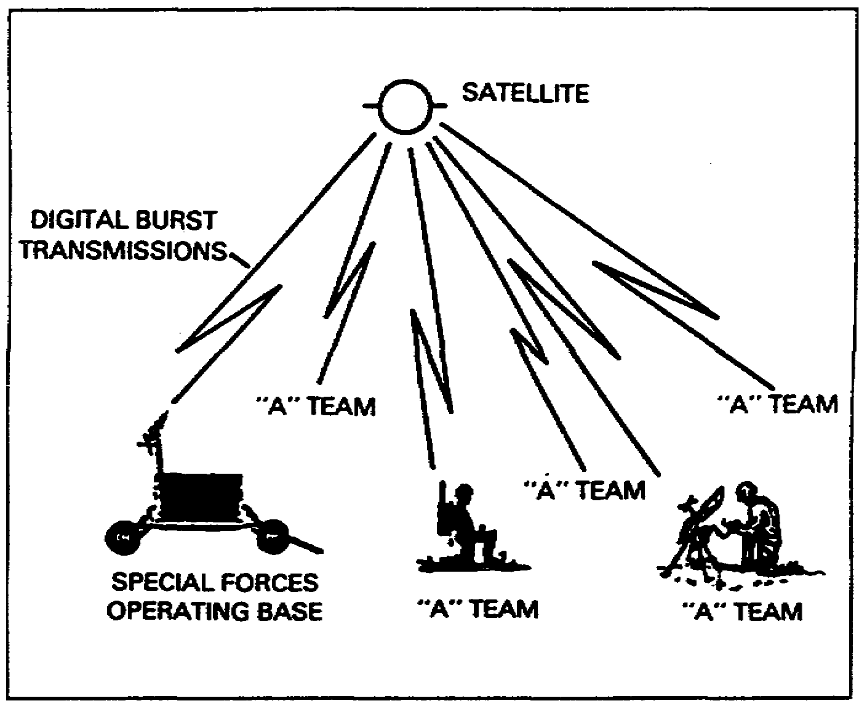

Figure 4-1. Manpack system concept of operation.

4-5 SS0031

3. The concept of operation for Special Forces and Engineers is to deploy the manpacks with selected teams with net control at the forward operation bases of both the Engineers and Special Forces groups. The concept of operation for Rangers is for the deployment of manpacks at the company headquarters/combat patrol bases with net control at the ranger battalion headquarters. (See Figures 4-2 and 4-3.) The system can be used with the AN/PRC-70, AN/PRC-77, single channel ground and airborne radio systems (SINCGARS), and the AN/VRC-12 series radio sets for retransmission capabilities.

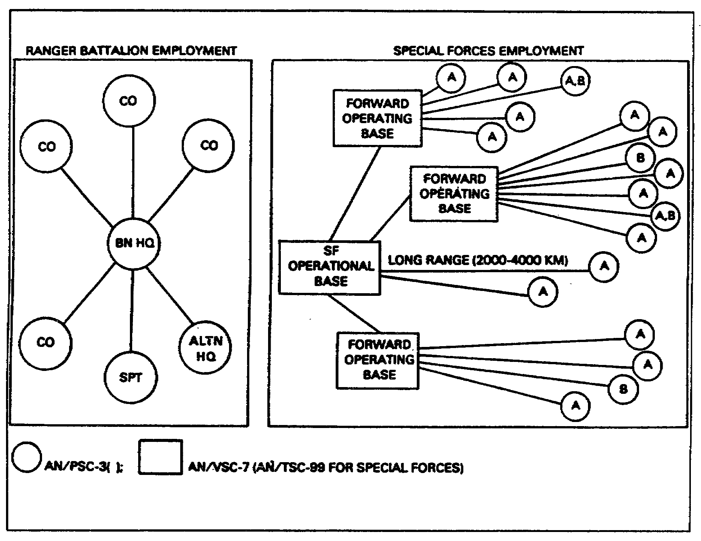

Figure 4-2. Manpack system typical employments.

SS0031 4-6

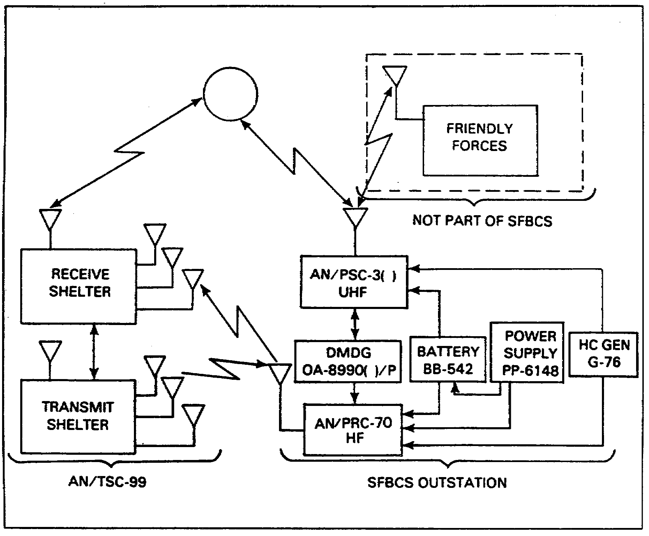

Figure 4-3. Special Forces BCS concept of operation.

LEARNING EVENT 7: SYSTEM DESCRIPTION

The manpack system is designed for low-echelon, highly mobile unit communications where units operate in either friendly or enemy territory at great distances from the home unit. The equipment can operate in the on-the-move/LOS mode using 2 watts output power or in the at-halt/satellite mode using 35 watts output power. It can transmit and receive in either voice or data format in either mode. The system complements the older tactical radios which operate in the HF spectrum and which are highly susceptible to enemy RDF and jamming as well as requiring relay-switching in order to operate over long distances. Furthermore, the manpack system requires less personnel training than does the older HF equipment and it requires no additional personnel at unit or support levels.

4-7 SS0031

LEARNING EVENT 8: EQUIPMENT DESCRIPTION

1. Radio set AN/PSC-3( ) (Figures 4-4a and 4-4b) is a battery-operated, portable communications terminal employing an RT-1402( )/G unit (Figure 4-5) which provides two-way communications in the frequency range of 225 MHz to 400 MHz in both satellite and LOS modes of operation.

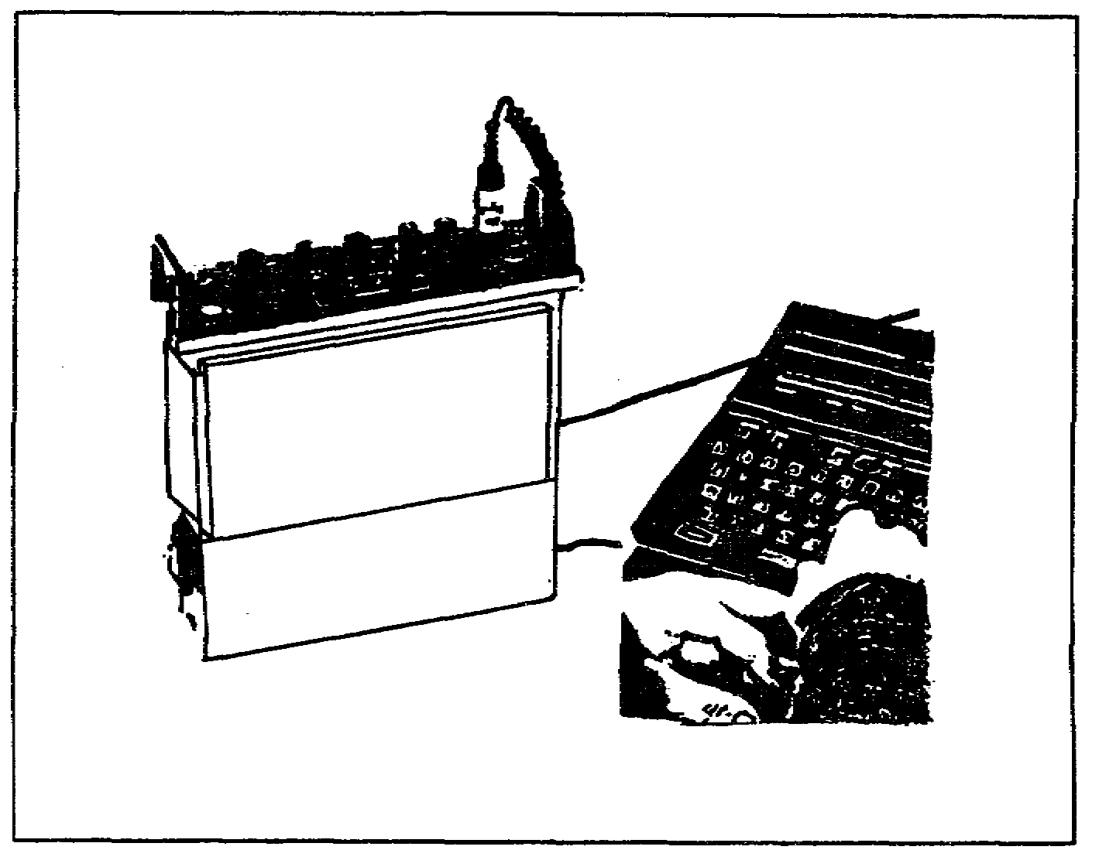

Figure 4-4a. AN/PSC-3( ) with OA-8990( )/P DMGD.

The terminal uses a low-gain omnidirectional whip antenna for LOS operation while in motion. This antenna also enables reception of a satellite alert ringing signal while in LOS mode (Figure 4-4b). The set uses an AS-3567( )/PSC-3 medium-gain antenna (Figure 4-6 on page 4-10) for at-halt satellite communications. The terminal provides half duplex communications at 300 bp/s and 1200 bp/s biphase shift keying (BPSK), 2400 bp/s synchronous BPS 16 kbp/s FM and frequency shift.

SS0031 4-8

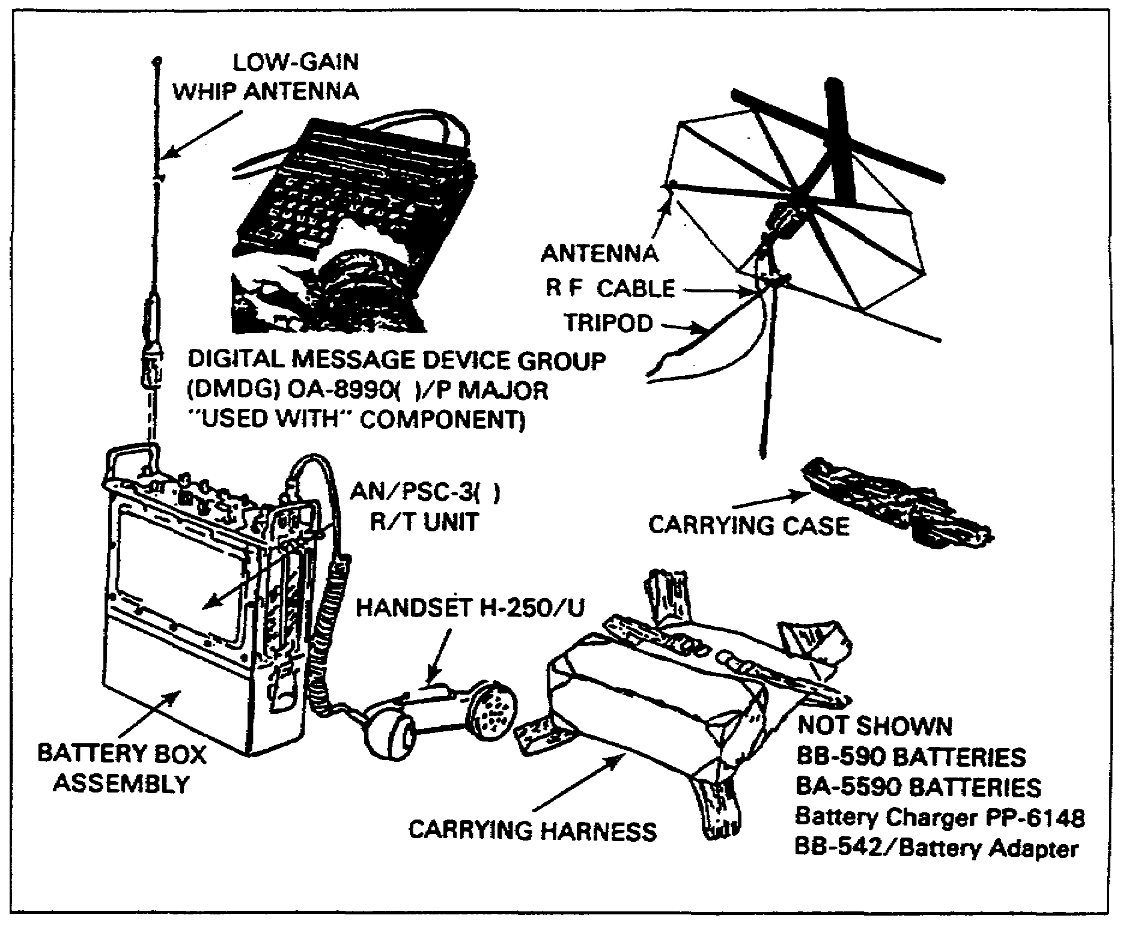

Figure 4-4b. Radio set AN/PSC-3( ) components.

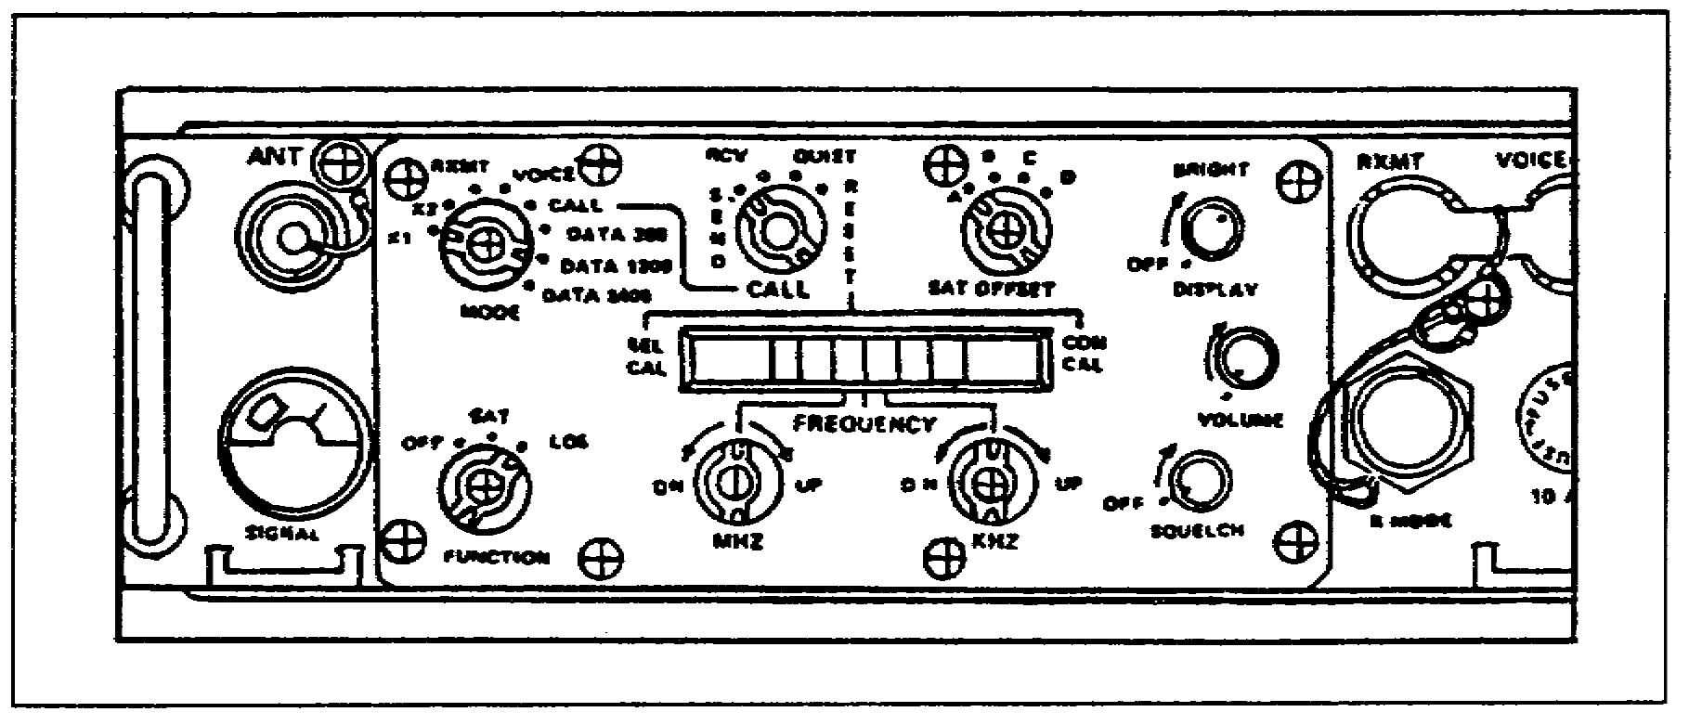

Figure 4-5. RT-1402( )/G.

4-9 SS0031

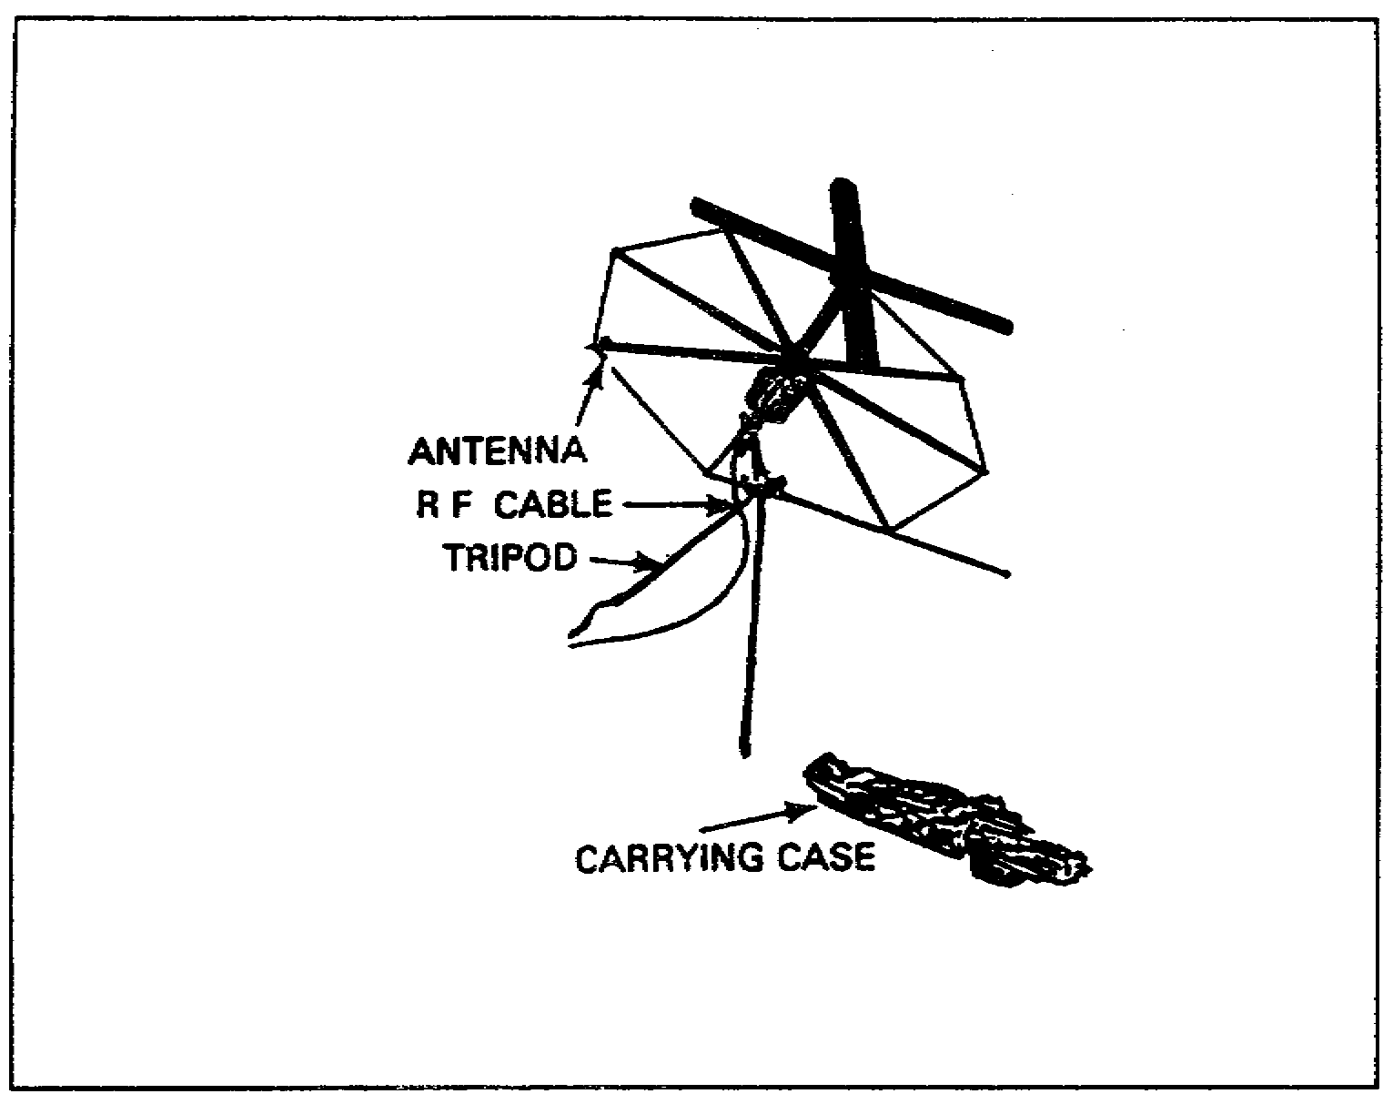

Figure 4-6. Medium-gain antenna AS-3567( )/PSC-3.

2. The vehicular NCS AN/VSC-7 uses the basic AN/PSC-3 R/T unit installed in a C-1119( )/VSC-7 control converter which is shock-mounted into a communications shelter or a military ground vehicle. Power to the NCS is derived from the vehicle's electrical system. It may also be used with an S-280 communications shelter mounted on an M-832 mobilizer. The power amplifier module in the control converter is blower-cooled to allow continuous key-down operation at temperatures up to 86°C (155°F). The NCS can serve up to 15 AN/PSC-3( ) terminals in a communications net with the selection of conference or individual call-codes available at the control converter front-panel. The NCS uses a high-gain (9 dB) AS-3566( )/VSC-7 antenna and a low-gain whip antenna (Figure 4-7). The low-gain AS-3566( )/G whip antenna is used for LOS operation and for CALL reception. The AS-3567( )/PSC-3 medium-gain antenna, used for satellite relay operation, provides 6 dB gain in the frequency range of 240 to 318 MHz and 5.5 dB gain in the frequency range of 318 to 400 MHz. Terminal characteristics include all features of the AN/PSC-3( ) and additionally provide

• Operation from vehicle electrical system

• Transmission of selective or conference call signals

• Input-power conditioning ·

• Automatic transmission/reception mode changeover

SS0031 4-10

• Electromagnetic interference protection against collocated transmitter(s)

• Continuous key-down operation

• High-gain (9 dB) antenna

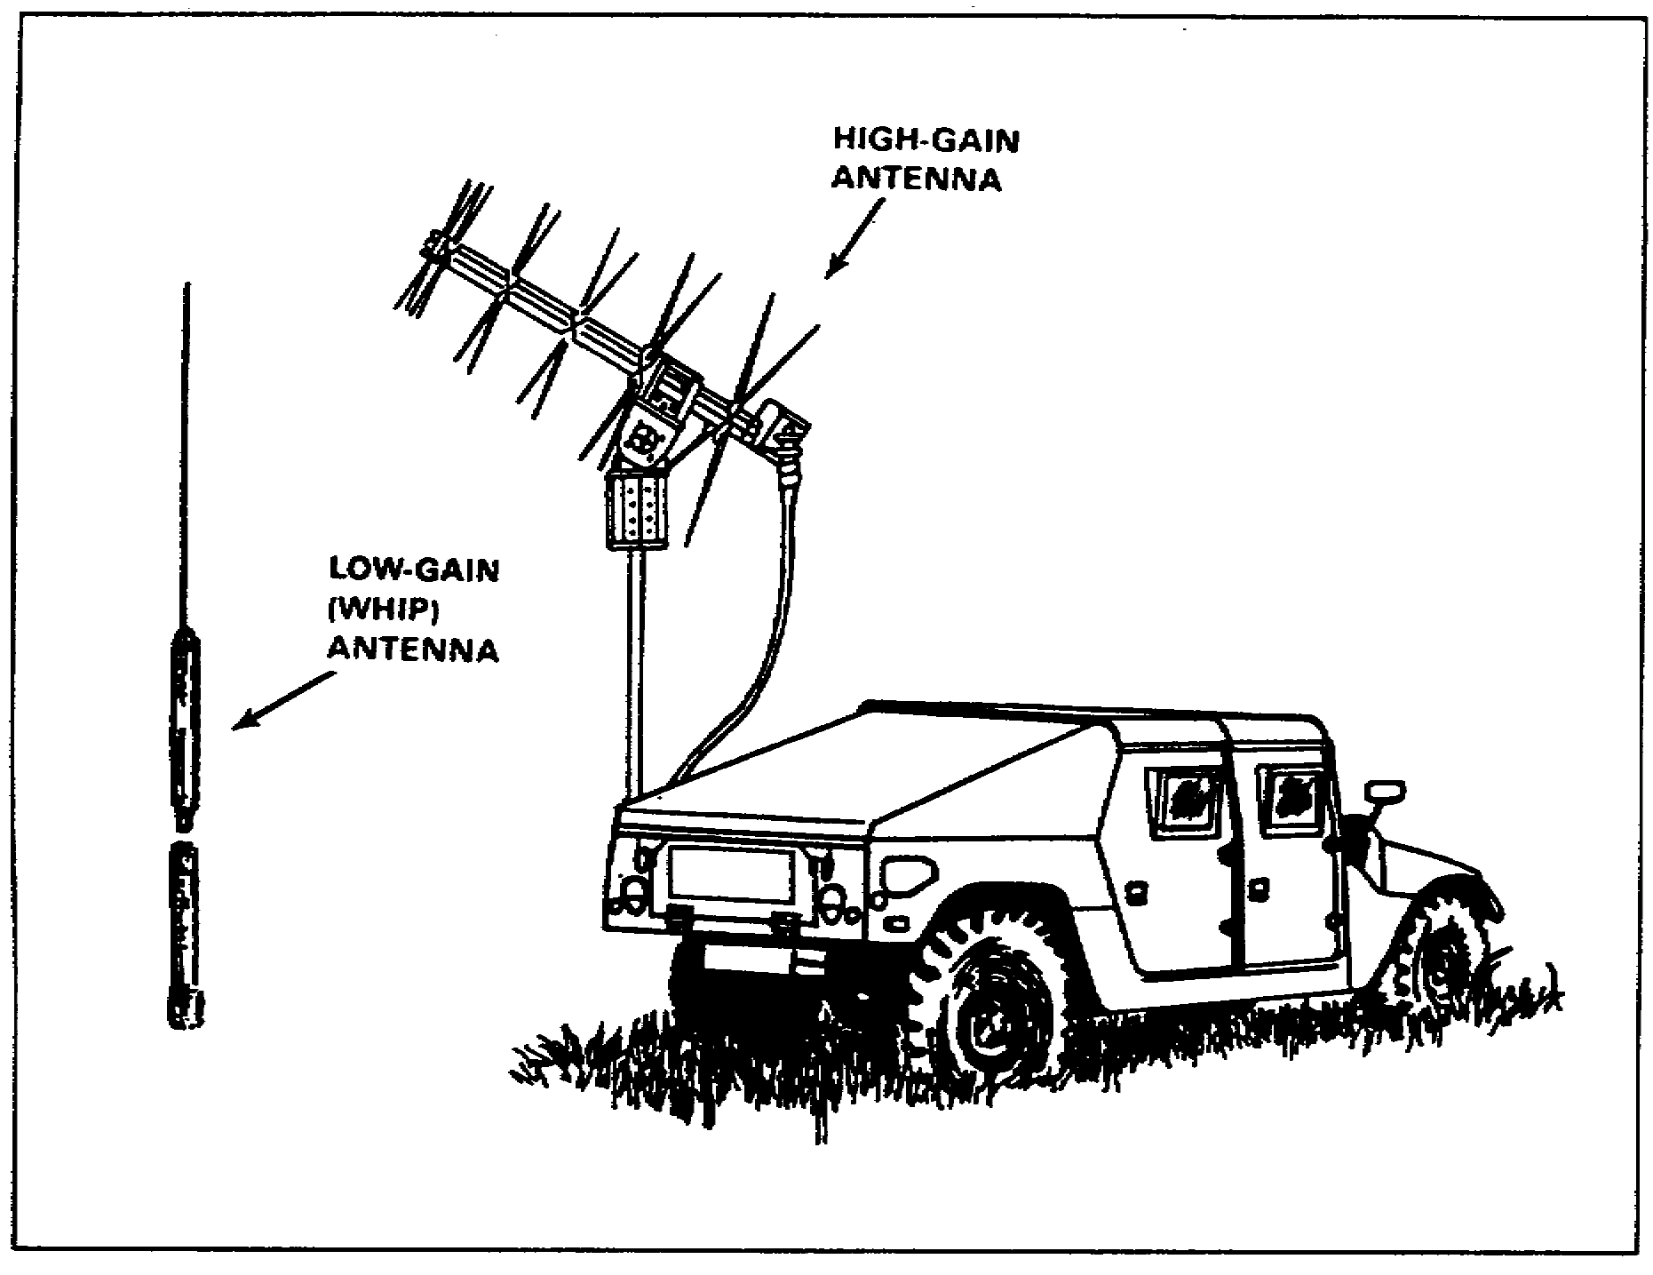

Figure 4-7. Hi- and low-gain (whip) antennas.

4-11 SS0031

THIS PAGE INTENTIONALLY LEFT BLANK

SS0031 4-12

LESSON 4

PRACTICE EXERCISE

The following items will test your grasp of the material covered in this lesson. There is only one correct answer for each item. When you complete exercise, check your answers with the answer key that follows. If you answer any item incorrectly, study again that part of the lesson which contains the portion involved.

1. All users at the Special Forces team level operate in data burst mode using the OA-8990 data burst device.

A. True
B. False

2. The primary mode of communications for the Special Forces, the Airborne/Air Assault divisions, and the selected Infantry divisions that use the manpack single-channel TACSAT is secure teletype with secure voice provided as backup.

A. True
B. False

3. In addition to voice and data, the AN/PSC-3 can interface with-

A. NRI
B. Teletype
C. Facsimile
D. All of the above

4-13 SS0031

LESSON 4

PRACTICE EXERCISE

ANSWER KEY AND FEEDBACK

Item Correct Answer and Feedback

1. A. True (page 4-2, Learning Event 3, para 1)

2. A. True (pages 4-2, 4-3; Learning Event 3, paras 1, 2, and 3)

3. D. All of the above (page 4-3, Learning Event 4, para 1c)

SS0031 4-14

LESSON 5

MULTICHANNEL SATELLITE COMMUNICATIONS SYSTEMS

Critical Task: 01-5768.07-0002

OVERVIEW

LESSON DESCRIPTION:

In this lesson, you will demonstrate an in-depth knowledge of multichannel satellite systems.

TERMINAL LEARNING OBJECTIVE:

ACTION: Demonstrate an in-depth knowledge of multichannel satellite systems, their deployment/employment, and system configuration. Demonstrate a basic knowledge of antijamming and ECCM techniques and the control and management of the systems.

CONDITION: Lesson material, pencil, paper, and without supervision.

STANDARD: Demonstrate competency of the task, skills, and knowledge of the material presented by responding to 70 percent of the test questions covering satellite communication.

INTRODUCTION

In this lesson, we will provide in-depth information on multichannel satellite communications systems. Additionally, it will include some planning considerations, system description, deployment and employment, configuration, planning and control of TACSAT systems, space segments, ECCM and antijamming techniques, and transmission techniques.

5-1 SS0031

SECTION I. MULTICHANNEL SATELLITE SYSTEMS

LEARNING EVENT 1: SYSTEM DESCRIPTION

1. In addition to strategic terminals utilizing the Defense Satellite Communications System (DSCS), there are also highly mobile, quick reaction tactical terminals supporting the services. These multichannel TACSAT terminals utilize the Ground Mobile Force (GMF) component of the DSCS, and provide range extension and connectivity between the tactical and strategic/base support communications networks.

2. Tactical multichannel super high frequency (SHF) satellite communications are provided by Phase II GMF satellite terminals. These terminals include the AN/TSC-100A and the AN/TSC-94A used by the Air Force, and the AN/TSC-85B and AN/TSC-93B used by the Army and Marine Corps. These terminals are compatible with Tri-Service Tactical Communications (TRI-TAC) and mobile subscriber equipment (MSE) area common-user systems. These multichannel TACSAT terminals employ frequency division multiple access (FDMA); as a result centralized frequency selection and uplink power control are required.

LEARNING EVENT 2: DEPLOYMENT

1. Theater through brigade level commanders, special contingencies, and selected divisions use tactical multichannel satellite systems to support Army mission requirements. These systems were developed to augment existing terrestrial multichannel communications systems.

2. Multichannel satellite systems are designed primarily for trunking. Consider the following factors when selecting a link requirement for multichannel TACSAT terminals:

• Criticality of the link to tactical command and control and the availability of other primary or supporting transmission means.

• Ground range over which the link must be operated in various scenarios.

• Responsiveness and flexibility required with respect to siting and system reconfiguration.

• Link survivability requirements.

3. Consider the following factors when deploying the AN/TSC-85B/93B:

• Equipment capabilities.

• Network configuration.

• System descriptions.

SS0031 5-2

4. Multipoint operations via satellite can be established with up to four non-nodal terminals to form a communications network. The nodal terminal AN/TSC-85B receives four pulse code modulation (PCM) data streams for transmission to four individual non-nodal terminals (AN/TSC-93B). The tactical satellite signal processor (TSSP) TD-1337 in the nodal terminal combines these data streams into a signal supergroup on a single carrier frequency. Each non-nodal terminal receives the entire supergroup data stream, demultiplexes it, and processes the data group intended for that particular terminal. Each non-nodal terminal in the network transmits its respective data on independent carrier frequencies which are received and separated. The four individual data streams are processed by the TSSP and sent to the individual multiplexers (TD-1389) in the nodal terminal.

5. The AN/TSC-85B TACSAT terminal is housed in a modified S-280 shelter. It operates with an organic AS-3036/TSC (8-foot diameter) antenna which is moved in an antenna pallet transit frame (APTF). It may also operate with either the non-organic AS-3299/TSC (20-foot diameter) antenna or the OE-361(V)/G quick reaction satellite antenna (QRSA). All three antennas operate with DSCS satellites.

a. The four curbside racks inside the shelter contain the baseband (multiplexing or demultiplexing) equipment. The four racks on the roadside of the shelter contain the modems and IF or RF assemblies. The electronic equipment can operate in a nuclear, biological, chemical (NBC) environment.

b. Each part of the satellite terminal equipment (shelter and APTF) is transportable by road, air (C-130, C-141, C-5A, or helicopter), rail (flatbed), and sea (ship). For the shelter to be mobile by rail or air, the M-720 mobilizer (non-organic) must be used.

c. Terminal setup time for a team using the organic AS-3036/TSC is 30 minutes.

6. The AN/TSC-85B TACSAT terminal (nodal) provides the following:

a. Transmission of a single SHF uplink carrier with up to 48 channels of voice and/or digital data internally multiplexed by the MD-1389 low rate multiplexers (LRM). An additional four digital transmission groups of voice and/or data from a remote (externally) multiplexed source may also be transmitted at rates up to a maximum of 1152 kb/s conditioned diphase (CDI) data. A total of eight data input ports are available in the TSSP. This does not include the dedicated user port (16 or 32 kb/s of data), or the digital voice orderwire (DVOV) circuit.

b. On the downlink side, four carriers can be received, demodulated, and switched to user interfaces.

c. Fully independent operation from a 15-kilowatt, three-phase, five-wire diesel generator or compatible commercial power.

5-3 SS0031

d. Link with a nodal or non-nodal terminal in the point-to-point, hub-spoke, and mesh or hybrid mode. (See Figures 5-1 through 5-3.)

e. Links with DSCS gateway terminal to provide DCS entry.

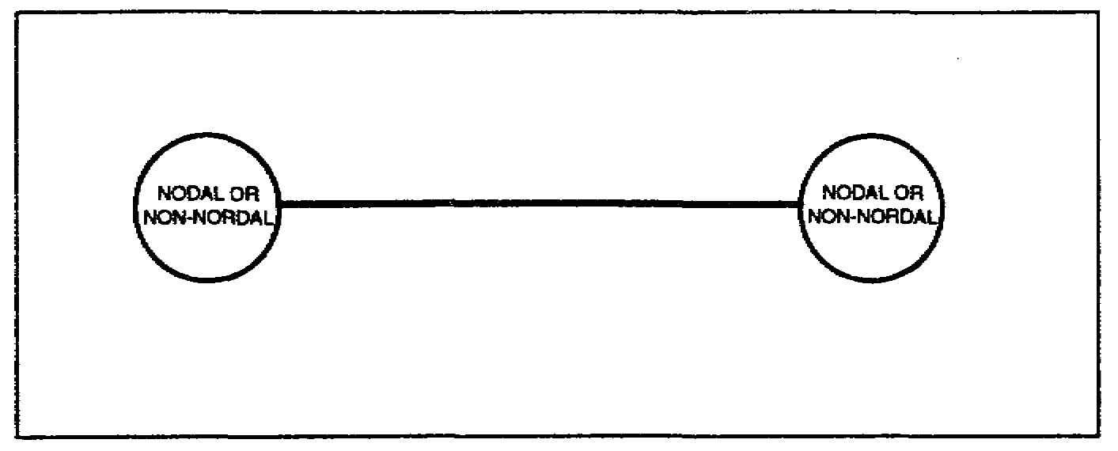

Figure 5-1. Terminals in a point-to-point configuration.

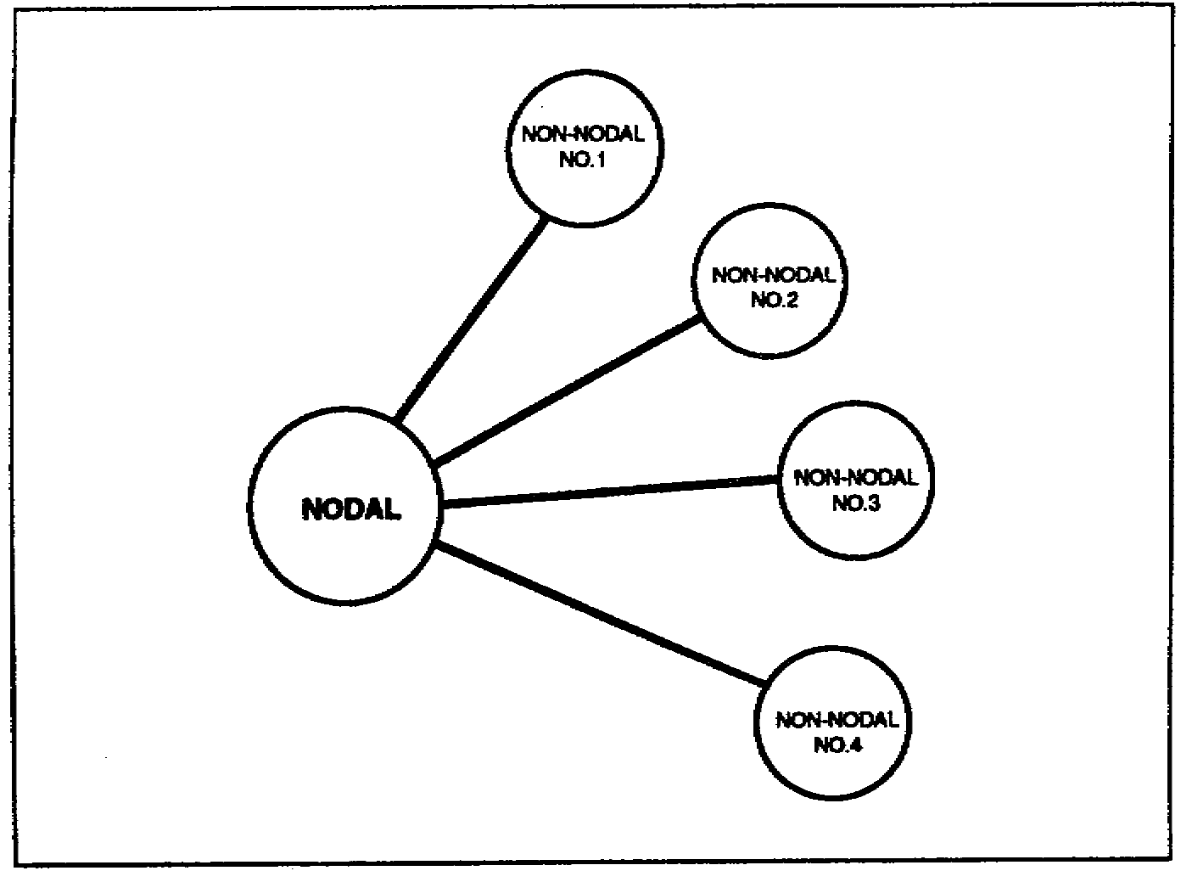

Figure 5-2. Terminals in a hub-spoke configuration.

SS0031 5-4

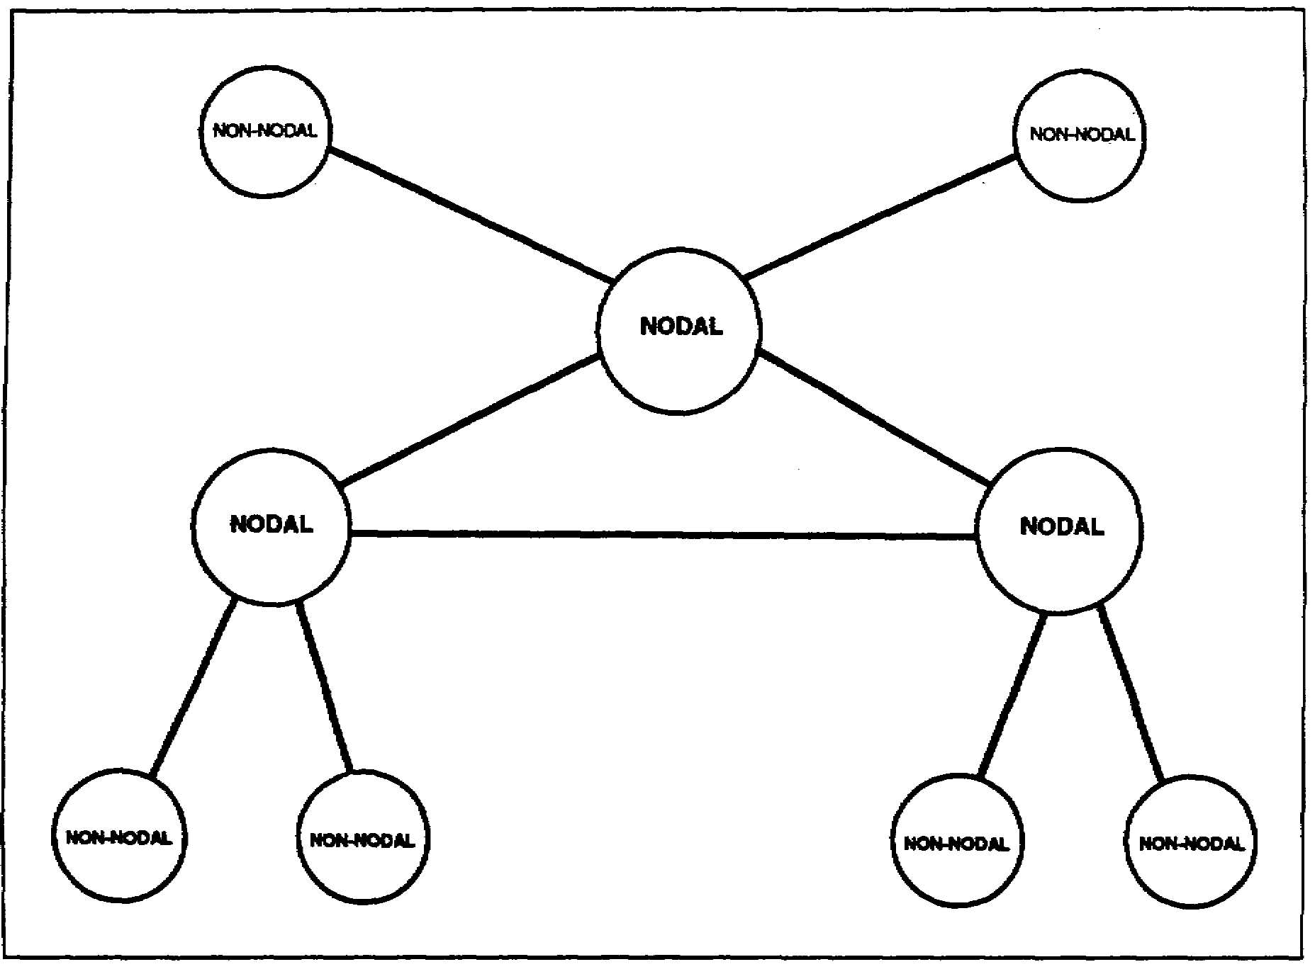

Figure 5-3. Terminals in a mesh or hybrid configuration.

7. A modified S-250 shelter houses the AN/TSC-93B TACSAT terminal. It operates with the AS-3036/TSC (8-foot diameter) antenna.

a. The shelter is normally transported on the bed of a 2 1/2-ton truck with the disassembled 8-foot antenna on an M1028 commercial utility cargo vehicle (CUCV). Each truck tows a trailer-mounted diesel generator or power unit.

b. Three curbside racks inside the shelter contain the baseband (multiplexing or demultiplexing) equipment. Three racks on the roadside of the shelter contain the modem and IF or RF assemblies.

c. Each part of the satellite terminal equipment is transportable by road, air (C-130, C-141, C-5A, or helicopter), rail (flatbed), and sea (ship).

8. The AN/TSC-93B TACSAT terminal (non-nodal terminal) provides the following:

a. Transmission of an SHF uplink carrier with up to 24 channels of voice and/or data (internally multiplexed). If only 12 channels are to be transmitted, one additional digital transmission group (DTG) of voice and/or data (externally) multiplexed source may

5-5 SS0031

also be transmitted. Alternatively, two CDI DTGs may be transmitted, one of which must be 256 kb/s or less; the other may be a data stream up to a maximum of 576 kb/s.

b. Link with a non-nodal terminal in the point-to-point or a nodal terminal hubspoke mode.

c. On the downlink side, can receive, demodulate, and switch a single SHF carrier via the demultiplexing equipment to the user interface.

d. Fully independent operation from a 10-kilowatt, three-phase, five-wire diesel generator or compatible commercial power.

e. Link with DSCS gateway terminal to provide DCS entry.

LEARNING EVENT 3: EMPLOYMENT

1. Limitations. Channel capacity on DSCS II and DSCS III satellites limits the number of TACSAT terminals that can operate at any one time. This number varies depending on several factors. These factors can include the type of terminal, number of channels, condition of terminals and satellite, size of antenna, and location of terminals within satellite footprint. These factors and others (for example, weather) affect how many terminals can use a satellite. For these reasons it is not possible to give a clear-cut number of terminals that can be operated at any one time. Unfortunately, there is not enough space segment to satisfy all the users. It should be stressed that DSCS II and DSCS III satellites support Army, Navy, Air Force, Marine, and other DoD/non-DoD users. The satellite channels on DSCS II and DSCS III are Joint Chiefs of Staff (JCS) assets and therefore not dedicated to any particular service.

2. Division.

a. The divisions receiving multichannel TACSAT terminals are selected based on their operational areas, terrain, and distance considerations. The signal battalion installs, operates, and maintains the AN/TSC-85B/93Bs.

b. In selected divisions, five multichannel TACSAT terminals provide extended distance connectivity. Division main and division support command (DISCOM) use one AN/TSC-85B each. One AN/TSC-93B is deployed to each of the three maneuver brigades. This is at the commander's discretion. An AN/TSC-85B at division main might terminate links from each maneuver brigade and DISCOM. During division main displacements, the terminal at DISCOM acts as the hub.

3. Corps. In the corps, two AN/TSC-85Bs and four AN/TSC-93Bs are pooled to provide support based on the general support (GS) concept. Terminals in support of corps are used for various missions such as restoration of critical links, out of sector operations, and deep operations. This concept has been developed based on the range extension capability of the MSE system. The corps signal brigade installs, operates, and maintains the AN/TSC-85B/93Bs.

SS0031 5-6

4. Contingency corps.

a. AN/TSC-85B/93Bs are distributed to the contingency corps based on their mission. The corps signal brigade installs, operates, and maintains the AN/TSC-85B/93Bs.

b. In the contingency corps, five AN/TSC-85s and eight AN/TSC-93Bs provide a low capacity multichannel range extension capability, independent of terrain and sitting restrictions. It provides links from corps main and forward CPs to corps support command (COSCOM), the subordinate divisions, and other attached units.

5. Echelons above corps (EAC).

a. At EAC, multichannel TACSAT provides connectivity between key EAC headquarters. EAC has been provided six AN/TSC-85Bs and ten AN/TSC-93Bs based on distance, terrain, criticality of links, and the need to augment LOS relays.

b. TACSAT provides connectivity between major Army and combined commands in Europe and Korea.

6. Contingency support.

a. For Army and JCS crisis contingency support missions, AN/TSC-85B/93Bs are allocated to a TACSAT company, table(s) of organization and equipment (TOE) 11603. They deploy in support of Army and JCS contingency missions worldwide. This unit uses M-720 mobilizers for its AN/TSC-85Bs. The United States Army Infantry School (USAIS) installs, operates, and maintains the AN/TSC-85B/93Bs.

b. The contingency corps area of operations is normally much larger than a doctrinal corps and requires augmentation. Three AN/TSC-85Bs and six AN/TSC-93Bs are allocated to the 235th Signal Detachment. They augment the contingency corps and Army contingency mission. This unit is also authorized M-720 mobilizers for its AN/TSC-85Bs.

LEARNING EVENT 4: CONTROL AND MANAGEMENT

1. USARSPACE RSSC GMF managers control and manage the TACSAT communications SHF multichannel terminals. These managers are collocated with the DISA elements at DISA-Europe, DISA-Pacific, and DISA-Washington. The GMF managers are the theater Commander in Chiefs (CINC) resource managers and interface to the DSCS and DISA. DISA is the overall DSCS system manager and technical director providing satellite resources to the GMF managers.

2. Communications control matches resources against requirements. It occurs at all levels of the control and management structure. The TACSAT multichannel terminals use the DSCS space system which includes the DSCS II and DSCS III satellites. The

5-7 SS0031

availability of resources is considered in all cases as in the single-channel TACSAT program. Emphasis is also placed on mission and organizational priorities in accordance with JCS military operations (MOP) 178.

3. The process for GMF satellite control, management, and access flow follows the path outlined below.

a. Communications system planning element (CSPE). The CINC's CSPE planner coordinates, consolidates, and prioritizes the user element's satellite requirements within his theater. He submits satellite access requests (SARs) to the GMF managers. On approval, he receives the satellite access authorization (SAA) that provides operation orders (OPORDs) or operation plans (OPLANs) to the terminal operators.

b. RSSC GMF manager. The RSSC GMF manager-

• Receives the SAR from the CSPE.

• Coordinates with DISA for added resources (if required).

• Develops alternate plans and coordinates with the CSPE if SARs cannot be met due to resource restrictions.

• Initiates and transmits an SAA to the CSPE or denies access based on available resources.

• Sends a copy of the SAA to the relevant Defense Satellite Communications System Operations Center (DSCSOC).

c. DISA. The DISA-

• Is the system manager and technical director for the DSCS.

• Allocates the resources available

• Adjudicates resource requirements between GMF and DSCS user.

d. JCS. The JCS adjudicates differing resource requirements of the CINC which cannot be resolved between the CSPE, the GMF manager, and the DISA due to resource limitations.

e. GMF network controller (GNC). The GNC-

• Is under the operational control (OPCON) of the GMF manager

• Has OPCON of all GMF TACSAT terminals

• Uses resources within the GMF allocation and the SAA

SS0031 5-8

f. The DSCSOC controller. The DSCSOC controller-

• Is the satellite network controller (SNC)

• Has overall control of the DSCS satellite

• Monitors the GMF subnetwork for violations and notifies the GNC for correction

LEARNING EVENT 5: SYSTEM CONFIGURATION

1. Capabilities. The AN/TSC-85B/93B terminal configurations allow digital interface with TRI-TAC equipment and MSE. They also provide limited capability for analog input and an ECCM capability for operation in a stressed environment. The baseband improvement modification incorporated replacing the TD-660s, TD-1065s, TD-1069s, KG-27s, and adding the antijam/control modem (AJ/CM), LRM/TD-1389, and KG-94A. Upon completing the program, the modified terminals were redesignated as AN/TSC-85B/93B.

2. AN/TSC-85B. Four TD-660s and TD-1065s were replaced by four TD-1389s to function as the multichannel multiplexer for unstressed/clear mode communications. Two CV-1548 telephone signal converters and two MX-9635 echo suppressors were removed and two CV-1548s and MX-9635s will remain. These two unit pairs will remain to support use of two-wire telephones. Four TD-1069s or their reserved cavity locations, were removed and replaced by four TD-1389s to function primarily as a multiplexer for the AJ/CM, or alternately as a submultiplexer into another TD-1389. Eight TD-1389s will be installed in each AN/TSC-85B. Sufficient crosspatch capability was provided to permit any TD-1389 to function in any role. Baseband patching will be available to provide access to all baseband ports on the shelter entry panels. This will allow the individual channels of the CV-1548/MX-9635 to be patched into any user channel as required. In addition, four KG-27s were replaced by four KG-94As to provide bulk encryption for four unstressed/clear mode multichannel groups. A nodal terminal AJ/CM will be installed. It will provide an antijamming communications channel and will replace the FM control orderwire. Four STU-III/equivalent 2.4 kb/s secure voice devices will be added to provide an AJ/CM stress mode secure voice capability. All other items in the terminal will remain the same.

3. AN/TSC-93B. Two TD-660s and two TD-1065s were replaced by one TD-1389 to function as the multichannel multiplexer for unstressed/clear mode traffic. One CV-1548 and one MX-9635 were removed and one of each will remain to support use to two-wire telephones. One TD-1069, or its reserved location, was removed and replaced with one TD-1389 to function primarily as a multiplexer for the AJ/CM or alternately as a submultiplexer into another LRM/TD-1389. A total of two LRM/TD-1389s were installed.

5-9 SS0031

Sufficient crosspatch capabilities were provided to permit any TD-1389 to function in any role. Baseband patching is able to access all baseband ports on the shelter entry panels. This will allow the individual channels of the CV-1548/MX-9635 to be patched into any user channel as required. In addition, two KG-27s were replaced by one KG-94A to provide bulk encryption for one unstressed multichannel group. A non-nodal terminal AJ/CM will be installed. This AJ/CM will provide an antijamming communications channel and replace the FM control orderwire. One STU-III/equivalent will be added to the AN/TSC-93B to provide an AJ/CM stress mode secure voice capability.

4. Differences. The main differences in tactical multichannel terminal configurations are the types and amount of redundant equipment in the configuration and the terminal's communications capability. The equipment is configured in either a nodal (hub) or non-nodal (spoke) configuration. A nodal terminal can be configured to operate with up to four terminals in a multipoint operation. Any two terminals, either nodal or non-nodal, can be configured to provide a point-to-point requirement.

LEARNING EVENT 6: ANTIJAMMING AND ECCM TECHNIQUES

1. AJ/CM is a family of spread-spectrum modem equipment designed to provide GMF TACSAT terminals with an ECCM capability for operation in a stressed environment. The normal mode of operation for high capacity links in a benign or nonstressed environment uses the current biphase shift keying/quadraphase shift keying (BPSK/QPSK) modems and FDMA link accesses.

2. The family of modems consists of a network control terminal (NCT), a nodal terminal (NT), and a non-nodal terminal (NNT). The AJ/CM provides a lower capacity 75 bp/s and 32 kb/s communications capability and an antijamming control orderwire.

a. NCT modem. The AN/MSQ-114/FSQ-124 satellite control and monitoring systems use the NCT modem. It is made up of two chassis assemblies-the MD-1133 and the OX-63 coder group.

(1) The MD-1133 network control unit (NCU) interfaces with the terminal frequency reference and distributes time and frequency to the NCT internally. The NCU also provides the NCT modem modulation/demodulation functions. User commands initialize and control NCU hardware elements to perform major NCT operations or processing. The NCT contains bus logic to control an externally-programmable downconverter. The NCT also provides modem and network status monitoring and provides status and messages to the NCT operator.

(2) The OX-63 coder group, transmission security (TRANSEC), 4-channel unit houses four KGV-9 TRANSEC modules, associated interface circuits, and the necessary power supplies.

SS0031 5-10

b. NT modem. Army and Marine AN/TSC-85As and Air Force AN/TSC-100As use the NT modem. It is made up of three chassis assemblies, the MD-1131 modem, the MD-1132 communications unit, and the OX-64 coder group.

(1) The MD-1131 modem contains a beacon demodulator, a 75 bp/s critical control circuit (CCC), and a variable data rate 75 bp/s to 32 kb/s link communications circuit (LCC). This modem also contains all operator controls.

(2) The MD-1132 communications unit contains three LGCs. These circuits provide the three links required for hub operation.

(3) The OX-64 coder group, TRANSEC, 10-channel unit houses ten KGV-9 TRANSEC modules, associated interface circuits, and the power supplies.

c. NNT modem. Army and Marine AN/TSC-93As, Air Force AN/TSC-94As, and selected satellite fixed station gateway terminals use the NNT modem. It is made up of two chassis assemblies-the MD-1131 modem and the OX-63 coder group.

(1) The MD-1131 modem is identical to the NT modem.

(2) The OX-63 coder group, TRANSEC, 4-channel unit is identical to the NCT modem.

LEARNING EVENT 7: DATA ENTRY

Data entry requirements for the operator of a multichannel TACSAT terminal AN/TSC-85B/93B consist of information (data) extracted from the SAA by the CSPE and included in either the mission OPLAN or the exercise OPORD.

1. This information takes the form of-

• Operating frequencies (may not apply until SAA is received).

• Data rates.

• Transmit power (may not apply until SAA is received).

• Mission configuration.

• Terminal identification.

5-11 SS0031

• Terminal locations.

• Satellite "look angles" (azimuth and elevation) (may not apply until SAA is received).

• Mission start and stop time.

• Priority of communications.

2. The CSPE extracts this information from the OPLAN/OPORD and provides it to the terminal operator. The data entries are categorized and differentiated between operating parameters, network characteristics, and configuration routines. Figures 5-4 and 5-5 are examples of data entry sheets.

a. Operating parameters include-

• Transmit frequencies.

• Receiver frequencies.

• Transmit power.

• Terminal locations.

• Satellite "look angles" (azimuth and elevation).

b. Network characteristics include-

• Data rates.

• Network configurations.

• Terminal call sign.

SS0031 5-12

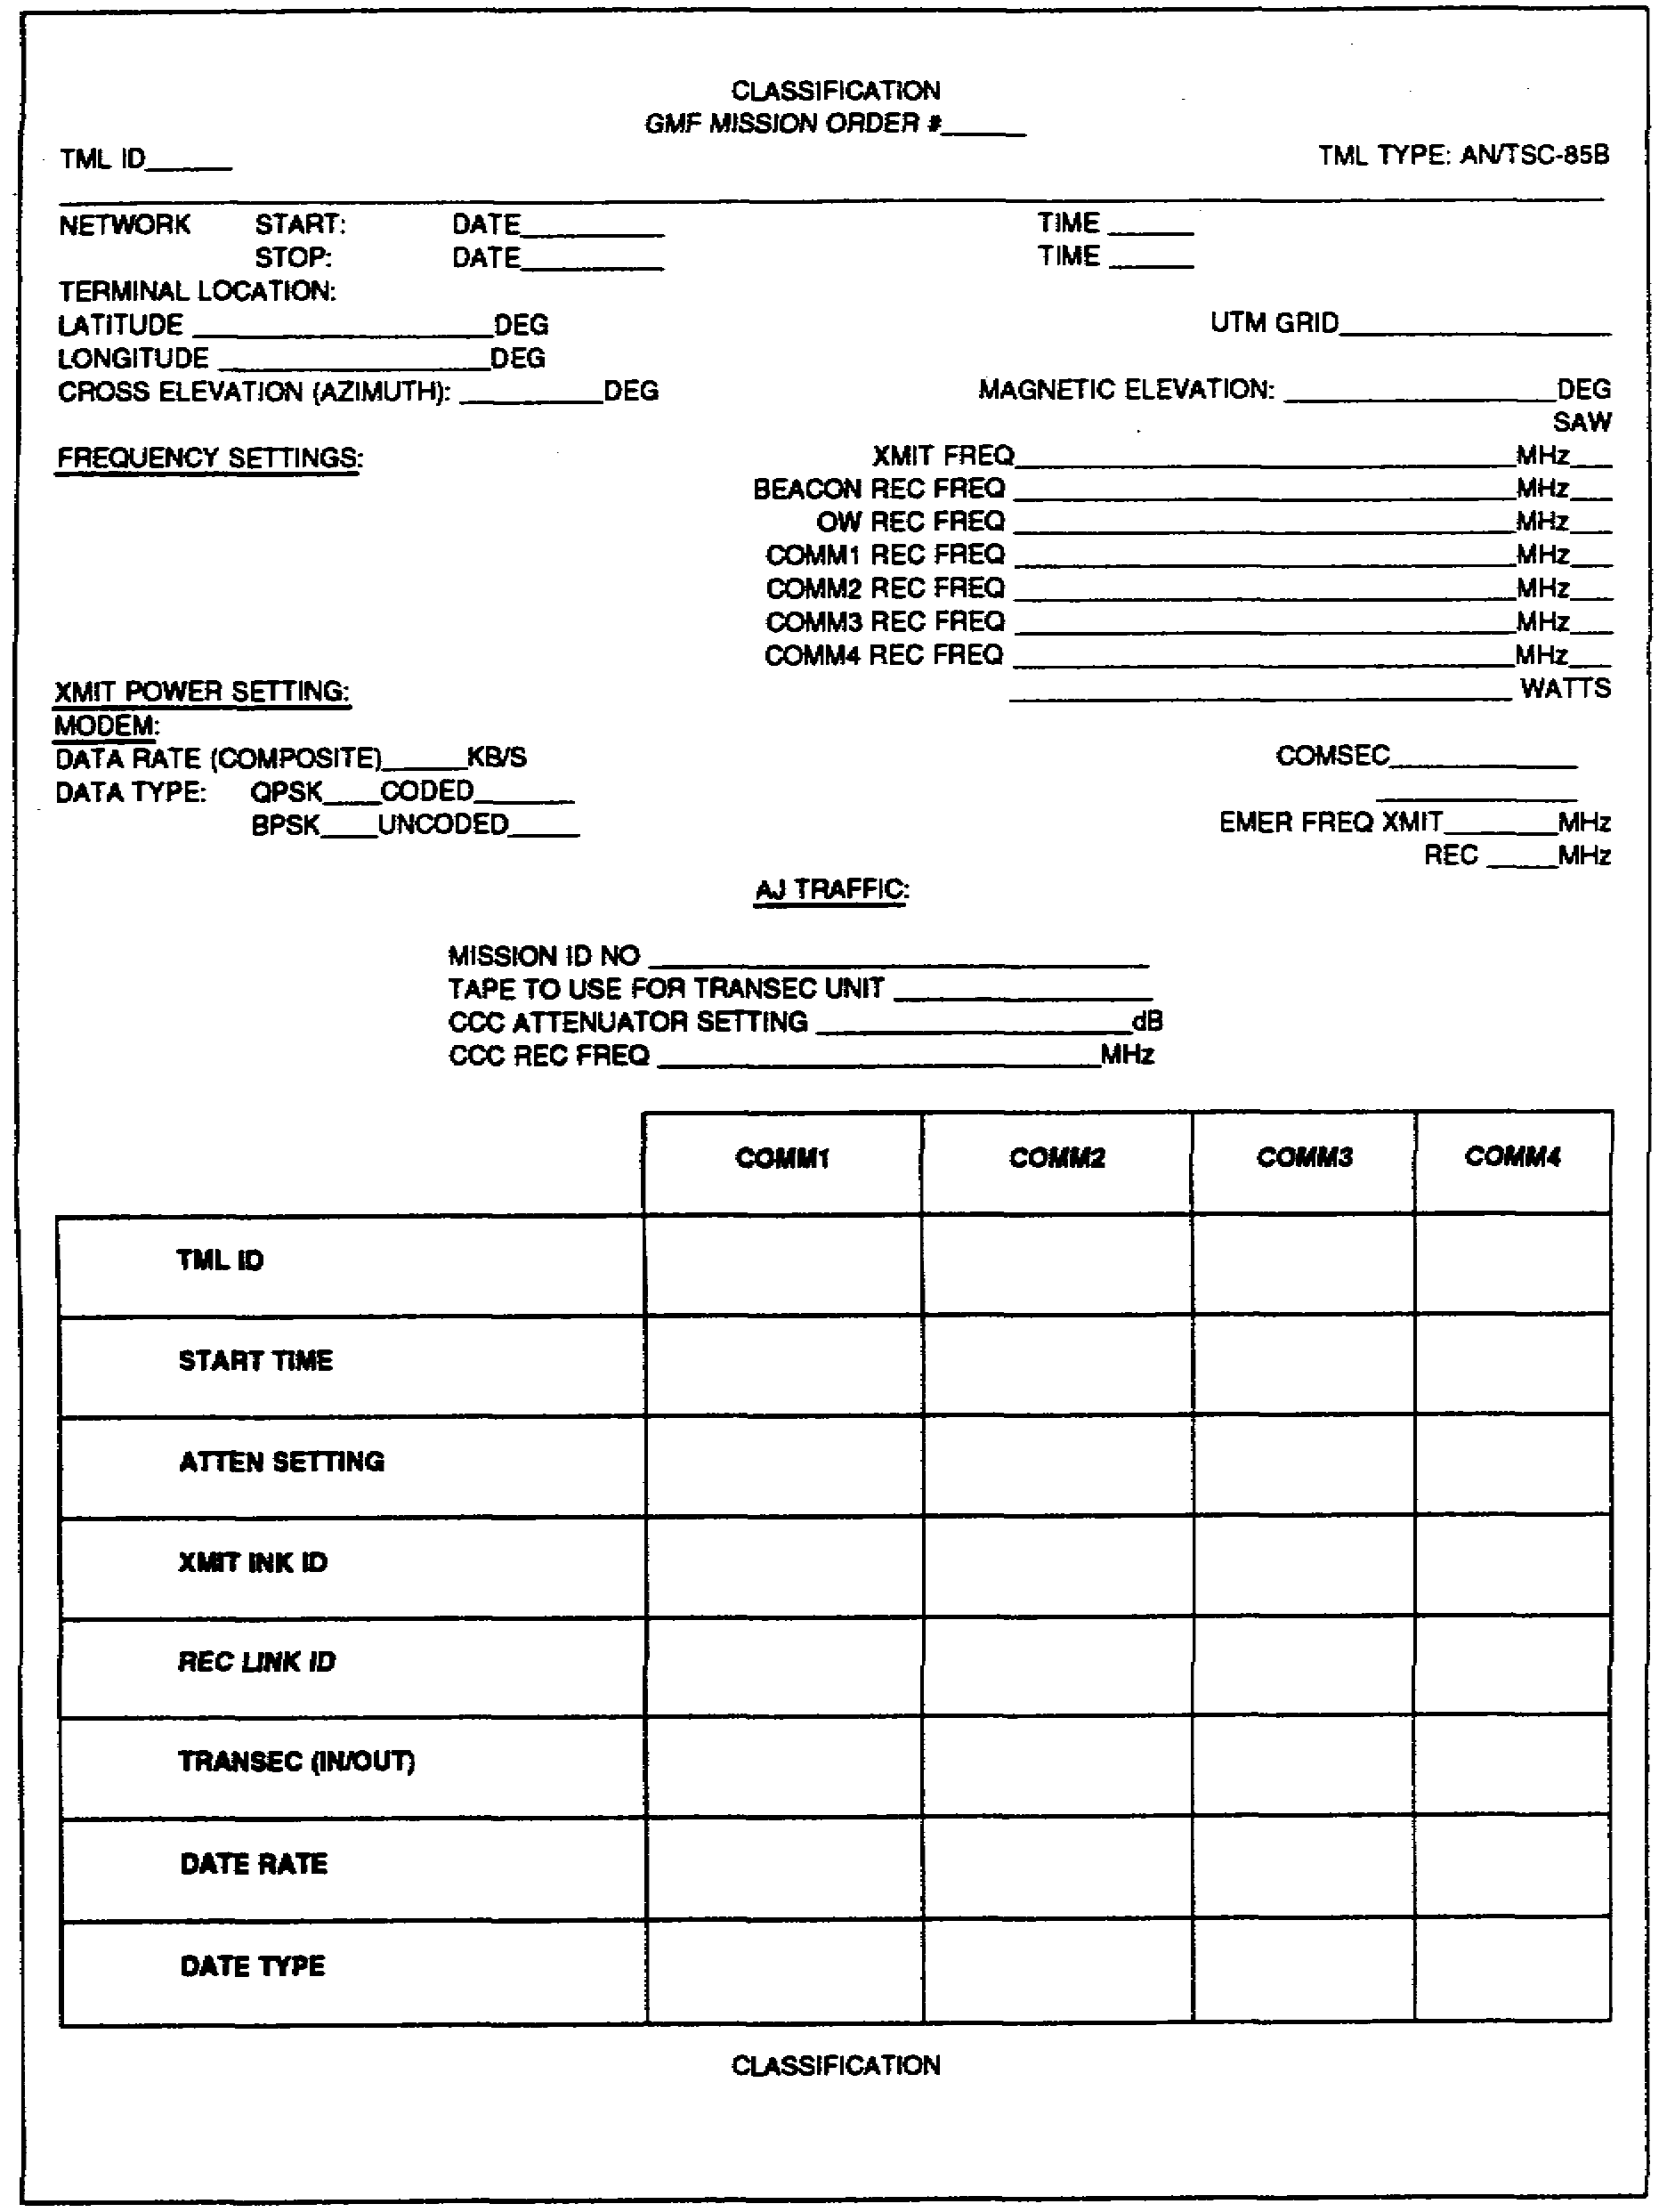

Figure 5-4. Example of a GMF mission order for AN/TSC-85B.

5-13 SS0031

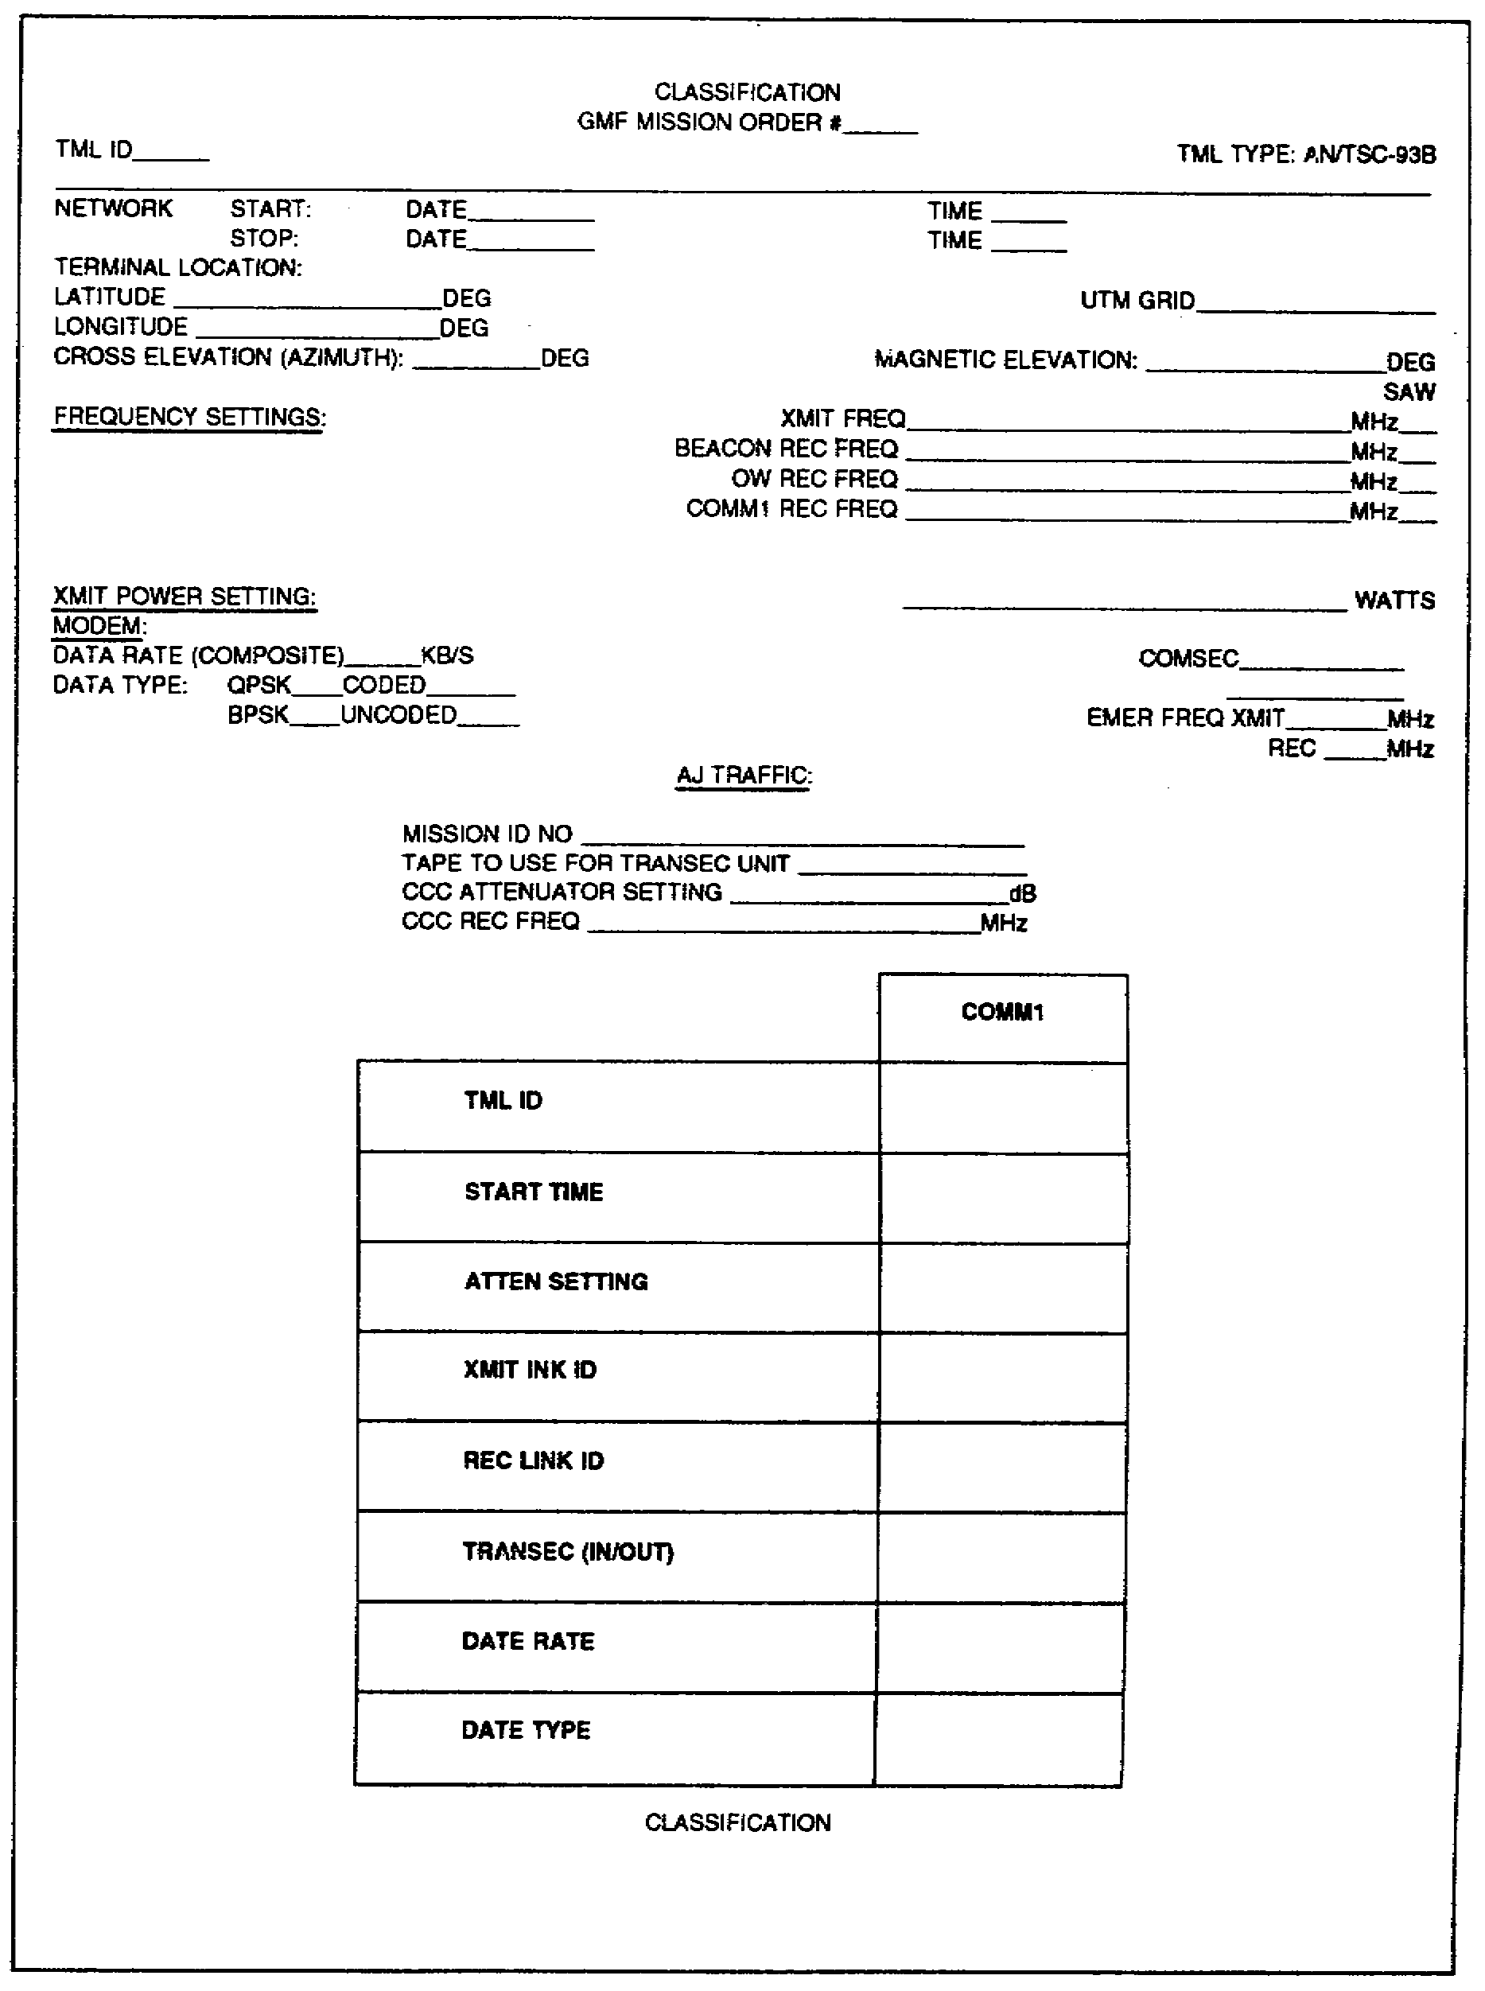

Figure 5-5. Example of a GMF mission order for AN/TSC-93B.

SS0031 5-14

SECTION II. MULTICHANNEL CONTROL SYSTEM

LEARNING EVENT 8: SYSTEM DESCRIPTION

1. With multichannel TACSAT communications terminals in use by the Army, Air Force, and Marine Corps, the DSCS controller cannot accommodate the increased number of users. The ground mobile forces satellite communications (GMFSC) system operates as a subnetwork providing its own control system. This prevents interference degradation for other users of the DSCS SHF satellites.

2. The GMF satellite communications control centers (GMFSCCC), AN/MSQ-114 and AN/FSQ-124, provide mobile and fixed control facilities. The United States Army Information Systems Command's (USAISC) operation and control procedures contain specific information and instructions on GMFSC planning, control, management, and terminal user procedures. (These procedures are currently being revised.)

3. Specially trained US Army GMF controllers provide GMFSC control for the terminals deployed by the multiservice (Army, Air Force, and Marine Corps) GMFSC system. The GMF controllers continuously monitor the downlink signs for all terminals in their networks to control uplink signals. They direct changes as necessary. The controller ensures that all terminals operate within the proper limits of frequency, power, and channel capacity. Should any discrepancies take place, the controller communicates by orderwire to initiate the changes necessary.

4. The GMFSCCC operates in the SHF frequency range of 7.9 to 8.4 GHz transmit and 7.25 to 7.75 GHz receive. Orderwire and AJ/CM units are used for communicating with terminals under their control. The satellite automatic monitoring system (SAMS) is used to monitor downlink frequencies of all terminals. This provides control over uplink power and frequency.

LEARNING EVENT 9: DEPLOYMENT

The AN/MSQ-114 is usually deployed one unit per theater of operation. Since the AN/MSQ-114 is a limited production item, its deployment is rigidly controlled. The AN/MSQ-114 can support forward deployed forces, nonforward deployed forces, or contingency operations. Nonforward deployment usually refers to the home location of the GMFSCCC (either AN/MSQ-114 or AN/FSQ-124). The control system must be within the respective satellite footprint, which usually is the NC/AC antenna footprints for DSCS II or the GDA footprint for the DSCS III satellites. (See Figure 5-6 on page 5-16.) Using DSCS II, a GMFSCCC located in Korea can control GMF terminals in continental United States (CONUS), provided the control system and GMF terminals are within the NC/AC footprints on that satellite. On DSCS III, the control system and GMF terminals must be within the GDA footprint. If the NC/AC or GDA footprint is moved to support a mission so that the control system falls outside the footprint, the AN/MSQ-114 would be deployed into a footprint to allow control coverage of the GMF mission.

5-15 SS0031

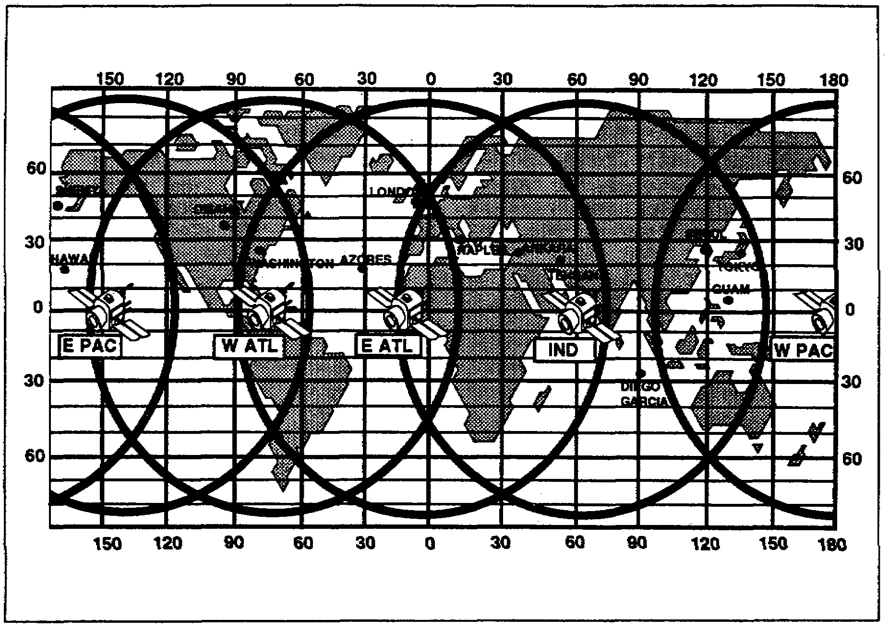

Figure 5-6. Earth coverage areas of a five-satellite system.

LEARNING EVENT 10: EMPLOYMENT

1. In their normal employment, the AN/MSQ-114 and the AN/FSQ-124 can control a number of GMFSC terminals. The exact number of terminals being controlled depends on the network configuration and the mission requirement. A point-to-point configuration is used when connectivity between two low-capacity terminals is desired. The hub-spoke configuration uses a multichannel terminal as the hub. Up to four low-capacity terminals are used as the spokes. When at least two hub terminals are connected by communications and each operates with up to three spoke terminals, a hybrid configuration is derived. The control terminal can monitor and control any configuration that may be active within the control area.

2. In the networks designated for control by an AN/MSQ-114 terminal, the controller-

• Coordinates satellite access data with the GMF manager.

• Establishes positive GMFSC subnetwork satellite control.

• Evaluates and determines satellite link parameters.

SS0031 5-16

• Establishes and reconfigures approved satellite networks.

• Conducts antijamming operations.

The first step in the start procedure after the AN/MSQ-114 is on station at a new location is to activate the control orderwire to the DSCS controller. Frequencies to be transmitted and received are authorized by the GMF manager from an allotment granted to the GMFSC system by DISA. Other system parameters that are determined prior to start are transmit power, number of channels, and type of modulation coding priority. The GMF controller accesses each tactical terminal using the control terminal (CT) orderwire. The controller then directs the adjusting of transmit power to achieve planned link performance. Measurements are made and entered into the SAMS for real-time monitoring of the link.

3. To evaluate link parameters, the SAMS monitors the network for out of tolerance conditions. Manual spectrum analyzers and user reports are also used to evaluate link parameters. Bad weather, equipment, operator errors, satellite problem and intentional or unintentional interference may cause problem conditions. The GMF controller detects and analyzes network problems. The next step is to direct work-around solutions. These solutions may be temporary power adjustments, reduction-in-link capacity (drop out by priority), or instructions to operators. In some cases, it may be necessary to interrupt service for major maintenance actions. The GMF controller maintains a log of all problems and terminal faults. A network status display printout is also maintained. The status display printouts that are available in the SAMS data base are status and statistics reports. These reports are available as a hard copy, a cathode ray tube (CRT) display, both on command, or at regularly timed intervals.

a. The status report displays the condition of authorized carriers under control of the AN/MSQ-114. This is done by a measured carrier-to-noise temperature ratio (C/KT) reading, a calculated energy per bit-to-noise density ratio (Eb/No), an operating noise temperature, an authorized C/KT, and a percentage of satellite allocated power for each terminal. A summary page of the status report shows-

• Measured percentage of transponder power.

• Allocated percentage of transponder power.

• Measured percentage of GMF power.

• Measured transponder C/KT.

b. The statistics report is generated for a given start and stop time frame with an established number of samples taken. For each terminal under control of the AN/MSQ-114 the report shows-

• Mean C/KT (dB).

• Authorized C/KT (dB).

5-17 SS0031

• Departure from authorized C/T (dB).

• Highest C/KT and time measured.

• Lowest C/KT and time measured.

• Number of samples taken.

4. Often, during network operations, it may be necessary to reconfigure a real-time link or the whole network. Some of the causes for reconfiguration are-

• Rapid terminal relocation.

• Enemy action.

• Degradation of a link.

• Changes in communications requirements.

5. Reconfiguration by adding or deleting terminals is done by the GMF controller. This involves changes to the SAMS data base and coordination with the tactical terminal by orderwire. Terminal relocation requires immediate action by the controller to coordinate the movement. New system parameters and look angles must be provided and the SAMS data base updated. Adding a new type Earth terminal and using a new satellite also requires reconfiguration. The GMF controller has the authority to reconfigure the network until changes in satellite power or new frequency assignments are required; then, the GMF manager must be informed of the change required. The DSCS controller is responsible for the DSCS satellite communications network. Since the GMF controller must interface with the DSCS controller when any action that takes place might impact on network performance. Coordination is normally required-

• Before GMFSC terminals come on the air.

• When changes in GMFSC transmit power are required.

• When serious link degradations occur that cannot be isolated by the GMF controller.

6. A more serious condition is when the DSCS controller informs the GMF controller that violations have taken place in the GMFSC network. As mentioned previously, a major duty of the GMF controller is to monitor the uplink and downlink characteristics of the GMFSC network for out of tolerance conditions. The result of this monitoring is to help TACSAT communications terminal operators find stations that are at fault and correct the problems. In severe cases, such as satellite failure or interference, the DSCS controller must help pinpoint and rectify the problem. The GMF controller, closely coordinating with the DSCS controller, directs and implements network antijamming plans.

SS0031 5-18

LEARNING EVENT 11: CONTROL AND MANAGEMENT

TACSAT communications links are not independent, unlike conventional radio communications such as HF or LOS. All links in a network use the same satellite transponder. Each of the users must carefully configure their link with reference to other users and keep uplink power within an allotted level. Failure to follow these guidelines will have-harmful consequences on all other users. The increase of power on one link improves the quality of that link but intermodulation products increase and cause interference on the other links. A large increase in power causes the downlink carriers on other links to be suppressed. Control of all links using the same satellite transponder is important. While the GMF controller is a major player in the operation, overall control is distributed among six activities. Those responsible for controlling the GMF/TACSAT communications resources are described in the following paragraphs.

1. The planner plans the action and provides the following information when establishing a communications link using a DSCS satellite:

• Types of terminals and locations.

• Connectivity of the network (for example, terrestrial, switchboard, and direct interface).

• Channel requirements.

• Duration of exercise.

• Priorities for individual links.

• Backup communications.

2. The GMF manager is responsible for managing the satellite resources allocated to the GMFSC. The manager combines all requests and coordinates any conflicting requirements by-

• Apportioning a share of the satellite resources to each requester.

• Designating uplink and downlink frequencies, transmit power levels, data rates, C/KT and bit error rates, link margins, and detailed equipment settings.

• Issuing orders for reconfiguring the system due to changing requirements.

• Maintaining logs of system and station failures, interference problems, and violations by the users.

• Interfacing with the DSCS controller to determine proper operation.

• Negotiating for extra power for the GMFSC users as the situations warrant.

5-19 SS0031

3. The DSCS controller is responsible for the DSCS network. This encompasses all users including GMF terminals working a particular satellite. The DSCS controller-

• Closely coordinates with the GMF controller during start and antijamming procedures.

• Informs the GMF controller when violations occur on the GMFSC network.

• Links up with the GMF controller on the control orderwire.

4. The GMF controller operates under the direct supervision of the GMF manager. The controller operates and maintains the control and monitoring equipment. The GMF controller-

• Establishes a positive control with each terminal over the control orderwire.

• Starts communications links within parameters provided by the GMF manager.

• Monitors systems and link performance.

• Controls adjustments of links to satisfy performance requirements.

• Instructs violators to operate within assigned parameters and reports willful violations.

• Analyzes system and station malfunctions.

• Maintains orderwire link with GMF operators and DSCS controllers.

• Analyzes jamming signals and interference to determine corrective actions.

• Determines frequency compatibility when terminals are relocating.

• Assigns previously cleared frequencies to another user when interference in the network is present.

5. The TACSAT communications terminal operator interfaces directly with the GMF controller. The user or operator follows instructions and reports status and performance of the TACSAT communications terminal. The operator-

• Operates and maintains the TACSAT communications terminal.

• Follows the GMF controllers instructions and coordinates during link start for reconfigurations and at the same time isolates system malfunctions.

• Monitors uplink power, downlink signal levels, and bit error rate (BER).

• Relocates TACSAT communications terminal on proper command.

SS0031 5-20

• Notifies the GMF controller of the move time and new terminal location.

• Interfaces with technical control of the subscriber.

LEARNING EVENT 12: SYSTEM CONFIGURATION

1. The GMFSCCC is deployed in a number of different system configurations depending on the mission and theater of operations. The simplest configuration is point-to-point, where the GMF controller monitors over two TACSAT communications terminals each used as a point. The slightly more complex network is the hub-spokes configuration. Each low capacity terminal becomes one of the spokes operating with either the AN/TSC-85B or AN/TSC-100A. The hybrid configuration deals with a number of hub-spoke configurations with the hubs communicating with each other as well as the spokes in their configuration. A DSCS terminal (a fixed station satellite communications facility called gateway) can replace a low capacity GMF terminal. In these configurations, the AN/MSQ-114 has an orderwire control link with all the TACSAT communications terminals and a monitor link to the satellite. The AN/MSQ-114 can communicate with a DSCS terminal via the terrestrial critical control circuit (TCCC) network using either an established terrestrial link or a communications circuit via the satellite. To make DSCS terminals compatible with GMFSC terminals, additional equipment must be included in the digital communications subsystem (DCSS) of the DSCS terminal. The GMF contingency rack 20 low rate initial production (LRIP) and GMF contingency rack 20A are single racks giving limited operational capabilities to the DSCS terminals in the GMF network. To enhance the capabilities, additional racks are added to produce the DSCS/GMF gateway racks. Included are encryption devices, antijamming modems, LRSs, and patch panels. The complement of racks is increased to six in this configuration.

2. The AN/MSQ-114 terminal consists of an environmentally controlled 34-foot semitrailer, two power generators, a 20-foot parabolic antenna, prime movers, and a shelter for maintenance and storage of spare parts. The AN/FSQ-124 consists of four electrical racks, a roll-around cart, and a control console in the facilities of the host terminal.

3. The AN/MSQ-114 antenna is a 20-foot parabolic antenna type AS-3199/TSC. It has a limited motion of +10 degrees cross elevation and a full 90 degrees in elevation. Antenna control can be from inside of the van or remote. The modes of operation provided are manual, acquisition, and auto-track. To acquire a satellite, the antenna must be implaced with the azimuth look angle very close to the bore sight of the feed system.

a. The receive subsystem consists of redundant antenna mounted low noise amplifiers (LNAs) with 37 to 41 dB gain each and the down-converters. The receive signal is processed from the LNA to a power divider that provides an eight-way split. Two of the outputs from the divider are dedicated to the SAMS equipment. Five are connected to five down-converters. The eighth is reserved for future addition of a sixth down-converter.

5-21 SS0031

b. The down-converters are a double conversion type with a 70-MHz output. Frequency selection for the down-converters is accomplished by front panel controls or by a microprocessor in an associated orderwire modem in the remote mode. Three down-converters can feed the AJ/CM with a beacon/CCC signal, an acquisition signal, and a polling signal.

c. The cesium beam standard, which is the principal part of the frequency generation subsystem, is also redundant. The on-line unit provides outputs of 5 MHz and one pulse per second for precise timing to the AJ/CM and other units as needed.

d. The transmit subsystem consists of up-converters, amplifiers/mixers, and power amplifiers (PAs). Redundancy is presented in the PA, high voltage power supply, and amplifier/mixer assemblies. The PA has a maximum power output of 500 watts with an adjustment range of 20 dB. Three up-converters are provided with a future development for a fourth. They accept a 70-MHz signal from the orderwire or AJ/CM modem. Through a conversion process, the transmit frequencies are presented to the intermediate power amplifier (IPA) /attenuator to be raised to a suitable power level for driving the PA.

4. The AN/FSQ-124 is a component of a DSCSOC which is collocated with a host Earth terminal. The host Earth terminal can be an AN/GSC-39, an AN/GSC-52, or an AN/FSC-78. The AN/FSQ-124 consists of a remote orderwire console and four equipment racks that contain up- and down-converters, SAMS, IPAs, and orderwire modems. The AN/FSQ-124 is operated and maintained by a specially trained operator who is one of the five individuals normally on shift in the DSCSOC.

LEARNING EVENT 13: ANTIJAMMING AND ECCM TECHNIQUES

1. The AN/MSQ-114, acting as the NCT, has the AJ/CM (ED-1133) that belongs to a family of spread spectrum modem equipment designed to provide the GMFSC terminals with ECCM capability for operation in a stressed environment. The spread spectrum link provided by the AJ/CM is more difficult to jam. This signal can coexist with the FDMA links by sharing the same frequency spectrum and presenting the appearance of not even being there. This link may well be the last ditch signal available in a stressed environment.

2. The MD-1133 used in the AN/MSQ-114 consists of one chassis assembly, the NCU. The NCU has a control and bus logic which provides functional terminal modem organization, execution, and control. The NCU control processor directs external programmable up-/down-converter synthesizer frequency control. The NCU requires a preset frequency and time reference from an external cesium beam standard. Redundant frequency standards (HP5061A), which are part of the AN/MSQ-114, provide the required time and frequency references. The NCU provides buffering for time and frequency reference signals for computational and code use. Software is modularized to specific terminal operations and functions. Terminal tasks are modularly executed through

SS0031 5-22

combinations of software modules, operator control, and fixed microprocessor hardware logic. Network control and status functions are provided on the NCU front panel along with monitor test and fault isolation functions. The AJ/CM replaces the RT-1287 nonsecure FM orderwire. It operates as an orderwire between the NT in addition to its communications function. In a jammed environment, the AJ/CM equipment provides the antenna tracking signal instead of normal communications tracking.

LEARNING EVENT 14: DATA ENTRY

1. The SAMS element of the AN/MSQ-114 and the AN/FSQ-124 provides the data base for planning GMF resources. The SAMS also provides the monitor facilities for managing the GMFSC network. The SAMS supports the GMF controller in translating satellite communications (SATCOM) requirements into channel capacities, time schedules, transmitter power, RF frequency assignments, and modes of operation. The SAMS monitors and measures the technical performance of deployed GMF ground terminals. This allows the mission to be accomplished with a minimum assignment of available RF power and bandwidth. It also helps determine compliance of GMF ground terminal with assignments.

2. Network management is done by the SAMS software which consists of various resource planning, measuring calculating, and report generating programs. These programs present the GMF controller with a real-time description of the satellite downlink.

3. The major parameters to be measured and calculated include C/KT density (analog and digital signals received by the AN/MSQ-114 and AN/FSQ-124 terminals), operating noise temperature, and percentage of satellite power usage. Alarm conditions and statistical data are also presented to the controller as conditions dictate and/or as required. A real-time operating system controls the SAMS software modules and data bases.

4. The SAMS uses all of the hardware, under control of computer programs, to perform the following required functions:

• Plan GMF links.

• Monitor the GMF downlink spectrum.

• Produce summary reports.

• Interact with the operator through a user friendly man-machine interface.

• Maintain a large database for use in the planning and monitoring function.

• Manage all operations.

5-23 SS0031

5. The GMF controller makes SAMS data base entries which are directly related to the AN/MSQ-114 and the AN/FSQ-124 functions. These functions are monitoring and controlling the GMFSC networks. The information to be entered comes from the Defense Communications Agency (DCA) planner and the GMF manager in the DSCS-GMF SAA. This information is entered into the SAMS database via the keyboard or by prepared cassette tape(s). The following examples of an SAR, sample report 1 (Figure 5-7 on pages 5-25 through 5-27), and DSCS-GMF SAA, sample report 2 (Figure 5-8 on pages 5-28 through 5-31), are the worksheets from which data to be entered into the SAMS is taken. The SAR must be in accordance with the DISA contingency/exercise plan. (All entries on these worksheets are fictitious although representative of actual data.)

SS0031 5-24

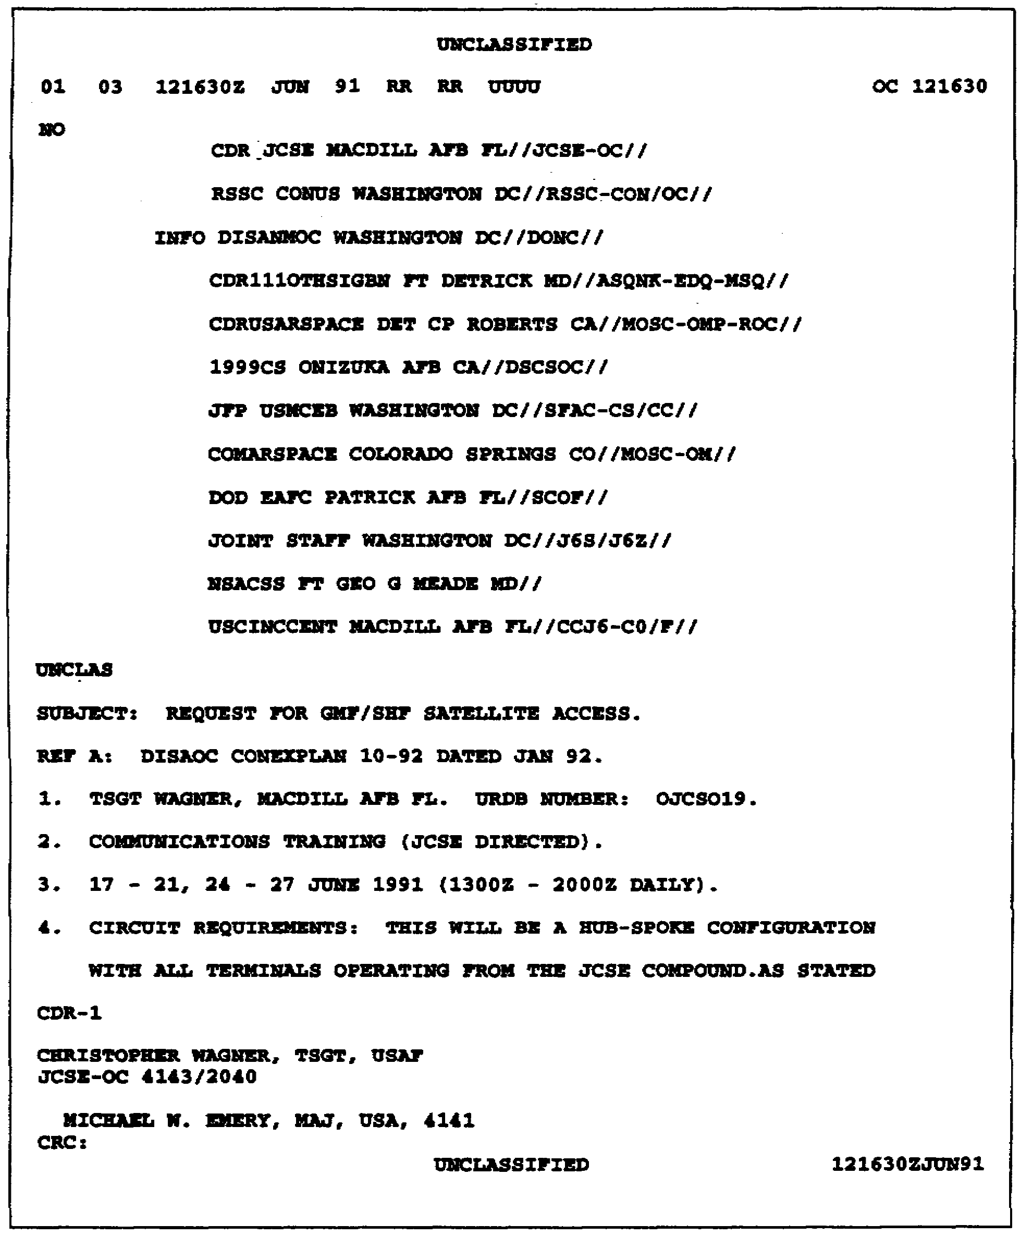

Figure 5-7. Sample SAR.

5-25 SS0031

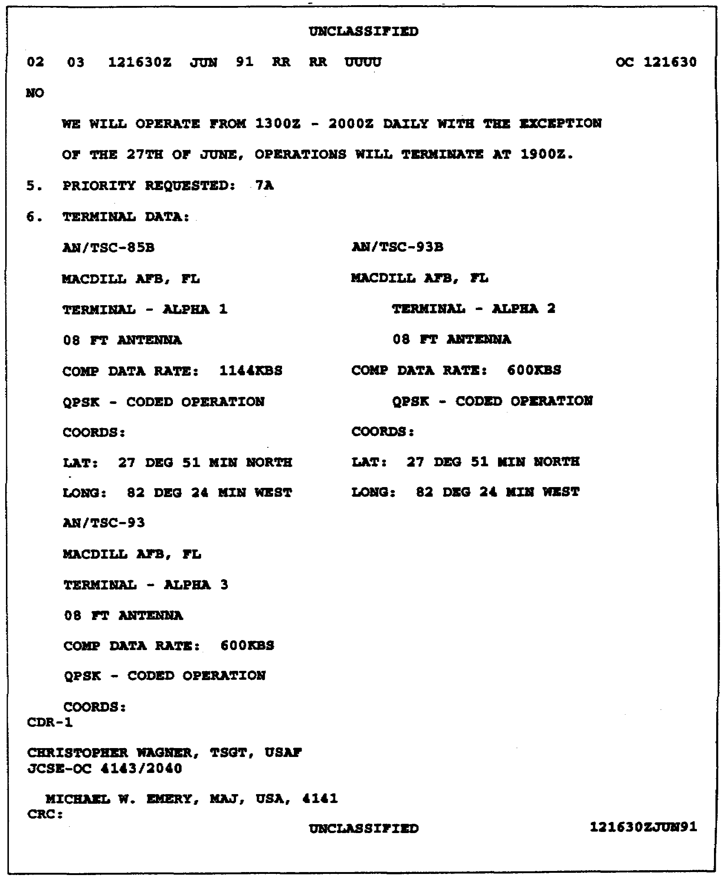

Figure 5-7. Sample SAR (continued).

SS0031 5-26

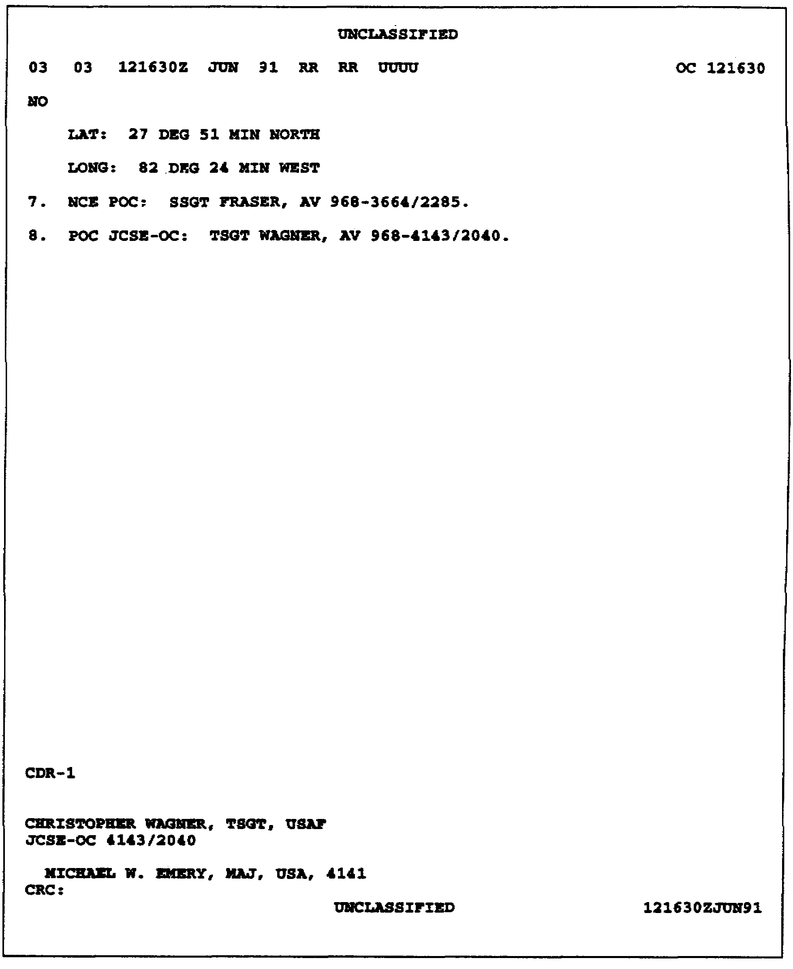

Figure 5-7. Sample SAR (continued).

5-27 SS0031

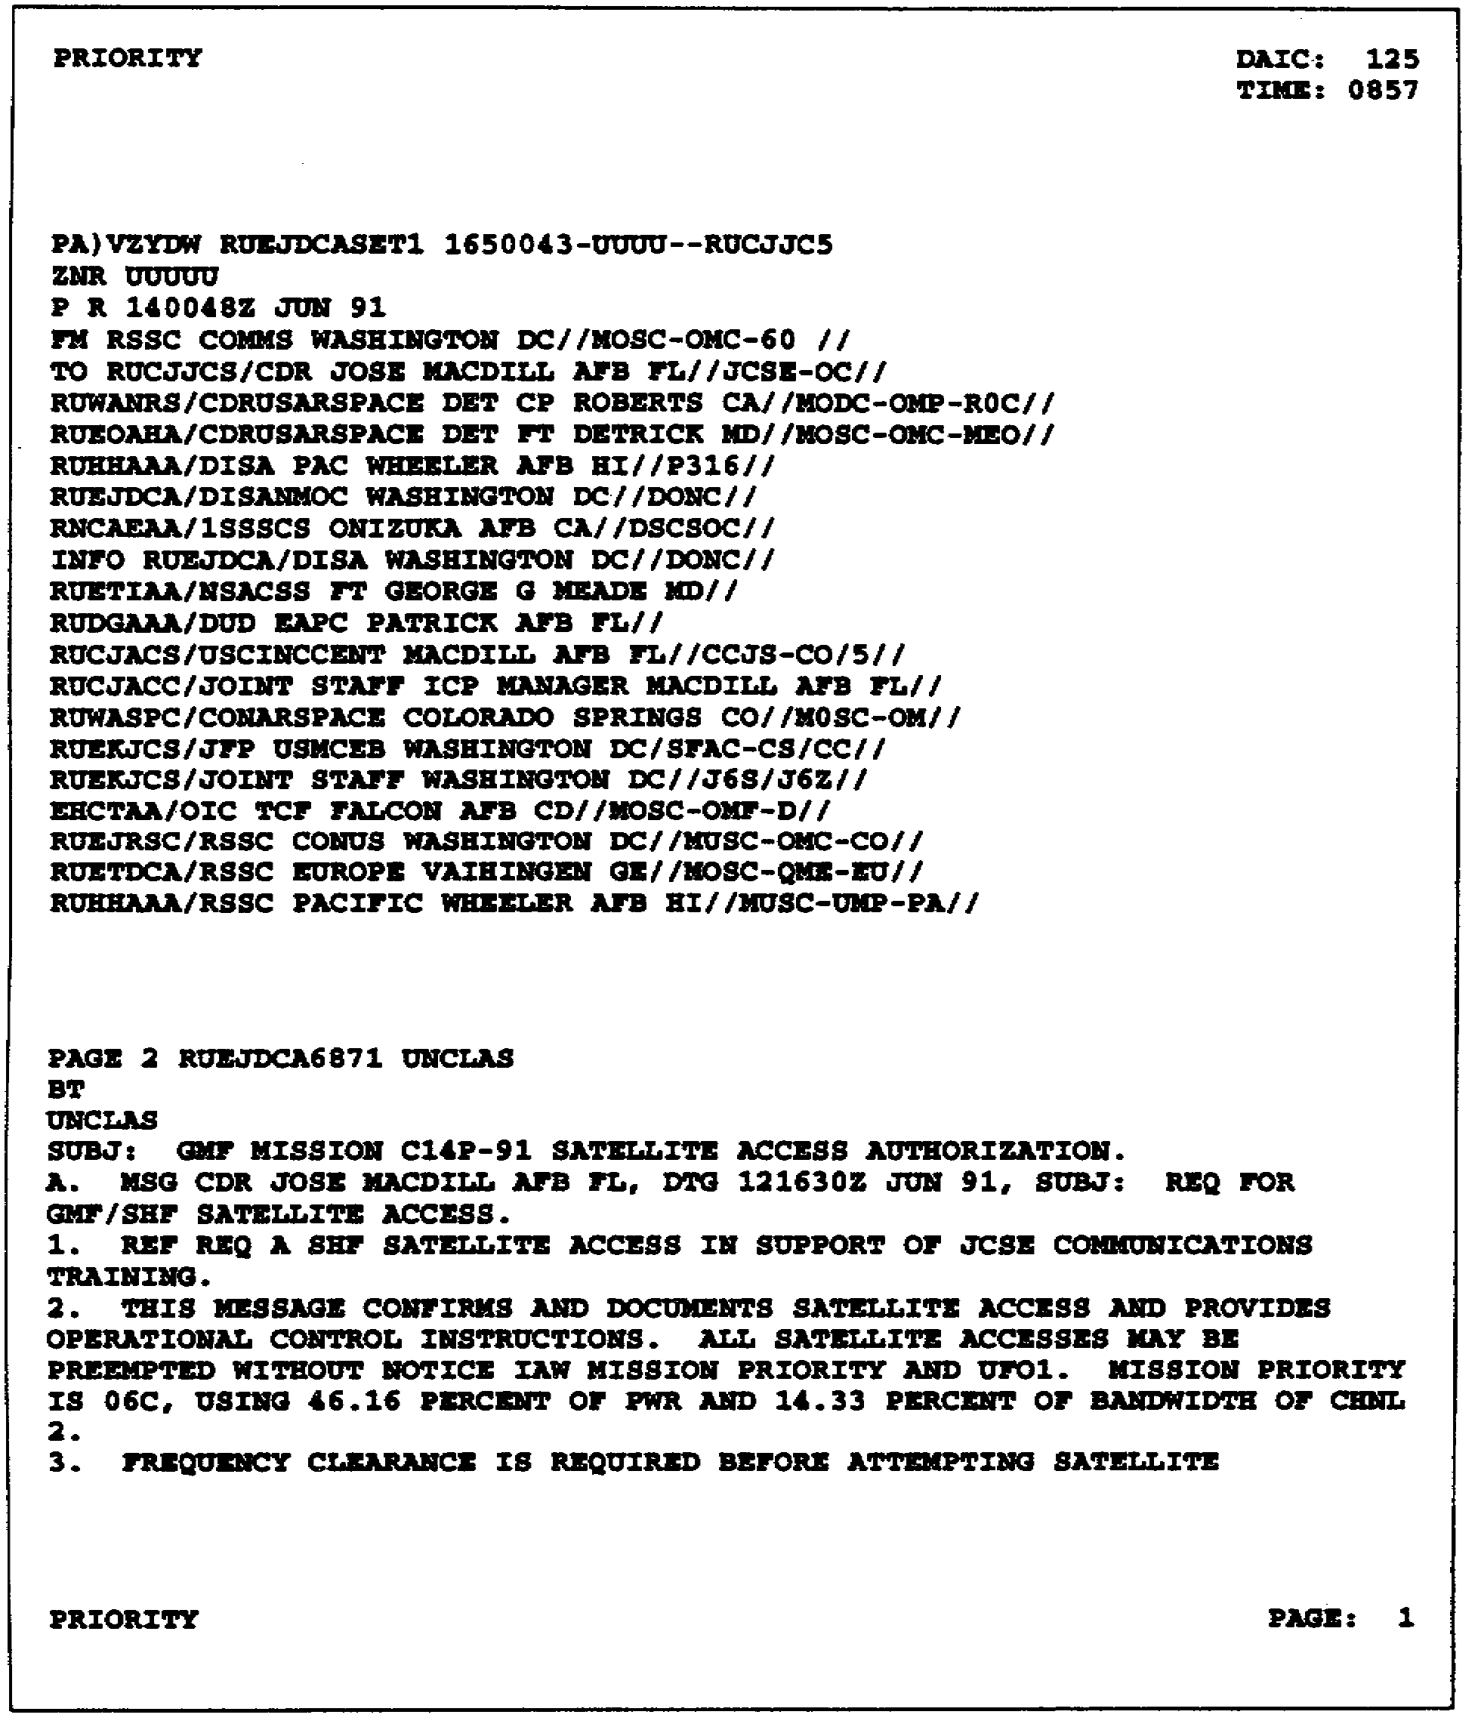

Figure 5-8. Sample SAA.

SS0031 5-28

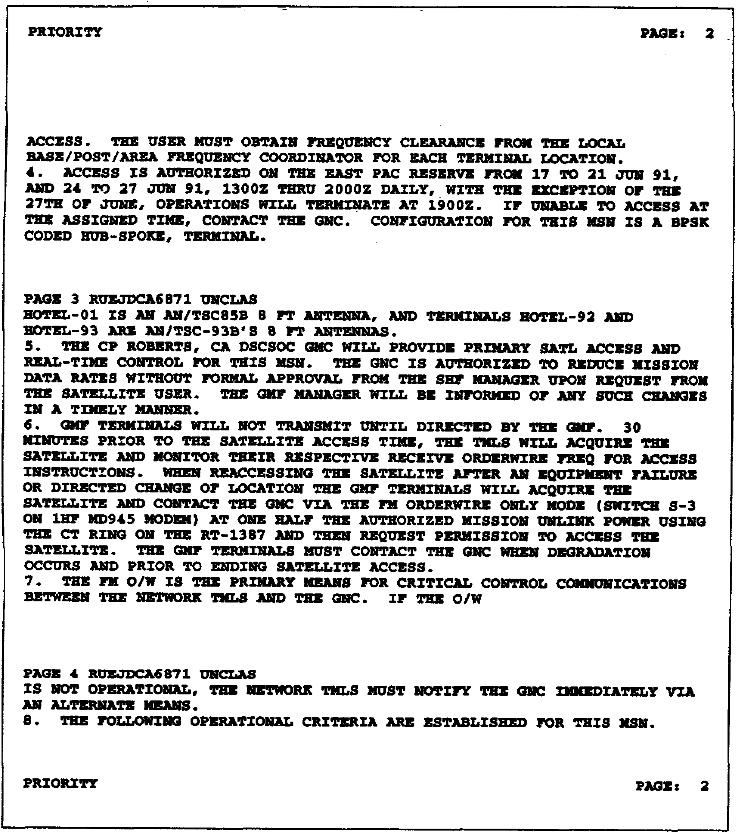

Figure 5-8. Sample SAA (continued).

5-29 SS0031

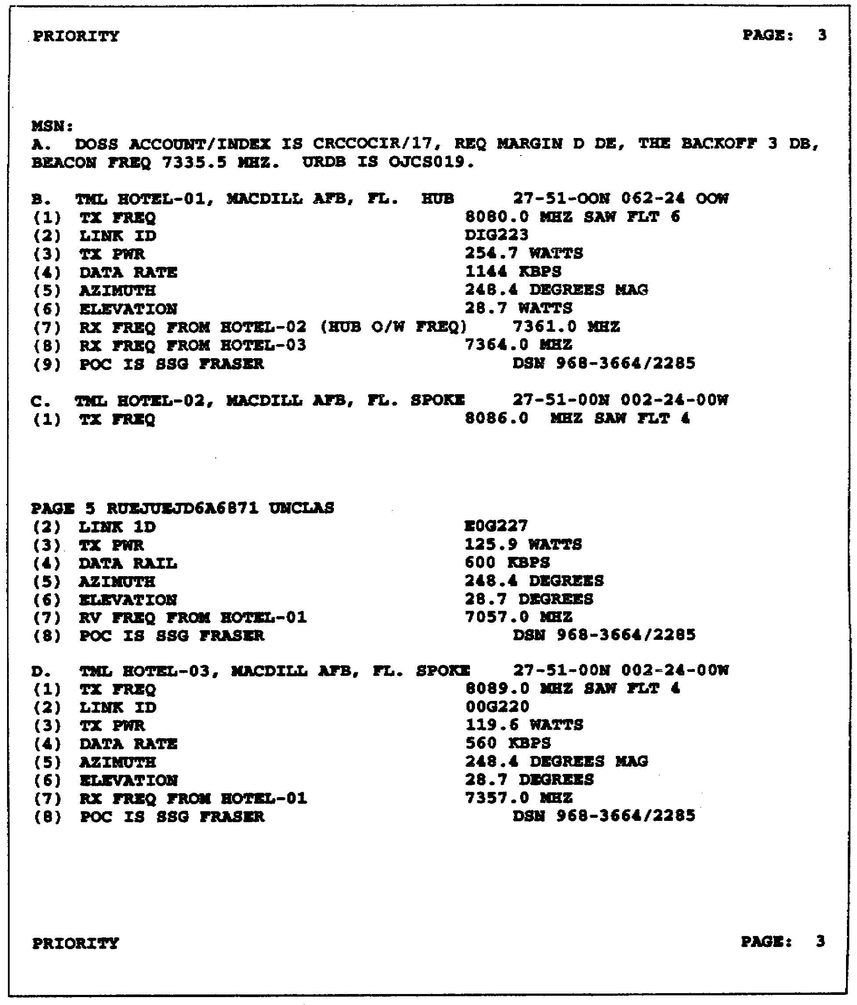

Figure 5-8. Sample SAA (continued).

SS0031 5-30

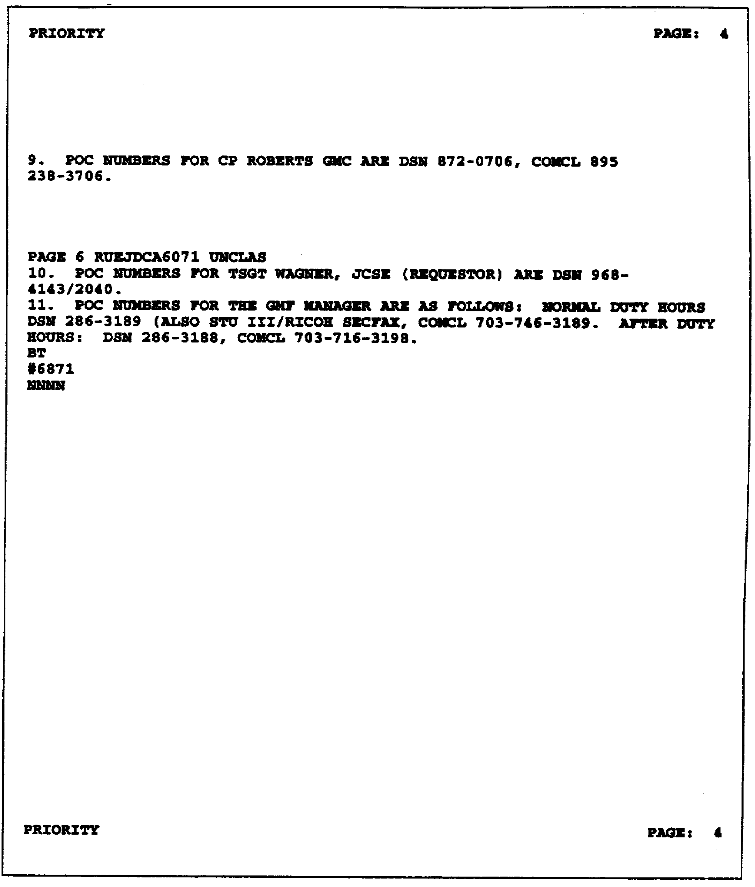

Figure 5-8. Sample SAA (continued).

5-31 SS0031

THIS PAGE INTENTIONALLY LEFT BLANK

SS0031 5-32

LESSON 5

PRACTICE EXERCISE

The following items will test your grasp of the material covered in this lesson. There is only one correct answer for each item. When you complete the exercise, check your answers with the answer key that follows. If you answer any item incorrectly, study again that part of the lesson which contains the portion involved.

1. The multichannel SHF system, currently used by the US Army, uses which of the following TACSAT systems?

A. DSCS II
B. FLSAT
C. DSCS III
D. Both A and C

2. The AN/TSC-85B, both the shelter and APTF, is transportable by road, air, rail, and sea with no nonorganic equipment required for transport.

A. True
B. False

3. The AN/TSC-85B/93B terminal configurations allow digital interface with TRI-TAC equipment, but not with MSE.

A. True
B. False

4. The usual deployment of the GMFSCCC AN/MSQ-114 is-

A. One per corps of operation
B. One per corps signal brigade
C. One per theater of operation
D. One per division signal battalion

5. Often, during network operations, it may become necessary to reconfigure a real-time link or the whole network. Which of the reasons below might necessitate a reconfiguration?

A. Enemy action
B. Degradation of a link(s)
C. Changes in requirements
D. All of the above

5-33 SS0031

LESSON 5

PRACTICE EXERCISE

ANSWER KEY AND FEEDBACK

Item Correct Answer and Feedback

1. A DSCS II (page 5-2, Learning Event 1, paras 1 and 2)

2. A True (page 5-3, Learning Event 2, para 5b)

3. B. False (page 5-9, Learning Event 5, para 1)

4. C. One per theater of operation (page 5-15, Learning Event 9)

5. D. All of the above (page 5-18, Learning Event 10, para 4)

SS0031 5-34

LESSON 6

SPECIAL COMMUNICATIONS SYSTEMS (SCS) AND
MILITARY STRATEGIC TACTICAL RELAY (MILSTAR)

Critical Task: 01-5768.07-0002

OVERVIEW

LESSON DESCRIPTION:

In this lesson, you will learn a basic knowledge of SCS and MILSTAR.

TERMINAL LEARNING OBJECTIVE:

ACTION: Demonstrate a basic knowledge of the special communications systems and MILSTAR to include their deployment/employment, system configuration, and description. Demonstrate a basic knowledge of the antijamming, ECCM techniques, and control techniques used with these systems.

CONDITION: Give lesson material, paper, pencil, and without supervision.

STANDARD: Demonstrate competency of the task, skills, and knowledge of the material presented by responding to 70 percent of the test questions covering satellite communications.

INTRODUCTION

This is the sixth and final lesson of this subcourse. It will provide in-depth information on SCS and MILSTAR-which is a relevantly new system being fielded in the nineties. Additionally, it will include a system description, deployment/employment of the MILSTAR system, and control and management of the system.

6-1 SS0031

SECTION I. SPECIAL COMMUNICATIONS SYSTEM

LEARNING EVENT 1: SYSTEM DESCRIPTION

1. The SCS permits direct, automated, real-time communications in support of joint forces requiring rapid deployment or redeployment. SCS terminals send and receive record narrative messages over a 5-kHz narrowband satellite channel.

2. The SCS operates in the UHF spectrum using the 225 to 400 MHz band. The Army, Navy, and Air Force operate SCS terminals. They consist of SATCOM terminals AN/GSC-40, AN/GSC-40A(V)1, AN/GSC-40A(V)2, and AN/MSC-64(V)2.

3. The SCS terminal AN/MSC-64(V)2 is a highly mobile set installed in an S-280 type shelter. The rack-mounted combined ground command post terminal (CGCPT) AN/GSC-40(*)(V)(*) is configured to the needs of the fixed site at which it is installed.

LEARNING EVENT 2: DEPLOYMENT

1. SCS terminals are deployed in Europe and Korea. All Army terminals function within a TACSAT network made up of force terminals (FTs) and command post (CP) equipment.

2. All SCS terminals deployed in a theater are operated as a network. The United States Pacific Air Force has operational responsibility for all Air Force SCS terminals in the Korean theater. The United States Army provides off-site maintenance support for United States Air Force terminals in the Korean theater. Within joint commands, the US Army component commands are responsible for operation and maintenance of the SCS terminals assigned to their subordinate units.

3. SCS terminals deployed to Europe and Korea support Army, Navy, and Air Force real-time communication requirements for on-going special missions.

LEARNING EVENT 3: EMPLOYMENT

1. The SCS terminal is a single-channel TACSAT set. Each SCS terminal uses an I/O device. The device has a keyboard and display for editing and composing narrative traffic. The keyboard and display equipment is the I/O unit MX-10159/G that functions as the sole subscriber data terminal equipment (DTE). The AN/MSC-64(V) and AN/GSC-40(V) are self-contained terminals.

a. The AN/MSC-64(V)2 contains a complete communications system housed in an S-280 shelter, carried by a 2 1/2-ton truck and powered by a trailer-mounted, 10-kilowatt generator. The AN/MSC-64(V)2 can also be powered by the vehicle engine with a 100-amp kit. The I/O unit organic to the terminal is the primary DTE and can be

SS0031 6-2

remoted up to 1,500 feet (455 meters). A low gain antenna is used during mobile operations. A high gain antenna is used during stationary operations.

b. The AN/GSC-40, AN/GSC-40A(V)1, and AN/GSC-40A(V)2 are rack mounted CGCPTs. These terminals are installed in CPs and configured according to the physical limits of the site.

2. A high degree of network flexibility is accomplished by using a time division multiple access (TDMA) control structure and a CGCPT. This technique allows communications to be executed on a time-shared basis between other terminals within the theater network. The terminal can operate in the random or time division multiplexing (TDM) modes. The random mode of operation allows the user to enter the TACSAT communications network on a random basis using an open selected channel.

LEARNING EVENT 4: CONTROL AND MANAGEMENT

1. The control and management procedures discussed here pertain to the communications between AN/GSC-40(V) and AN/MSC-64(V). The AN/GSC-40(V) performs the network control function (NCF) for a net of AN/MSC-64(V) FTs.

2. The NCF, normally located within a CP, performs the following subnet control actions:

• Transmits network timing synchronization message for initialization of a terminal entering the network and for retiming all receivers within the network.

• Transmits satellite operating mode for use by FTs.

• Transmits crypto-control data.

• Performs message preemption to allow transmission of a message with a higher precedence.

• In stressed mode, identifies each frame, establishes priorities, and dynamically assigns use of next slot.

3. The FTs perform the following control actions:

• Acknowledges/transmits messages.

• Loads and monitors the synchronization code.

• Selects transmit channel and time slot.

• Monitors emergency action message alarm.

6-3 SS0031

4. The AN/MSC-64(V) FT is transported by a 2½-ton truck and trainer, and is crewed by three operators. Other technical data is listed below:

• Frequency range-225 to 400 MHz.

• Power output-10 to 100 watts.

• Operating mode-AFSAT.

• Modulation type-noncoherent FSK.

• Data rate-75 bp/s.

• Encryption device-TSEC/KN-2.

• Spread spectrum technique-frequency hopping (FH).

LEARNING EVENT 5: ANTIJAMMING AND ECCM TECHNIQUES

1. The SCS uses FH emission techniques as an ECCM capability and terminal hardening against the effects of electromagnetic pulse (EMP). The CGCPT uses wideband operation of coded FSK, pseudorandomly generated, suppressed carrier RF burst that is frequency hopped. This type of RF emission provides excellent ECCM protection for discrete addressing, message privacy, and multiple addressing. For narrowband operations, noncoherent FSK is used.

2. Wideband operation is only used between the CGCPT and the national command authority AFSATCOM terminals. SCS, a UHF system, lacks any antijamming protection to the TACSAT terminal outside of the emission techniques listed previously. The short transmission times of burst communications present less attractive jamming targets than do longer continuous communications of regular nets. The only options available to TACSAT UHF terminals, in addition to short burst communications, are alternate frequency selection and mobility.

SECTION II. MILSTAR

LEARNING EVENT 6: SYSTEM DESCRIPTION

1. The Army's tactical command and control (C2) communications must be reliable, long range, transportable, and secure. These communications must survive in severe electronic warfare (EW)/NBC environments where ground relay networks that use prominent terrain may be disrupted. They must support the critical communications needs of the tactical commander. The MILSTAR SATCOM system provides these capabilities. It integrates SATCOM with an ECCM capability and balanced nuclear

SS0031 6-4

hardening into ground terminals for installation and operation in communications shelters. The MILSTAR SATCOM system provides the most survivable communications link on the battlefield in both intense jamming and nuclear environments.

2. The AN/TSC-124 will be the Army’s MILSTAR terminal. It will be fielded in Army units in the early nineties. It will provide antijamming scintillation-protected, tri-service interoperable satellite communications to support critical C2 communications. Exclusive of the SCS, the AN/TSC-124 does not replace existing communications equipment on the battlefield; it augments the existing terrestrial C2 nets when other communications means are degraded or destroyed. The traffic transmitted via the AN/TSC-124 terminals will normally be essential data communications. Voice communications, though possible, are not intended to be the primary method of communications through the MILSTAR system. System efficiency decreases as voice traffic levels increase. Therefore, data traffic will have a higher priority for channel access throughout the system.

LEARNING EVENT 7: DEPLOYMENT

1. SCS. AN/TSC-124 terminals will replace AN/MSC-64s, currently used within the SCS, to operate the Flaming Arrow Net in Europe and Korea.

2. Theater. At EAC in Europe and Korea, AN/TSC-124s will provide for connectivity between the theater main, theater alternate, theater Army main, theater Army alternate, the theater Army MILSTAR control center (TAMCC), and six discretionary headquarters such as major joint or allied unit headquarters, additional CINC support, and the like. The theater TACSAT signal company will install, operate, and maintain the terminals.

3. Contingency support The 235th Signal Detachment and 209th Signal Company will each employ AN/TSC-124 terminals in support of Army and JCS operations worldwide. They will augment the theater assets if necessary.

4. Special Operations Command (SOCOM). The 112th Signal Battalion will employ AN/TSC-124 terminals in support of SOCOM operations.

LEARNING EVENT 8: EMPLOYMENT

The AN/TSC-124 will be a commander's asset. Although regular and recurring association of terminals and headquarters will occur, the terminals can be employed at the commander's discretion. The commander can assign a priority of communications and fight the communications assets as a combat multiplier like any other weapons system.

1. Nets and networks. The unique characteristics and capabilities of the terminals and associated satellite systems make structured nets unnecessary. Because the terminals operate with a Department of the Army Materiel Annex (DAMA) technique, there is no requirement for dedicated channels. Because of the processing capabilities of the satellites and the ability to address discretely any terminal within the system, MILSTAR

6-5 SS0031

terminals can communicate with any other MILSTAR terminals, whether located within the same theater of operations or not. Different protocols, however, will be required for in-theater and out-of-theater communications. For network identification and TRANSEC key management, all AN/TSC-124 terminals operating within the Army spotbeam footprint on each satellite will make up a network. Therefore, separate nets are unnecessary. However, partitions may be formed by selecting and distributing different COMSEC keys and addresses to the users; for example, distributing like keys to those users who want to operate together to the exclusion of others. The discrete addresses would then be furnished in a format similar to the telephone books now employed. Terminal-to-terminal connectivity would remain possible, with end-to-end communications being possible only if like COMSEC keys are employed at each I/O device.

2. System characteristics.

a. The AN/TSC-124 will consist of the terminal, prime mover, antenna, and trailer-mounted power generator. The AN/TSC-124 will be installed in one S-250 or equivalent shelter. It will be transported under tactical conditions by a standard 4-ton truck. A 3-kilowatt generator will be mounted on a standard 3/4-ton trailer that will be towed by the prime mover. Backup power will be provided by an under-hood power plant installed on the vehicle.

b. The terminal can communicate at the halt; communicating while moving is a planned improvement that will come with fixture technology. Terminal setup and teardown times will not exceed 30 minutes by a team of three military occupational specialty (MOS) 31C soldiers.

c. Critical, operator-replaceable spares will be carried to enhance system survivability and ensure rapid repair and return to service. Additionally, crew, crew weapons, personal bags and equipment, camouflage netting, tents, and the like will be carried on the vehicle or in the terminal. C130/C141/short takeoff and landing (STOL) aircraft roll-on/roll-off with no preparation is possible.

d. The terminal will be able to accept up to four individual user inputs of data or voice at rates of 75 bp/s to 2.4 kbp/s by using user-controlled interface devices (UCIDs). The devices can be remoted 2,500 feet (758 meters) from the terminal using conventional field wire. Four DR-8s, modified to accept and dispense WF-16 field wire, will be provided with the terminal. The DR-8s will provide a minimum remoting capability independent of customer field wire resources.

e. Compatibility with the MILSTAR standard I/O and COMSEC devices (for data, the AN/UGC-74 and KG-84; for voice, the ANDVT) a well as the single subscriber terminal (SST), lightweight digital facsimile, and the Army Command and Control System (ACCS) hardware is provided. Each terminal will be furnished with one AN/UGC-74 and one ANDVT for operator use.

f. It will be hardened to the effects of EMP/high altitude EMP (HEMP) and will operate in EW/NBC environments.

SS0031 6-6

g. The system will adapt to changes in the jamming environment and changes in traffic demands regardless of environment. The terminal will use spread spectrum, burst, FH, and other techniques to reduce the vulnerability to RDF, interception, exploitation, and jamming. The AN/TSC-124 will be interoperable with all other MILSTAR terminals.

3. User-controlled interface device.

a. UCIDs interface between the user of the I/O device and the terminal. It can accept inputs between 75 bp/s and 2.4 kbp/s and support full-duplex communications. The user requests service through the UCID. The UCID lets a user tell the terminal which specific I/O and COMSEC devices are attached to the two ports of the UCID. Information relating to the service requested, discrete addresses of sender and receiver(s), and I/O device and COMSEC compatibility can be entered by the user. This alerts the terminal and the servicing satellite to establish the requested type of link between the sender and receiver(s). Once the link is established, the UCID must alert the sender that he may pass his traffic.

b. Four UCIDs will be provided with each AN/TSC-124. Each can accept two inputs, though not at the same time. Three UCIDs will normally be provided to the remote users. The fourth UCID will be reserved within the shelter to allow the AN/TSC-124 operator access to the system for the operator I/O devices provided with the terminal (AN/UCG-74 and ANDVT).

c. The UCID can be used by a general purpose user (GPU) of any grade or MOS. The UCID, although a component of the AN/TSC-124 terminal, will be provided to the user at the user's remote location. The UCID, associated COMSEC (that is, KG-84), and user-owned and provided I/O device will be operated by the user of the communications provided by the terminal.

LEARNING EVENT 9: CONTROL AND MANAGEMENT

1. MILSTAR.

a. The US Air Force MILSTAR ground command post terminal (GCPT), the Navy (EHF) Satellite Program (NESP), and the Army SCOTT (AN/TSC-124) provide the services with control and access to the MILSTAR satellite constellation to support the national command authority (NCA)..

b. The MILSTAR mission control element, called the Theater MILSTAR Control Center (TMCC), will exercise overall control within a theater of operations along with a number of constellation-control stations. The specific roles for each and the requirements for interface are being developed by the US Air Force Space Command. The Army Space Command is refining the specific responsibilities and procedures for Army-specific MILSTAR control.

6-7 SS0031

2. TRANSEC/COMSEC management.

a. The National Security Agency (NSA) distributes the TRANSEC keys. As part of the initial terminal startup, the TRANSEC variables are distributed to the units' COMSEC accounts and the operator manually loads the TRANSEC keys. Before the TRANSEC period expires, the mission control element (MCE) distributes, over the air, the keys for the upcoming TRANSEC period. Emergency rekey also occurs over the air (for example, when a network terminal is compromised). Backup and future TRANSEC keys should be on hand with the unit COMSEC custodian to facilitate rekey in the event over-the-air rekey is not possible.

b. The COMSEC keys are distributed to individual COMSEC accounts for dissemination to individual terminal users. Both the normal and emergency rekey for data and voice COMSEC devices are done manually. Backup and upcoming keys are on hand at the terminal-user locations. The number of variables issued to each terminal and user depends on the mission of that terminal or user and the network in which it operates.

SS0031 6-8

LESSON 6

PRACTICE EXERCISE

The following items will test your grasp of the material covered in this lesson. There is only one correct answer for each item. When you complete the exercise, check your answers with the answer key that follows. If you answer any item incorrectly, study again that part of the lesson which contains the portion involved.

1. The SCS permits direct, automated, real-time communications in support of joint forces requiring rapid deployment or redeployment.

A. True
B. False

2. Network flexibility in the SCS is accomplished through the use of a what control structure?

A. FDKA
B. DAK
C. TDMA
D. TCCP

3. What performs the network control functions for a net of what force terminals?

A. AN/GSC-40(V); AN/MSC-64(V)
B. AN/MSC-64(V); AN/GSC-40(V)
C. AN/GSC-40(V); AN/VSC-7(V)
D. AN/VSC-7(V); AN/PSC-9(V)

4. When deployed, the MILSTAR's AN/TSC-124 communication systems AN/GSC-40(V) is currently used.

A. True
B. False

6-9 SS0031

LESSON 6

PRACTICE EXERCISE

ANSWER KEY AND FEEDBACK

Item Correct Answer and Feedback

1. A True (page 6-2, Learning Event 1, para 1)

2. C. TDMA (page 6-3, Learning Event 3, para 2)

3. A. AN/GSC-40(V); AN/MSC-64(V)(page 6-3, Learning Event 4, para 1)

4. A. True (page 6-5, Learning Event 6, para 2)

SS0031 6-10

